A novel time-lapse imaging method for studying developing bacterial biofilms

Momir Futo, Tin Široki, Sara Koska, Nina Čorak, Anja Tušar, Mirjana Domazet-Lošo, Tomislav Domazet-Lošo^{2,3}

Supplementary material

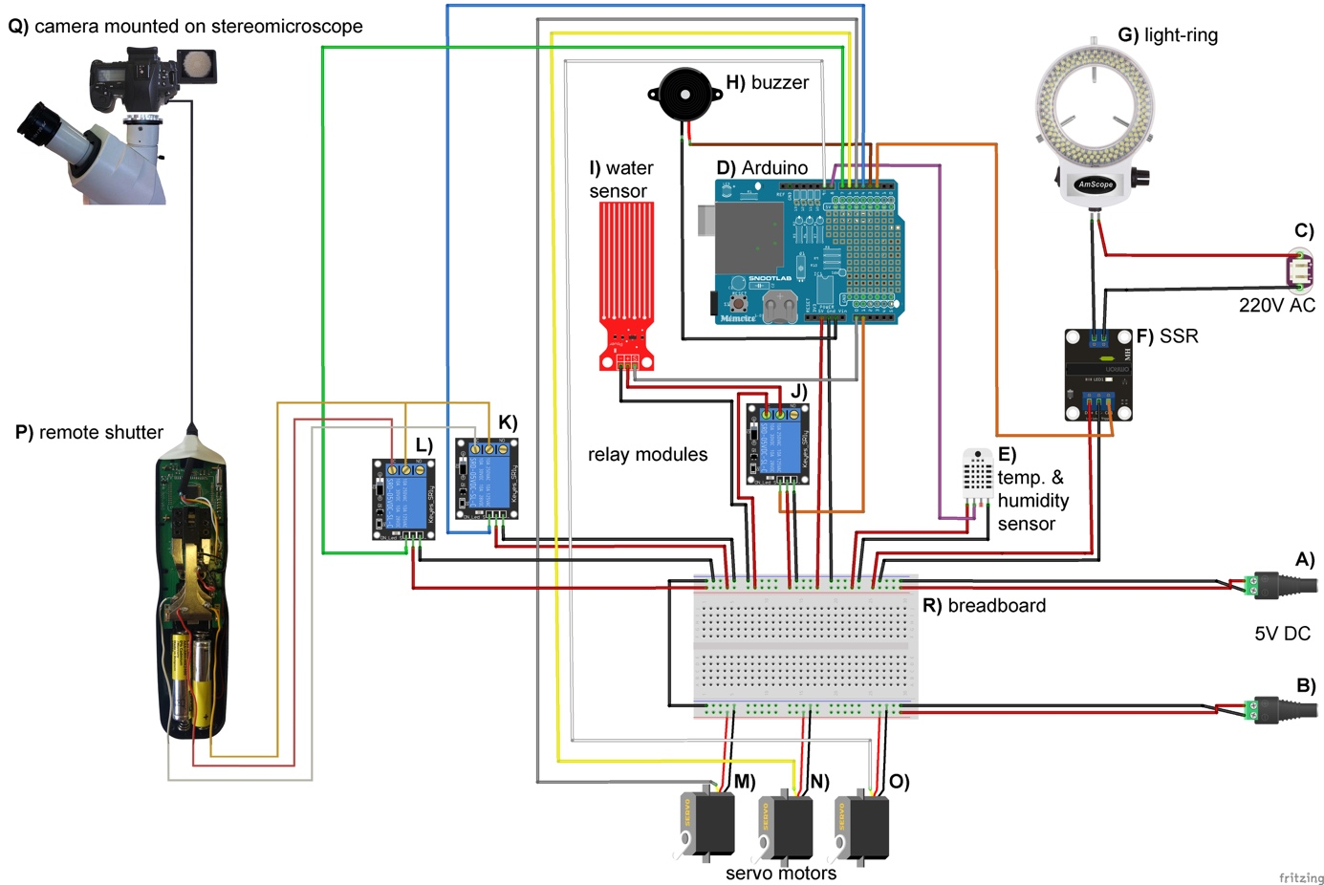

Supplementary Figure 1. Arduino microcontroller wiring schematics with temperature sensor. | A, B - 5V DC power sources, C – 220V AC power source, D – Arduino-compatible data logging shield (Velleman) mounted onto a Arduino Uno R3 microcontroller board, E – AM2302 DHT22 digital temperature and relative humidity sensor module, F – solid state relay module (Omron), G – 144 LED light-ring for stereo microscopes (AmScope), H - passive buzzer, I – water level detection sensor module, J, K, L – 5V DC Arduino KY-019 relay modules, M, N, O – SG90 servo motors, P – digital timer remote shutter release trigger MC-36B (Neewer), Q – SONY alpha 7 II mirrorless camera mounted on a Zeiss Stemi C-2000 stereo microscope using a T2 adapter, R – 30-row solderless breadboard with two bus stripes. Arduino schematic was developed using the Fritzing software V0.9.3²⁰ and Adobe Photoshop CC 2017.

