ESI:
ELECTRONIC SUPPLEMENTARY MATERIAL
The effectiveness of newly synthesized quaternary ammonium salts (QASs) differing in chains length and the type of counterion against priority human pathogens

1. Adhesion of microorganisms to silicone and glass

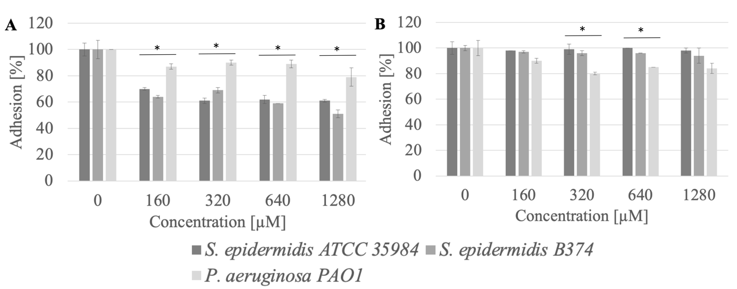
Figure S1. Adhesion of microorganisms to surfaces (A - silicone, B - glass) after incubation with MeC16 compound; * significant difference between groups (p<0.05).

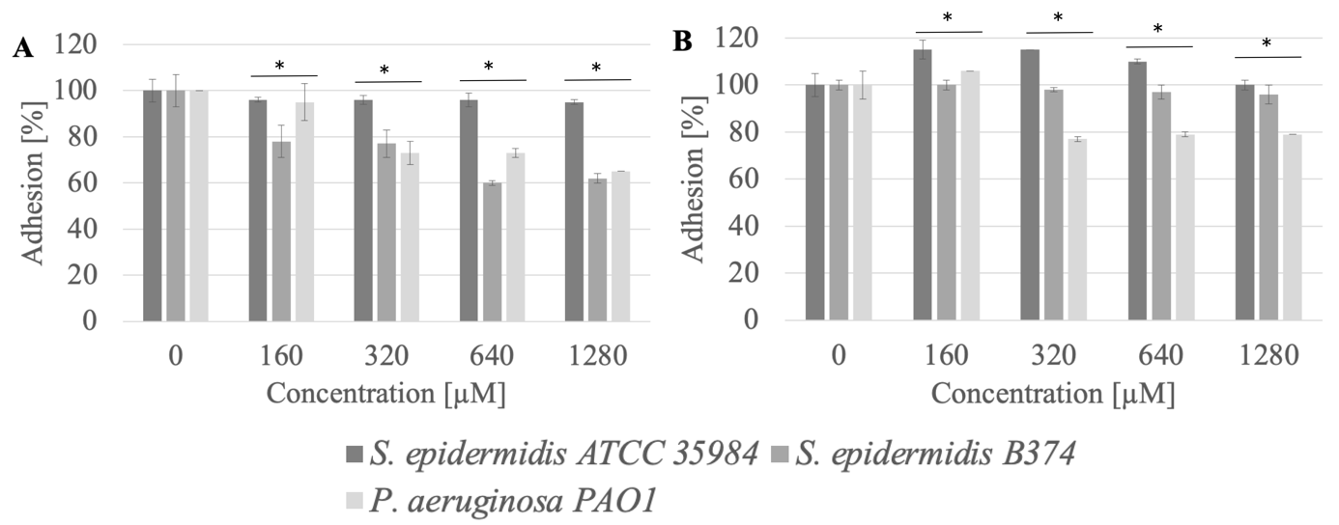
Figure S2. Adhesion of microorganisms to surfaces (A - silicone, B - glass) after incubation with MeC12 compound; * significant difference between groups (p<0.05).

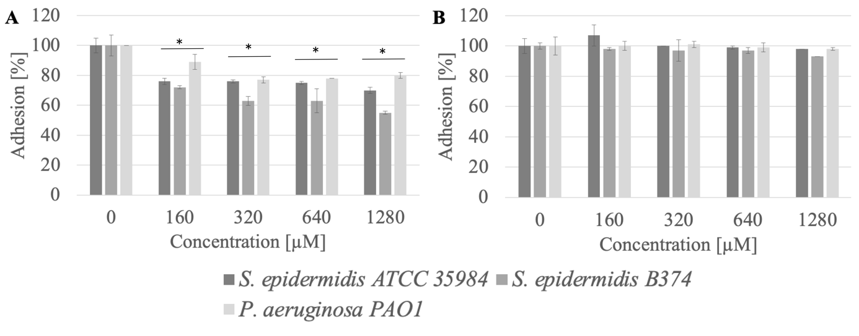
Figure S3. Adhesion of microorganisms to surfaces (A - silicone, B - glass) after incubation with MeC14 compound; * significant difference between groups (p<0.05).

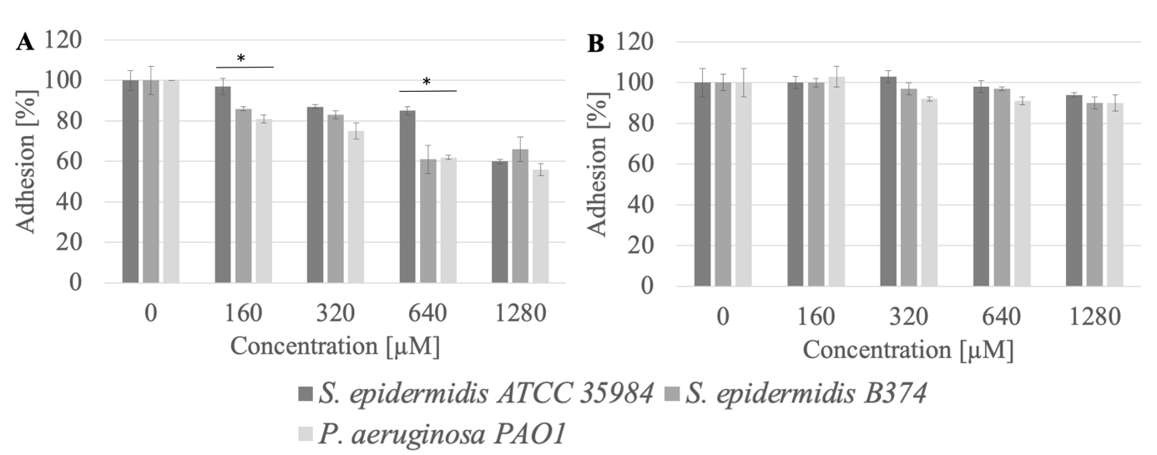
Figure S4. Adhesion of microorganisms to surfaces (A - silicone, B - glass) after incubation with AcC16 compound; * significant difference between groups (p<0.05).

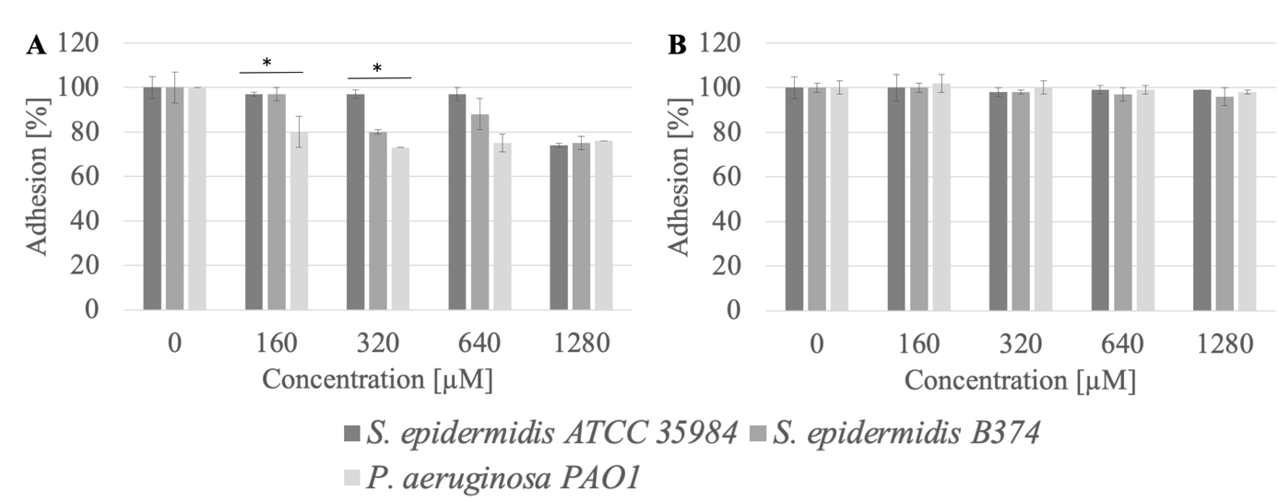
Figure S5. Adhesion of microorganisms to surfaces (A - silicone, B - glass) after incubation with AcC12 compound; * significant difference between groups (p<0.05).
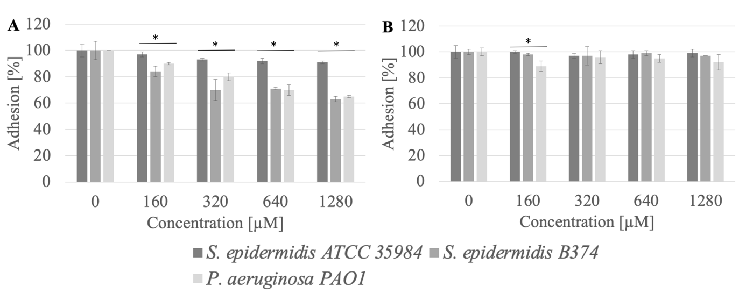
Figure S6. Adhesion of microorganisms to surfaces (A - silicone, B - glass) after incubation with AcC14 compound; * significant difference between groups (p<0.05).

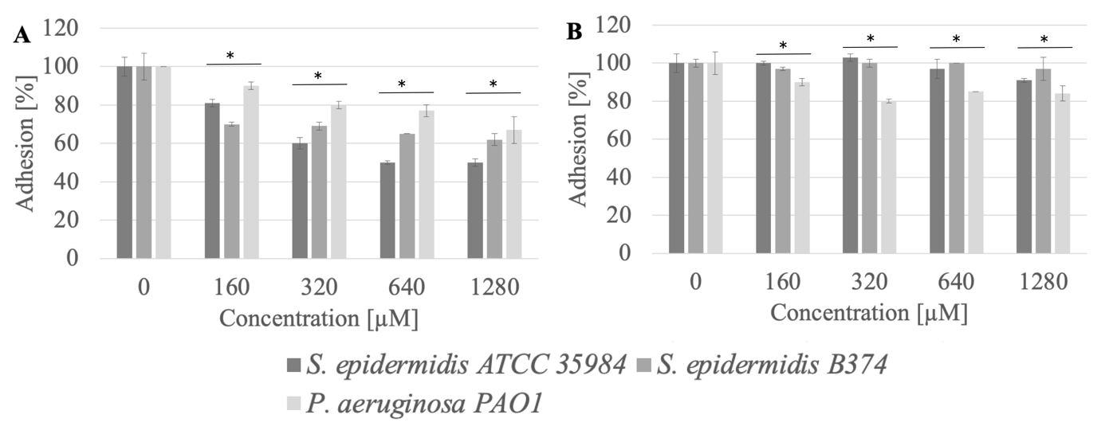
Figure S7. Adhesion of microorganisms to surfaces (A - silicone, B - glass) after incubation with BrC16 compound; * significant difference between groups (p<0.05).

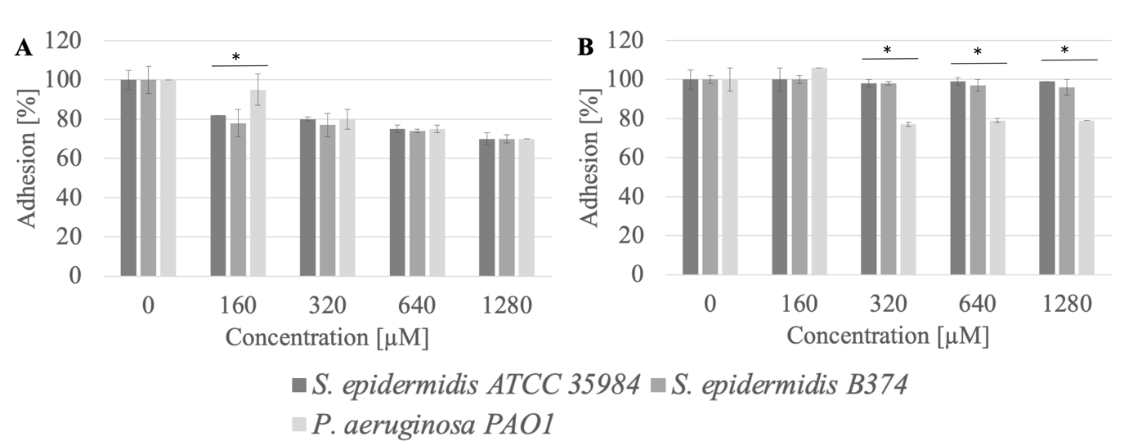
Figure S8. Adhesion of microorganisms to surfaces (A - silicone, B - glass) after incubation with BrC12 compound;* significant difference between groups (p<0.05).

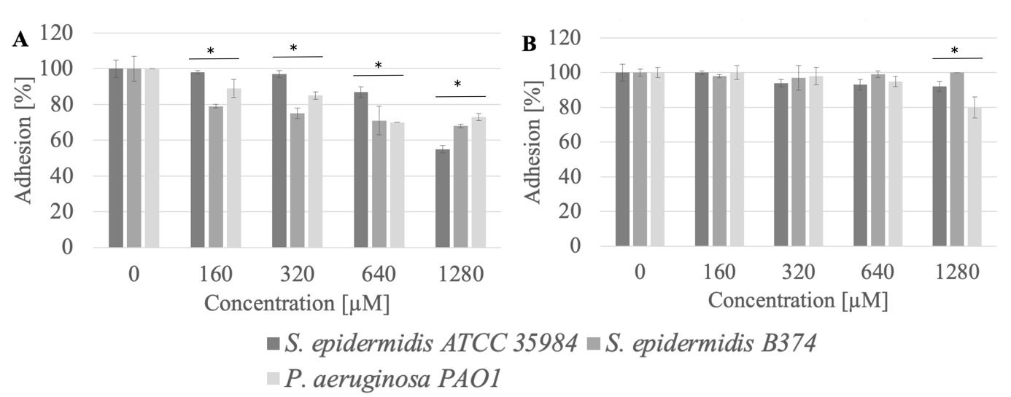
Figure S9. Adhesion of microorganisms to surfaces (A - silicone, B - glass) after incubation with BrC14 compound; * significant difference between groups (p<0.05).

2. Determination of CMC values of the studied surfactants by the conductometric method.
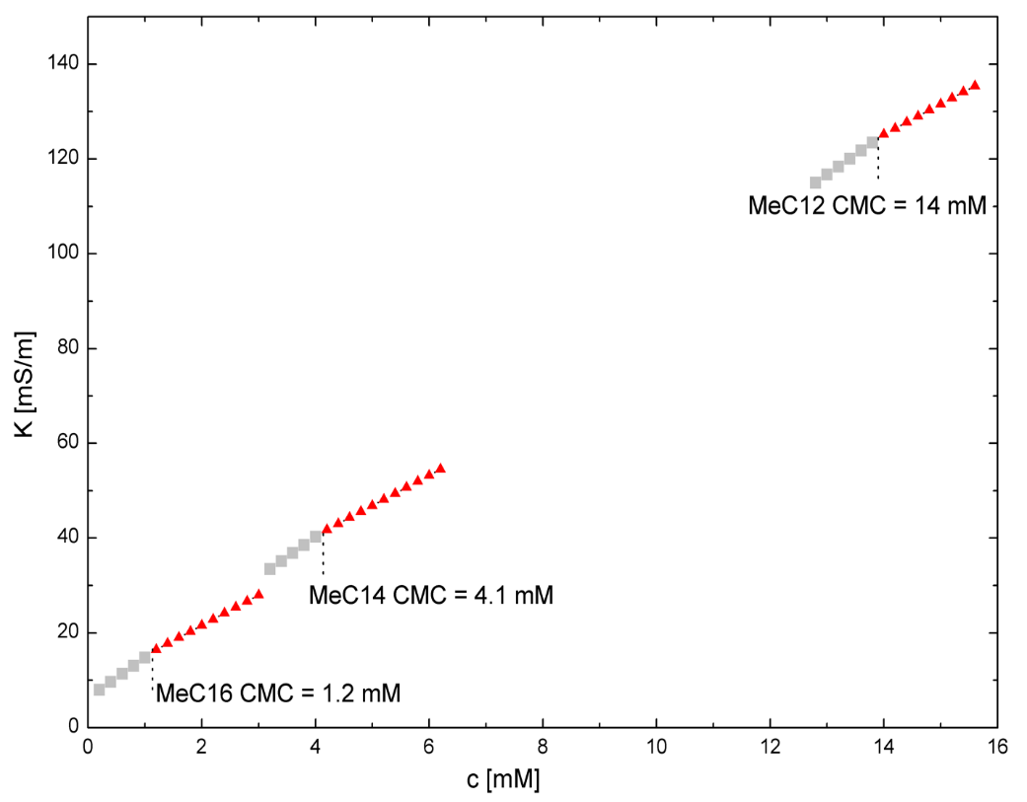
Figure S10. Electric conductivity vs. concentration of MeC12, MeC14 and MeC16 in aqueous solution at 25°C.
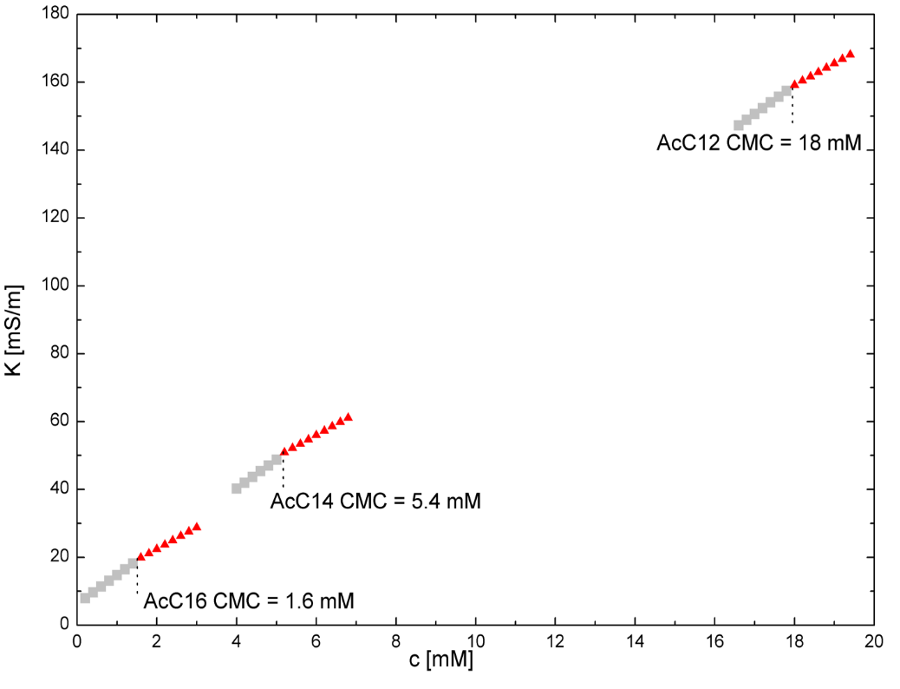
Figure S11. Electric conductivity vs. concentration of AcC12, AcC14 and AcC16 in aqueous solution at 25 °C.

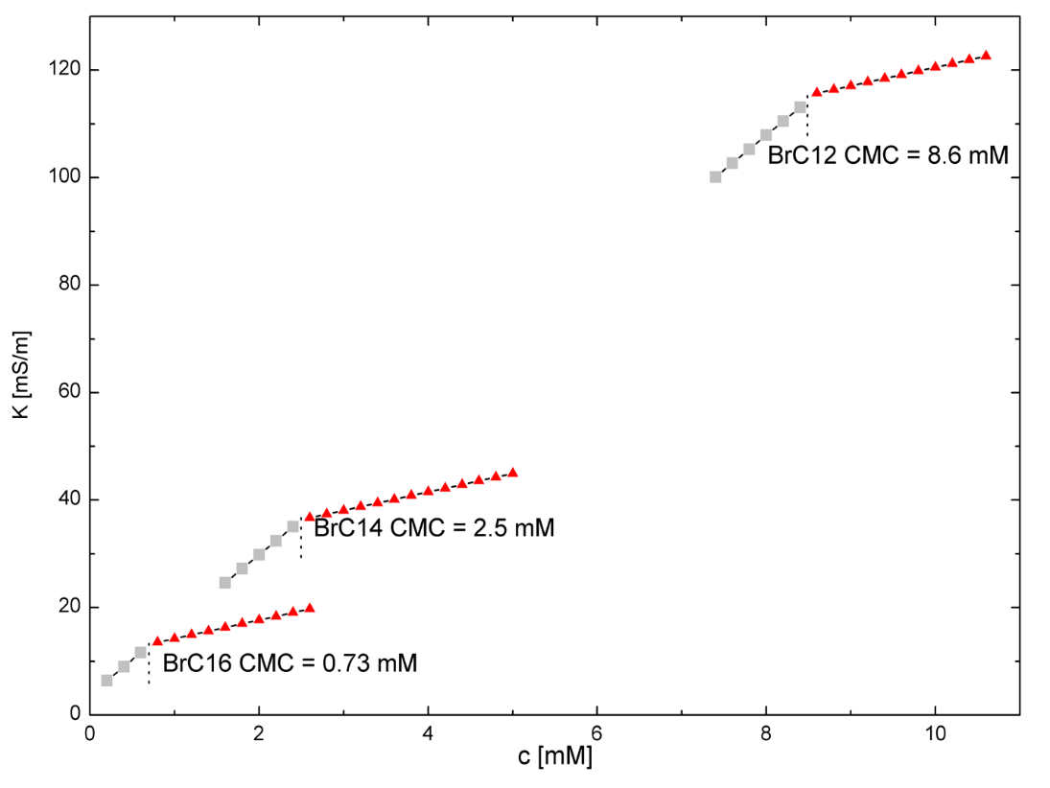
Figure S12. Electric conductivity vs. concentration of BrC12, BrC14 and BrC16 in aqueous solution at 25 °C.

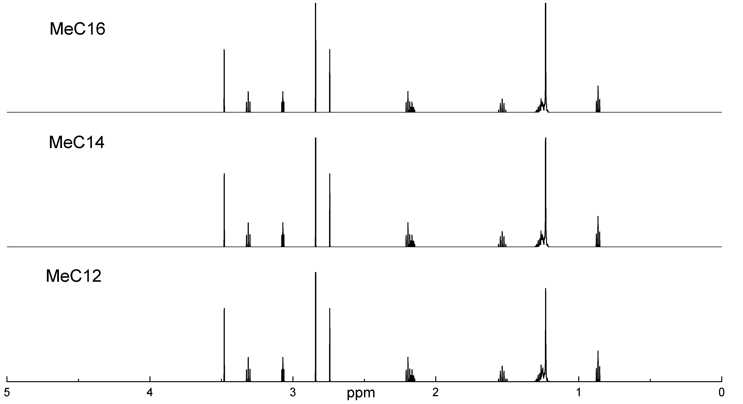
Figure S13. ¹H MNR spectra of MeC12, MeC14 and MeC16.

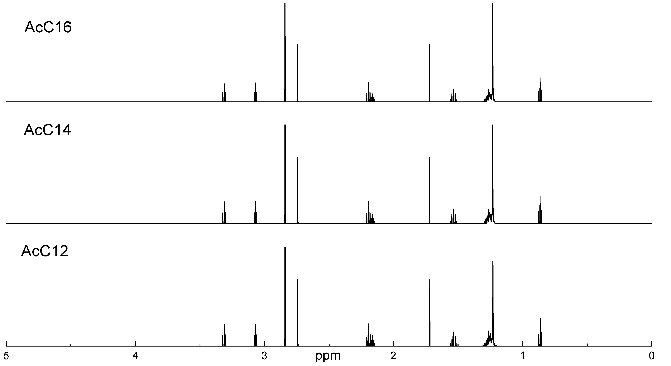
Figure S14. ¹H MNR spectra of AcC12, AcC14 and AcC16.

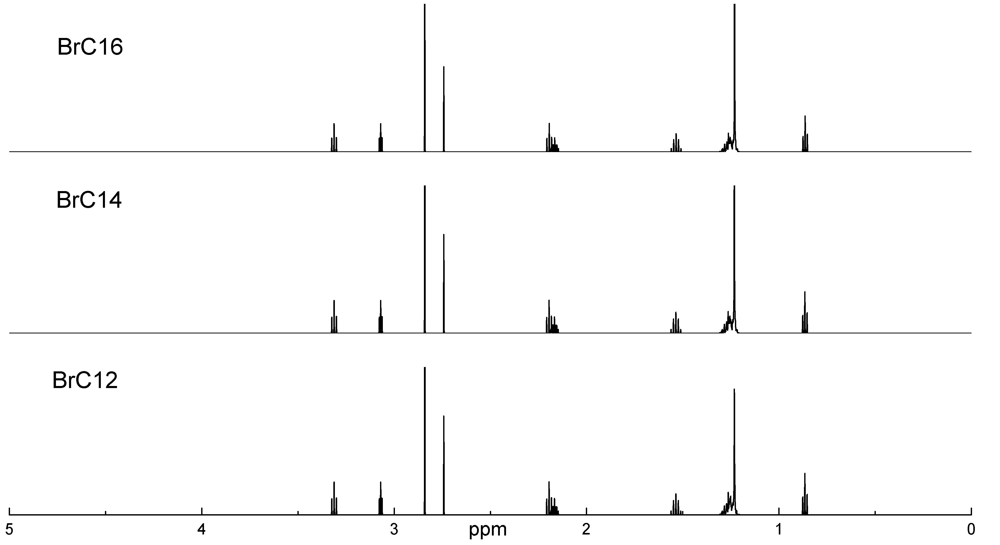
Figure S15. ¹H MNR spectra of BrC12, BrC14 and BrC16.

