SUPPLEMENTARY MATERIALS
Table 1: Cytotoxicity of the synthesised AgNPs from Allium sativum extract.
Concentration (μg/ml) | Cell Death (%)
0 | 0 ± 0
0.01 | 7.888072 ± 0.976385
0.1 | 10.72065 ± 0.392806
1 | 21.5925 ± 0.261503
10 | 23.67391 ± 0.92456
100 | 27.10937 ± 0.146112
Data was represented as mean ± SD, n=3

Table 2: Antioxidant activity of the synthesised AgNPs from Allium sativum extract
Concentration (µg/ml) | % of inhibition by AgNPs | % of inhibition by Ascorbic Acid
0 | 0 ± 0 | 0±0
20 | 31.86553 ± 2.075787 | 74.17929 ± 2.767716
40 | 36.60702 ± 0.745968 | 80.52482±2.230854
60 | 43.7799±2.3683 | 95.51768±1.51778
80 | 52.86998±1.164179 | 96.11493±0.532163
100 | 63.38467±1.561246 | 96.54938±0.744793
Data was represented as mean ± SD, n=3

Table 3: Effect of AgNPs on glucose uptake in L-6 cell line
Sample | Concentration (µg/ml) | Glucose Uptake (%)
 | 0 | 0 ± 0
AgNPs | 25 | 28.97521 ± 0.740278
 | 50 | 32.73621 ± 0.317892
 | 75 | 36.42466 ± 0.354886
 | 100 | 41.86735 ± 0.607135
Metformin | 50 | 28.23581 ± 0.469382
Data was represented as mean ± SD, n=3
Table 4: Effect of AgNPs on glucose production in L-6 cell line
Sample | Concentration (µg/ml) | Glucose production (%)
AgNPs | 0 | 0 ± 0
 | 25 | 26.27855 ± 2.329259
 | 50 | 32.78072 ± 2.107858
 | 75 | 48.57182 ± 5.255789
 | 100 | 57.72432 ± 0.356931
Metformin | 50 | 28.89093 ± 1.920134
Data was represented as mean ± SD, n=3

Table 5: Effect of AgNPs on Insulin secretion in pancreatic cells
Sample | Concentration (µg/ml) | Insulin Secretion (units/mg of Protein)
Control | 0 | 0.934157 ± 0.002817
Pioglitazone | 25 | 1.175381 ± 0.001437
AgNPs | 25 | 1.056467 ± 0.001989
 | 50 | 1.064682 ± 0.002354
 | 70 | 1.07183 ± 0.002781
 | 100 | 1.260353 ± 0.003387
Data was represented as mean ± SD, n=3

Table 6: Inhibition of α-Amylase by AgNPs
Concentration (µg/ml) | Percentage of Inhibition by AgNPs (%) | Percentage of Inhibition by Acarbose (%)
0 | 0 ± 0 | 0 ± 0
20 | 34.68063 ± 0.171221 | 14.99411 ± 1.743569
40 | 38.99055 ± 1.064886 | 24.2984 ± 1.678458
60 | 52.06065 ± 0.713013 | 35.32656 ± 1.422076
80 | 59.51279 ± 0.68046 | 54.00569 ± 0.706933
100 | 72.03404 ±1.563872 | 58.15841 ± 1.71515
Data was represented as mean ± SD, n=3
Table 7: Inhibition of α-Glucosidase by AgNPs
Concentration (μg/ml) | Percentage of Inhibition by AgNPs (%) | Percentage of Inhibition by Acarbose (%)
0 | 0 ± 0 | 0 ± 0
20 | 43.86942 ± 0.95269 | 31.12518 ± 0.670479
40 | 53.09808 ± 1.279717 | 38.99055 ± 1.064886
60 | 68.18119 ± 1.205639 | 52.06065 ± 0.713012
80 | 71.5252 ± 0.482974 | 58.30623 ± 0.955483
100 | 73.43919 ± 0.097911 | 59.59389 ± 2.034447
Data was represented as mean ± SD, n=3

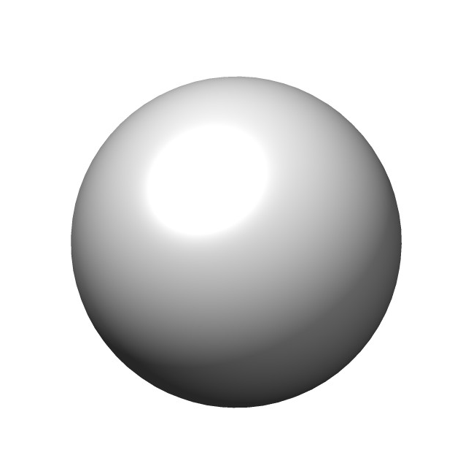
Figure 1: 3D-Image of the silver atom
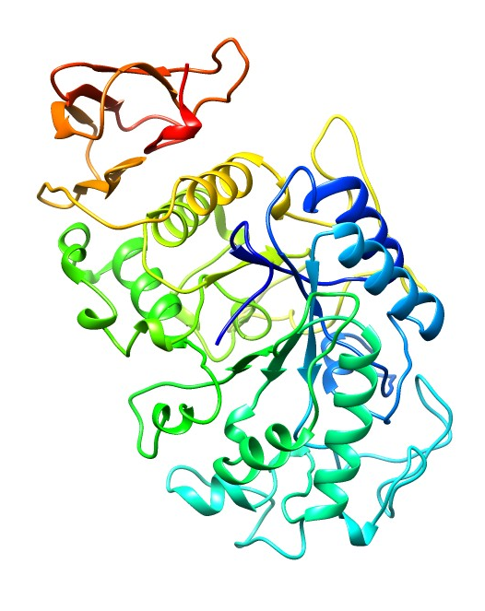
Figure 2: 3D image of α-Amylase
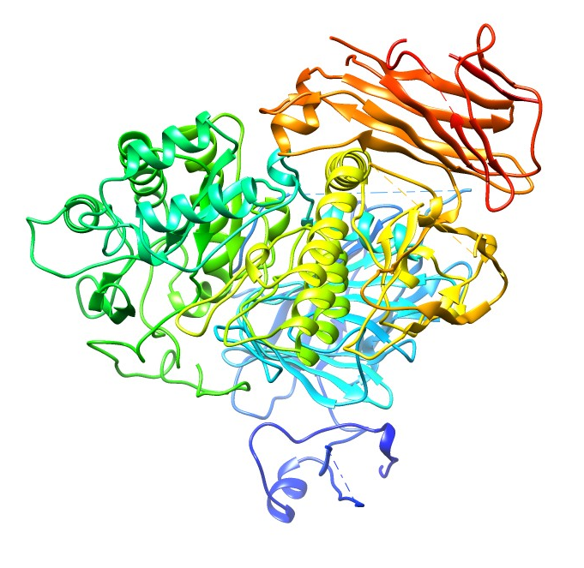
Figure 3: 3D image of α- Glycosidase
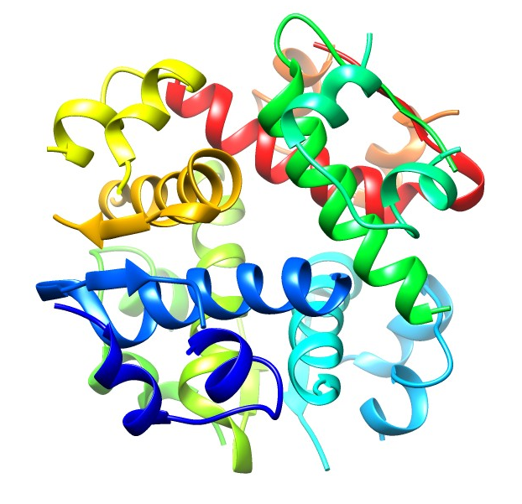
Figure 4: 3D image of Insulin
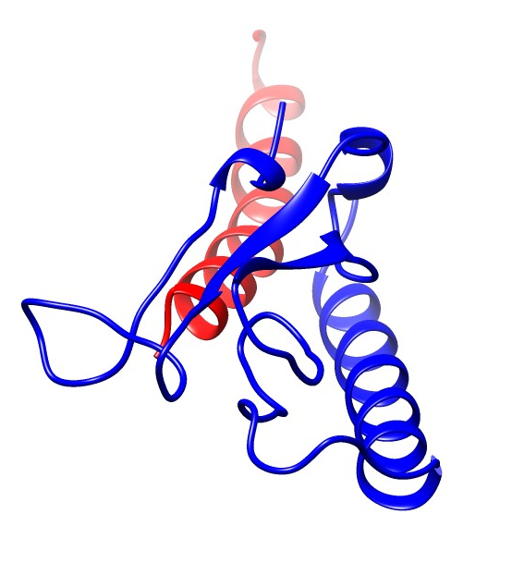

Figure 5: 3D image of Glucagon

