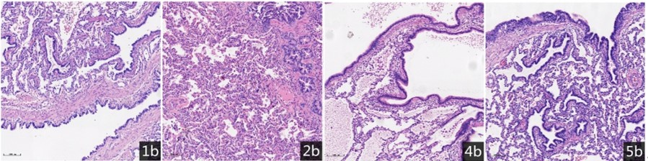
Supplementary Figure 1 CPAM samples(1b-5b) are type 1. More than one cyst with thick walls involve the single lobe. The cyst wall is mainly composed of pseudostratified ciliated columnar epithelium microscopically(10×).
Supplementary Figure 2 PCA of samples gene expression. The gene expression of 3b is abnormal.

