SUPPLEMENTAL DATA

Supplemental Figure S1. FMO controls of Foxp3, Ki67, CTLA-4, TIGIT and ICOS as measured by flow cytometry
Legend: Representative flow cytometry dot plots of CD4+CD25+CD127^{lo} T cells derived from peripheral blood of healthy controls and psoriatic arthritis patients. FMO controls of (A) Foxp3, (B) Ki67, (C) CTLA-4, (D) TIGIT and (E) ICOS. Abbreviations: CTLA-4: cytotoxic T-lymphocyte-associated protein 4 (CD152); FMO: Fluorescence minus one; Foxp3: forkhead box P3; ICOS: inducible T-cell costimulator (CD278); Ki67: antigen KI67; T cell immunoreceptor with Ig and ITIM domains.

Supplemental Figure S2. FMO, healthy and medium controls of CD161, RORγt, IL-10 and IL-17A as measured by flow cytometry
Legend: Representative flow cytometry dot plots of CD4+CD25+CD127^{lo} T cells derived from peripheral blood of healthy controls and psoriatic arthritis patients. (A,B) Comparison CD161 (A) and RORγt (B) expression between FMO controls, representative healthy controls and psoriatic arthritis samples. (C,D) Comparison IL-10 (C) and IL-17A (D) expression between FMO controls, medium controls and PMA/ionomycin stimulated Tregs. Abbreviations: Fluorescence minus one; IL: interleukin; Ki67: antigen KI67; RORγt: retinoic acid receptor-related orphan receptor gamma; Treg: T regulatory cell.
Supplemental Figure S3. Correlation of Foxp3^{int} with Foxp3^{hi} Tregs in peripheral blood and synovial fluid of HC, PsO and PsA patients
Legend: Flow cytometry analysis of Foxp3 expression by CD4+CD25+CD127^{lo} T cells derived from peripheral blood of HC (n=13), psoriasis patients (n=21) and PsA patients (n=20), and from synovial fluid of PsA patients (n=6). Shown are scatter plots of the proportion of Tregs with Foxp3^{int} and Foxp3^{hi} expression. Correlation was tested using Spearman’s rho (ρ). Included samples are (A) pooled PBMC and SFMC of HC, PsO and PsA patients, (B) pooled PBMC of HC, PsO and PsA patients, (C) PBMC of PsA patients and (D) SFMC of PsA patients. Abbreviations: Foxp3^{int} / ^{-hi}: forkhead box P3 expression intermediate / high; HC: healthy control; PBMC: peripheral blood mononuclear cells; PsA: psoriatic arthritis; PsO: psoriasis; SFMC: synovial fluid mononuclear cells.

Supplemental Figure S4. Increase of proliferating Tregs in PsA synovial fluid, as compared to circulation
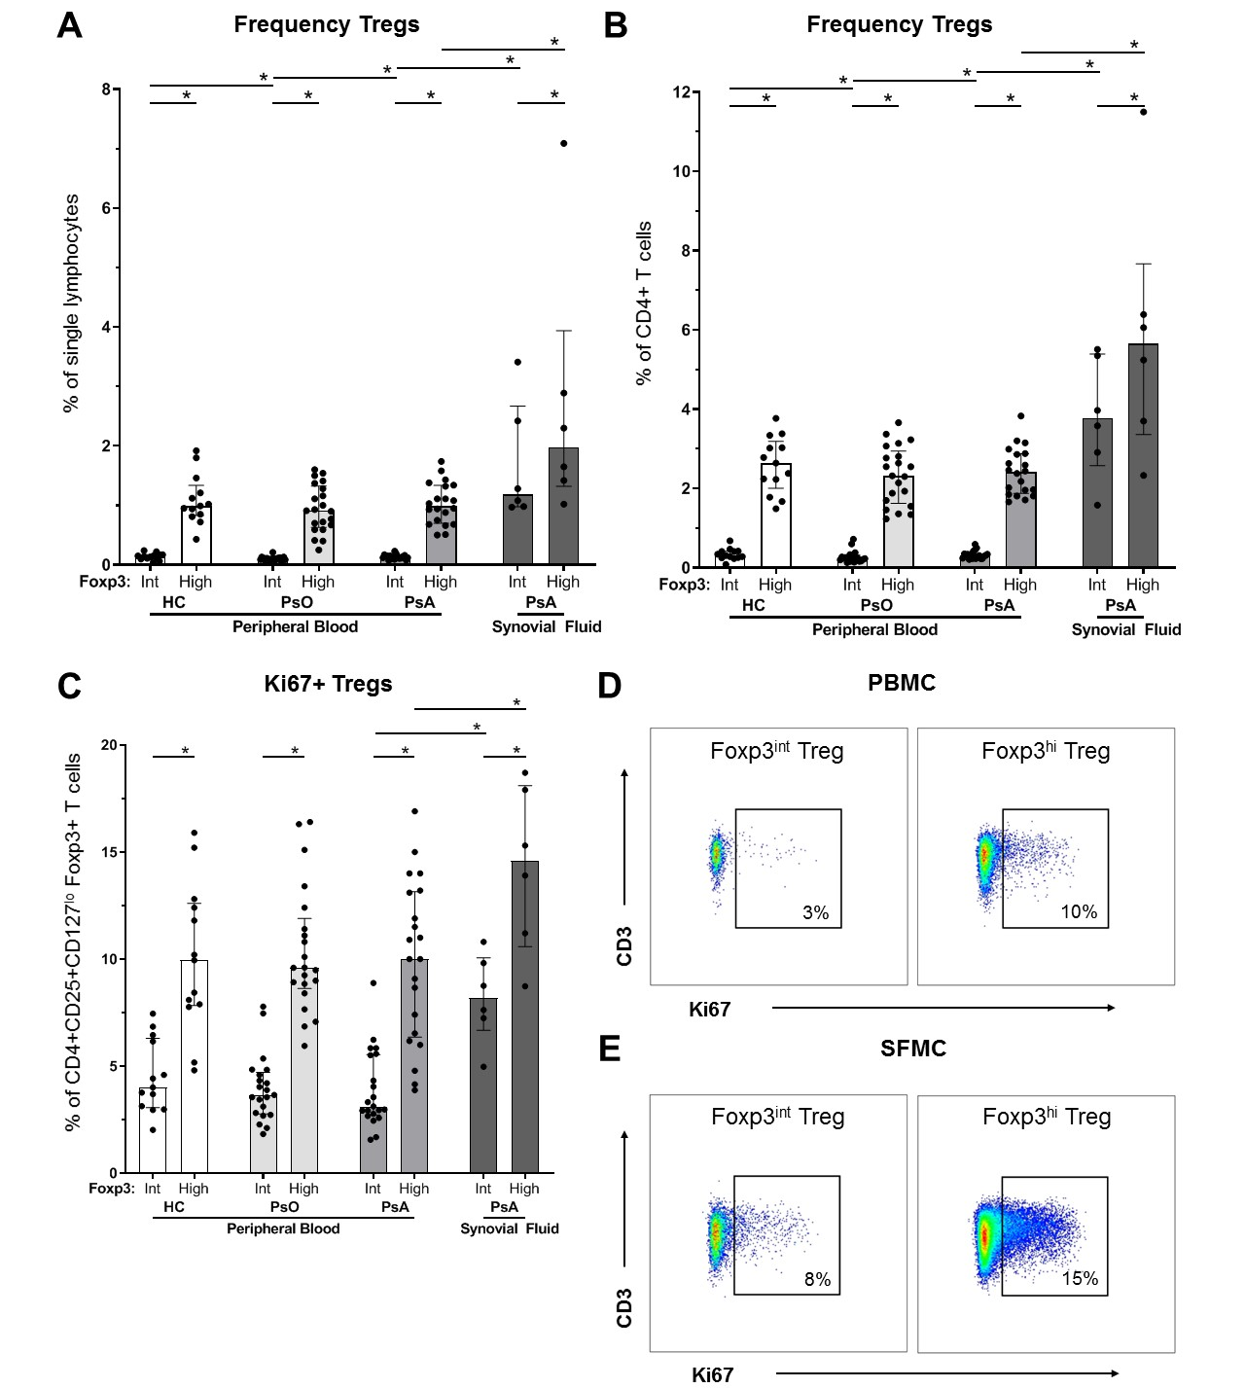
Legend: Flow cytometry analysis of CD4+CD25+CD127^{lo}Foxp3+ Tregs derived from peripheral blood of HC (n=13), psoriasis patients (n=21) and PsA patients (n=21), and from synovial fluid of PsA patients (n=6). Bar graphs: symbols represent individual subjects; bars show median with interquartile range; * P value <0.05 (PsA synovial fluid only compared with PsA peripheral blood). (A,B) Proportion of Foxp3^{int} and Foxp3^{hi} Tregs of single lymphocytes (A) and CD4+ T cells (B). (C) Proportions of Ki67+Foxp3^{int} and Ki67+Foxp3^{hi} Tregs. (D,E) Representative flow cytometry plots to identify Ki67+Foxp3^{int} and -Foxp3^{hi} Tregs derived from peripheral blood (D) and synovial fluid (E). Percentages in PBMC dot plots represent median of PB-derived Tregs in PsA. Percentages in SFMC dot plots represent median of SF-derived Tregs. Abbreviations: Foxp3^{int} / ^{hi}: forkhead box P3 expression intermediate / high; HC: healthy control; Int: intermediate expression of Foxp3; Ki67: antigen KI67; MFI: median fluorescent intensity; PBMC: peripheral blood mononuclear cells; PsA: psoriatic arthritis; PsO: psoriasis; SFMC: synovial fluid mononuclear cells; Tregs: T regulatory cells.
Supplemental Figure S5. Treg cytokine production
Legend: Flow cytometry analysis of cytokine-producing CD4+CD25+CD127^{lo}Foxp3+ Tregs derived from peripheral blood of HC (n=13), psoriasis patients (n=21) and PsA patients (n=20), and from synovial fluid of PsA patients (n=6). PBMC and SFMC were cultured for 4,5 hours with 20 ng/mL PMA, 1 µg/ml ionomycin and 1:1000 BD GolgiStop. Symbols represent individual subjects; bars show median with interquartile range; * P value <0.05 (synovial fluid only compared with PsA peripheral blood). (A) Proportion of CD4+CD25+CD127^{lo}Foxp3+ Tregs, that upon activation produce IL-10, IL-17A or both. (B) Proportion of CD4+CD25+CD127^{lo}Foxp3+ Tregs, that upon activation produce IL-17A. Abbreviations: HC: healthy control; IL: interleukin; PsA: psoriatic arthritis; PsO: psoriasis; SFMC: synovial fluid mononuclear cells; Tregs: T regulatory cells.

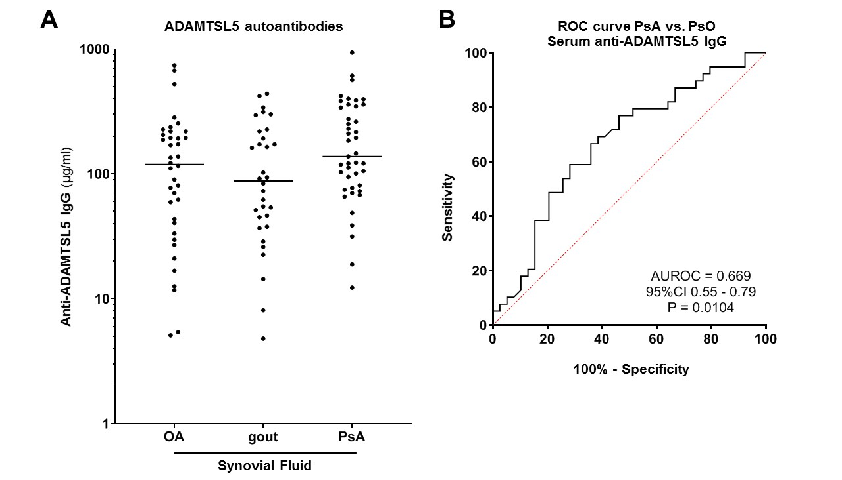
Supplemental Figure S6. ADAMTSL5 autoantibodies: quantification in synovial fluid and discriminating performance of serum concentration

Legend: ELISA of anti-ADAMTSL5 IgG. (A) Autoantibody concentration in synovial fluid of OA (n=38), gout (n=32) and PsA patients (n=43). (B) Discriminating performance between PsA and psoriasis of serum IgG autoantibodies against ADAMTSL5 in patients with psoriatic disease (psoriasis n=39, PsA n=39). Abbreviations: ADAMTSL5: A Disintegrin And Metalloprotease domain containing ThromboSpondin type 1 motif-Like 5; AUROC: area under the receiver operating characteristic curve; CI: confidence interval; IgG: Immunoglobulin G; OA: osteoarthritis; P: p value; PsA: psoriatic arthritis; PsO: psoriasis.

Supplemental Figure S7. No association of Foxp3 downregulation by Tregs with ADAMTSL5 autoantibodies in healthy controls
Legend: Association of ADAMTSL5 autoantibodies (as measured by ELISA) with Foxp3 expression by Tregs (as measured by flow cytometry) in healthy controls (n=13). Shown are scatterplots of serum anti-ADAMTSL5 IgG autoantibody concentration (µg/mL) with the proportion of Tregs that express intermediate Foxp3 (A) and the proportion of Tregs that express high Foxp3 (B). Abbreviations: ADAMTSL5: A Disintegrin And Metalloprotease domain containing ThromboSpondin type 1 motif-Like 5; Foxp3^{int} / ^{-hi}: forkhead box P3 expression intermediate / high; HC: healthy control; IgG: Immunoglobulin G; P: p value; PBMC: peripheral blood mononuclear cells; PsA: psoriatic arthritis; PsO: psoriasis; ρ: Spearman’s rho.

Supplemental Table S1. Antibodies flow cytometry

Target (label, category number, company) | Dilution (1:x) | Stain
Panel I
CD127 (BV605; 2356670; Sony Biotechnology) | 20 | Cell surface
CD152 (PE; 555853; BD) | 12.5 | Cell surface
CD25 (PE-Cy7; 557741; BD) | 25 | Cell surface
CD278 (APC; 17-9948-42; eBioscience) | 20 | Cell surface
CD3 (AF700; 300424; Biolegend) | 50 | Cell surface
CD4 (BV785; 300554; Biolegend) | 50 | Cell surface
Fixable Viability Dye (eF506; 65-0866-14; eBioscience) | 1000 | Cell surface
Foxp3 (eF450; 48-4776-42; eBioscience) | 50 | Intra-cellular
Ki67 (FITC; F7268; DAKO) | 50 | Intra-cellular
TIGIT (PerCP-eF710; 46-9500-42; eBioscience) | 50 | Cell surface
Panel II
CD127 (BV421; 562436; BD) | 40 | Cell surface
CD161 (BV510; 563212; BD) | 50 | Cell surface
CD25 (BV711; 563159; BD) | 50 | Cell surface
CD4 (PerCP; 300528; Biolegend) | 20 | Intra-cellular
Fixable Viability Dye (eF780; 65-0865-14, eBioscience) | 1000 | Cell surface
Foxp3 (PE-CF594; 562421; BD) | 20 | Intra-cellular
IL-10 (PE; 554706; BD) | 20 | Intra-cellular
IL-17A (FITC; 11-7179-82; eBioscience) | 40 | Intra-cellular
RORγt (APC; 17-6988-82; eBioscience) | 60 | Intra-cellular

Supplemental Table S2. Baseline characteristics flow cytometry cohort

Characteristic | Peripheral blood |  |  | Synovial Fluid
Characteristic | HC  (n=13) | PsO  (n=21) | PsA  (n=21) | PsA  (n=6)
Age (y) * | 46 ± 15 | 39 ± 14 | 49 ± 11 | 50 ± 10
Female, n | 9 (69%) | 10 (48%) | 7 (33%) | 0 (0%)
DMARD use, n ** | - | 0 (0%) | 0 (0%) | 2 (33%) ^{a)}
PsO duration (y) * | - | 5.5 (2.3-20.2) | 21.9 (9.5-31.4) | 24.0 (1.6-51.8)
PsA duration (y) | - | - | 3.0 (0.1-8.6) | 6.8 (4.7-12.2)
BMI (kg/m²) | - | 25.7 ± 2.8 | 26.3 (24.6-30.7) | 27.9 (23.5-33.7)
CRP (mg/L) | - | 1.6 (1.1-3.7) | 2.1 (1.4-3.5) | 3 (1.3-.)
ESR (mm/h) | - | 5 (2-8) | 8 (5-13) | 8 (5-15)
ACPA positive, n | - | 0 (0%) | 0 (0%) | 0 (0%)
RF positive, n | - | 0 (0%) | 1 (7%) | 0 (0%)
PASI * | - | 5.2 (1.6-8.9) | 1.9 (0.9-3.0) | 3.7 ^{d)}
Tender joints (78) * | - | 0 (0-0) | 4 (1-9) | 1 (1-1)
Swollen joints (76) * | - | 0 (0-0) | 3 (1-7) | 1 (1-2)
Nail psoriasis, n | - | 10 (48%) | 13 (65%) | 3 (50%)
Dactylitis, n | - | 0 (0%) | 2 (11%) | 0 (0-0)
Dactylitis ever, n * | - | 0 (0%) | 6 (32%) | 1 (17%)
LEI | - | 0 (0-0) | 0 (0-0) | 0 (0-0)
Enthesitis ever, n | - | 5 (24%) | 5 (40%) | 3 (60%)
Erosions, n * | - | 0 (0%) | 8 (42%) | 2 (40%)
HAQ | - | 0.0 (0.0-0.75) | 0.38 (0.13-1.00) | 0.25 ^{d)}
DLQI | - | 7.5 (3.5-13.3) | 3.0 (1.0-5.0) | 2.0 ^{d)}
SF-36 PCS | - | 54 (44-58) | 48 (45-53) | 33.2 ^{d)}
SF-36 MCS | - | 53 (38-56) | 54 (46-58) | 61.8 ^{d)}
DAPSA ^{b)} | - | - | 14.3 (12.1-27.1) | 16.3 ^{d)}
PASDAS ^{c)} | - | - | 5.5 (3.3-4.8) | 5.4 ^{d)}
Legend: Presented data are from time of visit, unless otherwise indicated. Categorical data are presented with frequencies (%) and continuous data are presented as mean ± SD (normally distributed variables) or median (IQR)(non-normally distributed variables). * P value PsO vs. PsA <0.05. ** P value PsA PB vs. SF <0.05. Footnotes: ª) Golimumab (n=1) and methotrexate (n=1). ^{b)} DAPSA: (TJC68 + SJC66 + VAS PGA (range 0-10) + VAS pain (range 0-10) + CRP (range 0-10 mg/dL))). ^{c)} PASDAS: (((0.18 √(VAS PhGA (range 0-100)) + (0.159 √(VAS PGA (range 0-100)) – (0.253 * √(SF-36 PCS)) + (0.101 * ln(SJC66 +1)) + (0.048 * ln(TJC68 +1)) + (0.23 * ln(enthesitis count+1)) + (0.37 * ln(dactylitis count+1)) + (0.102 * ln(CRP (mg/L) +1)) +2) * 1.5). ^{d)} Data available from n=1. Abbreviations: ACPA: anti-citrullinated protein antibodies; BMI: body mass index; CRP: C-reactive protein; DAPSA: disease activity index for PsA (range 0-164); DMARD: disease modifying anti-rheumatic drug use past three months; Erosions: reported by radiologist on conventional radiography and/or magnetic resonance imaging; ESR: erythrocyte sedimentation rate; HAQ: health assessment questionnaire (range 0-3); HC: healthy control; LEI: leeds enthesitis index (range 0-6); PASDAS: psoriatic arthritis disease activity score (range 0-10); PASI: psoriasis severity index (range 0-72); PsA: psoriatic arthritis; PsO: psoriasis; RF: rheumatoid factor.

Supplemental Table S3. Baseline characteristics ELISA cohort – serum

Characteristic | HC  (n=35) | PsO  (n=39) | PsA  (n=39)
Age (years) | 44 ± 13 | 42 ± 16 | 44 ± 13
Female, n (%) * | 17 (50%) | 22 (56%) | 12 (31%)
DMARD use, n (%) | 0 (0%) | 0 (0%) | 0 (0%)
PsO duration (y) | - | 10.2 (3.7-21.1) | 13.8 (7.0-25.8)
PsA duration (y) | - | - | 1.0 (0.1-5.4)
BMI (kg/m²) | - | 29.2 ± 7.2 | 27.5 ± 3.6
CRP (mg/L) | - | 2.1 (1.0-5.4) | 3.0 (1.9-4.6)
ESR (mm/hour) | - | 6 (2-11) | 8 (3-13)
ACPA positive, n | - | 0 (0%) | 1 (4%)
RF positive, n | - | 1 (14%) | 2 (7%)
PASI | - | 3.9 (1.7-8.2) | 2.5 (1.0-4.2)
Tender joints (78) | - | 0 (0-1) | 3 (0-7)
Swollen joints (76) | - | 0 (0-0) | 2 (0-7)
Nail psoriasis, n |  | 23 (59%) | 24 (65%)
Dactylitis, n * | - | 0 (0%) | 6 (17%)
Dactylitis ever, n | - | 1 (3%) | 13 (36%)
LEI * ^{a)} | - | 0 (0-0) | 0 (0-0)
Enthesitis ever, n | - | 8 (21%) | 22 (58%)
Erosions, n | - | 0 (0%) | 12 (32%)
HAQ | - | 0.0 (0.0-0.7) | 0.5 (0.3-1.0)
DLQI | - | 8 (2-12) | 3 (1-7)
SF-36 PCS | - | 53.0 (41.3-57.2) | 47.2 (38.3-51.5)
SF-36 MCS | - | 49.9 (36.7-56.6) | 55.0 (48.0-58.7)
DAPSA ^{b)} | - | - | 14.3 (11.0-26.9)
PASDAS ^{c)} | - | - | 4.6 (3.6-5.3)
Legend: Presented data are from time of visit, unless otherwise indicated. Categorical data are presented with frequencies (%) and continuous data are presented as mean ± SD (normally distributed variables) or median (IQR)(non-normally distributed variables). * P value PsO vs. PsA <0.05. Footnotes: ª) LEI mean: PsO 0.1 ± 0.3; LEI mean PsA 0.4 ± 0.8. ^{b)} DAPSA: (TJC68 + SJC66 + VAS PGA (range 0-10) + VAS pain (range 0-10) + CRP (range 0-10 mg/dL))). ^{c)} PASDAS: (((0.18 √(VAS PhGA (range 0-100)) + (0.159 √(VAS PGA (range 0-100)) – (0.253 * √(SF-36 PCS)) + (0.101 * ln(SJC66 +1)) + (0.048 * ln(TJC68 +1)) + (0.23 * ln(enthesitis count+1)) + (0.37 * ln(dactylitis count+1)) + (0.102 * ln(CRP (mg/L) +1)) +2) * 1.5). Abbreviations: ACPA: anti-citrullinated protein antibodies; BMI: body mass index; CRP: C-reactive protein; DAPSA: disease activity index for PsA (range 0-164); DMARD: disease modifying anti-rheumatic drug use past three months; Erosions: reported by radiologist on conventional radiography and/or magnetic resonance imaging; ESR: erythrocyte sedimentation rate; HAQ: health assessment questionnaire (range 0-3); HC: healthy control; LEI: leeds enthesitis index (range 0-6); PASDAS: psoriatic arthritis disease activity score (range 0-10); PASI: psoriasis severity index (range 0-72); PsA: psoriatic arthritis; PsO: psoriasis; RF: rheumatoid factor.

Supplemental Table S4. Baseline characteristics ELISA cohort – synovial fluid

Characteristic | OA  (n=38) | Gout  (n=32) | PsA  (n=43)
Age (years) | 54 ± 10 | 55 ± 12 | 50 ± 12
Female, n (%) * | 17 (45%) | 1 (3%) | 11 (26%)
DMARD use, n (%) | 0 (0%) | 0 (0%) | 0 (0%)
CRP (mg/L) | NM | NM | 9.5 (0.5-21.3)
ESR (mm/hour) | NM | NM | 14 (7-24)
Legend: SF was collected from 2004 to 2014. Presented data are from time of SF collection. Categorical data are presented with frequencies (%) and continuous data are presented as mean ± SD (normally distributed variables) or median (IQR)(non-normally distributed variables). * P value PsA vs. Gout <0.05, and P value OA vs. Gout <0.05. Abbreviations: CRP: C-reactive protein; DMARD: disease modifying anti-rheumatic drug use past three months; ESR: erythrocyte sedimentation rate; NM: not measured; OA: osteoarthritis; PsA: psoriatic arthritis.

