Supplementary Tables and Figures for:
Risk of Type 2 Diabetes and KCNJ11 Gene Polymorphisms: A Nested Case-control Study and Meta-analysis

Supplementary Table 1. Baseline characteristics of the TCGS cohort (1999–2017) participants used in the present study

Variables | Diabetic | Non-diabetic
Sex (Male/Female, number) | 575/750 | 610/983
Age (mean ± SD) | 50.41 ± 12 | 37.53 ± 13
Body mass index (mean ± SD) | 28.98 ± 4.6 | 25.58 ± 4.7
Fasting plasma glucose (mean ± SD) | 124.4 ± 51.5 | 85 ± 6.57
2-h plasma glucose (mean ± SD) | 171.67 ± 84.2 | 93 ± 19.4

Supplementary Table 2 Association of KCNJ11 polymorphisms with type 2 diabetes development among Iranian adults. Models were adjusted for age, sex, and BMI.
 |  | Additive model |  | Dominant model |  | Recessive model |  |  | Over-dominant model
SNP and Effect allele | EAF | OR (95% CI) | FDR | OR (95% CI) | FDR |  | OR (95% CI) | FDR | OR (95% CI) | FDR
rs5210-A | 0.281 | 0.92 (0.8-1.05) | 0.72 | 0.94 (0.8-1.13) | 0.89 |  | 0.7 (0.57-1.06) | 0.64 | 0.85 (0.6-1.07) | 0.88
rs5215-T | 0.359 | 1.023 (0.9-1.16) | 0.7 | 1.008 (0.8-1.2) | 0.9 |  | 1.08 (0.83-1.4) | 0.9 | 1.05 (0.72-1.2) | 0.93
rs5219-C | 0.36 | 1.03 (0.9-1.17) | 0.7 | 1.01 (0.85-1.2) | 0.92 |  | 1.09 (0.84-1.43) | 0.92 | 0.96 (0.83-1.12) | 0.8
EAF: Effect allele frequency, OR: odds ratio, CI: confidence interval, FDR: False discovery rate

Supplementary Table 3. Comparison of β-cell function (log-transformed) among non-diabetic participants with different rs5219 genotypes

Genotype | Sample size | mean ± SD | p-value
CC | 334 | 3.22 ± 0.55 | 0.69
CT | 377 | 3.2 ± 0.6 | 0.69
TT | 97 | 3.17 ± 0.54 | 0.69

Supplementary Fig.1 Forest plot for the association between rs5210 and type 2 diabetes risk under different genetic models. Diamond shows the pooled odds ratio size and its 95% CI

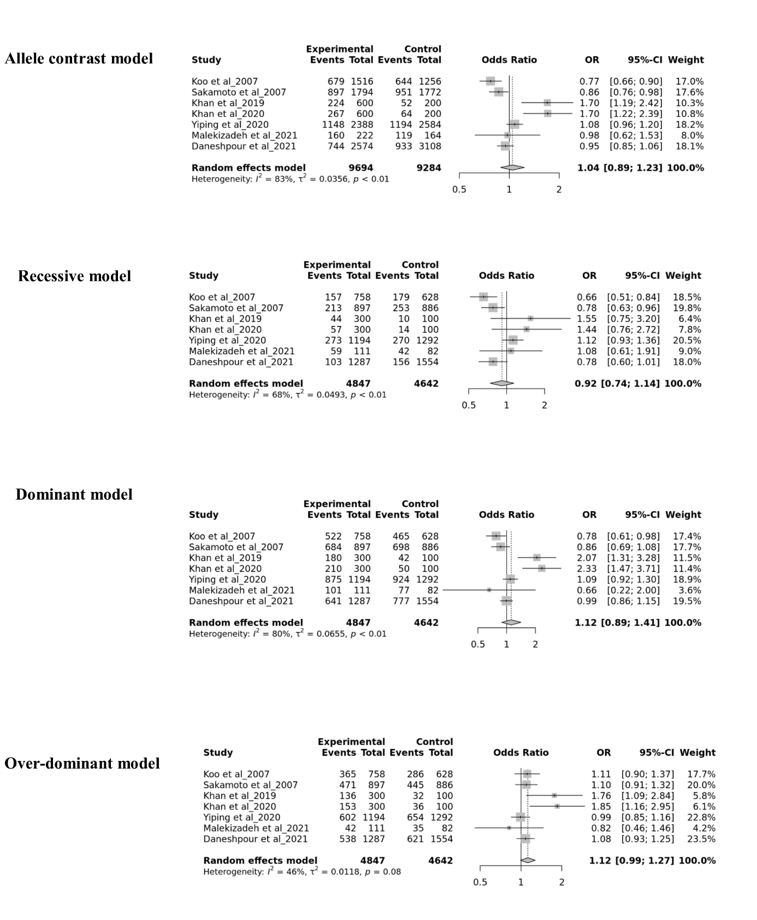

Supplementary Fig.2 Forest plot for the association between rs5215 and type 2 diabetes risk under different genetic models. Diamond shows the pooled odds ratio size and its 95% CI

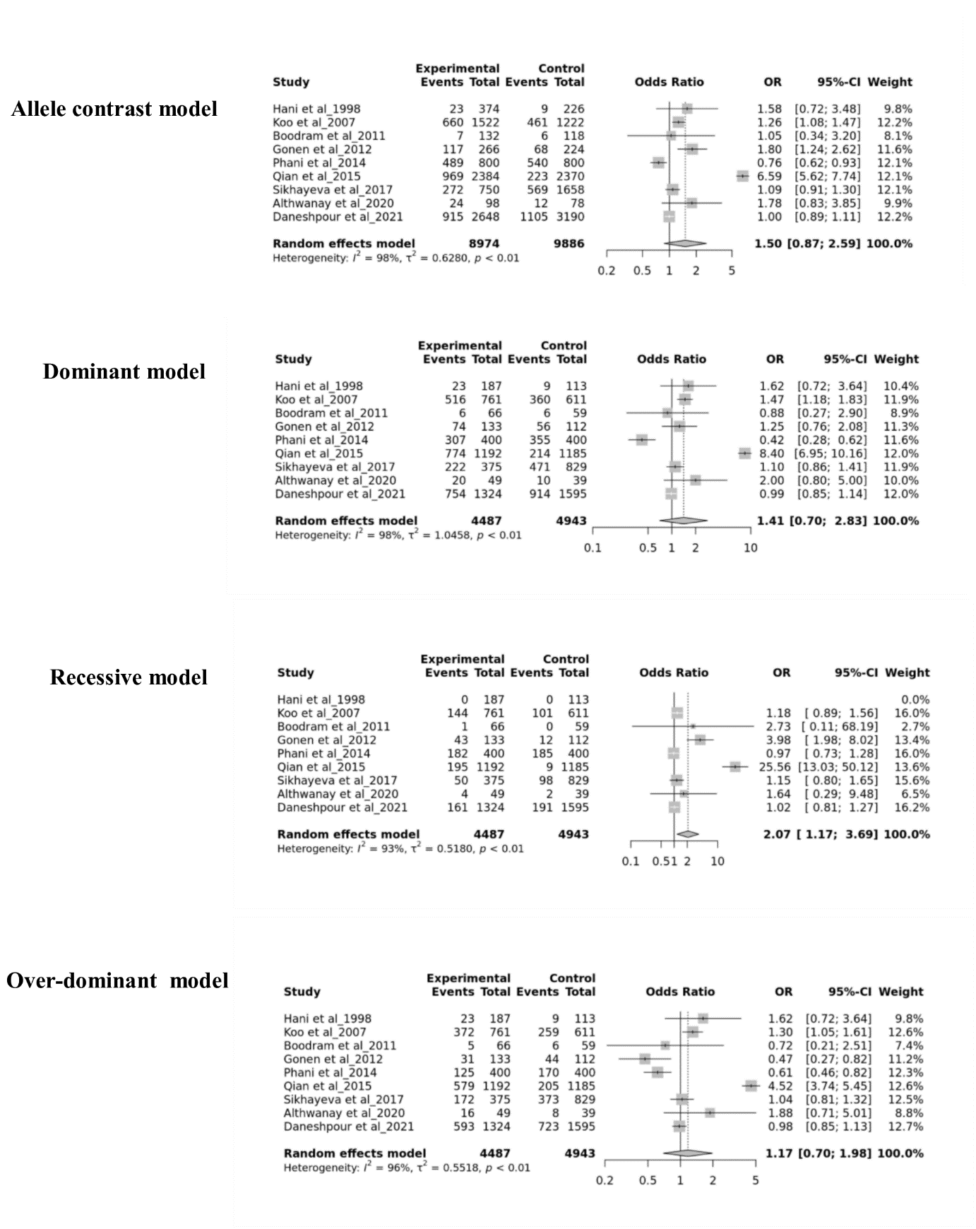

Supplementary Fig. 3 Sensitivity analysis of meta-analysis association of rs5210, rs5215, and rs5219 with type 2 diabetes development under different genetic models, allele contrast (A), recessive (B), dominant (C), and over-dominant (D) models.

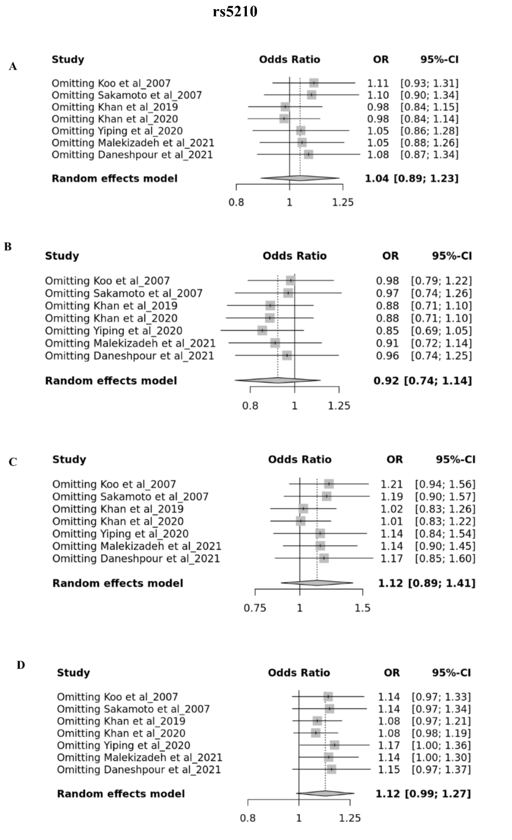

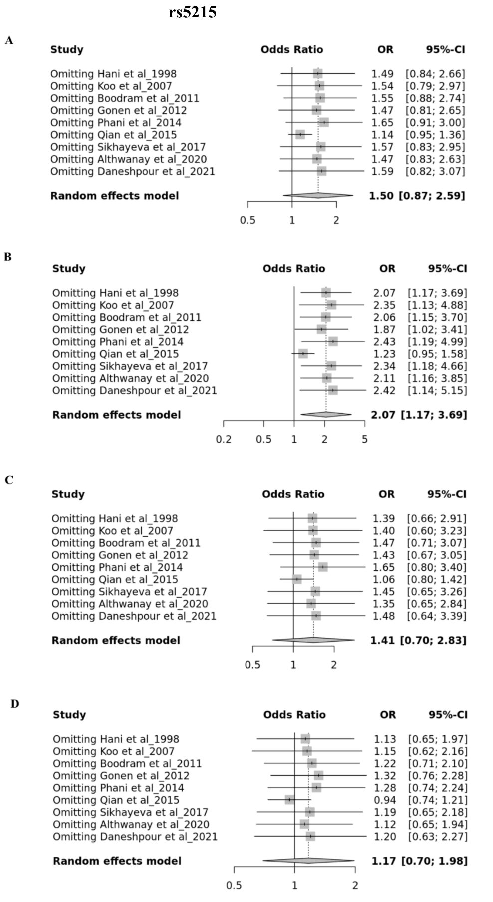

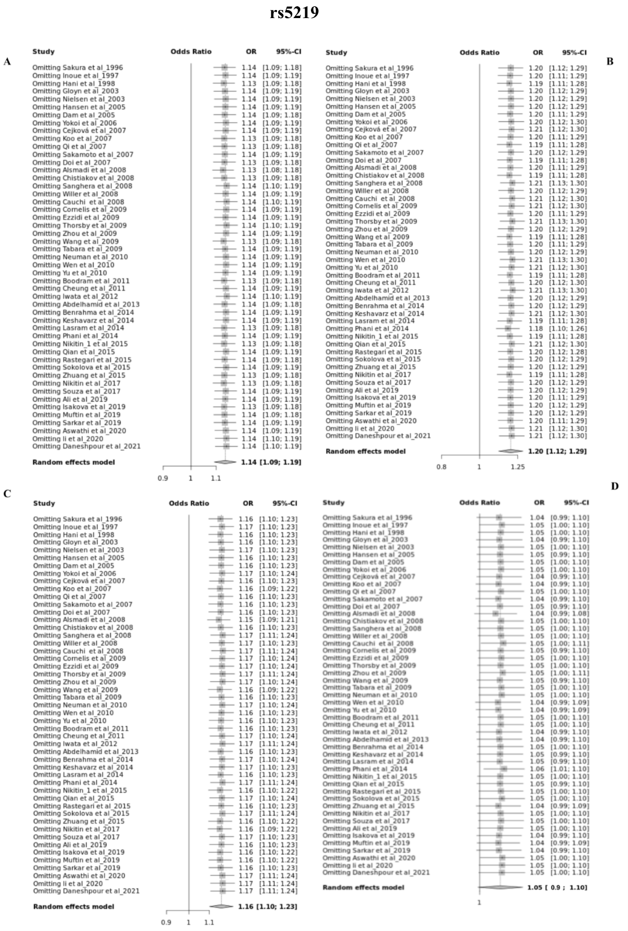

Supplementary Fig. 4 Funnel plot of the meta-analysis association for rs5219 under allele contrast (A), recessive (B), and over-dominant (C) models. Each point represents the log odds ratio and the standard error for a single study. The empty circles are observed studies and the filled circles are imputed studies for correcting the publication bias.

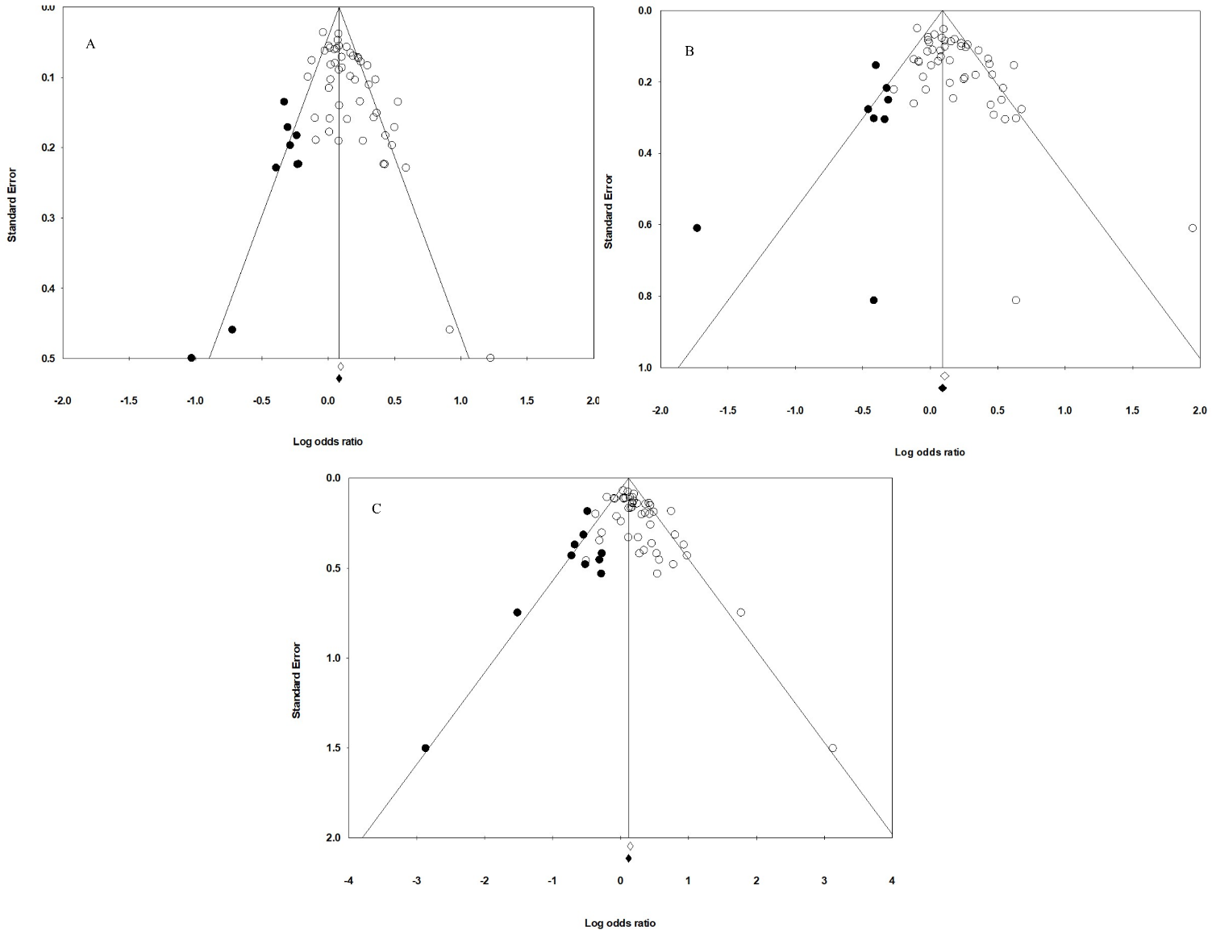

Supplementary Fig. 5 Funnel plot of the meta-analysis association for rs5210 and rs5215 under different genetic models, allele contrast (A), recessive (B), dominant (C), and over-dominant (D) models.

