Supplementary material

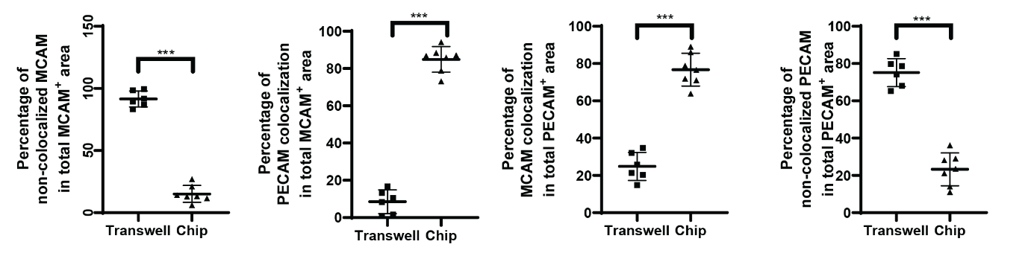
Supplementary Figure 1: colocalization analysis of MCAM and PECAM expression. Colocalization analysis of MCAM and PECAM in organoid endothelial cells. Organoids cultured on chip (n = 7) show higher percentages of colocalization for both markers, whilst organoids cultured on transwell (n = 6) show higher percentages of non-colocalization. Each data point = 1 organoid. Error bars = SD. *** = P < 0.001.

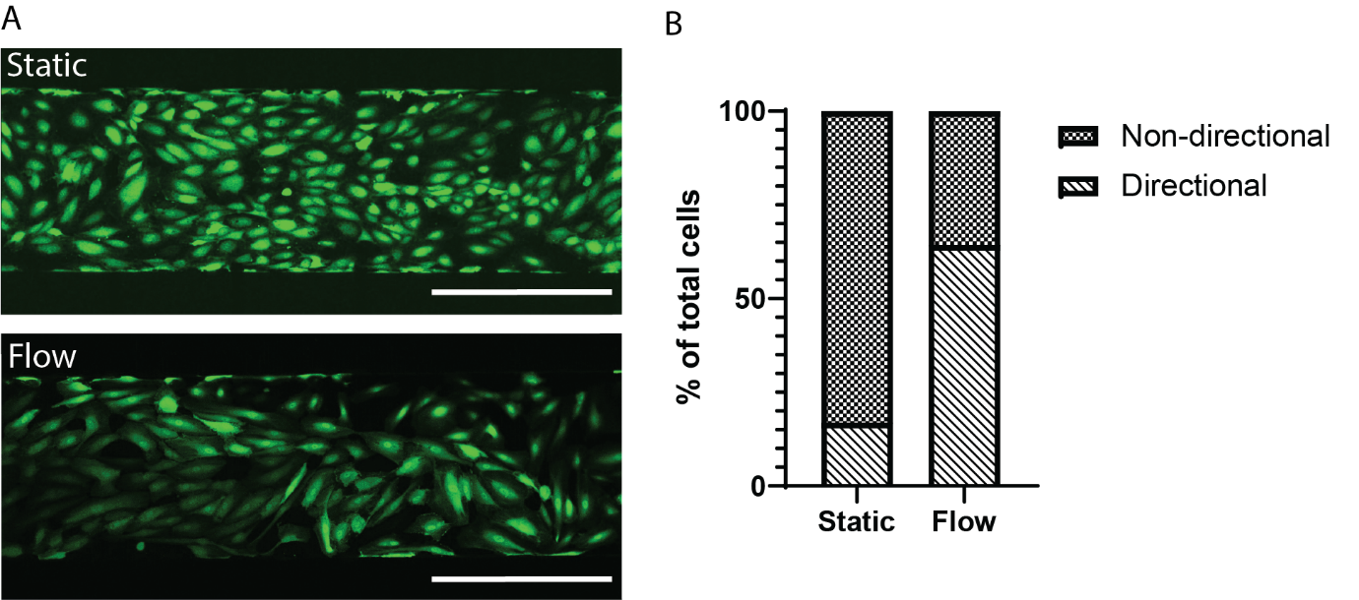
Supplementary Figure 2: HUVECs acquire directionality upon start of flow conditions. A) Portions of the chip channels imaged with confocal microscopy after 48h of static culture (top) and after 48h of static culture + 24h of flow (bottom). Scale bar = 400 µm. B) Graphical representation of the percentage of directional vs. non-directional cells in both static and flow conditions.

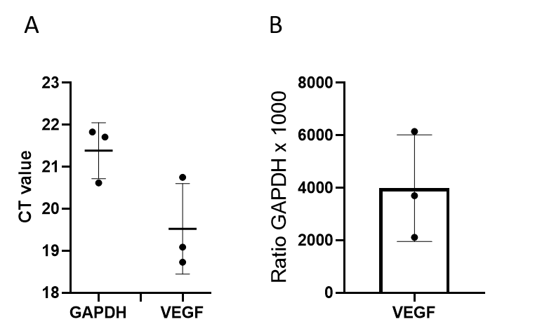

Supplementary Figure 3: VEGF mRNA expression of kidney organoids. A) CT (cycler threshold) values of housekeeping gene GAPDH compared to CT values of VEGF. B) VEGF mRNA expression normalized to GAPDH. Each data point = 1 organoid, error bar = SD.

Supplementary Figure 4: validation of GFP expression in HUVECs: Flow cytometry results showing >99% of GFP-HUVEC expressed GFP (green peak). Grey peak indicates WT-HUVEC.

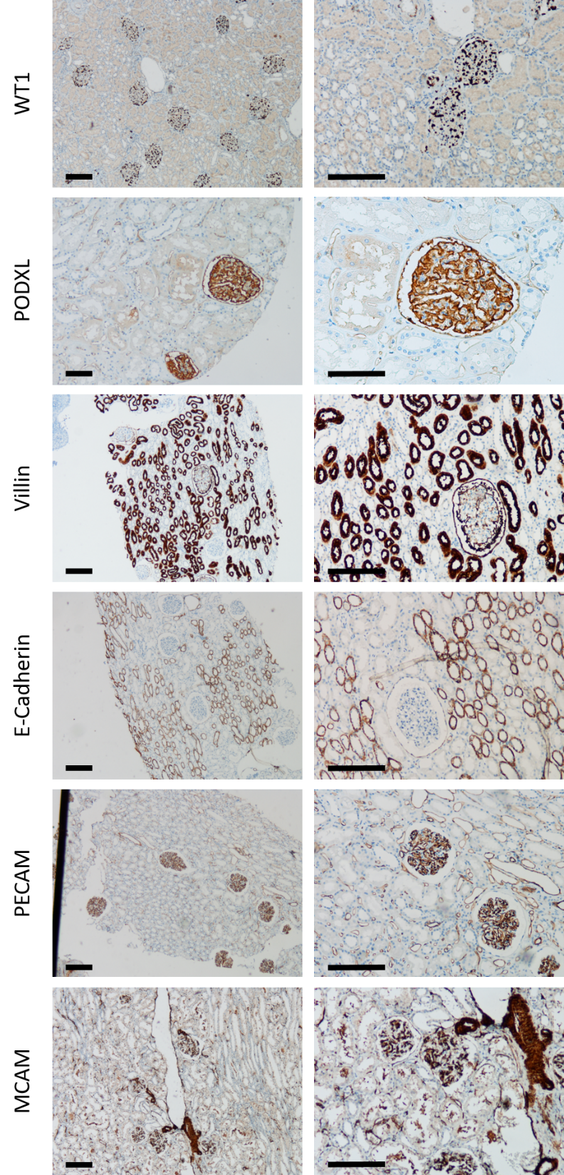
Supplementary Figure 5: immunohistochemical staining controls in healthy human kidney tissue. Bright field images of immunohistochemical stainings of the markers WT1, PODXL, Villin, E-Cadherin, PECAM and MCAM on healthy human kidney tissue used to validate organoid stainings. Scale bars = 200 µM.

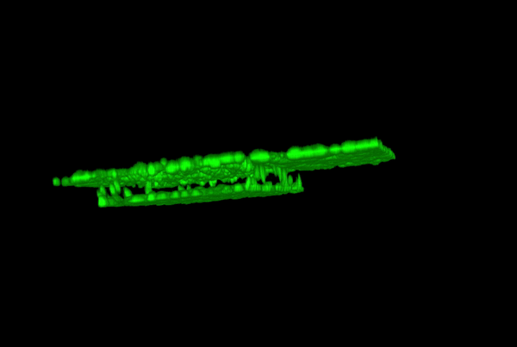

Supplementary video 1: 3D render of endothelialized chip channel I. 3D figure rendered from confocal tiled stacks rotating along Y axis. GFP⁺ HUVECs can be seen in all planes of the chip channel 48h after seeding. Channel width = 500 µm.
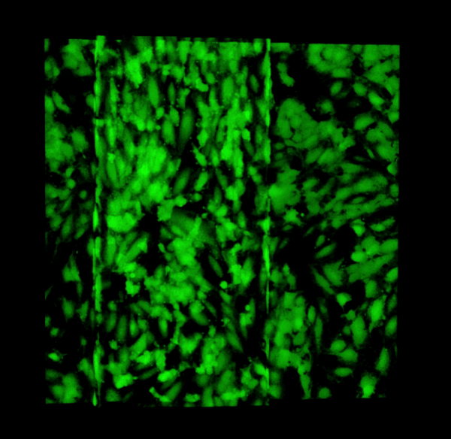

Supplementary video 2: 3D render of endothelialized chip channel II. 3D figure rendered from confocal tiled stacks rotating along X axis. GFP⁺ HUVECs can be seen in all planes of the chip channel 48h after seeding. Channel width = 500 µm.

Supplementary Table 1: Reagents

Product | Company | Catalogue number
Activin A | R&D Systems | 338-AC-010/CF
Advanced RPMI 1640 Medium | Invitrogen | 1263/3020
Agarose | Roche | 11685660001
CHIR99021 | Tocris Bioscience | 4423/10
EBM-2 | Lonza | 190860
EDTA | Invitrogen | 155750020
Tissue marking kit | Thermo Fisher Scientific | C1311
Essential 8 basal medium | Thermo Fisher Scientific | A1517001
FGF9 | Prepotech | 100-23
Fibronectin | Sigma-Aldrich | FC010
Geltrex | Invitrogen | A1413201
GFP-HUVECs | Cellworks | ZHC-2402
Heparin | Sigma-Aldrich | H0200000
Lipofectamine stem | Life Technologies | STEM00001
DPBS | Invitrogen | 10010023
PFA | Klinipath | 4078-9001
Primer GAPDH | Thermo Fisher Scientific | Hs 999999.m1
Primer VEGF | Thermo Fisher Scientific | Hs 00173626.m1
RevitaCell | Invitrogen | A2644501
RPMI 1640 | Invitrogen | 61870036
Transwells | Corning | CLS3450-24EA
Trypan blue | Invitrogen | 15250061
Tryple E select | Invitrogen | 12605036
Trypsin-EDTA | Sigma-Aldrich | T3924-100ML
Supplementary Table 2. Immunohistochemistry information
Antibody | Type | Concentration | Company | Clone | Procedure | Ab incubation  time
Villin | Anti-Rabbit | 1/800 | Abcam | EPR3491 | Optiview CC1 32' | 32 minutes
ECAD | Anti-Mouse | 0.314 µg/ml | Ventana | 36 | Optiview CC1 32' | 16 minutes
PODXL | Anti-Rabbit | 1/1000 | Abcam | EPR9518 | Ultraview CC1 32' | 32 minutes
WT1 | Anti-Mouse | 2.49 µg/ml | Cell Marque | 6F-H2 | Optiview CC1 56' | 32 minutes
CD31 | Anti-Mouse | 0.4 µg/ml | Ventana | JC-70 | Ultraview CC1 32' | 28 minutes
CD146 | Anti-Mouse | 1/1000 | Origene | UMAB155 | Optiview CC1 32' | 32 minutes

