Supplemental material for
Mapping Algorithms for Predicting EuroQol-5D-3L Utilities from the Assessment Test of chronic obstructive pulmonary disease

Chun-Hsiang Yu¹, Sheng-Mao Chang², Chih-Hui Hsu³, Sheng-Han Tsai⁴, Xin-Min Liao¹, Chang-Wei Chen¹, Ching-Hsiung Lin⁵, Jung-Der Wang⁶, Tzuen-Ren Hsiue¹, and Chiung-Zuei Chen¹*

Authors’ affiliation
1. Division of Pulmonary Medicine, Department of Internal Medicine, National Cheng Kung University Hospital, College of Medicine, National Cheng Kung University, Tainan, Taiwan
2. Department of Statistics, National Taipei University
3. Clinical Medicine Research Center, National Cheng Kung University Hospital, Tainan, Taiwan
4. Division of General Medicine, Department of Internal Medicine, National Cheng Kung University Hospital, College of Medicine, National Cheng Kung University, Tainan, Taiwan
5. Division of Chest Medicine, Department of Internal Medicine, Changhua Christian Hospital, Changhua, Taiwan
6. Department of Public Health, College of Medicine, National Cheng Kung University, Tainan, Taiwan

Corresponding author full contact details:
Name: Chiung-Zuei Chen
Address: No. 138 Sheng-Li Road
Post code: 704
City: Tainan
Country: Taiwan
Email: chen96@mail.ncku.edu.tw

Supplementary Tables
supplementary Table 1.
Comparison of demographic and clinical characteristics between patients randomly allocated into the two groups
 | Training group  (N=160) | Validation group  (N=163) | p-value *
Variables | n (%) / mean ± SD | n (%) / mean ± SD | p-value *
Gender |  |  | 0.537
Male | 151 (94.38) | 150 (92.02)
Female | 9 (5.63) | 13 (7.98)
Age | 72.67 ± 10.34 | 72.43 ± 9.99 | 0.831
Age group |  |  | 0.786
<50 | 2 (1.25) | 1 (0.61)
50-64 | 36 (22.50) | 37 (22.70)
65-79 | 78 (48.75) | 86 (52.76)
≥80 | 44 (27.50) | 39 (23.93)
BMI | 24.32 ± 5.02 | 24.01 ± 4.63 | 0.569
BMI group |  |  | 0.812
<18 | 8 (5.00) | 11 (6.75)
18-<24 | 72 (45.00) | 78 (47.85)
24-<27 | 38 (23.75) | 34 (20.86)
≥27 | 42 (26.25) | 40 (24.54)
mMRC |  |  | 0.921
0 | 4 (2.50) | 2 (1.23)
1 | 38 (23.75) | 39 (23.93)
2 | 73 (45.63) | 72 (44.17)
3 | 35 (21.88) | 39 (23.93)
4 | 10 (6.25) | 11 (6.75)
Smoking |  |  | 0.967
Never smoking | 21 (13.13) | 23 (14.11)
Quit smoking | 105 (65.63) | 106 (65.03)
Still smoking | 34 (21.25) | 34 (20.86)
FEV1 (% predicted) | 52.37 ± 11.88 | 50.88 ± 12.12 | 0.265
Pulmonary stage |  |  | 0.571
≥ 80 (mild) | 44 (27.50) | 35 (21.47)
50-80 (moderate) | 76 (47.50) | 87 (53.37)
30-50 (severe) | 33 (20.63) | 32 (19.63)
<30 (very severe) | 7 (4.38) | 9 (5.52)
* The chi-square homogeneity test was used to test the distribution of categorical variables (Gender, Age group, BMI group, mMRC, Smoking, Pulmonary stage) between groups. The student’s t-test was used to test the distribution of continuous variables (Age, BMI, FEV1 (% predicted)) between groups.

supplementary Table 2
Generalized estimating equations (GEE) for CAT mapping to EQ5D (Multinomial logistic regression) for model development
  - Mobility (total CAT score)

Variables | MOB=2 vs MOB=1 |  |  | MOB=3 vs MOB=1
Variables | Estimate ± SE | p-value |  | Estimate ± SE | p-value
Intercept | -13.79±1.58 | <0.001 |  | -25.27±3.54 | <0.001
CAT total scores | 0.37±0.03 | <0.001 |  | 0.48±0.06 | <0.001
Age | 0.10±0.02 | <0.001 |  | 0.18±0.04 | <0.001
Male vs. Female | 0.64±0.36 | 0.074 |  | -1.52±1.26 | 0.228

1-2. Mobility (selected CAT items)
Variables | MOB=2 vs MOB=1 |  |  | MOB=3 vs MOB=1
Variables | Estimate ± SE | p-value |  | Estimate ± SE | p-value
Intercept | -10.90±1.20 | <0.001 |  | -22.18±3.68 | <0.001
CAT items
Phlegm | -0.14±0.11 | 0.200 |  | -0.01±0.45 | 0.980
Chest tightness | -0.14±0.10 | 0.175 |  | -0.17±0.41 | 0.680
Breathlessness | 0.59±0.10 | <0.001 |  | 0.51±0.35 | 0.139
Activity at home | 0.76±0.12 | <0.001 |  | 1.41±0.39 | <0.001
Confidence | 0.84±0.12 | <0.001 |  | 1.42±0.35 | <0.001
Energy | 0.39±0.18 | 0.028 |  | -0.70±0.48 | 0.143
Age | 0.07±0.01 | <0.001 |  | 0.15±0.04 | 0.001

1-3. Self-care (total CAT score)
Variables | SELFC=2 vs SELFC=1 |  |  | SELFC=3 vs SELFC=1
Variables | Estimate ± SE | p-value |  | Estimate ± SE | p-value
Intercept | -10.41±1.01 | <0.001 |  | -18.28±1.75 | <0.001
CAT total scores | 0.38±0.02 | <0.001 |  | 0.49±0.05 | <0.001
Age | 0.06±0.01 | <0.001 |  | 0.11±0.02 | <0.001
Male vs. Female | 0.95±0.40 | 0.018 |  | 0.24±1.28 | 0.851

1-4. Self-care (selected CAT items)
Variables | SELFC=2 vs SELFC=1 |  |  | SELFC=3 vs SELFC=1
Variables | Estimate ± SE | p-value |  | Estimate ± SE | p-value
Intercept | -8.62±1.13 | <0.001 |  | -16.45±2.54 | <0.001
CAT items
Phlegm | -0.04±0.13 | 0.771 |  | -0.08±0.31 | 0.796
Activity at home | 1.44±0.14 | <0.001 |  | 2.16±0.26 | <0.001
Confidence | 0.80±0.13 | <0.001 |  | 0.98±0.25 | <0.001
Sleep | 0.06±0.14 | 0.699 |  | -0.05±0.28 | 0.848
Age | 0.03±0.01 | 0.019 |  | 0.08±0.02 | <0.001
Male vs. Female | 1.39±0.59 | 0.019 |  | 1.22±1.58 | 0.440
1-5. Usual activities (total CAT score)
Variables | UACT=2 vs UACT =1 |  |  | UACT=3 vs UACT=1
Variables | Estimate ± SE | p-value |  | Estimate ± SE | p-value
Intercept | -11.67±1.00 | <0.001 |  | -20.99±1.95 | <0.001
CAT total scores | 0.45±0.03 | <0.001 |  | 0.63±0.05 | <0.001
Age | 0.07±0.01 | <0.001 |  | 0.12±0.02 | <0.001
Male vs. Female | 0.46±0.44 | 0.296 |  | 0.73±1.25 | 0.559

1-6. Usual activities (selected CAT items)
Variables | UACT=2 vs UACT =1 |  |  | UACT=3 vs UACT=1
Variables | Estimate ± SE | p-value |  | Estimate ± SE | p-value
Intercept | -9.43±1.00 | <0.001 |  | -17.88±2.10 | <0.001
CAT items
Chest tightness | 0.27±0.12 | 0.019 |  | 0.29±0.18 | 0.114
Breathlessness | 0.49±0.11 | <0.001 |  | 0.36±0.25 | 0.156
Activity at home | 1.21±0.13 | <0.001 |  | 2.27±0.32 | <0.001
Confidence | 0.97±0.13 | <0.001 |  | 1.21±0.34 | <0.001
Sleep | 0.23±0.14 | 0.109 |  | 0.14±0.23 | 0.532
Age | 0.05±0.01 | <0.001 |  | 0.08±0.02 | <0.001
Male vs. Female | 0.70±0.36 | 0.049 |  | 1.47±1.10 | 0.179

1-7. Pain/ Discomfort (total CAT score)
Variables | PAIN=2 vs PAIN=1 |  |  | PAIN=3 vs PAIN=1
Variables | Estimate ± SE | p-value |  | Estimate ± SE | p-value
Intercept | -6.49±0.78 | <0.001 |  | -19.91±5.46 | <0.001
CAT total scores | 0.31±0.02 | <0.001 |  | 0.69±0.11 | <0.001
Age | 0.01±0.01 | 0.327 |  | 0.02±0.06 | 0.704
Male vs. Female | -0.66±0.41 | 0.111 |  | 9.87±0.88 | <0.001

1-8. Pain/ Discomfort (selected CAT items)
Variables | PAIN=2 vs PAIN=1 |  |  | PAIN=3 vs PAIN=1
Variables | Estimate ± SE | p-value |  | Estimate ± SE | p-value
Intercept | -4.40±0.89 | <0.001 |  | -27.97±5.12 | 0.001
CAT items
Phlegm | 0.08±0.12 | 0.466 |  | 0.63±0.64 | 0.320
Chest tightness | 0.46±0.10 | <0.001 |  | 0.70±0.67 | 0.297
Breathlessness | 0.08±0.09 | 0.409 |  | 0.61±1.16 | 0.602
Confidence | 0.84±0.09 | <0.001 |  | 1.89±0.42 | <0.001
Energy | 0.73±0.14 | <0.001 |  | 1.73±0.64 | 0.007
Age | 0.002±0.01 | 0.885 |  | -0.01±0.09 | 0.906
Male vs. Female | -0.66±0.42 | 0.122 |  | 9.87±0.93 | <0.001
1-9. Anxiety/ Depression (total CAT score)
Variables | MOOD=2 vs MOOD=1 |  |  | MOOD=3 vs MOOD=1
Variables | Estimate ± SE | p-value |  | Estimate ± SE | p-value
Intercept | -4.22±0.87 | <0.001 |  | -22.02±3.57 | <0.001
CAT total scores | 0.28±0.02 | <0.001 |  | 0.68±0.19 | 0.001
Age | -0.01±0.01 | 0.211 |  | -0.09±0.04 | 0.016
Male vs. Female | -0.52±0.37 | 0.157 |  | 9.81±1.13 | <0.001

1-10. Anxiety/ Depression (selected CAT items)
Variables | MOOD=2 vs MOOD=1 |  |  | MOOD=3 vs MOOD=1
Variables | Estimate ± SE | p-value |  | Estimate ± SE | p-value
Intercept | -3.30±0.91 | <0.001 |  | -11.31±5.00 | 0.024
CAT items
Phlegm | -0.11±0.12 | 0.349 |  | -0.42±0.38 | 0.266
Chest tightness | 0.48±0.11 | <0.001 |  | 0.85±0.41 | 0.039
Activity at home | 0.39±0.12 | 0.001 |  | 1.96±0.57 | 0.001
Confidence | 0.55±0.12 | <0.001 |  | 1.42±1.12 | 0.206
Sleep | 0.54±0.11 | <0.001 |  | 2.05±0.46 | <0.001
Age | -0.02±0.01 | 0.088 |  | -0.15±0.08 | 0.067
Multinomial logistic regression is used to evaluate the effect of those included variables over the different levels of mobility (MOB), self-care (SELFC), usual activities (UAUC), pain/discomfort (PAIN), and anxiety/depression (MOOD) in the datasets of development group. These factors include CAT total scores, age, and gender. Generalized estimating equation (GEE) is used for CAT mapping to EQ5D. The quasi-information criterion (QIC) is adjusted for regression.

Supplementary Figures
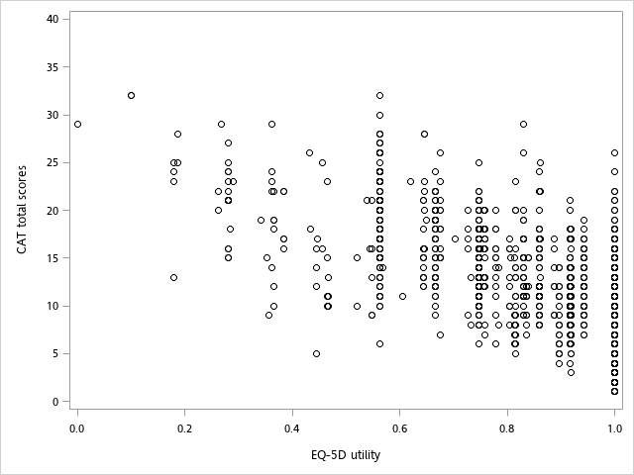
Supplementary Figure S1
Figure S1. Scatter graph of EQ-5D-3L utilities and CAT total scores. The darker circles represent higher data point density. A negative correlation (-0.69) between EQ-5D-3L utility and CAT total score was observed.

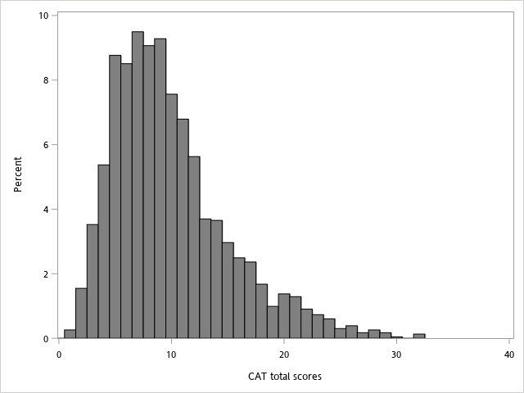
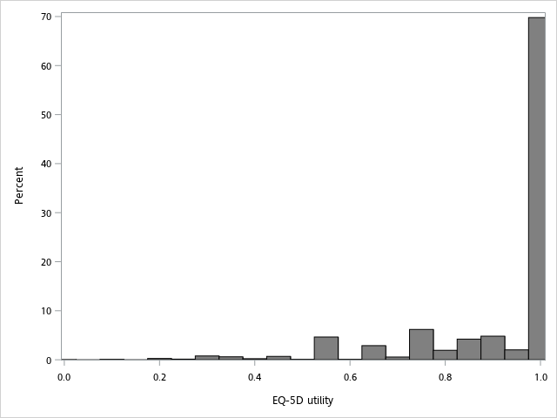
Supplementary Figure S2

Figure S2. Distributions of EQ-5D-3L utilities and CAT total scores. The largest cluster was located at EQ-5D utility=1: n=1624 (69.79% of observations). The other clusters were 0 ≤ EQ-5D < 0.5: n=65 (2.79%) and 0.5 ≤ EQ-5D < 1: n=638 (27.42%).
CAT, COPD assessment test; COPD, chronic obstructive pulmonary disease; EQ-5D, EuroQol five-dimensional questionnaire.

