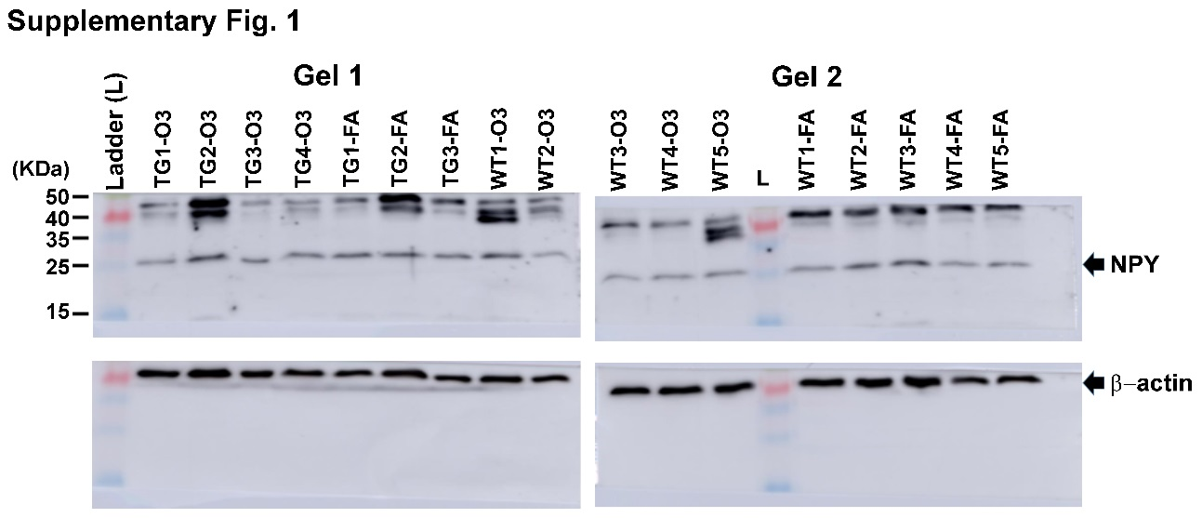
Suppl. Fig. S1. Blots of Figs 1C. The blotted membranes (gel 1 and 2) were trimmed to the expected molecular weight range and staining with NPY antibody, then the antibody was stripped, and the trimmed membranes were re-probed with anti-β-actin antibody. Abbreviations: WT, Wild-type mice; TG, TDP-43^{A315T} mice; FA, filtered air; O₃, ozone.

