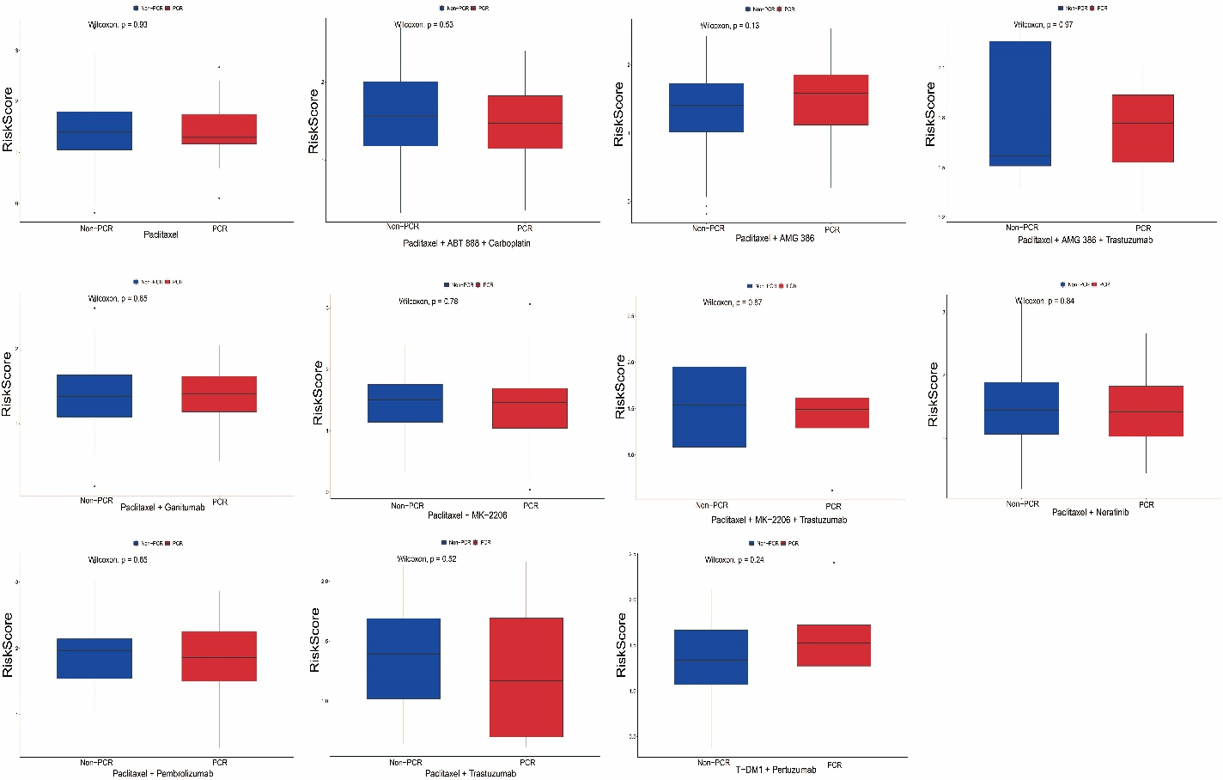Figure S4 Risk scores for no-pCR and pCR with different neoadjuvant chemotherapy.

