Supplementary Tables
Supplementary Table S1. Tumor characteristics for CNB and OEB results

Characteristics | CNB | OEB | P-value
Characteristics | N (%) | N (%) | P-value
Histologic type |  |  | 0.722
Invasive ductal carcinoma | 1956 (90.0) | 1966 (90.5)
Invasive lobular carcinoma | 68 (3.1) | 69 (3.2)
Mucinous carcinoma | 76 (3.5) | 78 (3.6)
Mixed carcinoma | 73 (3.4) | 60 (2.8)
Histological grade |  |  | <0.001
I | 168 (7.7) | 120 (5.5)
II | 1071 (49.3) | 1060 (48.8)
III | 748 (34.4) | 987 (45.4)
NA | 186 (8.6) | 6 (0.3)
Estrogen Receptor |  |  | 0.498
Negative | 593 (27.3) | 613 (28.2)
Positive | 1580 (72.7) | 1560 (71.8)
Progesterone Receptor |  |  | 0.051
Negative | 989 (45.4) | 925 (42.6)
Positive | 1184 (54.5) | 1248 (57.4)
Hormonal receptor |  |  | 0.587
Negative | 589 (27.1) | 605 (27.8)
Positive | 1584 (72.9) | 1568 (72.2)
HER2 |  |  | 0.488
Negative | 1699 (78.2) | 1680 (77.3)
Positive | 474 (21.8) | 493 (22.7)
Ki67, % |  |  | <0.001
$<$20 | 1047 (48.2) | 812 (37.4)
$≥$20 | 1126 (51.8) | 1361 (62.6)
Molecular subtype |  |  | 0.037
Luminal A | 546 (25.1) | 460 (21.2)
Luminal B-HER2- | 804 (37.0) | 868 (39.9)
Luminal B-HER2+ | 234 (10.8) | 240 (11.0)
HER2-positive | 240 (11.0) | 253 (11.6)
Triple negative | 349 (16.1) | 352 (16.2)

Abbreviation: CNB, core needle biopsy; OEB, open excision biopsy; NA, not available; HER2, human epidermal growth factor receptor-2.

Supplementary Table S2. Univariate analysis of Ki67 alteration and clinic-pathological factors

Characteristic | Ki67% alteration |  | P-value
Characteristic | <5%  N (%) | ≥5%  N (%) | P-value
Age, years |  |  | 0.174
<56 | 361 (35.3) | 661 (64.7)
≥56 | 439 (38.1) | 712 (61.9)
Menstrual status |  |  | 0.361
Peri/pre-menopause | 270 (35.5) | 490 (64.5)
Post-menopause | 530 (37.5) | 883 (62.5)
Breast surgery type |  |  | 0.046
Mastectomy | 556 (35.5) | 1009 (64.5)
Lumpectomy | 244 (40.1) | 364 (59.9)
Clinical tumor stage |  |  | 0.023
T_{x} | 1 (33.3) | 2 (66.7)
T₁ | 462 (39.7) | 703 (60.3)
T₂ | 311 (33.2) | 627 (66.8)
T₃₋₄ | 16 (34.8) | 30 (65.2)
Axillary lymph node |  |  | <0.001
Negative | 517 (40.1) | 772 (59.9)
Positive | 283 (32.0) | 601 (68.0)
STI (days) |  |  | 0.001
1-2 | 185 (44.6) | 230 (55.4)
3-4 | 309 (35.4) | 564 (64.6)
≥5 | 306 (34.6) | 579 (65.4)
Histologic type* |  |  | 0.144
IDC | 708 (36.2) | 1248 (63.8)
ILC | 31 (45.6) | 37 (54.4)
Mucinous carcinoma | 35 (46.1) | 41 (53.9)
Mixed carcinoma | 26 (35.6) | 47 (64.4)
Histological grade* |  |  | <0.001
I | 105 (62.5) | 63 (37.5)
II | 403 (37.6) | 668 (62.4)
III | 224 (29.9) | 524 (70.1)
NA | 68 (36.6) | 118 (63.4)
Estrogen receptor* |  |  | 0.003
Negative | 189 (31.9) | 404 (68.1)
Positive | 611 (38.7) | 969 (61.3)
Progesterone receptor* |  |  | <0.001
Negative | 318 (32.2) | 671 (67.8)
Positive | 482 (40.7) | 702 (59.3)
HER2* |  |  | <0.001
Negative | 663 (39.0) | 1036 (61.0)
Positive | 137 (28.9) | 337 (71.1)
Molecular subtype* |  |  | <0.001
Luminal A | 270 (49.5) | 276 (50.5)
Luminal B-HER2- | 281 (35.0) | 523 (65.0)
Luminal B-HER2+ | 63 (26.9) | 171 (73.1)
HER2 positive | 74 (30.8) | 166 (69.2)
Triple negative | 112 (32.1) | 237 (67.9)
Abbreviation: CNB, core needle biopsy; OEB, open excision biopsy; STI, Surgery time interval; IDC, invasive ductal carcinoma; ILC, invasive lobular carcinoma; NA, not available; HER2, human epidermal growth factor receptor-2.
* Expression status in CNB sample.

Supplementary Table S3. Univariate analysis of clinic-pathological factors affecting DFS and OS in invasive breast cancer patients

Clinic-pathological factors | DFS  P-value | OS  P-value
Age | 0.730 | 0.078
Menopause status | 0.168 | 0.016
Breast surgery type | 0.025 | 0.001
Histologic type* | 0.466 | 0.477
Histological grade* | 0.005 | 0.020
Pathological tumor size | <0.001 | <0.001
Lymph node status | <0.001 | <0.001
Estrogen receptor * | <0.001 | <0.001
Progesterone receptor * | <0.001 | <0.001
HER2 * | 0.250 | 0.980
Molecular subtype * | <0.001 | 0.001
STI | 0.279 | 0.030
Ki67 alteration ** | 0.026 | 0.118
Abbreviation: DFS, disease free survival; OS, overall survival; STI, surgery time interval.
* Expression status in radical surgical sample
**Ki67 alteration value = Absolute value of Ki67% in open excision biopsy sample minus Ki67% value in core needle biopsy.

Supplementary Table S4. Univariate analysis of adjuvant treatments affecting DFS and OS in invasive breast cancer patients

Adjuvant treatments | DFS  P-value | OS  P-value
Chemotherapy | 0.268 | 0.902
Radiotherapy | 0.333 | 0.677
Target therapy | 0.913 | 0.064
Endocrine therapy | 0.004 | <0.001
Abbreviation: DFS, disease free survival; OS, overall survival.

Supplementary Table S5. Univariate analysis of clinic-pathological factors affecting DFS and OS in HER2-negative breast cancer patients

Clinic-pathological factors | DFS  P-value | OS  P-value
Age | 0.934 | 0.022
Menopause status | 0.283 | 0.004
Breast surgery type | 0.083 | 0.003
Histologic type* | 0.173 | 0.212
Grade* | 0.004 | 0.020
pT | <0.001 | <0.001
Lymph node status | <0.001 | <0.001
Estrogen receptor * | 0.017 | <0.001
Progesterone receptor * | <0.001 | <0.001
Molecular subtype * | <0.001 | <0.001
STI | 0.410 | 0.015
Ki67 difference** | 0.004 | 0.010
Abbreviation: DFS, disease free survival; OS, overall survival; BMI, body mass index; STI, surgery time interval.
* Expression status in radical surgical sample
**Ki67 difference value = Absolute value of Ki67% in open excision biopsy sample minus Ki67% value in core needle biopsy.

Supplementary Table S6. Univariate analysis of clinic-pathological factors affecting DFS and OS in HER2-positive breast cancer patients

Clinic-pathological factors | DFS  P-value | OS  P-value
Age | 0.439 | 0.479
Menopause status | 0.361 | 0.711
Breast surgery type | 0.202 | 0.194
Histologic type* | 0.576 | 0.628
Grade* | <0.001 | 0.530
pT | 0.002 | 0.013
Lymph node status | 0.001 | 0.008
Estrogen receptor * | 0.025 | 0.490
Progesterone receptor * | 0.021 | 0.079
Molecular subtype * | 0.017 | 0.443
STI | 0.405 | 0.398
Ki67 difference** | 0.379 | 0.094
Abbreviation: DFS, disease free survival; OS, overall survival; BMI, body mass index; STI, surgery time interval.
* Expression status in radical surgical sample
**Ki67 difference value = Absolute value of Ki67% in open excision biopsy sample minus Ki67% value in core needle biopsy.

Supplementary Figures
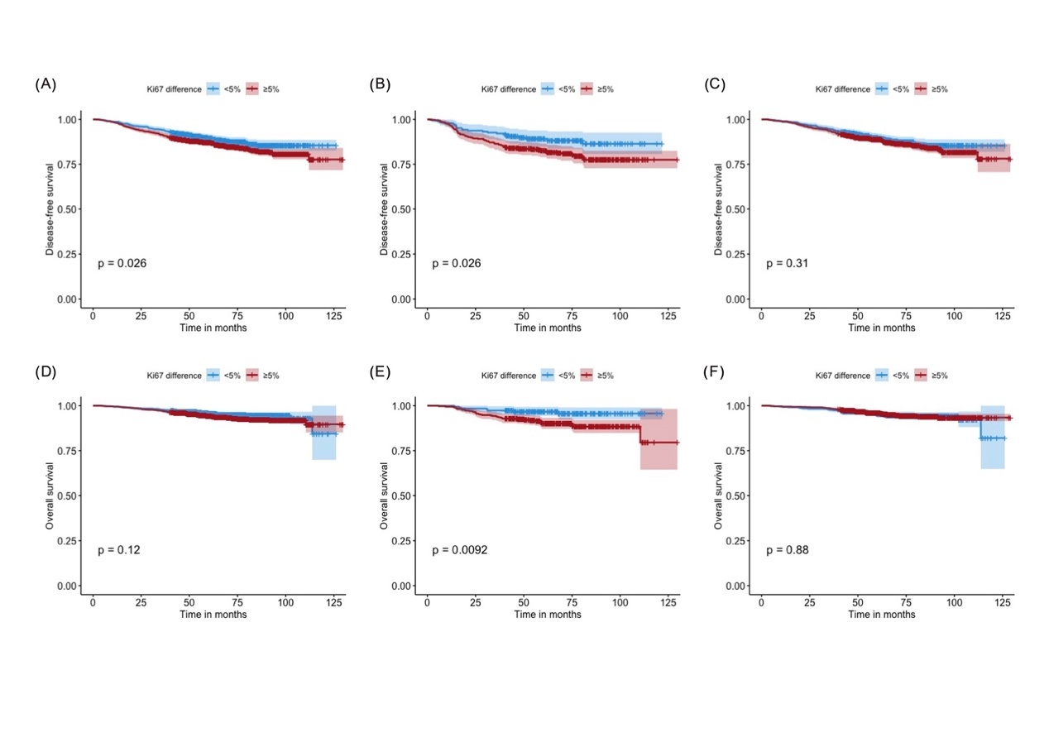
Supplementary Figure 1. Ki67 difference and disease outcome in breast cancer patients by estrogen receptor (ER) status at core needle biopsy.
Disease-free survival results for patients with different ΔKi67 (A) in the whole population, (B) in ER-negative population, and (C) in ER-positive population. Overall survival results for patients with different ΔKi67 (D) in the whole population, (E) in ER-negative population, and (F) in ER-positive population.

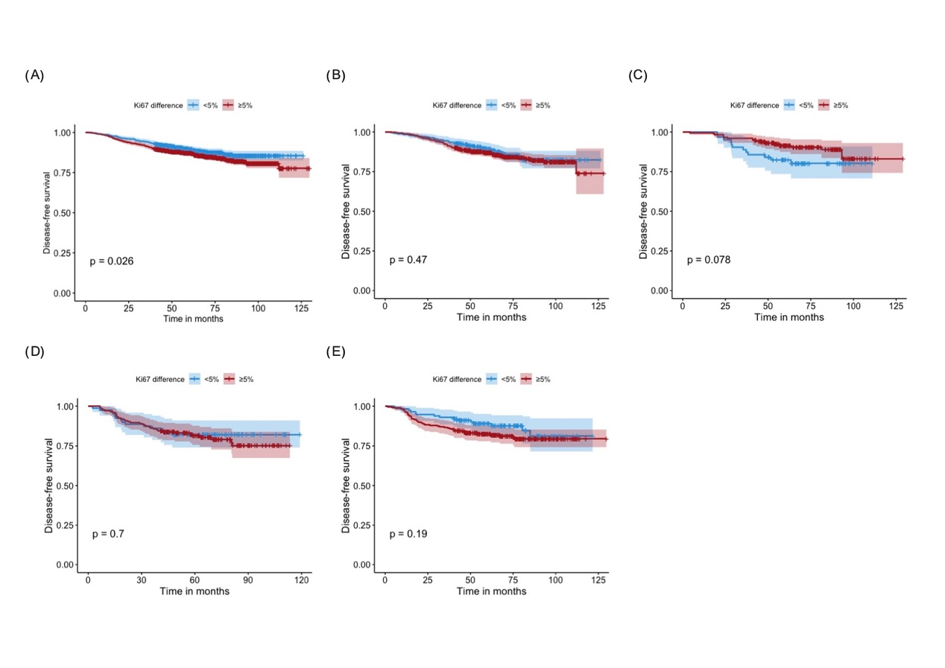

Supplementary Figure 2. Ki67 difference and DFS in breast cancer patients by molecular subtype.
DFS for patients with different ΔKi67 in (A) Luminal A, (B) Luminal B HER2-negative, (C) Luminal B HER2-positive, (D) hormone receptor-negative HER2-positive, and (E) triple negative population.
Abbreviations: DFS, disease-free survival; HER2, human epidermal growth factor receptor 2.

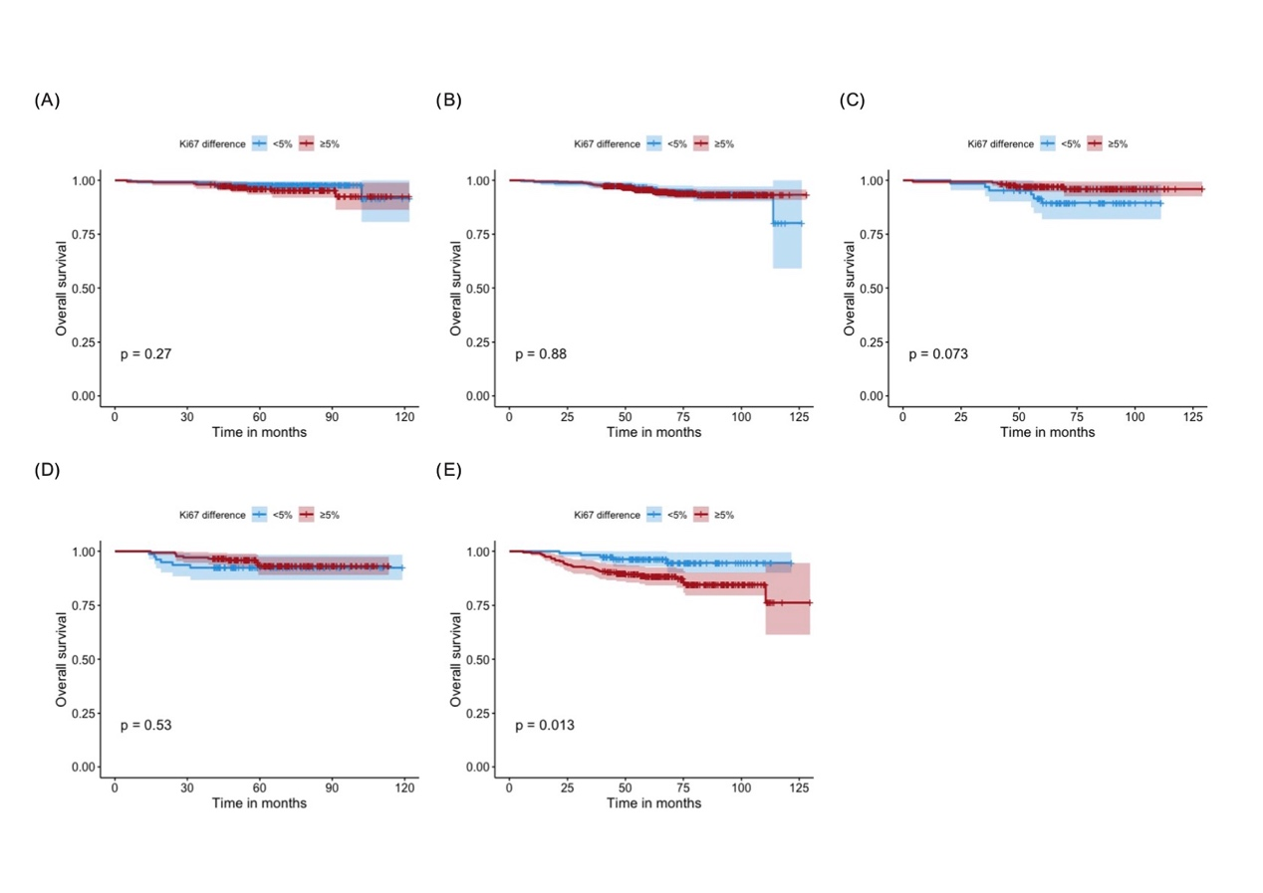
Supplementary Figure 3. Ki67 difference and OS in breast cancer patients by molecular subtype.
OS for patients with different ΔKi67 in (A) Luminal A, (B) Luminal B HER2-negative, (C) Luminal B HER2-positive, (D) hormone receptor-negative HER2-positive, and (E) triple negative population.
Abbreviations: OS, overall survival; HER2, human epidermal growth factor receptor 2.

