Supplementary files S1: Detailed search strategy in various databases
1a. PubMed Search Strategy
Search | Query | No. of hits
#1 | ("Colitis") OR ("Colitis Gravis") OR ("Inflammatory Bowel Disease, Ulcerative Colitis Type") OR ("Crohn's Enteritis") OR ("Regional Enteritis") OR ("Crohn's Disease") OR ("Crohns Disease") OR ("Inflammatory Bowel Disease") OR ("Enteritis, Granulomatous") OR ("Granulomatous Enteritis") OR ("Enteritis") OR ("Regional Ileocolitis") OR ("Colitis, Granulomatous") OR ("Granulomatous Colitis") OR ("Ileitis, Terminal") OR ("Terminal Ileitis") OR ("Ileitis, Regional") OR ("Regional Ileitides") OR ("Regional Ileitis") | 150,992
#2 | “Inflammatory bowel disease” [All Fields] | 112,070
#3 | #1 OR #2 | 159,661
#4 | “COVID 19” OR “ COVID-19 Virus Disease” OR “ COVID 19 Virus Disease” OR “ COVID-19 Virus Diseases” OR “ Disease, COVID-19 Virus” OR “ Virus Disease, COVID-19” OR “ COVID-19 Virus Infection” OR “ COVID 19 Virus Infection” OR “ COVID-19 Virus InfectionsOR Infection, COVID-19 Virus” OR “ Virus Infection, COVID-19” OR “ 2019-nCoV Infection” OR “ 2019 nCoV Infection” OR “ 2019-nCoV Infections” OR “ Infection, 2019-nCoV” OR “ Coronavirus Disease-19” OR “ Coronavirus Disease 19” OR “ 2019 Novel Coronavirus Disease” OR “ 2019 Novel Coronavirus Infection” OR “ 2019-nCoV Disease” OR “ 2019 nCoV Disease” OR “ 2019-nCoV Diseases” OR “ Disease, 2019-nCoV” OR “ COVID19 Coronavirus Disease” OR “ 2019 Disease 2019, Coronavirus” OR “ SARS Coronavirus 2 Infection” OR “ SARS-CoV-2 Infection” OR “ Infection, SARS-CoV-2” OR “ SARS CoV 2 Infection” OR “ SARS-CoV-2 Infections” | 155,681
#5 | #3 AND #4 | 756

1b. Scopus Search Strategy
Search | Query | No. of hits
#1 | ("Colitis") OR ("Colitis Gravis") OR ("Inflammatory Bowel Disease, Ulcerative Colitis Type") OR ("Crohn's Enteritis") OR ("Regional Enteritis") OR ("Crohn's Disease") OR ("Crohns Disease") OR ("Inflammatory Bowel Disease") OR ("Enteritis, Granulomatous") OR ("Granulomatous Enteritis") OR ("Enteritis") OR ("Regional Ileocolitis") OR ("Colitis, Granulomatous") OR ("Granulomatous Colitis") OR ("Ileitis, Terminal") OR ("Terminal Ileitis") OR ("Ileitis, Regional") OR ("Regional Ileitides") OR ("Regional Ileitis") | 564,837
#2 | “Inflammatory bowel disease” [All Fields] | 253,633
#3 | #1 OR #2 | 564,837
#4 | “COVID 19” OR “ COVID-19 Virus Disease” OR “ COVID 19 Virus Disease” OR “ COVID-19 Virus Diseases” OR “ Disease, COVID-19 Virus” OR “ Virus Disease, COVID-19” OR “ COVID-19 Virus Infection” OR “ COVID 19 Virus Infection” OR “ COVID-19 Virus InfectionsOR Infection, COVID-19 Virus” OR “ Virus Infection, COVID-19” OR “ 2019-nCoV Infection” OR “ 2019 nCoV Infection” OR “ 2019-nCoV Infections” OR “ Infection, 2019-nCoV” OR “ Coronavirus Disease-19” OR “ Coronavirus Disease 19” OR “ 2019 Novel Coronavirus Disease” OR “ 2019 Novel Coronavirus Infection” OR “ 2019-nCoV Disease” OR “ 2019 nCoV Disease” OR “ 2019-nCoV Diseases” OR “ Disease, 2019-nCoV” OR “ COVID19 Coronavirus Disease” OR “ 2019 Disease 2019, Coronavirus” OR “ SARS Coronavirus 2 Infection” OR “ SARS-CoV-2 Infection” OR “ Infection, SARS-CoV-2” OR “ SARS CoV 2 Infection” OR “ SARS-CoV-2 Infections” | 220,515
#5 | #3 AND #4 | 4,039
#6 | #5 AND ( LIMIT-TO ( DOCTYPE , "ar" ) OR LIMIT-TO ( DOCTYPE , "ed" ) OR LIMIT-TO ( DOCTYPE , "sh" ) ) | 1,969

1c. Cochrane Search Strategy
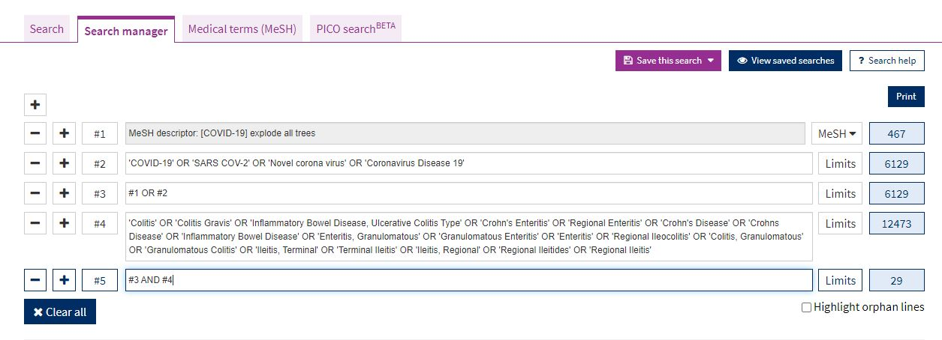

1d. Embase search strategy