Supplementary file S4: Sensitivity analysis for COVID-19 outcomes in IBD patients
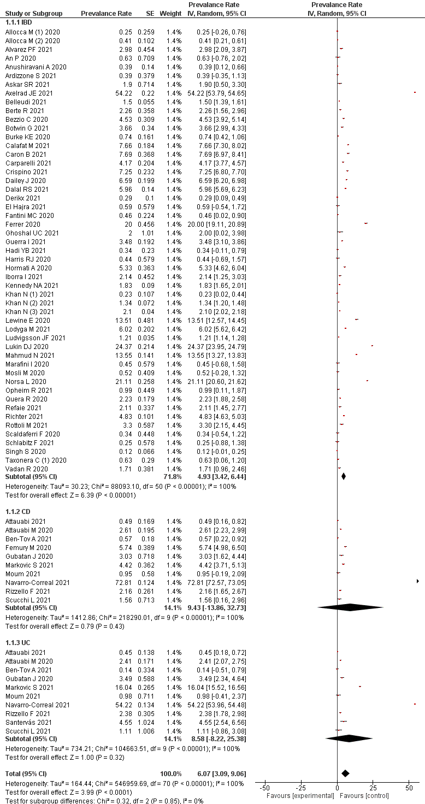
S4A: Pooled prevalance of COVID-19

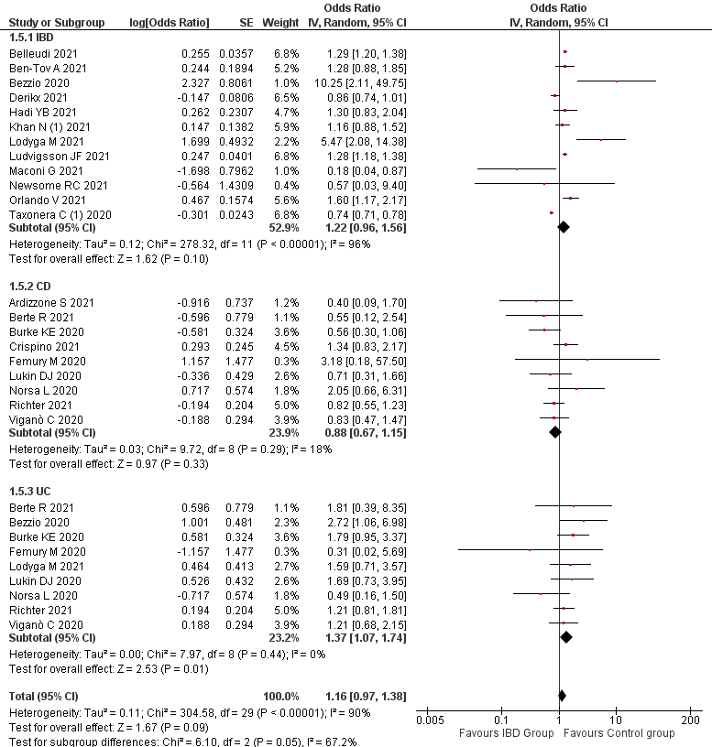
S4B: Risk of COVID-19

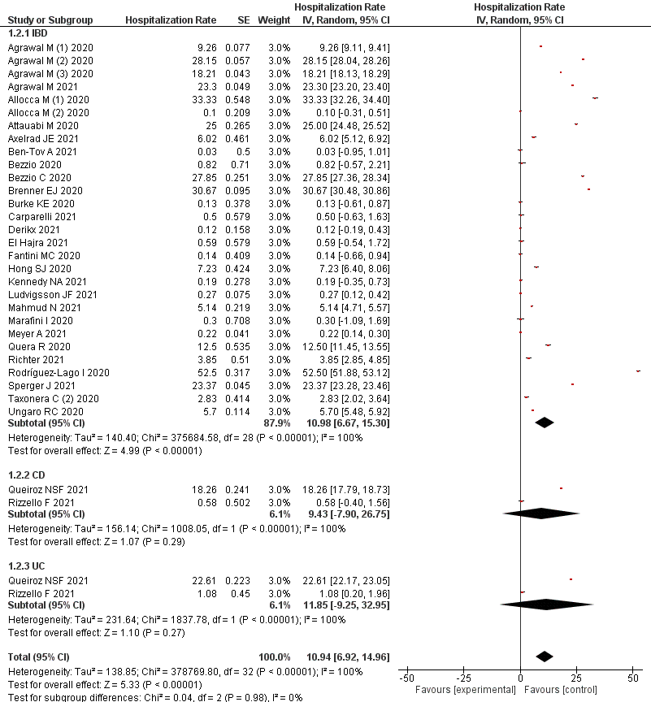
Supplementary file S4C: COVID-19 associated hospitalization prevalence

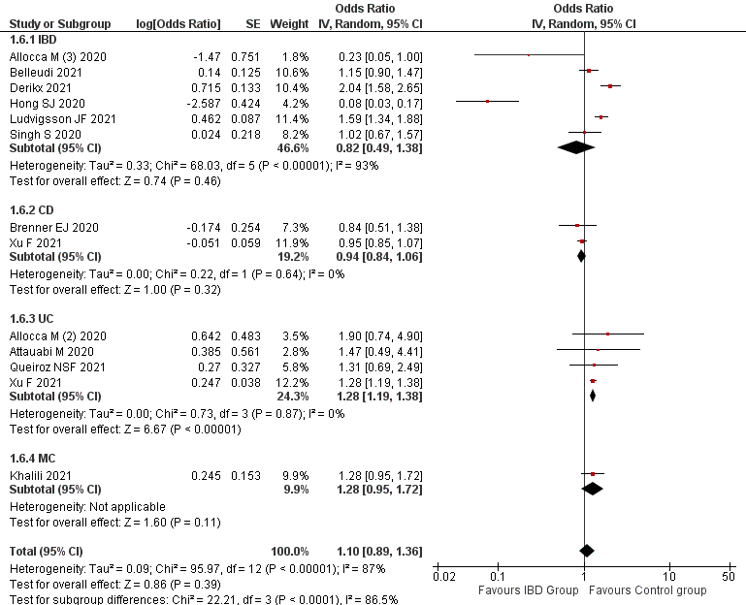

Supplementary file S4D: Risk of COVID-19 associated hospitalization

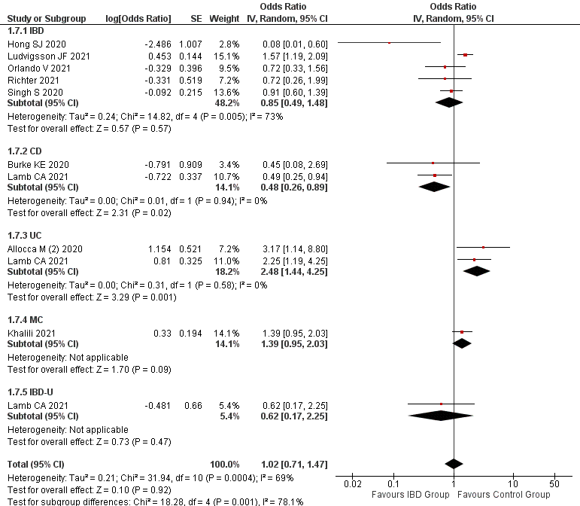
Supplementary file S4E: Risk of severe COVID-19
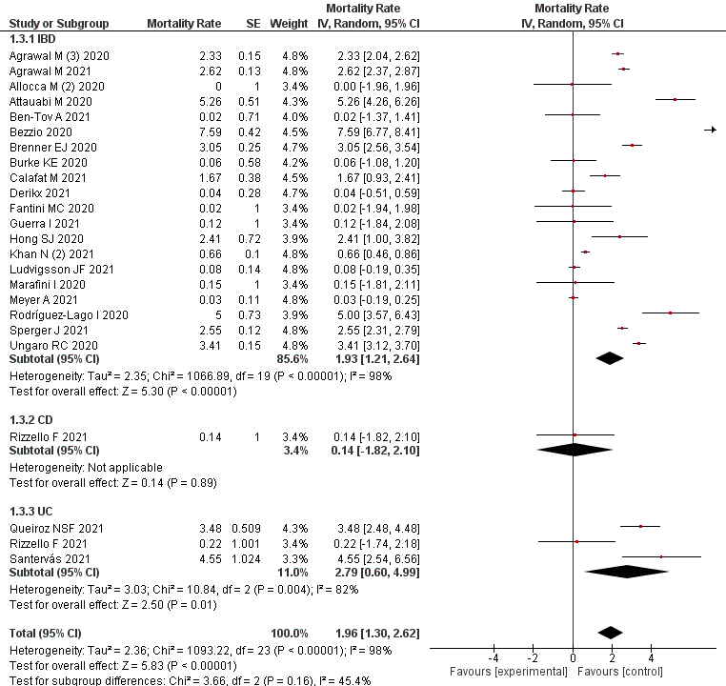

Supplementary file S4F: COVID-19 mortality
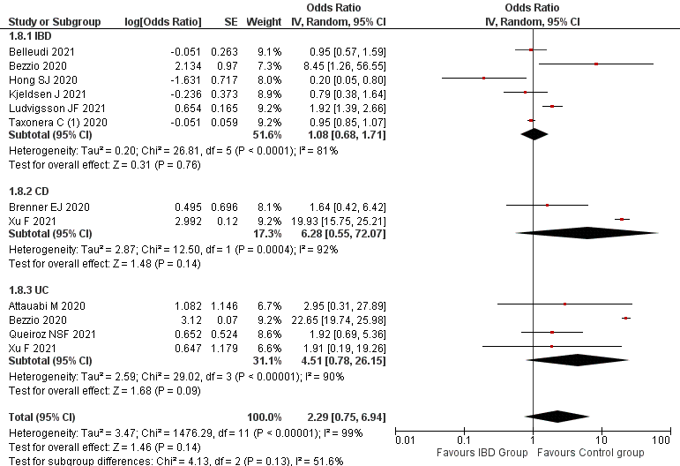

Supplementary file S4G: Risk of COVID-19 mortality

