Supplementary Information

Supplementary Video 1. Illustration of stimuli delivered in the two experiments.

Supplementary Video 2. Example of a mosquito taking-off in response to the looming square.

Supplementary Video 3. Mosquitoes’ spontaneous flight trajectory differ from escape (take-off) responses triggered by visual stimulation
Normalized 2-D histograms of the locations occupied by individual mosquitoes (white dots) within the LED arena. The trajectories are rotated to fictively re-position the stimuli introductions at the top at 0°, and data are mirrored on the vertical axis to the left to complement the data visualization in Figure 4A,B. Left: positions occupied by mosquitoes during 1 sec (30 frames) of free flight, in the absence of visual stimulation. Right: positions occupied by landed mosquitoes ⅓ of a second before introduction of a looming square and ⅔ of a second after stimulation. Stimuli introductions have been fictively repositioned the at the top, at 0°. Introduction of the looming square is time stamped on the video.

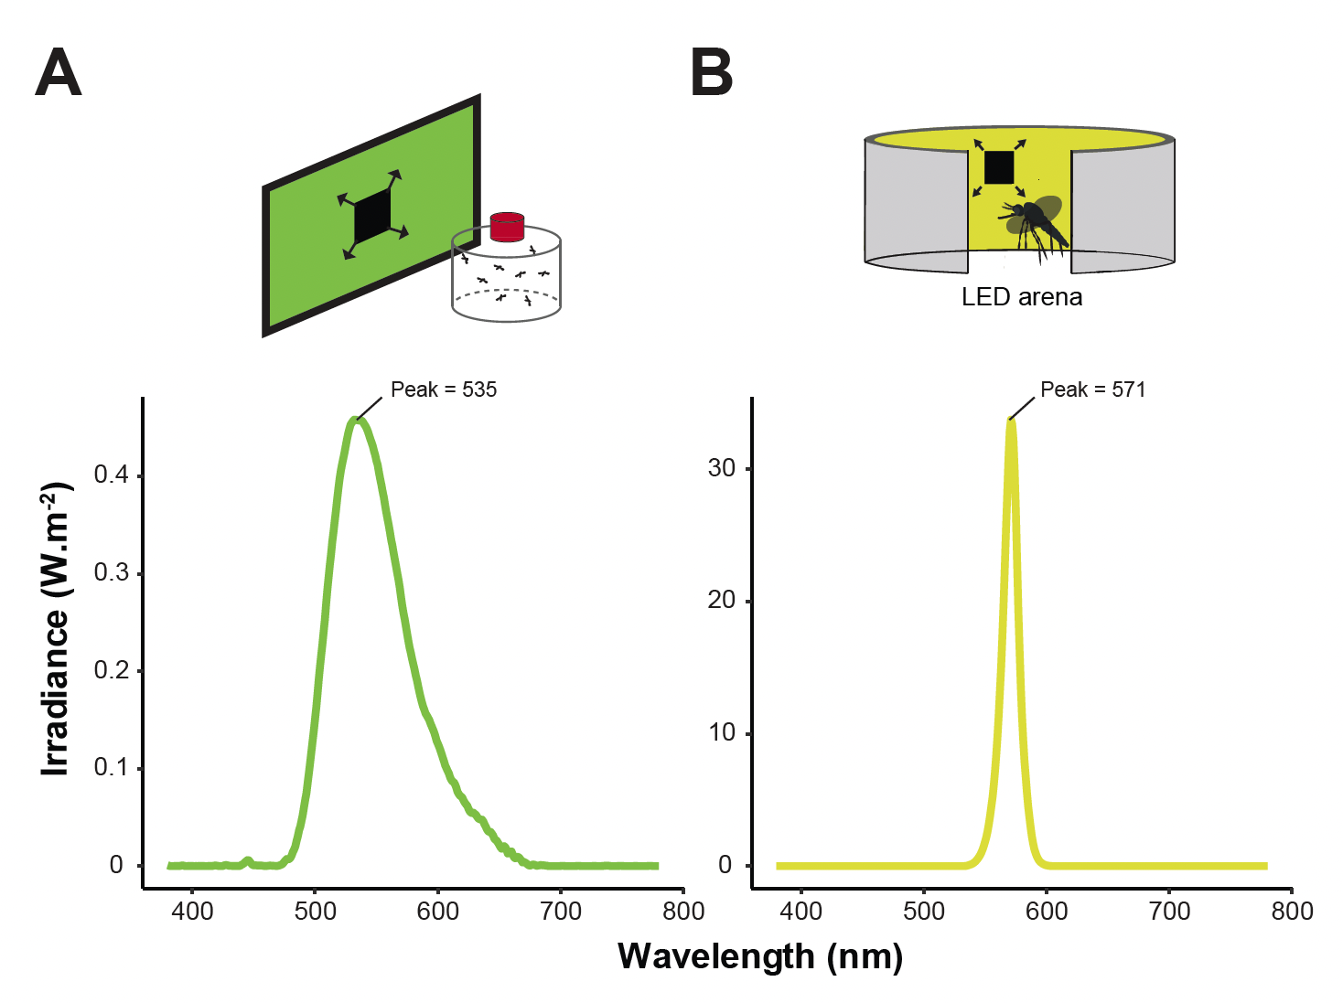

Figure S1. Spectral irradiance of the visual displays.
The spectral signature of the green backgrounds used in the feeding (A) and take-off (B) assays was determined by measuring the irradiance of displays for wavelengths between 380 and 780 nm, using a portable spectral irradiance colorimeter (OHSP350, Hopoocolor, Hangzhou China).

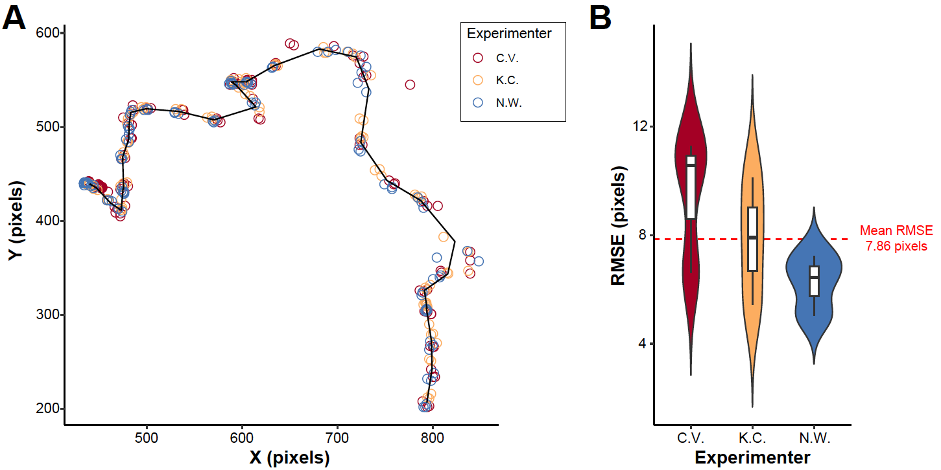

Figure S2. Digitization error associated with manual tracking.
(A) Tracking of a 59-frame flight sequence by 3 different experimenters on 3 consecutive days. Experimenters are identified by their initials. Data were collected in triplicates and results are color-coded for the individual experimenter. The solid black line indicates the mean trajectory calculated from the mean of the coordinates tracked by all 3 experimenters. (B) Digitizing error quantified as the Root Square Mean Error (RMSE), representing the average deviation from the mean trajectory, for each experimenter. The dashed red line indicates the mean RMSE.

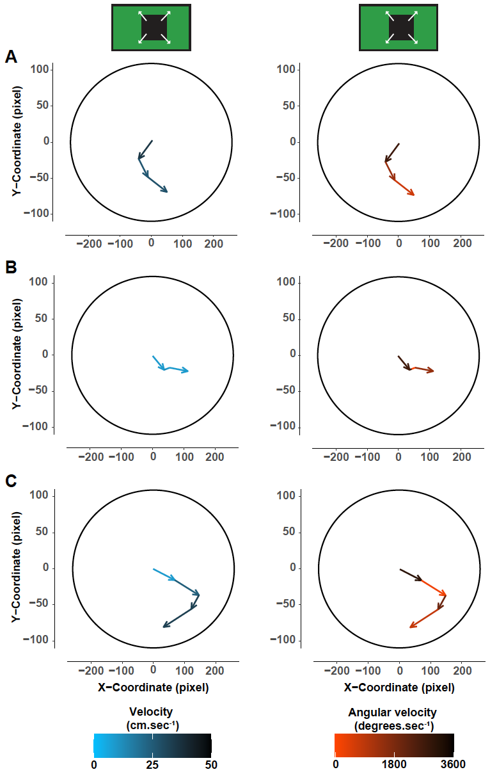

Figure S3. Representative trajectories of mosquitoes’ escape (take-off) responses.
Digitized trajectories of the escape (take-off) responses of three mosquitoes (A-C) to the expanding stimulus. The visualized cartesian coordinates are tracks of the respective mosquitoes’ head in the first 5 frames of the escape (take-off) response upon stimulus introduction (i.e., ⅙ of a second). The trajectories are rotated to fictively re-position the stimuli introductions at the top at 0° (represented as a schematic). The trajectories are color coded as a function of the mosquitoes’ velocity (left panel, blue) and angular velocity (right panel, red).

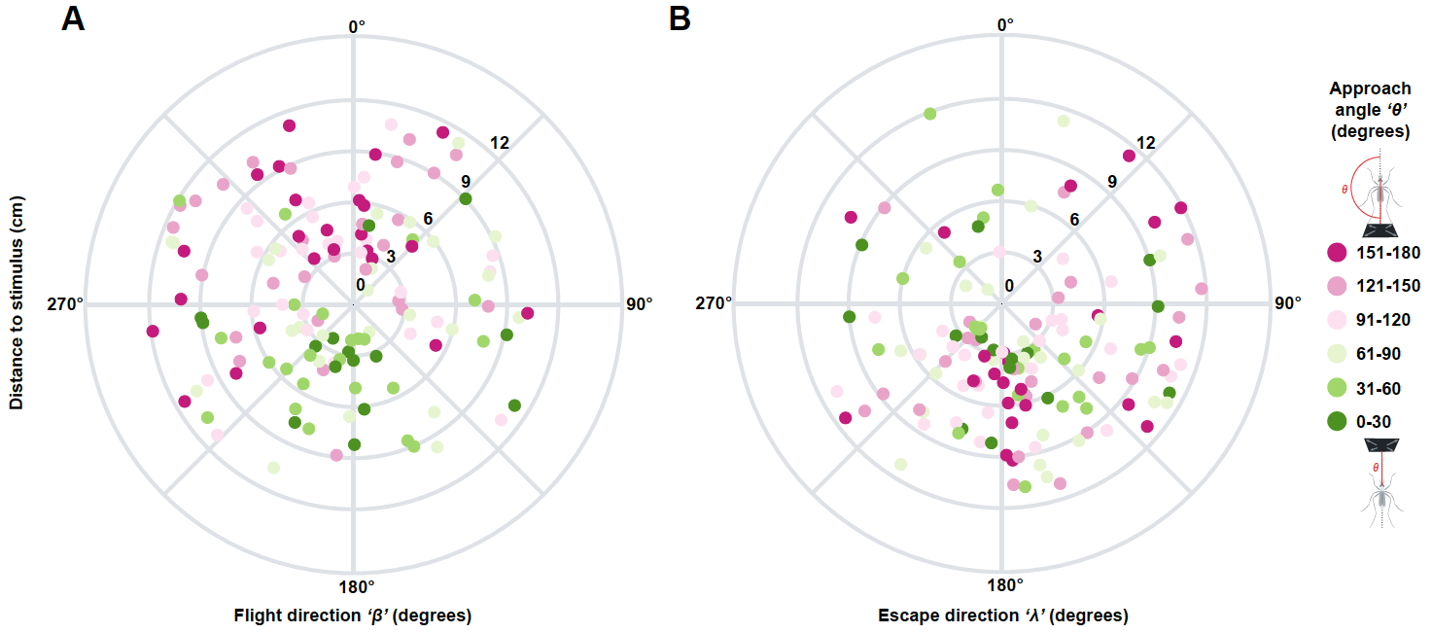

Figure S4. Flight direction (𝛽) and escape direction (𝜆) as a function of mosquitoes’ distance to the stimulus
Circle plots showing the (A) flight direction, 𝛽 (i.e., the direction of escape relative to the mosquito’s body orientation) and (B) escape direction, 𝜆 (i.e., the direction of escape relative to the stimulus, at 0°) within 0.17 sec of stimulus-triggered take-offs. The response variables are visualized as a function of the mosquitoes’ distance to the stimulus and color-coded as a function of the approach angle, 𝜃 where 0° is to the front of the mosquito and 180° is behind the mosquito. Each point represents one take-off (n = 142).

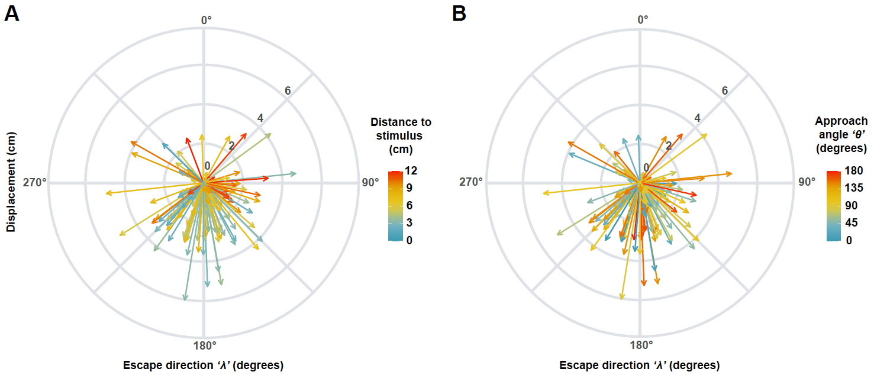

Figure S5. Mosquito displacement as a function of the escape direction (𝜆) in response to the looming stimulus
Circle plot showing the displacement of mosquitoes (i.e., distance travelled on a scale ranging from 0-6 cm) within 0.17 sec of stimulus-triggered take-offs. The length of the vectors encodes for displacement, color coded as a function of the (A) distance to the stimulus’ point of introduction, and (B) approach angle, 𝜃 where 0° is to the front of the mosquito and 180° is behind the mosquito. The position of the vector around the circle encodes for the escape direction, 𝜆 (i.e., the direction of escape relative to the stimulus, at 0°). Each vector represents one take-off (n = 142).

Supplementary Table 1: Number of mosquitoes sampled for their responses to expanding stimuli as a function of the approach angle ‘𝜃’

Approach angle ‘𝜃’  (degrees) | No.  trials | Lower  CI | Upper  CI | z-ratio
0 – 10 | 22 | 14.5 | 33.4 | 14.498
10 – 20 | 23 | 15.3 | 34.6 | 15.037
20 – 30 | 21 | 13.7 | 32.2 | 13.952
30 – 40 | 20 | 12.9 | 31 | 13.397
40 – 50 | 25 | 16.9 | 37 | 16.094
50 – 60 | 22 | 14.5 | 33.4 | 14.498
60 – 70 | 24 | 16.1 | 35.8 | 15.569
70 – 80 | 27 | 18.5 | 39.4 | 17.126
80 – 90 | 23 | 15.3 | 34.6 | 15.037
90 – 100 | 26 | 17.7 | 38.2 | 16.613
100 – 110 | 28 | 19.3 | 40.6 | 17.632
110 – 120 | 32 | 22.6 | 45.3 | 19.605
210 – 130 | 37 | 26.8 | 51.1 | 21.964
130 – 140 | 35 | 25.1 | 48.7 | 21.034
140 – 150 | 55 | 42.2 | 71.6 | 29.719
150 – 160 | 47 | 35.3 | 62.6 | 26.395
160 – 170 | 42 | 31 | 56.8 | 24.223
170 – 180 | 42 | 31 | 56.8 | 24.223

Supplementary Table 2: Number of mosquitoes sampled for their responses to expanding stimuli as a function of the mosquitoes’ distance to the expanding stimulus

Distance to stimulus (cm) | No.  trials | Lower  CI | Upper  CI | z-ratio
0 – 2 | 13 | 7.55 | 22.4 | 9.248
2 – 3 | 33 | 23.46 | 46.4 | 20.086
3 – 4 | 48 | 36.17 | 63.7 | 26.82
4 – 5 | 34 | 24.29 | 47.6 | 20.562
5 – 6 | 55 | 42.23 | 71.6 | 29.719
6 – 7 | 52 | 39.62 | 68.2 | 28.493
7 – 8 | 44 | 32.74 | 59.1 | 25.101
8 – 9 | 48 | 36.17 | 63.7 | 26.82
9 – 10 | 68 | 53.61 | 86.2 | 34.795
10 – 11 | 60 | 46.59 | 77.3 | 31.715
11 – 12 | 63 | 49.22 | 80.6 | 32.885
12 – 13 | 16 | 9.8 | 26.1 | 11.09
13 – 14 | 17 | 10.57 | 27.3 | 11.682

