S1 Table
Please note the separate file S1_Table.xlsx
S2 Table
Please note the separate file S2_Table.xlsx
S3 Table
The machine learning parameter settings for the models
Name | Classifier | Predicts | Fixed Parameters | Cross-validated parameters *
LOG-C** | Penalised Multinomial Logistic Regression – classification | Region, Country, and GPS | Penalty type = ”L1”  Tolerance=0.001  Maximum iterations=1000 | Penalty = 0.01/0.1
LIN-R** | Penalised Linear Regression -regression | GPS | Penalty type = ”L1”  Tolerance=0.001  Maximum iterations=1000 | Penalty = 0.003/0.003
CNN-C | Convolutional Neural Network -classification | Region, Country, and GPS | Epochs=1000  Early stopping with patience of 900 | -
CNN-R | Convolutional Neural Network – regression | GPS | Epochs=1000  Early stopping with patience of 900 | -
GPS Global Positioning System; LOG-C penalised multinomial logistic regression classifier; CNN-C CNN classifier; LIN-R penalised linear regression model; CNN-R CNN regression model.
* Performed on P. falciparum and P. vivax data separately, across a cross-validation range of parameter values of 0.001, 0.0031, 0.01, 0.031, 0.1, 0.31 and 1, resulting in this case in the same penalty values for P. falciparum and P. vivax.
** There are two penalty parameters due to latitude/longitude

S4 Table
Classification accuracy at a country level for P. falciparum (Pf) and P. vivax (Pv)
Region | Country | Pf  LOG-C | Pf  CNN-C | Pv  LOG-C | Pv  CNN-C
West Africa | Benin | 100 | 100 | - | -
 | Burkina Faso | 75.0 | 75.0 | - | -
 | Gambia | 93.8 | 100.0 | - | -
 | Ghana | 95.7 | 90.3 | - | -
 | Guinea | 62.5 | 62.5 | - | -
 | Mali | 63.2 | 63.2 | - | -
 | Mauritania | - | 50.0 | - | -
 | Nigeria | 50.0 | 50.0 | - | -
 | Senegal | 62.5 | 50.0 | - | -
East Africa | Kenya | 63.6 | 72.7 | - | -
 | Tanzania | 100 | 100 | - | -
 | Uganda | 50.0 | 50.0 | - | -
Horn of Africa | Ethiopia | 100 | 100 | 100 | 100
Central Africa | Cameroon | 95.7 | 100 | - | -
South Central Africa | DRC | 100 | 100 | - | -
Southern Africa | Madagascar | 100 | 100 | - | -
 | Malawi | 66.7 | 33.3 | - | -
South Asia | India | - | - | 100 | 100
 | Bangladesh | 100 | 100 | - | -
South East Asia (SEA) | Cambodia | 98.2 | 97.3 | 100 | 100
 | Laos | 83.3 | 83.3 | - | -
 | Myanmar | 100.0 | 95.8 | 66.7 | 66.7
 | Thailand | 98.9 | 98.9 | 100 | 100
 | Vietnam | 71.4 | 92.9 | 100 | 100
 | China | - | - | 0 | 100
Southern SEA | Malaysia | - | - | 100 | 100
South America | Colombia | 100 | 100 | 100 | 100
 | Peru | 100 | 100 | 100 | 100
 | Brazil | - | - | 100 | 100
 | Mexico | - | - | 100 | 100
Oceania | Papua New Guinea | 100 | 100 | 100 | 100
CNN Convolutional Neural Network, DRC Democratic Republic of Congo; LOG-C multinomial logistic regression classifier; CNN-C CNN deep learning classifier; LIN-R penalised linear regression model; CNN-R Penalised CNN regression model.

S5 Table
Confusion matrices for the best predictive classification models
- P. falciparum (CNN-C, regional level)
Please note the separate file S5_Table.xlsx
- P. vivax (LOG-C, regional level)
Please note the separate file S5_Table.xlsx
- P. falciparum (CNN-C, country level)
Please note the separate file S5_Table.xlsx
- P. vivax (LOG-C, country level)
Please note the separate file S5_Table.xlsx
CNN Convolutional Neural Network, LOG-C multinomial logistic regression classifier; CNN-C CNN deep learning classifier

S1 Figure

Distribution of the minor allele frequencies across the SNPs

- P. falciparum (N=750k SNPs)
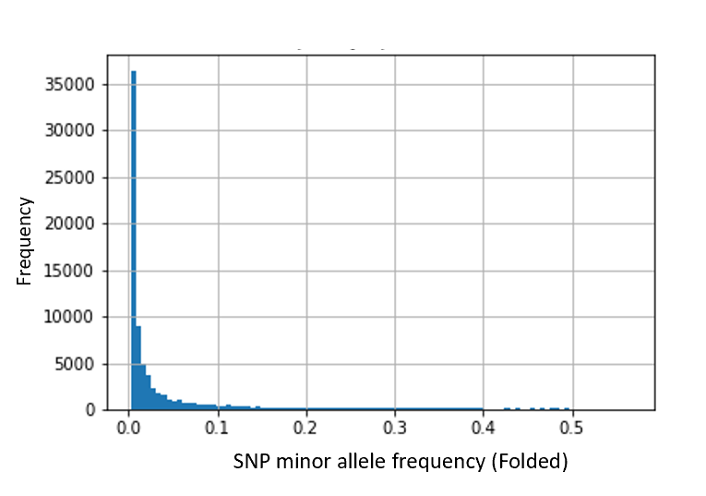
- P. vivax (N=588k SNPs)
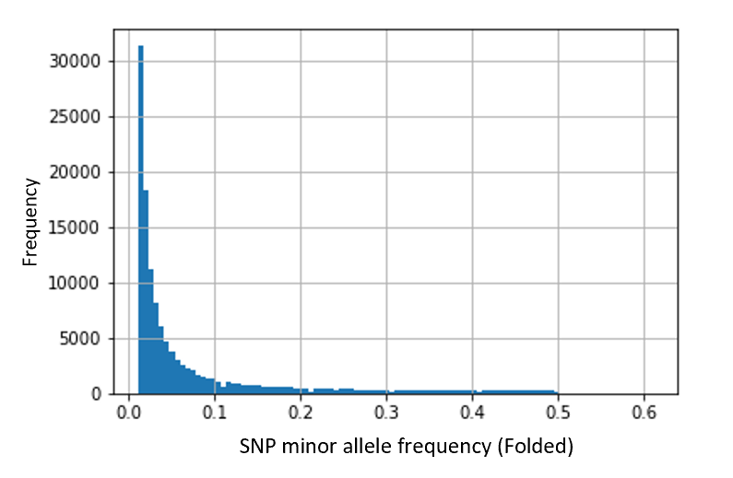

S2 Figure
Maps with predicted vs. actual locations for all models
- P. falciparum
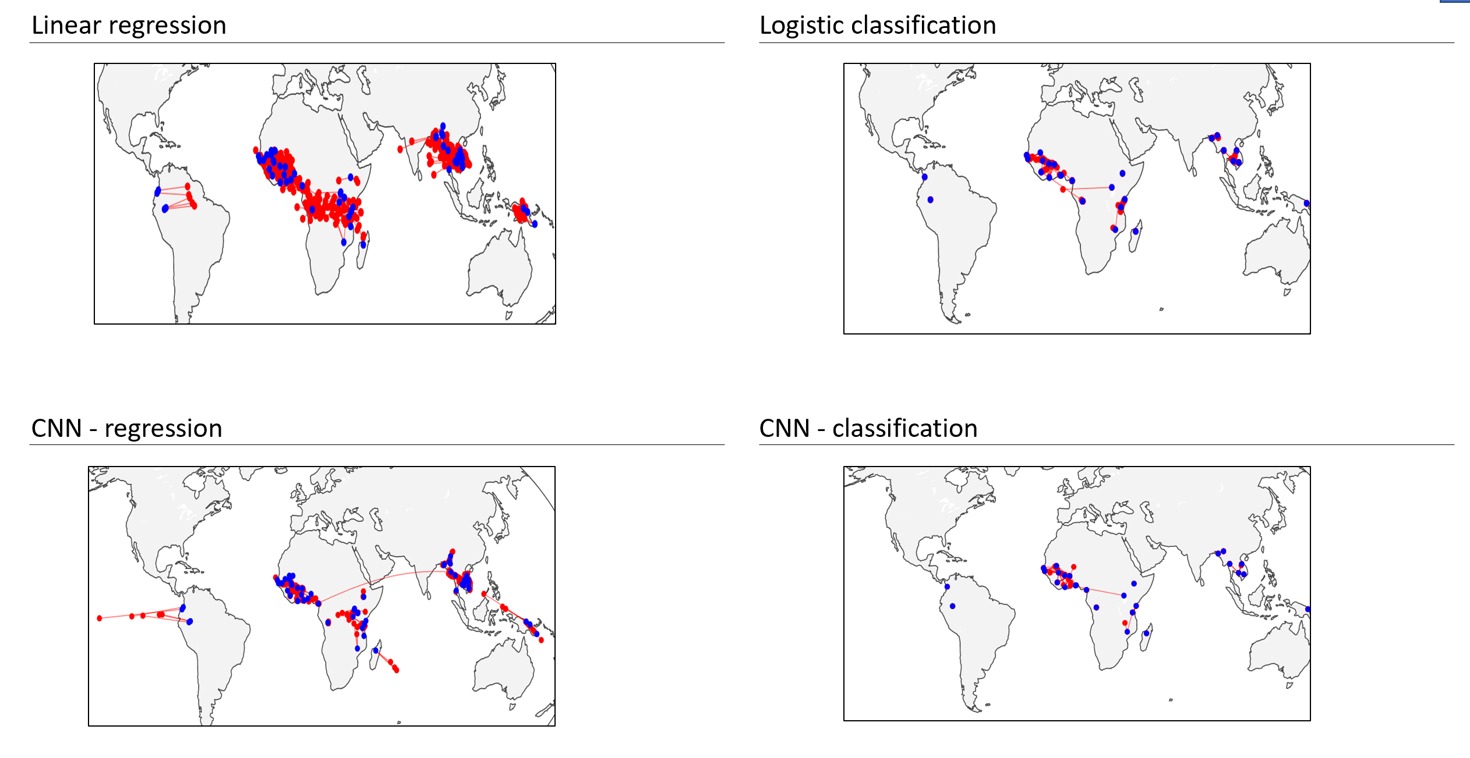
Legend: Blue points are the actual locations in the dataset, red points are the predicted locations, with red lines linking the actual and the predicted locations. Logistic classification refers to a multinomial logistic model.

- P. vivax
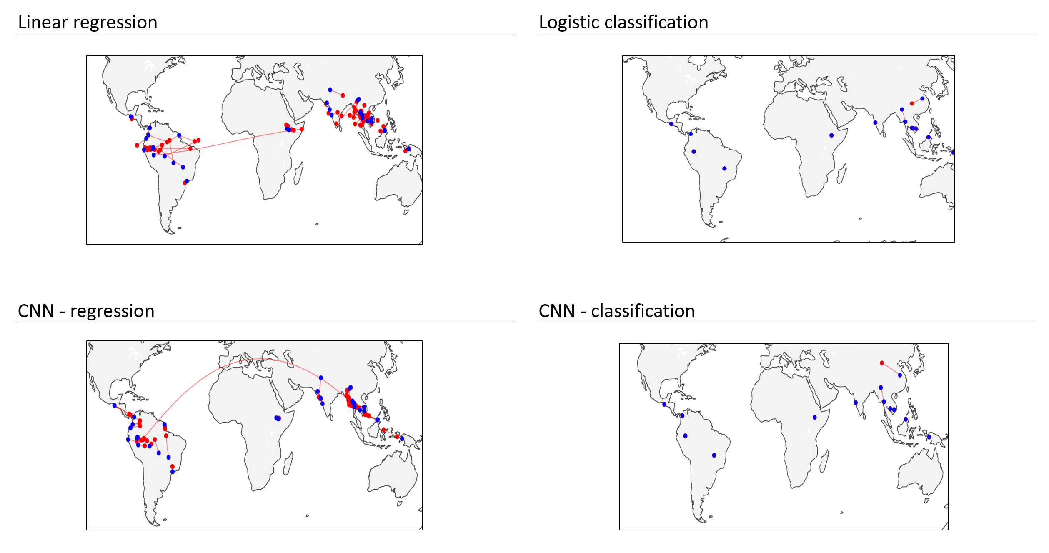
Legend: Blue points are the actual locations in the dataset, red points are the predicted locations, with red lines linking the actual and the predicted locations; Logistic classification refers to a multinomial logistic model.

