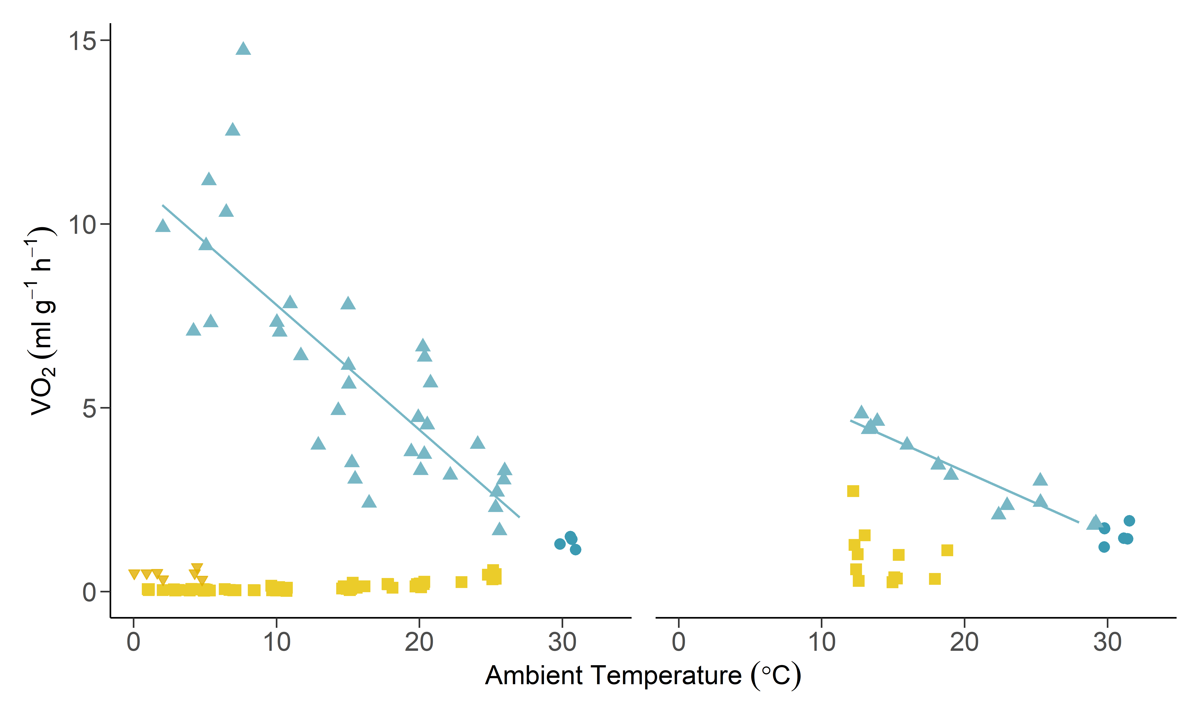
Supplementary Material
A) B)

Supplementary Figure 1. V̇O₂ as a function of T_{a} for A) Nyctophilus gouldi and B) S. australis. BMR (filled grey circles) was recorded in the thermoneutral zone 29.5-34°C. Below this resting V̇O₂ (circles) increased linearly; A) V̇O₂ = 11.2-0.34(T_{a}), r²=0.64, p <0.001 B) V̇O₂ = 6.74-0.17(T_{a}), r²=0.90, p<0.001. Bats entered torpor (filled yellow squares) when exposed to T_{a} below 20°C. Below T_{a} 3°C N. gouldi individuals began thermoregulating when torpid (grey triangles).
Supplementary Figure 2. Subcutaneous temperature (T_{sub}) as a function of ambient temperature (T_{a}) during torpor (filled circles) and at rest (circles). Solid line represents the line of equality (T_{sub}=T_{a}) A) S. australis individuals entered torpor below T_{a} of 20°C maintained a T_{sub} in torpor >15°C B) N. gouldi individuals entered torpor at T_{a} ≤ 25°C and thermoconformed in torpor down to ~3-5°C (depending on the individual).
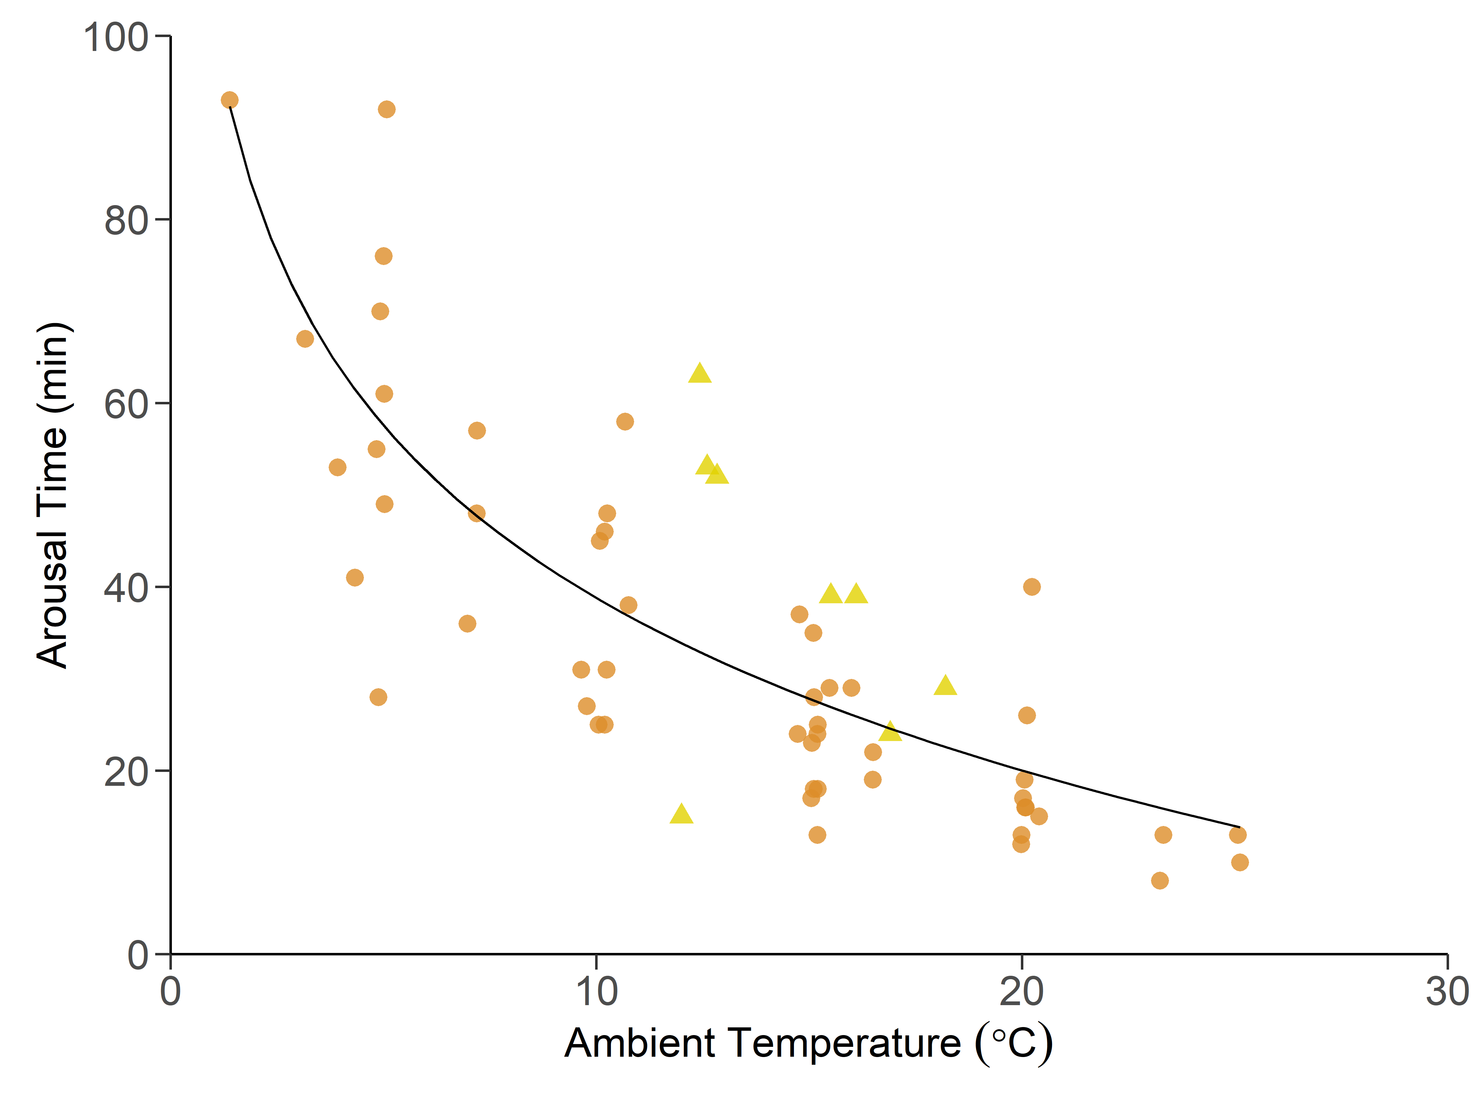
Supplementary Figure 3. Time taken to arouse as a function of T_{a} for both species (N. gouldi; filled circles, S. australis; circles). There was no significant effect of species and as such data were pooled.
Supplementary Figure 4. Map of eastern Australia showing the distribution of S. australis (blue shading) and N. gouldi (yellow shading) along with the locations of their capture. Map generated using R Studio using packages ggplot2 (Wickham, 2016) and sf (Pebesma, 2018) with shape files for species distribution taken from the Map of Life database (Marsh et al., 2022).

REFERENCES
- Marsh, C. J. Sica, Y. V. Burgin, C. J. Dorman, W. A. Anderson, R. C. Del Toro Mijares, I. Vigneron, J. G. Barve, V. Dombrowik, V. L. Duong, M. et al. (2022). Expert range maps of global mammal distributions harmonised to three taxonomic authorities. J Biogeogr 49, 979-992.
- Pebesma, E. (2018). Simple Features for R: Standardized Support for Spatial Vecotr Data. The R Journal 10, 439-446.
- Wickham, H. (2016). ggplot2: Elegant Graphics for Data Analysis: Springer-Verlag New York.

