Supplementary Information for

‘The method of exclusion (still) cannot identify specific mechanisms of cultural inheritance’
Alberto Acerbi, William Daniel Snyder, Claudio Tennie

Additional model information
This document provides additional information on the individual-based model described in the paper The method of exclusion (still) can not identify mechanisms of cultural inheritance. The full code to run the model and to reproduce the results can be found in https://github.com/albertoacerbi/oranzees, together with a detailed documentation of the model development.

The oranzees’ world
The oranzees model is an individual-based model, fully written in R, that reproduces a world where six populations of “oranzees” (a hypothetical ape species) live. The model is spatially-explicit: the six populations are located at relative positions analogous to the six populations of chimpanzees in¹ - see . For modelling convenience, we put these locations approximately in the center of a 1000 x 1000 squared environment in order to be able to process their relative distances, that we use to calculate genetic propensity and ecological availability of the behaviours (see below).
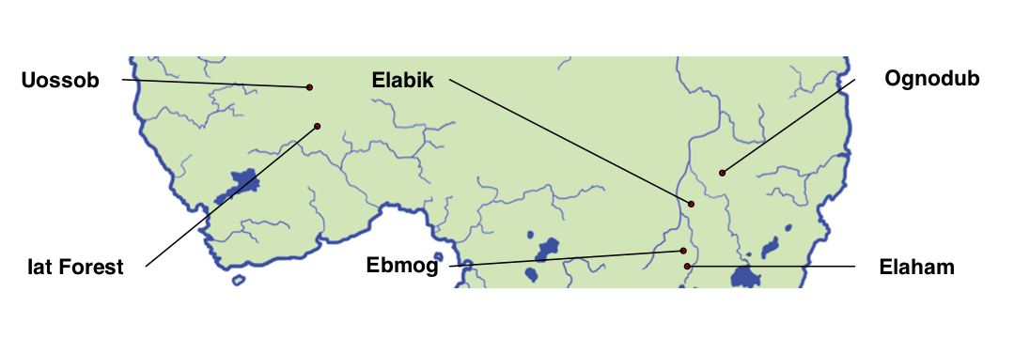
Figure S1. Location of the six populations of oranzees. (The map was created using the software R (https://www.r-project.org).

The population sizes are also modelled on the real chimpanzees populations considered in the study above. Following², we use data from³:
Group | Population size
Uossob | 20
Elabik | 42
Ognodub | 49
Iat Forest | 76
Ebmog | 50
Elaham | 95

Geographical gradient for genetic propensity and ecological availability
As described in the main manuscript, two parameters of the models, $α_{g}$ and $α_{e}$, determine the probability that the genetic propensity and ecological availability associated to the behaviours are equal for all the six populations, or if they differ among the populations.
Independently for each behaviour, if genetic propensity (or ecological availability) is equal, the probability associated ($p_{g}$ or $p_{e}$) is a randomly drawn number between 0 and 1, the same for all six populations. If they are not equal, the values of $p_{g}$ (or $p_{e}$) are assigned using a geographical gradient, by choosing a random point in the oranzees’ world, and calculating its distance to each population. Distances are then transformed to $p_{g}$ (or $p_{e}$) by rescaling them between 0 and 1, so that for the farther population $p_{g}=0$ i.e. the associated behaviour will be impossible to express (or $p_{e}=0$ i.e. the associated behaviour will be absent with an “ecological explanation”).
In the example in , a particular behaviour will have $p_{g}=1$ (or $p_{e}=1$) in the Ognodub site, $p_{g}=0$ (or $p_{e}=0$) in Iat Forest and Uossob, and intermediate values in the other sites.
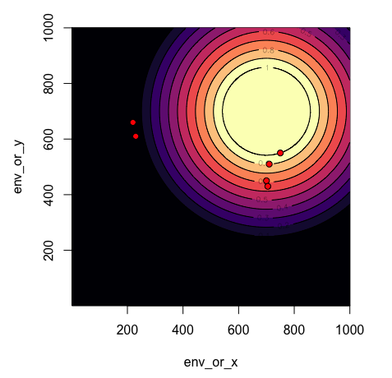
Figure S2. Example of calcualtion of $p_{g}$ (or $p_{e}$). The red points represent the oranzee populations. The color gradient represents the value of $p_{g}$ (or $p_{e}$).

Sub-categories of behaviours
There are 64 behaviours possible in the model (inspired by the 65 coded in¹, but made into an even number for modelling convenience), divided in two main categories: “social” and “food-related”. Each category is further subdivided in sub-categories. Sub-categories, for food-related behaviour, are further assigned to specific “nutrients”. This information is used to calculate the oranzee’s state according to its behaviour (see main manuscript). The names of behaviours and of the sub-categories are only evocative. They are used to illustrate our results in Figure 2 (main manuscript).

Social
Sub-category | behaviour
Play | fruit-missile
Play | slap-fight
Play | air-split
Play | leaf-mask
Play | whistle
Play | pebble-tease
Play | tumbling
Play | brick-fall
Display | stone drop
Display | branch pull-release
Display | arm-cross
Display | two-hand-drum
Display | splash
Display | arm-swing
Display | explode-leaf
Display | contorsionist
Groom | tool back-scratcher
Groom | hand back-scratcher
Groom | tongue-bathe
Groom | tooth-pick
Groom | dirt-shower
Groom | ant-shower
Groom | q-tip
Groom | exfoliate-fruit
Courtship | flower-offer
Courtship | hand-stand
Courtship | rope-swing
Courtship | leaf-fan
Courtship | wreath-clutch
Courtship | ear-pull
Courtship | kissy-hand
Courtship | hop-dance

Food-related
Sub-category | behaviour | Nutrient
Fruit-hammer foraging | wood-wood | Y
Fruit-hammer foraging | wood-stone | Y
Fruit-hammer foraging | stone-wood | Y
Fruit-hammer foraging | stone-stone | Y
Fruit-hammer foraging | bone-wood | Y
Fruit-hammer foraging | bone-stone | Y
Fruit-hammer foraging | wood-ground | Y
Fruit-hammer foraging | stone-ground | Y
Stick-based foraging | stick-throw V | Z
Stick-based foraging | stick-throw A | Z
Stick-based foraging | fish-stab | Z
Stick-based foraging | hedgehog-flick | Z
Stick-based foraging | worm-hook | Z
Stick-based foraging | bird-probe | Z
Stick-based foraging | fish-hammer | Z
Stick-based foraging | spin-seed | Z
Anvil smash | anvil-smash S | Y
Anvil smash | anvil-smash W | Y
Anvil smash | smash-ground | Y
Anvil smash | drop-ground | Y
Rolling pin techniques | rolling-wood | Z
Rolling pin techniques | rolling-stone | Z
Rolling pin techniques | rolling-bone | Z
Rolling pin techniques | rolling-other | Z
Insect swatting | bug-clap | Y
Insect swatting | stick-insect | Y
Fish stunning | fish-stun-stone | Z
Fish stunning | fish-stun-wood | Z
Tortoise-flip | tortoise-drop-on-stone | Y
Potato-mash | tuber-mash | Z
Clubbing | mammal-clubbing | Y
Egg cracking | egg-crack | Z

Example of single run
This shows an example of the entire history of all behaviours in a single run, for a single population (geographical location and population size are based on “Uossob”), with $α_{g}=0.2$, $α_{e}=0.8$, and $S=1$, i.e. one of the combinations of parameters that produces a number of cultural behaviours similar to¹.
Figure S3. Example of a single run with $α_{g}=0.2$, $α_{e}=0.8$, and $S=1$. The plots show the frequencies of the 64 possible behaviours, divided in panels by sub-category.

Age classes to calculate customary behaviours
To determine customary behaviours, we need to define age classes for individuals (the definition of customary behaviours, from¹ is a behaviour observed in over 50% of individuals in at least one age class). We define three age classes as follows:
- adults: individuals that are more than 16 years old.
- subadults: individuals between 8 and 16 years old.
- juveniles: individuals that are less than 8 years old.

Supplementary figures

Figure S4

Figure S4: Cultural traits in oranzees, after varying the probability of socially-mediated/triggered innovations. Red color indicates simulation runs that produced more than 38 cultural behaviours (the number of cultural traits identified in 2); blue color indicates simulation runs that produces less than 38 cultural behaviours. S, αe and αg as indicated in the plot. N = 10 runs for each combination of parameters.

Figure S5

Figure S5: Another suggestion of our model’s fit with empirical data is that when our outputs reproduce the number of 38 cultural behaviours (pattern D), they also reproduce the number of behaviours classified in the other three patterns (A, B, C, see above). Number of traits for each of the four patterns (A, B, C, D, see description in the main manuscript) for the parameters αe = 0.8; αg = 0.2, S = 1. The red values are the values described for real chimpanzees populations. N = 20 runs.

Figure S6

Figure S6: Number of cultural traits for each population for the parameters αe = 0.8; αg = 0.2, S = 1. The blue line is a linear fit of the data. N = 100 runs.

Figure S7

Figure S7: Number of cultural traits in complete absence of ecological and genetic variation (αe = 0; αg = 0), with varying probability of socially-mediated/triggered innovations (S). N = 10 runs for each value of S. Note that culture-like patterns often remain even in the total absence of genetic differences, environmental differences and social learning (result on far left). To the best of our knowledge this is a result not previously described in the literature - though we suspect these cultures would not be stable over time.

References
1. Whiten, A. et al. Cultures in chimpanzees. Nature 399, 682–685 (1999).
2. Lind, J. & Lindenfors, P. The Number of Cultural Traits Is Correlated with Female Group Size but Not with Male Group Size in Chimpanzee Communities. PLoS ONE 5, (2010).
3. Wrangham, R. W. Why are male chimpanzees more gregarious than mothers? A scramble competition hypothesis. in Primate males: Causes and consequences of variation in group composition 248–258 (Cambridge University Press, 2000).

