Supplementary Table S1. Variables with missing information
Variables | N of missing | %
Sex | 0 | 0
Income | 244,016 | 2.43
BMI | 6,039 | 0.06
Systolic BP | 2,609 | 0.03
Diastolic BP | 2,640 | 0.03
Fasting glucose | 2,107 | 0.02
Total cholesterol | 1,872 | 0.02
AST | 2,080 | 0.02
ALT | 2,100 | 0.02
GGT | 2,097 | 0.02
Waist Circumference | 3,555 | 0.03
Triglyceride | 2,632 | 0.03
HDL -C | 3,908 | 0.04
LDL -C | 4,122 | 0.04
Serum Creatinine | 2,685 | 0.03
Smoking | 65,231 | 0.64
Drinking | 160,625 | 1.58
Regular exercise | 209,705 | 2.08
Estimated GFR | 3,200 | 0.03
Fatty Liver Index | 11,715 | 0.11
BMI, body mass index; BP, blood pressure; HDL-C, high density lipoprotein-cholesterol; LDL-C, low density lipoprotein -cholesterol; TG, triglyceride; AST, aspartate transaminase; ALT, alanine transferase; GGT, gamma-glutamyl transferase; GFR, glomerular filtration rate

Supplementary Table S2. Number of population and death by covariates
 |  | All-cause mortality | CVD-specific mortality | Cancer-specific mortality | Respiratory disease-specific mortality | Liver disease-specific mortality
 | Total number (N) | Death events (N)
Sex
Male | 5,277,397 | 295,567 | 52,134 | 109,565 | 29,553 | 21,079
Female | 4,409,669 | 165,132 | 38,423 | 52,927 | 14,091 | 5,747
Age, years
<40 | 3,024,064 | 16,295 | 2,059 | 4,078 | 135 | 1,022
40-64 | 5,390,738 | 150,593 | 22,991 | 67,082 | 6,201 | 14,271
≥65 | 1,272,264 | 293,811 | 65,507 | 91,332 | 37,308 | 11,533
Smoking status
No | 7,157,808 | 334,920 | 68,728 | 114,440 | 34,210 | 16,195
Yes | 2,529,258 | 125,779 | 21,829 | 48,052 | 9,434 | 10,631
Current Smoking
<20 pack years | 1,686,091 | 48,356 | 8,792 | 15,811 | 3,211 | 4,324
≥20 pack years | 843,167 | 77,423 | 13,037 | 32,241 | 6,223 | 6,307
Drinking
None | 4,991,425 | 291,699 | 62,874 | 96,367 | 31,084 | 11,908
Mild to moderate | 3,867,631 | 126,602 | 21,422 | 49,939 | 9,553 | 9,745
Heavy | 828,010 | 42,398 | 6,261 | 16,186 | 3,007 | 5,173
History of CVD
No | 9,509,127 | 419,768 | 78,026 | 153,178 | 38,842 | 25,752
Yes | 177,939 | 40,931 | 12,531 | 9,314 | 4,802 | 1,074
History of cancer
No | 9,538,474 | 434,262 | 88,280 | 78,930 | 22,466 | 25,513
Yes | 148,592 | 26,437 | 2,277 | 83,562 | 21,178 | 1,313
CVD, cardiovascular disease

Supplementary Table S3. All-cause and disease-specific mortality by tertiles of gamma-glutamyl transferase with additional adjustment for fatty liver index and AST/ALT ratio

 | N | Event | Duration | IR,  per 1000 PY | Model 4 | Model 5
Total |  |  |  |  | HR (95% CI) | HR (95% CI)
All-cause mortality
Tertile 1 | 3,116,836 | 132,733 | 25663193.16 | 5.2 | 1 (Ref.) | 1 (Ref.)
Tertile 2 | 3,330,242 | 145,927 | 27415683.45 | 5.3 | 1.02 (1.02 - 1.03) | 1.03 (1.02 - 1.03)
Tertile 3 | 3,239,988 | 182,039 | 26528308.89 | 6.9 | 1.20 (1.19 - 1.21) | 1.20 (1.19 - 1.21)
CVD-specific mortality
Tertile 1 | 3,116,836 | 25,315 | 25663193.16 | 1.0 | 1 (Ref.) | 1 (Ref.)
Tertile 2 | 3,330,242 | 29,733 | 27415683.45 | 1.1 | 1.05 (1.03 - 1.07) | 1.04 (1.03 - 1.06)
Tertile 3 | 3,239,988 | 35,509 | 26528308.89 | 1.3 | 1.19 (1.16 - 1.21) | 1.16 (1.14 - 1.19)
Cancer-specific mortality
Tertile 1 | 3,116,836 | 45,280 | 25663193.16 | 1.8 | 1 (Ref.) | 1 (Ref.)
Tertile 2 | 3,330,242 | 52,132 | 27415683.45 | 1.9 | 1.07 (1.06 - 1.09) | 1.07 (1.06 - 1.09)
Tertile 3 | 3,239,988 | 65,080 | 26528308.89 | 2.5 | 1.31 (1.29 - 1.33) | 1.31 (1.29 - 1.33)
Respiratory disease-specific mortality
Tertile 1 | 3,116,836 | 15,323 | 25663193.16 | 0.6 | 1 (Ref.) | 1 (Ref.)
Tertile 2 | 3,330,242 | 14,146 | 27415683.45 | 0.5 | 1.08 (1.05 - 1.10) | 1.06 (1.03 - 1.09)
Tertile 3 | 3,239,988 | 14,175 | 26528308.89 | 0.5 | 1.25 (1.22 - 1.29) | 1.19 (1.15 - 1.22)
Liver disease-related mortality
Tertile 1 | 3,116,836 | 2,851 | 25663193.16 | 0.1 | 1 (Ref.) | 1 (Ref.)
Tertile 2 | 3,330,242 | 4,967 | 27415683.45 | 0.2 | 1.74 (1.65 - 1.82) | 1.74 (1.66 - 1.82)
Tertile 3 | 3,239,988 | 19,008 | 26528308.89 | 0.7 | 5.82 (5.56 - 6.10) | 5.86 (5.59 - 6.14)
Male |  |  |  |  | HR (95% CI) | HR (95% CI)
All-cause mortality
Tertile 1 | 1,761,605 | 96,785 | 14426469.99 | 6.7 | 1 (Ref.) | 1 (Ref.)
Tertile 2 | 1,736,845 | 90,199 | 14226226.51 | 6.3 | 1.05 (1.04 - 1.06) | 1.06 (1.04 - 1.07)
Tertile 3 | 1,778,947 | 108,583 | 14485267.72 | 7.5 | 1.31 (1.30 - 1.33) | 1.32 (1.30 - 1.33)
CVD-specific mortality
Tertile 1 | 1,761,605 | 17,285 | 14426469.99 | 1.2 | 1 (Ref.) | 1 (Ref.)
Tertile 2 | 1,736,845 | 16,918 | 14226226.51 | 1.2 | 1.08 (1.05 - 1.10) | 1.07 (1.05 - 1.10)
Tertile 3 | 1,778,947 | 17,931 | 14485267.72 | 1.2 | 1.22 (1.18 - 1.25) | 1.20 (1.17 - 1.24)
Cancer-specific mortality
Tertile 1 | 1,761,605 | 33,878 | 14426469.99 | 2.3 | 1 (Ref.) | 1 (Ref.)
Tertile 2 | 1,736,845 | 34,022 | 14226226.51 | 2.4 | 1.11 (1.10 - 1.13) | 1.12 (1.10 - 1.13)
Tertile 3 | 1,778,947 | 41,665 | 14485267.72 | 2.9 | 1.48 (1.45 - 1.51) | 1.49 (1.46 - 1.51)
Respiratory disease-specific mortality
Tertile 1 | 1,761,605 | 12,103 | 14426469.99 | 0.8 | 1 (Ref.) | 1 (Ref.)
Tertile 2 | 1,736,845 | 9,243 | 14226226.51 | 0.6 | 1.12 (1.09 - 1.15) | 1.10 (1.07 - 1.14)
Tertile 3 | 1,778,947 | 8,207 | 14485267.72 | 0.6 | 1.28 (1.24 - 1.33) | 1.22 (1.17 - 1.27)
Liver disease-related mortality
Tertile 1 | 1,761,605 | 2,290 | 14426469.99 | 0.2 | 1 (Ref.) | 1 (Ref.)
Tertile 2 | 1,736,845 | 3,766 | 14226226.51 | 0.3 | 1.88 (1.78 - 1.99) | 1.89 (1.79 - 2.00)
Tertile 3 | 1,778,947 | 15,023 | 14485267.72 | 1.0 | 7.05 (6.68 - 7.44) | 7.09 (6.72 - 7.48)
Female |  |  |  |  | HR (95% CI) | HR (95% CI)
All-cause mortality
Tertile 1 | 1,355,231 | 35,948 | 11236723.17 | 3.2 | 1 (Ref.) | 1 (Ref.)
Tertile 2 | 1,593,397 | 55,728 | 13189456.94 | 4.2 | 0.97 (0.96 - 0.99) | 0.97 (0.96 - 0.98)
Tertile 3 | 1,461,041 | 73,456 | 12043041.18 | 6.1 | 1.06 (1.05 - 1.08) | 1.05 (1.03 - 1.06)
CVD-specific mortality
Tertile 1 | 1,355,231 | 8,030 | 11236723.17 | 0.7 | 1 (Ref.) | 1 (Ref.)
Tertile 2 | 1,593,397 | 12,815 | 13189456.94 | 1.0 | 0.99 (0.96 - 1.01) | 0.98 (0.95 - 1.01)
Tertile 3 | 1,461,041 | 17,578 | 12043041.18 | 1.5 | 1.15 (1.12 - 1.19) | 1.11 (1.08 - 1.140)
Cancer-specific mortality
Tertile 1 | 1,355,231 | 11,402 | 11236723.17 | 1.0 | 1 (Ref.) | 1 (Ref.)
Tertile 2 | 1,593,397 | 18,110 | 13189456.94 | 1.4 | 1.02 (0.99 - 1.04) | 1.02 (0.99 - 1.05)
Tertile 3 | 1,461,041 | 23,415 | 12043041.18 | 1.9 | 1.11 (1.08 - 1.14) | 1.12 (1.09 - 1.14)
Respiratory disease-specific mortality
Tertile 1 | 1,355,231 | 3,220 | 11236723.17 | 0.3 | 1 (Ref.) | 1 (Ref.)
Tertile 2 | 1,593,397 | 4,903 | 13189456.94 | 0.4 | 1.02 (0.97 - 1.06) | 1.00 (0.96 - 1.05)
Tertile 3 | 1,461,041 | 5,968 | 12043041.18 | 0.5 | 1.15 (1.10 - 1.21) | 1.09 (1.04 - 1.14)
Liver disease-related mortality
Tertile 1 | 1,355,231 | 561 | 11236723.17 | 0.0 | 1 (Ref.) | 1 (Ref.)
Tertile 2 | 1,593,397 | 1,201 | 13189456.94 | 0.1 | 1.38 (1.25 - 1.53) | 1.38 (1.25 - 1.53)
Tertile 3 | 1,461,041 | 3,985 | 12043041.18 | 0.3 | 3.46 (3.14 - 3.80) | 3.50 (3.19 - 3.85)
IR, incidence rate; PY, person year; CVD, cardiovascular diseases, HR, hazard ratio; CI, confidence interval; AST, aspartate aminotransferase; ALT, alanine transaminase
Model 4 was adjusted for age, sex, smoking status, alcohol consumption, physical activity, low income, body mass index, alanine aminotransferase, diabetes mellitus, hypertension, dyslipidemia, Charlson comorbidity index score, and fatty liver index.
Model 5 was adjusted for age, sex, smoking status, alcohol consumption, physical activity, low income, body mass index, diabetes mellitus, hypertension, dyslipidemia, Charlson comorbidity index score, fatty liver index, and AST/ALT ratio.

Supplementary Table S4. Sensitivity analyses with 2 and 4 years of lag time
 | N | Event | IR, per 1000 PY | Model 1 | Model 2 | Model 3
2-year lag |  |  |  | HR (95% CI) | HR (95% CI) | HR (95% CI)
All-cause mortality
Tertile 1 | 3,107,132 | 123,029 | 5.5 | 1 (Ref.) | 1 (Ref.) | 1 (Ref.)
Tertile 2 | 3,320,225 | 135,910 | 5.6 | 1.04 (1.04 - 1.05) | 1.02 (1.02 - 1.03) | 1.05 (1.04 - 1.06)
Tertile 3 | 3,226,826 | 168,877 | 7.2 | 1.37 (1.36 - 1.38) | 1.29 (1.28 - 1.30) | 1.31 (1.30 - 1.32)
CVD-specific mortality
Tertile 1 | 3,107,132 | 23,528 | 1.0 | 1 (Ref.) | 1 (Ref.) | 1 (Ref.)
Tertile 2 | 3,320,225 | 27,717 | 1.2 | 1.11 (1.09 - 1.13) | 1.10 (1.08 - 1.12) | 1.07 (1.05 - 1.09)
Tertile 3 | 3,226,826 | 32,978 | 1.4 | 1.40 (1.38 - 1.43) | 1.36 (1.34 - 1.39) | 1.28 (1.26 - 1.31)
Cancer-specific mortality
Tertile 1 | 3,107,132 | 41,634 | 1.8 | 1 (Ref.) | 1 (Ref.) | 1 (Ref.)
Tertile 2 | 3,320,225 | 48,413 | 2.0 | 1.09 (1.08 - 1.11) | 1.06 (1.05 - 1.08) | 1.08 (1.06 - 1.09)
Tertile 3 | 3,226,826 | 60,200 | 2.6 | 1.42 (1.40 - 1.44) | 1.32 (1.30 - 1.34) | 1.34 (1.32 - 1.36)
Respiratory disease-specific mortality
Tertile 1 | 3,107,132 | 14,607 | 0.6 | 1 (Ref.) | 1 (Ref.) | 1 (Ref.)
Tertile 2 | 3,320,225 | 13,515 | 0.6 | 0.99 (0.97 - 1.02) | 0.99 (0.97 - 1.01) | 1.10 (1.07 - 1.13)
Tertile 3 | 3,226,826 | 13,563 | 0.6 | 1.18 (1.15 - 1.21) | 1.15 (1.12 - 1.18) | 1.38 (1.34 - 1.41)
Liver disease-related mortality
Tertile 1 | 3,107,132 | 2,665 | 0.1 | 1 (Ref.) | 1 (Ref.) | 1 (Ref.)
Tertile 2 | 3,320,225 | 4,638 | 0.2 | 1.70 (1.62 - 1.78) | 1.67 (1.59 - 1.76) | 1.76 (1.67 - 1.85)
Tertile 3 | 3,226,826 | 17,494 | 0.8 | 6.73 (6.46 - 7.03) | 6.00 (5.75 - 6.26) | 6.42 (6.15 - 6.71)
4-year lag
All-cause mortality
Tertile 1 | 3,083,979 | 99,876 | 6.1 | 1 (Ref.) | 1 (Ref.) | 1 (Ref.)
Tertile 2 | 3,295,621 | 111,306 | 6.4 | 1.05 (1.04 - 1.05) | 1.03 (1.02 - 1.04) | 1.04 (1.04 - 1.05)
Tertile 3 | 3,195,591 | 137,642 | 8.2 | 1.37 (1.35 - 1.38) | 1.28 (1.27 - 1.29) | 1.29 (1.28 - 1.31)
CVD-specific mortality
Tertile 1 | 3,083,979 | 19,270 | 1.2 | 1 (Ref.) | 1 (Ref.) | 1 (Ref.)
Tertile 2 | 3,295,621 | 22,927 | 1.3 | 1.11 (1.09 - 1.13) | 1.10 (1.08 - 1.12) | 1.07 (1.05 - 1.09)
Tertile 3 | 3,195,591 | 27,096 | 1.6 | 1.40 (1.37 - 1.42) | 1.35 (1.33 - 1.38) | 1.27 (1.24 - 1.29)
Cancer-specific mortality
Tertile 1 | 3,083,979 | 33,021 | 2.0 | 1 (Ref.) | 1 (Ref.) | 1 (Ref.)
Tertile 2 | 3,295,621 | 38,957 | 2.2 | 1.10 (1.08 - 1.12) | 1.07 (1.05 -1.08) | 1.08 (1.06 - 1.10)
Tertile 3 | 3,195,591 | 48,346 | 2.9 | 1.42 (1.40 - 1.44) | 1.31 (1.29 - 1.33) | 1.32 (1.30 - 1.35)
Respiratory disease-specific mortality
Tertile 1 | 3,083,979 | 12,563 | 0.8 | 1 (Ref.) | 1 (Ref.) | 1 (Ref.)
Tertile 2 | 3,295,621 | 11,801 | 0.7 | 1.00 (0.98 - 1.03) | 0.99 (0.97 - 1.02) | 1.09 (1.07 - 1.12)
Tertile 3 | 3,195,591 | 11,848 | 0.7 | 1.18 (1.15 - 1.21) | 1.15 (1.12 - 1.18) | 1.36 (1.32 - 1.40)
Liver disease-related mortality
Tertile 1 | 3,083,979 | 2,145 | 0.1 | 1 (Ref.) | 1 (Ref.) | 1 (Ref.)
Tertile 2 | 3,295,621 | 3,777 | 0.2 | 1.70 (1.62 - 1.80) | 1.68 (1.59 - 1.77) | 1.75 (1.65 - 1.84)
Tertile 3 | 3,195,591 | 13,905 | 0.8 | 6.59 (6.29 - 6.90) | 5.84 (5.57 - 6.13) | 6.17 (5.88 - 6.48)
PY, person year; CVD, cardiovascular diseases, HR, hazard ratio; CI, confidence interval
Model 1 was adjusted for age and sex; Model 2 was adjusted for smoking status, alcohol consumption, physical activity, and low income in addition to covariates in model 1; Model 3 was adjusted for body mass index, alanine aminotransferase, diabetes mellitus, hypertension, dyslipidemia, and Charlson comorbidity index score in addition to covariates in model 2.

Supplementary Table S5. All-cause and disease-specific mortality by quintiles of gamma-glutamyl transferase
Quintilesª | N | Event | IR  (per 1000 PY) | Model 1 | Model 2 | Model 3
Total
All-cause mortality
Quintile 1 | 1,795,767 | 78,052 | 5.3 | 1 (Ref.) | 1 (Ref.) | 1 (Ref.)
Quintile 2 | 2,001,782 | 84,133 | 5.1 | 0.98 (0.98 - 0.99) | 0.98 (0.97 - 0.99) | 0.99 (0.99 - 1.01)
Quintile 3 | 1,995,390 | 86,764 | 5.3 | 1.03 (1.02 - 1.04) | 1.01 (0.99 - 1.02) | 1.05 (1.04 - 1.06)
Quintile 4 | 2,002,679 | 93,971 | 5.7 | 1.11 (1.10 - 1.12) | 1.08 (1.07 - 1.09) | 1.13 (1.11 - 1.14)
Quintile 5 | 1,891,448 | 117,779 | 7.6 | 1.53 (1.52 - 1.55) | 1.42 (1.41 - 1.44) | 1.46 (1.45 - 1.48)
CVD-specific mortality
Quintile 1 | 1,795,767 | 14,586 | 1.0 | 1 (Ref.) | 1 (Ref.) | 1 (Ref.)
Quintile 2 | 2,001,782 | 16,597 | 1.0 | 1.05 (1.03 - 1.07) | 1.05 (1.02 - 1.07) | 1.03 (1.01 - 1.06)
Quintile 3 | 1,995,390 | 17,665 | 1.1 | 1.12 (1.10 - 1.15) | 1.11 (1.09 - 1.14) | 1.09 (1.06 - 1.11)
Quintile 4 | 2,002,679 | 19,427 | 1.2 | 1.22 (1.20 - 1.25) | 1.21 (1.18 - 1.24) | 1.16 (1.14 - 1.19)
Quintile 5 | 1,891,448 | 22,282 | 1.4 | 1.57 (1.54 - 1.61) | 1.52 (1.49 - 1.55) | 1.43 (1.40 - 1.46)
Cancer-specific mortality
Quintile 1 | 1,795,767 | 26,036 | 1.8 | 1 (Ref.) | 1 (Ref.) | 1 (Ref.)
Quintile 2 | 2,001,782 | 29,678 | 1.8 | 1.03 (1.01 - 1.05) | 1.02 (0.99 - 1.03) | 1.03 (1.01 - 1.05)
Quintile 3 | 1,995,390 | 31,116 | 1.9 | 1.10 (1.08 - 1.12) | 1.06 (1.05 - 1.08) | 1.09 (1.08 - 1.11)
Quintile 4 | 2,002,679 | 33,869 | 2.1 | 1.19 (1.17 - 1.21) | 1.13 (1.11 - 1.15) | 1.18 (1.16 - 1.20)
Quintile 5 | 1,891,448 | 41,793 | 2.7 | 1.59 (1.57 - 1.62) | 1.47 (1.45 - 1.50) | 1.52 (1.49 - 1.54)
Respiratory disease-specific mortality
Quintile 1 | 1,795,767 | 9,506 | 0.6 | 1 (Ref.) | 1 (Ref.) | 1 (Ref.)
Quintile 2 | 2,001,782 | 8,903 | 0.5 | 0.94 (0.92 - 0.97) | 0.94 (0.91 - 0.97) | 1.02 (0.99 - 1.05)
Quintile 3 | 1,995,390 | 8,340 | 0.5 | 0.96 (0.94 - 0.99) | 0.96 (0.93 - 0.99) | 1.11 (1.07 - 1.14)
Quintile 4 | 2,002,679 | 8,337 | 0.5 | 1.02 (0.99 - 1.05) | 1.01 (0.98 - 1.05) | 1.23 (1.19 - 1.27)
Quintile 5 | 1,891,448 | 8,558 | 0.6 | 1.24 (1.20 - 1.28) | 1.20 (1.17 - 1.24) | 1.53 (1.48 - 1.58)
Liver disease-related mortality
Quintile 1 | 1,795,767 | 1,561 | 0.1 | 1 (Ref.) | 1 (Ref.) | 1 (Ref.)
Quintile 2 | 2,001,782 | 2,072 | 0.1 | 1.21 (1.13 - 1.29) | 1.19 (1.11 - 1.27) | 1.24 (1.16 - 1.33)
Quintile 3 | 1,995,390 | 2,943 | 0.2 | 1.81 (1.70 - 1.93) | 1.78 (1.67 - 1.90) | 1.93 (1.81 - 2.05)
Quintile 4 | 2,002,679 | 4,548 | 0.3 | 2.84 (2.68 - 3.01) | 2.79 (2.63 - 2.96) | 3.09 (2.91 - 3.28)
Quintile 5 | 1,891,448 | 15,702 | 1.0 | 10.54 (9.99 - 11.10) | 9.53 (9.02 - 10.06) | 10.55 (9.98 - 11.15)
Male
All-cause mortality
Quintile 1 | 1,027,361 | 58,439 | 6.9 | 1 (Ref.) | 1 (Ref.) | 1 (Ref.)
Quintile 2 | 1,122,651 | 58,830 | 6.4 | 0.98 (0.97 - 0.99) | 0.98 (0.97 - 0.99) | 1.01 (0.99 - 1.02)
Quintile 3 | 1,033,012 | 53,541 | 6.3 | 1.03 (1.02 - 1.05) | 1.02 (1.01 - 1.03) | 1.08 (1.06 - 1.09)
Quintile 4 | 1,052,035 | 53,126 | 6.2 | 1.13 (1.11 - 1.14) | 1.10 (1.09 - 1.12) | 1.18 (1.16 - 1.19)
Quintile 5 | 1,042,338 | 71,631 | 8.5 | 1.69 (1.67 - 1.71) | 1.59 (1.57 - 1.61) | 1.65 (1.63 - 1.67)
CVD-specific mortality
Quintile 1 | 1,027,361 | 10,346 | 1.2 | 1 (Ref.) | 1 (Ref.) | 1 (Ref.)
Quintile 2 | 1,122,651 | 10,761 | 1.2 | 1.04 (1.01 - 1.06) | 1.04 (1.01 - 1.06) | 1.02 (0.99 - 1.04)
Quintile 3 | 1,033,012 | 10,016 | 1.2 | 1.13 (1.10 - 1.16) | 1.13 (1.10 - 1.16) | 1.09 (1.06 - 1.12)
Quintile 4 | 1,052,035 | 9,742 | 1.1 | 1.23 (1.19 - 1.26) | 1.24 (1.20 - 1.27) | 1.17 (1.14 - 1.21)
Quintile 5 | 1,042,338 | 11,269 | 1.3 | 1.61 (1.56 - 1.65) | 1.57 (1.52 - 1.62) | 1.44 (1.40 -1.49)
Cancer-specific mortality
Quintile 1 | 1,027,361 | 19,917 | 2.4 | 1 (Ref.) | 1 (Ref.) | 1 (Ref.)
Quintile 2 | 1,122,651 | 21,513 | 2.3 | 1.05 (1.03 - 1.07) | 1.04 (1.02 - 1.06) | 1.06 (1.04 - 1.08)
Quintile 3 | 1,033,012 | 20,263 | 2.4 | 1.14 (1.12 - 1.17) | 1.10 (1.08 - 1.13) | 1.15 (1.13 - 1.17)
Quintile 4 | 1,052,035 | 20,713 | 2.4 | 1.28 (1.26 - 1.31) | 1.22 (1.19 - 1.24) | 1.28 (1.25 - 1.30)
Quintile 5 | 1,042,338 | 27,159 | 3.2 | 1.86 (1.83 - 1.90) | 1.73 (1.69 - 1.76) | 1.80 (1.76 - 1.84)
Respiratory disease-specific mortality
Quintile 1 | 1,027,361 | 7,691 | 0.9 | 1 (Ref.) | 1 (Ref.) | 1 (Ref.)
Quintile 2 | 1,122,651 | 6,672 | 0.7 | 0.94 (0.91 - 0.97) | 0.94 (0.90 - 0.97) | 1.04 (1.01 - 1.08)
Quintile 3 | 1,033,012 | 5,465 | 0.6 | 0.97 (0.94 - 1.01) | 0.97 (0.94 - 1.01) | 1.18 (1.13 - 1.22)
Quintile 4 | 1,052,035 | 4,787 | 0.6 | 1.02 (0.98 - 1.06) | 1.02 (0.98 - 1.06) | 1.30 (1.25 - 1.35)
Quintile 5 | 1,042,338 | 4,938 | 0.6 | 1.28 (1.23 - 1.33) | 1.25 (1.20 - 1.30) | 1.60 (1.53 - 1.67)
Liver disease-related mortality
Quintile 1 | 1,027,361 | 1,270 | 0.2 | 1 (Ref.) | 1 (Ref.) | 1 (Ref.)
Quintile 2 | 1,122,651 | 1,676 | 0.2 | 1.24 (1.15 - 1.33) | 1.22 (1.13 - 1.31) | 1.29 (1.20 - 1.39)
Quintile 3 | 1,033,012 | 2,225 | 0.3 | 1.84 (1.72 - 1.97) | 1.82 (1.70 - 1.96) | 2.03 (1.89 - 2.18)
Quintile 4 | 1,052,035 | 3,488 | 0.4 | 3.06 (2.86 - 3.26) | 3.05 (2.85 - 3.26) | 3.49 (3.26 - 3.73)
Quintile 5 | 1,042,338 | 12,420 | 1.5 | 11.70 (11.04 - 12.40) | 10.70 (10.07 - 11.37) | 12.13 (11.41 - 12.91)
Female
All-cause mortality
Quintile 1 | 768,406 | 19,613 | 3.1 | 1 (Ref.) | 1 (Ref.) | 1 (Ref.)
Quintile 2 | 879,131 | 25,303 | 3.5 | 0.94 (0.92 - 0.96) | 0.94 (0.92 - 0.96) | 0.95 (0.93 - 0.97)
Quintile 3 | 962,378 | 33,223 | 4.2 | 0.94 (0.92 - 0.95) | 0.93 (0.92 - 0.95) | 0.95 (0.93 - 0.96)
Quintile 4 | 950,644 | 40,845 | 5.2 | 0.98 (0.96 - 0.99) | 0.97 (0.96 - 0.99) | 0.99 (0.97 - 1.01)
Quintile 5 | 849,110 | 46,148 | 6.6 | 1.20 (1.18 - 1.22) | 1.18 (1.16 - 1.20) | 1.19 (1.17 - 1.21)
CVD-specific mortality
Quintile 1 | 768,406 | 4,240 | 0.7 | 1 (Ref.) | 1 (Ref.) | 1 (Ref.)
Quintile 2 | 879,131 | 5,836 | 0.8 | 1.01 (0.98 - 1.06) | 1.01 (0.98 - 1.06) | 1.01 (0.97 - 1.05)
Quintile 3 | 962,378 | 7,649 | 1.0 | 1.00 (0.97 - 1.04) | 1.00 (0.96 - 1.04) | 0.99 (0.96 - 1.03)
Quintile 4 | 950,644 | 9,685 | 1.2 | 1.09 (1.05 - 1.13) | 1.08 (1.04 - 1.12) | 1.06 (1.02 - 1.10)
Quintile 5 | 849,110 | 11,013 | 1.6 | 1.38 (1.33 - 1.43) | 1.36 (1.31 - 1.41) | 1.35 (1.29 - 1.40)
Cancer-specific mortality
Quintile 1 | 768,406 | 6,119 | 1.0 | 1 (Ref.) | 1 (Ref.) | 1 (Ref.)
Quintile 2 | 879,131 | 8,165 | 1.1 | 0.99 (0.96 - 1.02) | 0.99 (0.96 - 1.02) | 0.99 (0.96 - 1.02)
Quintile 3 | 962,378 | 10,853 | 1.4 | 1.02 (0.99 - 1.05) | 1.02 (0.98 - 1.05) | 1.01 (0.98 - 1.05)
Quintile 4 | 950,644 | 13,156 | 1.7 | 1.06 (1.03 - 1.10) | 1.06 (1.03 - 1.09) | 1.04 (1.01 - 1.08)
Quintile 5 | 849,110 | 14,634 | 2.1 | 1.26 (1.22 - 1.29) | 1.24 (1.20 - 1.28) | 1.20 (1.16 - 1.23)
Respiratory disease-specific mortality
Quintile 1 | 768,406 | 1,815 | 0.3 | 1 (Ref.) | 1 (Ref.) | 1 (Ref.)
Quintile 2 | 879,131 | 2,231 | 0.3 | 0.92 (0.87 - 0.98) | 0.92 (0.87 - 0.98) | 0.95 (0.89 - 1.01)
Quintile 3 | 962,378 | 2,875 | 0.4 | 0.90 (0.85 - 0.95) | 0.89 (0.84 - 0.95) | 0.95 (0.90 - 1.01)
Quintile 4 | 950,644 | 3,550 | 0.5 | 0.96 (0.91 - 1.02) | 0.96 (0.90 - 1.01) | 1.06 (0.99 - 1.12)
Quintile 5 | 849,110 | 3,620 | 0.5 | 1.13 (1.06 - 1.19) | 1.11 (1.05 - 1.17) | 1.30 (1.23 - 1.38)
Liver disease-related mortality
Quintile 1 | 768,406 | 291 | 0.0 | 1 (Ref.) | 1 (Ref.) | 1 (Ref.)
Quintile 2 | 879,131 | 396 | 0.1 | 1.00 (0.86 - 1.17) | 0.99 (0.85 - 1.16) | 1.01 (0.87 - 1.18)
Quintile 3 | 962,378 | 718 | 0.1 | 1.40 (1.22 - 1.60) | 1.38 (1.20 - 1.58) | 1.42 (1.24 - 1.63)
Quintile 4 | 950,644 | 1,060 | 0.1 | 1.77 (1.55 - 2.01) | 1.75 (1.53 - 1.99) | 1.82 (1.59 - 2.07)
Quintile 5 | 849,110 | 3,282 | 0.5 | 5.82 (5.17 - 6.57) | 5.59 (4.95 - 6.30) | 5.78 (5.12 - 6.53)
PY, person year; CVD, cardiovascular diseases, HR, hazard ratio; CI, confidence interval
ªQuintile 1 (< 20, and < 12), quintile 2 (21-27, and 12-14), quintile 3 (28-38, and 15-18), quintile 4 (39-62, and 19-26), and quintile 5 (≥ 63, and ≥ 27) were used for men and women, respectively.
Model 1 was adjusted for age and sex; Model 2 was adjusted for smoking status, alcohol consumption, physical activity, and low income in addition to covariates in model 1; Model 3 was adjusted for body mass index, alanine aminotransferase, diabetes mellitus, hypertension, dyslipidemia, and Charlson comorbidity index score in addition to covariates in model 2.

Supplementary Figure S1. Restricted cubic spline curve for association between gamma-glutamyl transferase and mortality
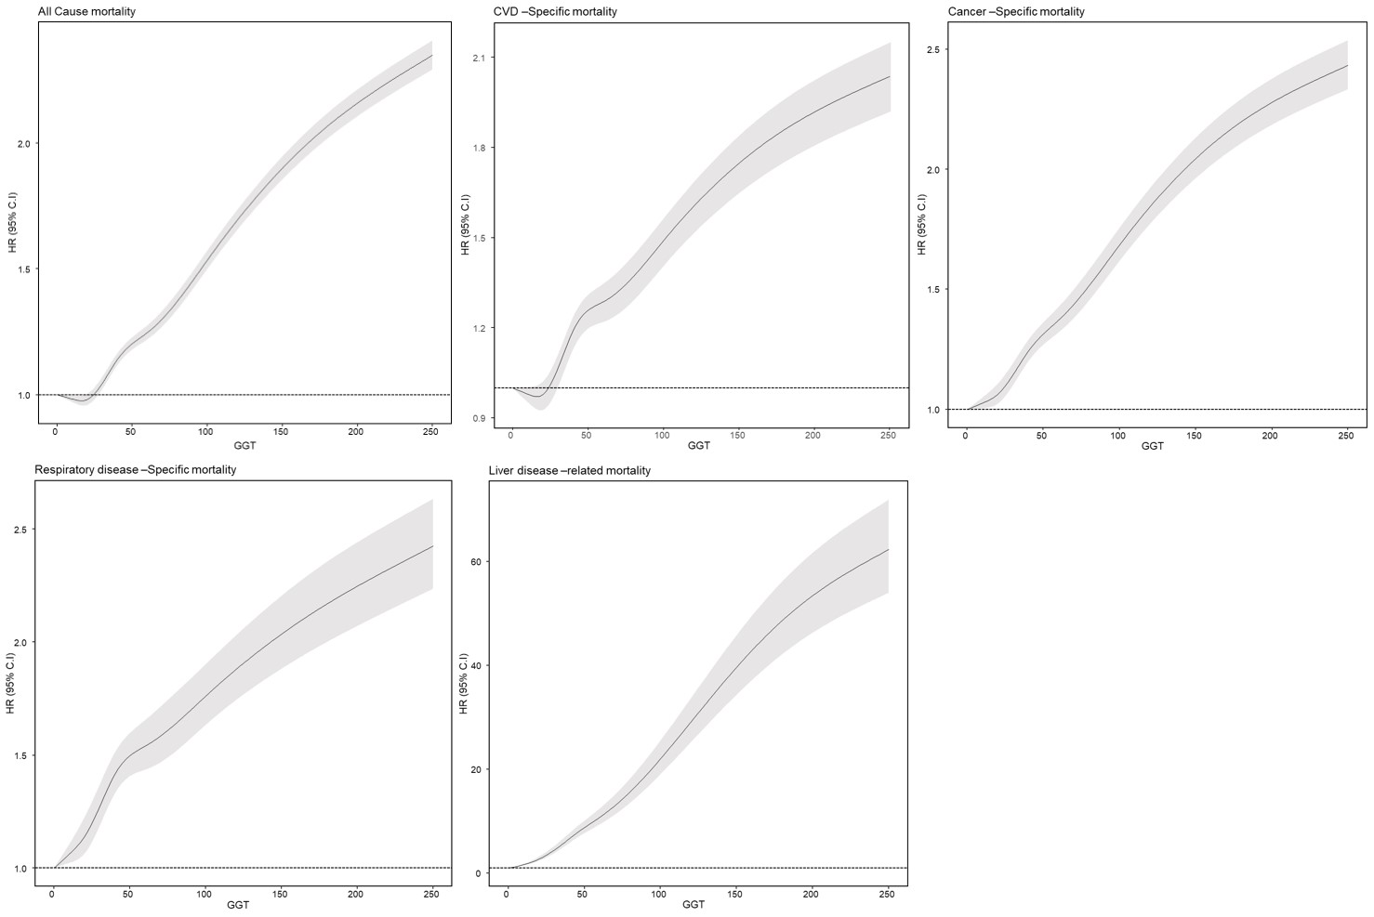
CVD, cardiovascular disease; GGT, gamma-glutamyl transferase
Supplementary Figure S2. Stratification analysis by covariates for association between gamma-glutamyl transferase and all-cause mortality

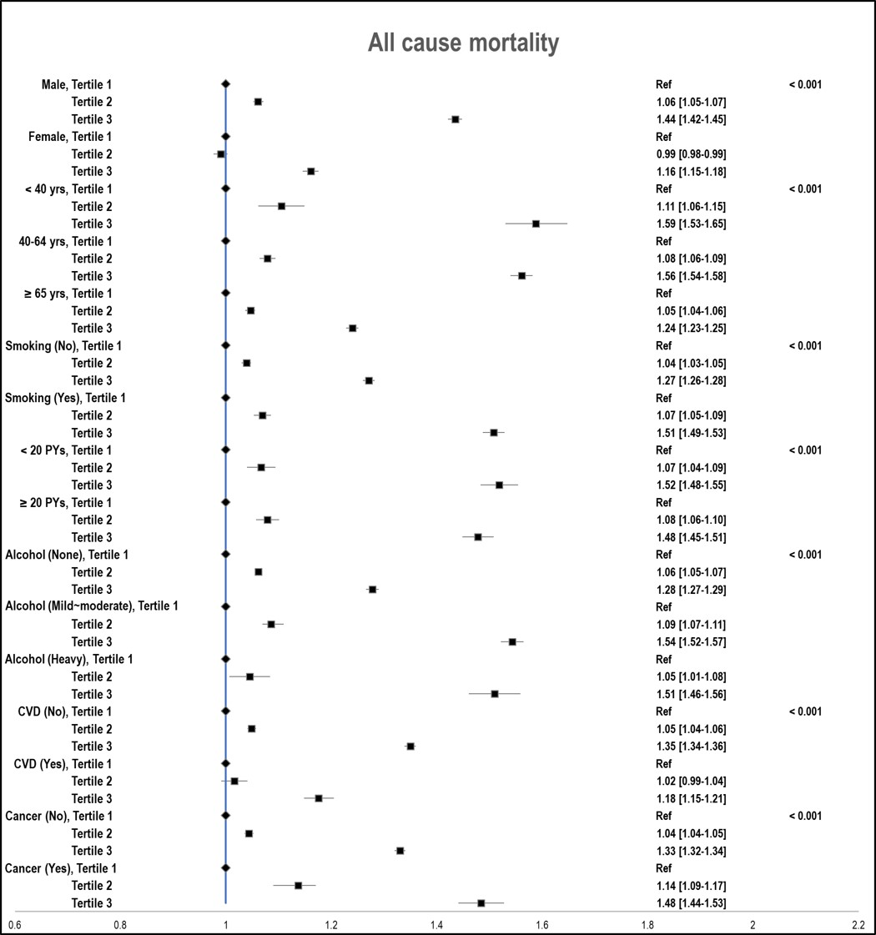
PYs, pack-years, CVD, cardiovascular disease
Supplementary Figure S3. Stratification analysis by covariates for association between gamma-glutamyl transferase and cardiovascular disease-specific mortality
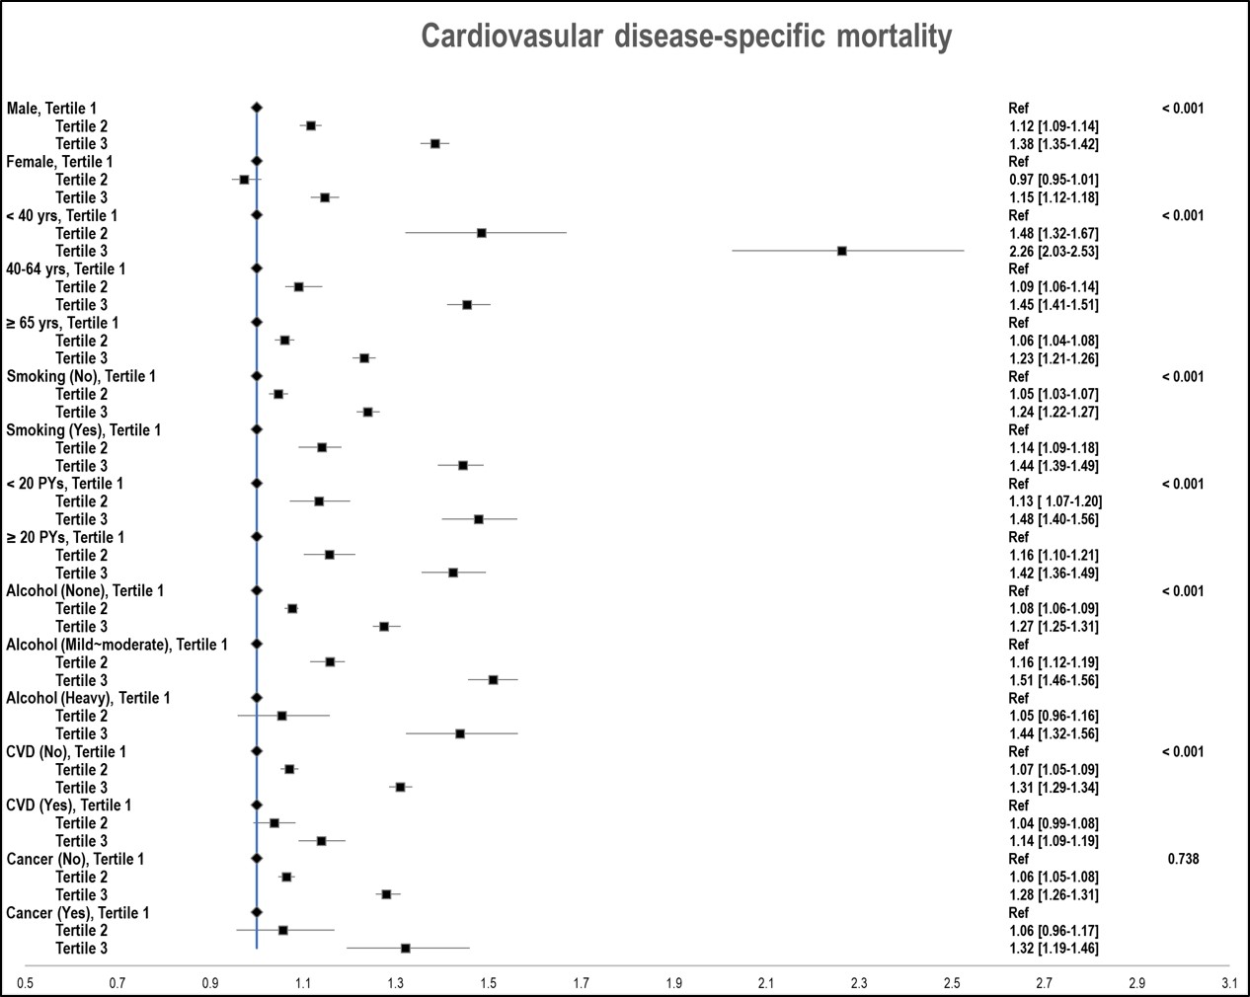
PYs, pack-years, CVD, cardiovascular disease

Supplementary Figure S4. Stratification analysis by covariates for association between gamma-glutamyl transferase and cancer-specific mortality
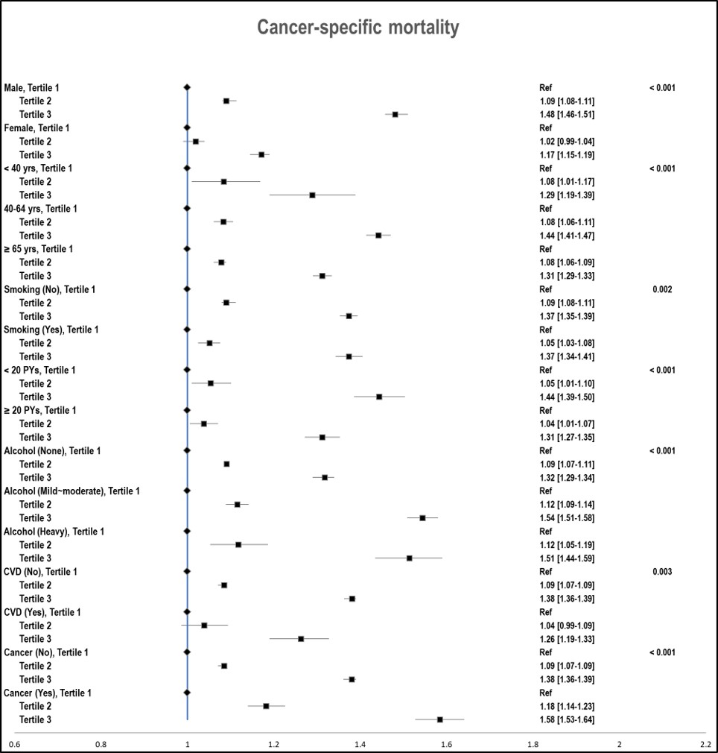
PYs, pack-years, CVD, cardiovascular disease
Supplementary Figure S5. Stratification analysis by covariates for association between gamma-glutamyl transferase and respiratory disease-specific mortality

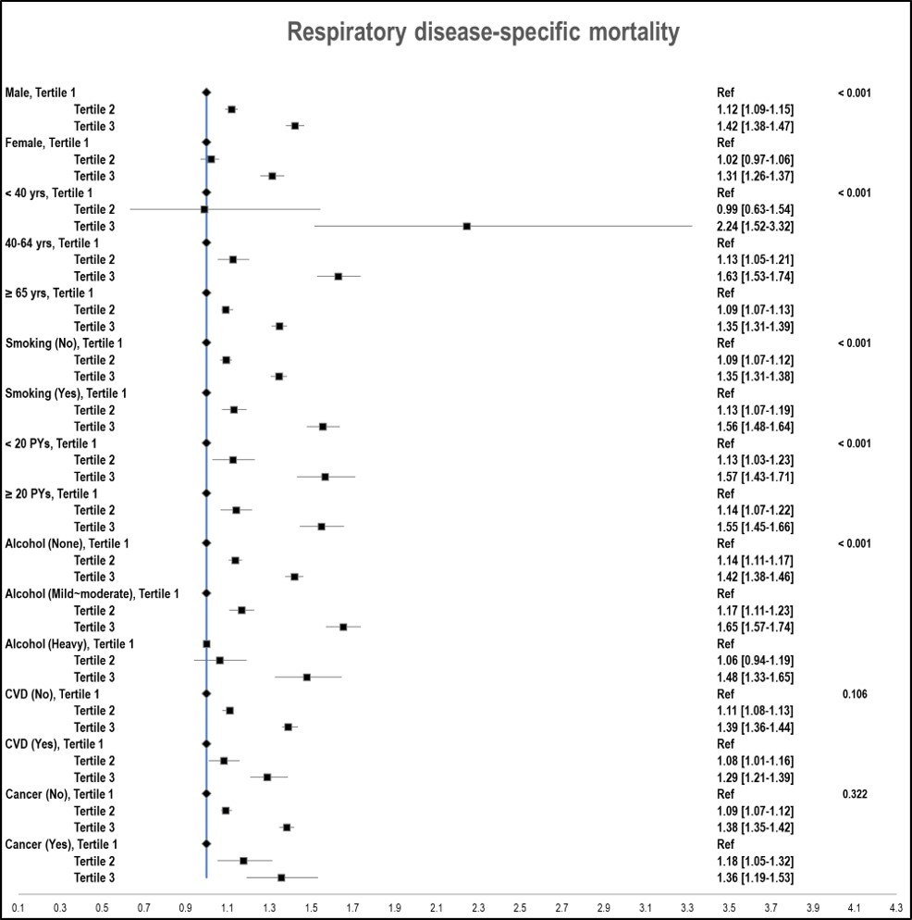
PYs, pack-years, CVD, cardiovascular disease
Supplementary Figure S6. Stratification analysis by covariates for association between gamma-glutamyl transferase and liver disease-specific mortality

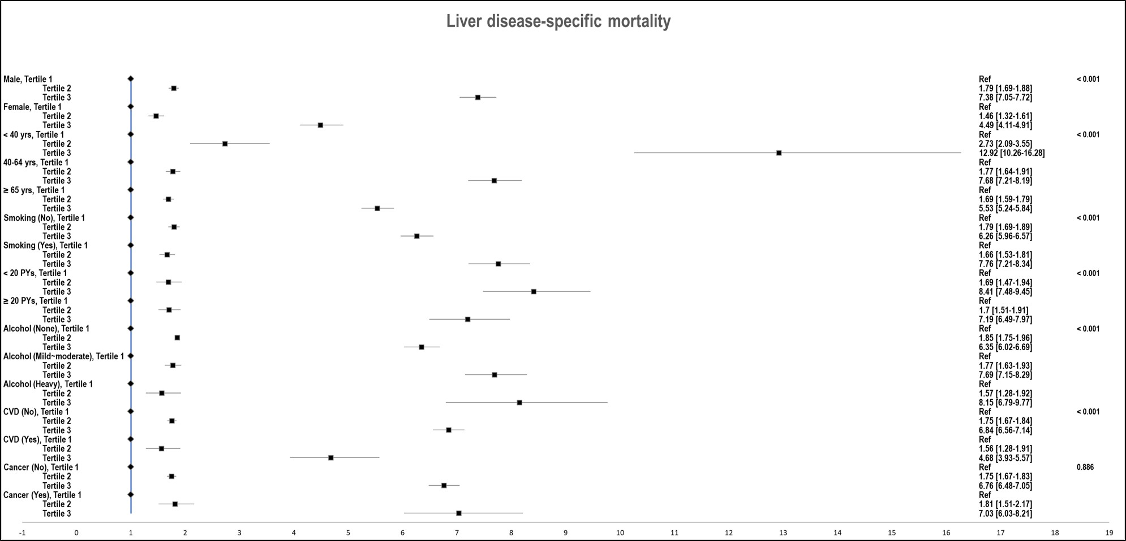
PYs, pack-years, CVD, cardiovascular disease

