SUPPLEMENTARY INFORMATION
Residual ST-segment elevation to predict long-term clinical and CMR-derived outcomes in STEMI
Hector Merenciano-González MD^{1, #}, Víctor Marcos-Garcés MD PhD^{1,2, #}, Jose Gavara PhD^{2,3}, Ana Pedro-Tudela⁴, Maria P. Lopez-Lereu MD PhD⁵, Jose V. Monmeneu MD PhD⁵, Nerea Perez BSc², Cesar Rios-Navarro PhD², Elena De Dios MSc^{4,6}, Ana Gabaldón-Pérez MD¹, Cristina Albiach MD¹, Paolo Racugno MD¹, Clara Bonanad MD PhD^{1,2,4}, Joaquim Canoves MD PhD^{1,2,4}, Francisco J. Chorro MD PhD^{1,2,4,6}, Vicente Bodi MD PhD^{1,2,4,6,*}

#These authors contributed equally.

Author Affiliations:
¹Department of Cardiology, Hospital Clínico Universitario de Valencia, Valencia, Spain.
²Health Research Institute - INCLIVA, Valencia, Spain.
³Center for Biomaterials and Tissue Engineering, Universitat Politècnica de València. Valencia, Spain.
⁴Faculty of Medicine and Odontology, University of Valencia, Valencia, Spain.
⁵Cardiovascular Magnetic Resonance Unit, ASCIRES Biomedical Group, Valencia, Spain.
⁶Centro de Investigación Biomédica en Red de Enfermedades Cardiovasculares (CIBER-CV), Madrid, Spain.

SUPPLEMENTARY TABLES

Supplementary Table S1. Baseline, echocardiographic and ECG characteristics according to 6-month CMR structural parameters.
 |  | Reduced (<40%) LVEF on 6-month CMR |  |  | Large (>30% of LV mass) infarct size on 6-month CMR
 | All patients (n=319) | Yes (n=45) | No (n=274) | p | Yes (n=59) | No (n=260) | p
Baseline characteristics
Age (years) | 58.32±11.74 | 58.87±12.68 | 58.24±11.6 | 0.74 | 57.19±12.33 | 58.58±11.61 | 0.41
Male sex | 261 (81.8) | 39 (86.7) | 222 (81) | 0.41 | 51 (86.4) | 210 (80.8) | 0.36
Smoker | 193 (60.5) | 31 (68.9) | 162 (59.1) | 0.25 | 38 (64.4) | 155 (59.6) | 0.56
Hypertension | 147 (46.1) | 21 (46.7) | 126 (46) | 1 | 28 (47.5) | 119 (45.8) | 0.89
Hypercholesterolemia | 131 (41.1) | 24 (53.3) | 107 (39.1) | 0.08 | 27 (45.8) | 104 (40) | 0.46
Diabetes mellitus | 56 (17.6) | 11 (24.4) | 45 (16.4) | 0.21 | 12 (20.3) | 44 (16.9) | 0.57
Previous CAD | 14 (4.4) | 2 (4.4) | 12 (4.4) | 1 | 3 (5.1) | 11 (4.2) | 0.73
Killip class
I | 276 (86.5) | 34 (75.6) | 242 (88.3) | 0.03 | 45 (76.3) | 231 (88.8) | 0.2
≥II | 43 (13.5) | 11 (24.4) | 32 (11.7) | 0.03 | 14 (23.7) | 29 (11.2) | 0.2
GRACE risk score | 141.04±26.54 | 152.6±29.95 | 139.14±25.5 | 0.002 | 148.22±29.04 | 139.41±25.72 | 0.02
Heart rate (bpm) | 80.87±20.54 | 90.11±22.26 | 79.36±19.88 | 0.001 | 88.88±21.71 | 79.06±19.86 | 0.001
Systolic pressure (mmHg) | 129.49±27.55 | 120.69±23.26 | 130.93±27.96 | 0.02 | 123.2±27.71 | 130.91±27.37 | 0.05
Localization
Anterior | 174 (54.7) | 37 (82.2) | 137 (50.2) | <0.001 | 56 (94.9) | 118 (45.6) | <0.001
Inferior | 119 (37.4) | 5 (11.1) | 114 (41.8) | <0.001 | 3 (5.1) | 116 (44.8) | <0.001
Lateral | 25 (7.9) | 3 (6.7) | 22 (8.1) | <0.001 | 0 | 25 (9.7) | <0.001
Multivessel disease | 76 (23.9) | 18 (40) | 58 (21.2) | 0.01 | 17 (28.8) | 59 (22.8) | 0.32
Time to revascularization (min) | 190 [130-300] | 240 [150-450] | 185 [128-300] | 0.14 | 200 [130-399] | 195 [129-307.5] | 0.98
TIMI flow grade before pPCI
0 | 143 (45) | 22 (48.9) | 121 (44.3) | 0.01 | 31 (52.5) | 112 (43.2) | 0.18
1 | 21 (6.6) | 1 (2.2) | 20 (7.3) | 0.01 | 1 (1.7) | 20 (7.7) | 0.18
2 | 33 (10.4) | 10 (22.2) | 23 (8.4) | 0.01 | 8 (13.6) | 25 (9.7) | 0.18
3 | 121 (38.1) | 12 (26.7) | 109 (39.9) | 0.01 | 19 (32.2) | 102 (39.4) | 0.18
TIMI flow grade after pPCI
0 | 5 (1.6) | 2 (4.4) | 3 (1.1) | 0.002 | 0 | 5 (1.9) | 0.01
1 | 1 (0.3) | 0 | 1 (0.4) | 0.002 | 0 | 1 (0.4) | 0.01
2 | 20 (6.3) | 8 (17.8) | 12 (4.4) | 0.002 | 9 (15.3) | 11 (4.2) | 0.01
3 | 293 (91.8) | 35 (77.8) | 258 (94.2) | 0.002 | 50 (84.7) | 243 (93.5) | 0.01
Medical treatment at discharge
Dual antiplatelet therapy | 299 (93.7) | 40 (88.9) | 259 (94.5) | 0.18 | 55 (93.2) | 244 (93.8) | 0.77
Oral anticoagulation | 35 (11) | 12 (26.7) | 23 (8.4) | 0.001 | 9 (15.3) | 26 (10) | 0.25
Beta blockers | 229 (71.8) | 27 (60) | 202 (73.7) | 0.07 | 39 (66.1) | 190 (73.1) | 0.34
Angiotensin-converting-enzyme inhibitors | 169 (53) | 25 (55.6) | 144 (52.6) | 0.75 | 30 (50.8) | 139 (53.5) | 0.77
Angiotensin receptor blockers | 79 (24.8) | 13 (28.9) | 66 (24.1) | 0.46 | 18 (30.5) | 61 (23.5) | 0.32
Mineralocorticoid receptor antagonist | 34 (10.7) | 12 (26.7) | 22 (8) | 0.001 | 15 (25.4) | 19 (7.3) | <0.001
Statins | 276 (86.5) | 40 (88.9) | 236 (86.1) | 0.81 | 52 (88.1) | 224 (86.2) | 0.83
Diuretics | 39 (12.2) | 14 (31.1) | 25 (9.1) | <0.001 | 13 (22) | 26 (10) | 0.02
Echocardiographic variables
LVEF (%) | 54.67±10.89 | 42.66±8.9 | 57.1±9.59 | <0.001 | 44.1±9.49 | 57.01±9.75 | <0.001
LV end-diastolic volume (mL) | 109.7±34.46 | 119.71±26.51 | 107.06±36.02 | 0.22 | 117.64±30.71 | 107.6±35.35 | 0.34
LV end-systolic volume (mL) | 54.43±21.62 | 70.79±17.54 | 50.11±20.63 | 0.001 | 66.14±19.85 | 51.34±21.17 | 0.02
TAPSE (mm) | 20.98±3.24 | 20.71±3.09 | 21.01±3.28 | 0.82 | 19.93±2.29 | 21.12±3.34 | 0.33
E wave velocity (m/s) | 0.69±0.16 | 0.74±0.19 | 0.69±0.15 | 0.15 | 0.75±0.14 | 0.68±0.16 | 0.14
A wave velocity (m/s) | 0.73±0.18 | 0.67±0.22 | 0.74±0.17 | 0.14 | 0.72±0.23 | 0.74±0.17 | 0.81
Left atrium diameter (mm) | 35 [31-38] | 36 [32-39] | 35 [31-38] | 0.29 | 37 [33-41] | 34 [31-37] | 0.14
ECG variables
Maximum sum-STE (mm) | 11.43±8.22 | 15.9±8.6 | 10.69±7.94 | <0.001 | 15.25±8.25 | 10.56±7.99 | <0.001
Minimum sum-STE (mm) | 2.56±2.93 | 4.46±3.17 | 2.25±2.78 | <0.001 | 4.64±3.55 | 2.01±2.56 | <0.001
Sum-STE before pPCI (mm) | 13.21±10.04 | 16.36±8.36 | 12.79±10.2 | 0.21 | 17.03±8.57 | 12.52±10.17 | 0.08
Sum-STE after pPCI (mm) | 5.37±5.23 | 7.89±4.75 | 5.03±5.22 | 0.05 | 7.47±5.76 | 4.99±5.07 | 0.06
ST resolution (%) | 75.14±26.16 | 64.13±26.75 | 76.94±25.66 | 0.002 | 65.05±22.37 | 77.42±26.45 | 0.001
Q wave (n of leads) | 3 [2-3] | 4 [3-4] | 3 [2-3] | <0.001 | 4 [3-4] | 3 [1-3] | <0.001
Q-STE (n of leads) | 1 [0-2] | 2 [1-3] | 0 [0-2] | 0.002 | 2 [1-3] | 0 [0-2] | <0.001
Q-STE
0-1 leads | 198 (62.1) | 18 (40) | 180 (65.7) | 0.001 | 18 (30.5) | 180 (69.2) | <0.001
≥2 leads | 121 (37.9) | 27 (60) | 94 (34.3) | 0.001 | 41 (69.5) | 80 (30.8) | <0.001

Categorical variables are presented as a number (percentage). Continuous parametric variables are presented as mean ± standard deviation. Continuous non-parametric variables are presented as median [interquartile range].
Abbreviations: bpm= beats per minute. CAD= coronary artery disease. GRACE= Global Registry of Acute Coronary Events. LV= Left ventricular. LVEF= Left ventricular ejection fraction. MACE= major adverse cardiovascular events. pPCI= primary percutaneous coronary intervention. Q-STE= Q wave and residual STE > 1 mm. Sum-STE= sum of ST-segment elevation. TAPSE= Tricuspid annular plane systolic excursion. TIMI= Thrombolysis in Myocardial Infarction.
In patients with atrial fibrillation at the moment of the echocardiography E and A wave velocities were not considered for analyses.

Supplementary Table S2. Predictors of reduced (<40%) LVEF on 6-month CMR.
 | Model 1: Baseline characteristics |  | Model 2: Baseline characteristics + echocardiography |  | Model 3: Baseline characteristics + echocardiography + ECG
Variable | Hazard Ratio [95% CI] | p | Hazard Ratio [95% CI] | p | Hazard Ratio [95% CI] | p
Baseline characteristics
Hypercholesterolemia | 1.31 [0.63-2.73] | 0.46 | ... | ... | ... | ...
Killip class ≥II | 1.37 [0.47-4.04] | 0.57 | ... | ... | ... | ...
GRACE risk score | 1 [0.98-1.02] | 0.93 | ... | ... | ... | ...
Heart rate (bpm) | 1.02 [1-1.04] | 0.02 | 1.03 [1.01-1.05] | 0.001 | 1.03 [1-1.05] | 0.005
Systolic pressure (mmHg) | 0.98 [0.96-0.99] | 0.001 | 0.98 [0.96-0.99] | 0.006 | 0.98 [0.96-0.99] | 0.007
Inferior infarction (vs anterior infarction) | 0.18 [0.06-0.5] | 0.001 | 0.28 [0.07-2.1] | 0.07 | ... | ...
Multivessel disease | 3.39 [1.62-7.12] | 0.001 | 3.81 [1.57-9.26] | 0.003 | 3.78 [1.54-9.27] | 0.004
TIMI flow grade before pPCI <3 | 1.55 [0.27-8.87] | 0.62 | ... | ... | ... | ...
TIMI flow grade 0 after pPCI | 5.45 [1.86-15.98] | 0.002 | 4.22 [0.98-17.34] | 0.06 | ... | ...
Oral anticoagulation | 1.89 [0.68-5.28] | 0.22 | ... | ... | ... | ...
Beta blockers | 0.47 [0.22-1.04] | 0.06 | ... | ... | ... | ...
Mineralocorticoid receptor antagonist | 2.66 [1.13-6.25] | 0.03 | 1.61 [0.56-4.63] | 0.38 | ... | ...
Diuretics | 2.63 [1.06-6.56] | 0.04 | 2.33 [0.72-7.57] | 0.16 | ... | ...
Echocardiographic variables
LVEF | ... | ... | 0.86 [0.82-0.9] | <0.001 | 0.86 [0.82-0.91] | <0.001
LV end-systolic volume (mL) | ... | ... | ...* | ...* | ...* | ...*
ECG variables
Maximum sum-STE (mm) | ... | ... | ... | ... | 0.99 [0.85-1.16] | 0.91
Minimum sum-STE (mm) | ... | ... | ... | ... | 1.08 [0.72-1.62] | 0.73
Sum-STE after pPCI (mm) | ... | ... | ... | ... | 1.04 [0.83-1.29] | 0.76
ST resolution (%) | ... | ... | ... | ... | 1.01 [0.96-1.07] | 0.66
Q wave (n of leads) | ... | ... | ... | ... | 1.46 [0.87-2.46] | 0.17
Q-STE (n of leads) | ... | ... | ... | ... | 1.36 [1.02-1.82] | 0.04

Abbreviations: bpm= beats per minute. CI= confidence interval. CMR= cardiac magnetic resonance. GRACE= Global Registry of Acute Coronary Events. LV= Left ventricular. LVEF= Left ventricular ejection fraction. pPCI= primary percutaneous coronary intervention. Q-STE= Q wave and residual STE > 1 mm. Sum-STE= sum of ST-segment elevation. TIMI= Thrombolysis in Myocardial Infarction.
“Model 1: Baseline characteristics” refers to the 13 baseline variables showing an association (p-value<0.1 in Supplemental Table 1) with the occurrence of reduced (<40%) LVEF on 6-month CMR.
“Model 2: Baseline characteristics + echocardiography” includes variables of Model 1 plus echocardiographic indices showing an association with reduced (<40%) LVEF on 6-month CMR (p-value<0.1 in Supplemental Table 1). *LV end-systolic volume (mL) was removed from multivariable analysis due to excessive collinearity (variance inflation factor>5 and tolerance statistic<0.2) with LVEF.
“Model 3: Baseline characteristics + echocardiography + ECG” includes variables of Model 2 plus ECG indices showing an association with reduced (<40%) LVEF on 6-month CMR (p-value<0.1 in Supplemental Table 1).

Supplementary Table S3. Predictors of large (>30% of LV mass) infarct size on 6-month CMR.
 | Model 1: Baseline characteristics |  | Model 2: Baseline characteristics + echocardiography |  | Model 3: Baseline characteristics + echocardiography + ECG
Variable | Hazard Ratio [95% CI] | p | Hazard Ratio [95% CI] | p | Hazard Ratio [95% CI] | p
Baseline characteristics
GRACE risk score | 1 [0.99-1.02] | 0.6 | ... | ... | ... | ...
Heart rate (bpm) | 1.02 [0.99-1.03] | 0.06 | ... | ... | ... | ...
Systolic pressure (mmHg) | 0.98 [0.97-0.99] | 0.003 | 0.98 [0.97-1] | 0.04 | 0.87 [0.93-1.01] | 0.13
Inferior infarction (vs anterior infarction) | 0.05 [0.02-0.18] | <0.001 | 0.04 [0-0.28] | 0.002 | 0 [0-0] | 1
TIMI flow grade 0 after pPCI | 3.66 [1.21-11.06] | 0.02 | 1.71 [0.41-7.23] | 0.47 | ... | ...
Mineralocorticoid receptor antagonist | 2.49 [1.07-5.78] | 0.04 | 1.77 [0.61-5.15] | 0.29 | ... | ...
Diuretics | 2.54 [1.22-5.32] | 0.01 | 1.59 [0.5-5.02] | 0.43 | ... | ...
Echocardiographic variables
LVEF | ... | ... | 0.9 [0.86-0.94] | <0.001 | 0.88 [0.84-0.92] | <0.001
LV end-systolic volume (mL) | ... | ... | ...* | ...* | ...* | ...*
ECG variables
Maximum sum-STE (mm) | ... | ... | ... | ... | 1.01 [0.81-1.26] | 0.95
Minimum sum-STE (mm) | ... | ... | ... | ... | 1.64 [0.92-2.9] | 0.09
Sum-STE before pPCI (mm) | ... | ... | ... | ... | 0.89 [0.69-1.13] | 0.33
Sum-STE after pPCI (mm) | ... | ... | ... | ... | 1.08 [0.82-1.41] | 0.58
ST resolution (%) | ... | ... | ... | ... | 1.09 [0.99-1.19] | 0.09
Q wave (n of leads) | ... | ... | ... | ... | 1.54 [0.83-2.86] | 0.17
Q-STE (n of leads) | ... | ... | ... | ... | 1.43 [1.11-1.85] | 0.006

Abbreviations: bpm= beats per minute. CI= confidence interval. CMR= cardiac magnetic resonance. GRACE= Global Registry of Acute Coronary Events. LV= Left ventricular. LVEF= Left ventricular ejection fraction. pPCI= primary percutaneous coronary intervention. Sum-STE= summatory of ST-segment elevation. Q-STE= Q wave and residual STE > 1 mm. TIMI= Thrombolysis in Myocardial Infarction.
“Model 1: Baseline characteristics” refers to the 7 baseline variables showing an association (p-value<0.1 in Supplemental Table 1) with the occurrence of large (>30% of LV mass) infarct size on 6-month CMR.
“Model 2: Baseline characteristics + echocardiography” includes variables of Model 1 plus echocardiographic indices showing an association with large (>30% of LV mass) infarct size on 6-month CMR (p-value<0.1 in Supplemental Table 1). *LV end-systolic volume (mL) was removed from multivariable analysis due to excessive collinearity (variance inflation factor>5 and tolerance statistic<0.2) with LVEF.
“Model 3: Baseline characteristics + echocardiography + ECG” includes variables of Model 2 plus ECG indices showing an association with large (>30% of LV mass) infarct size on 6-month CMR (p-value<0.1 in Supplemental Table 1).

SUPPLEMENTARY FIGURES
Supplementary Figure S1. Flowchart of patients included in the study.
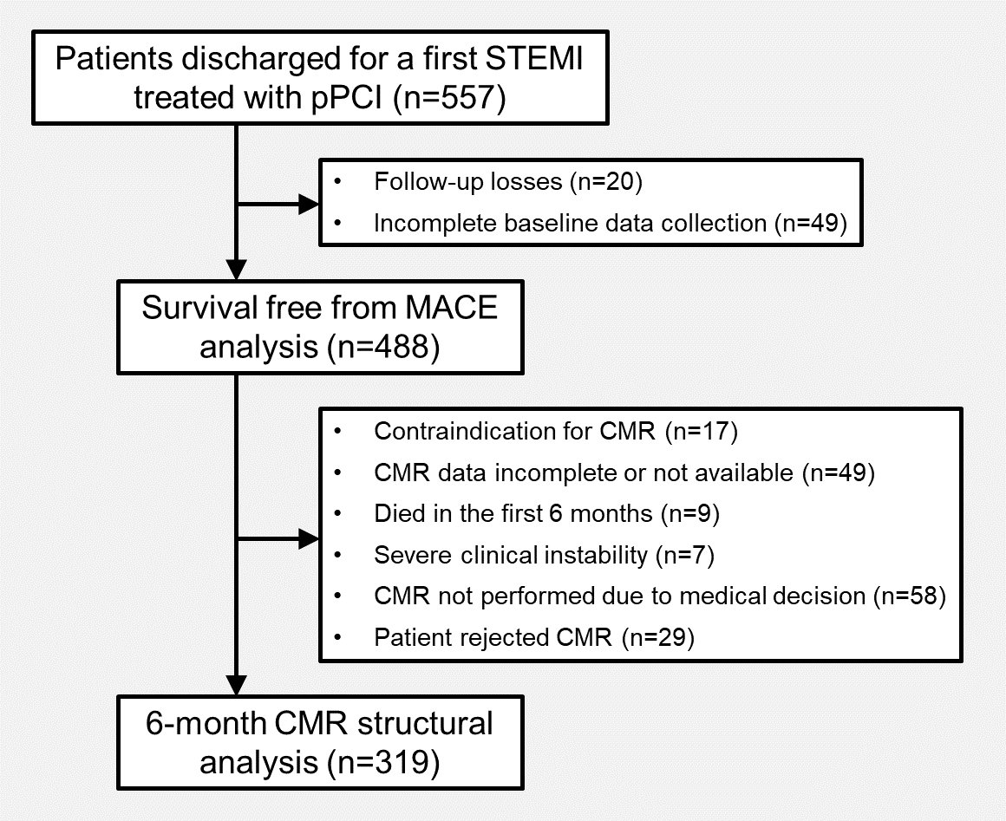
Abbreviations: CMR= cardiac magnetic resonance. MACE= major adverse cardiovascular events. pPCI= primary percutaneous coronary intervention. STEMI= ST-segment elevation myocardial infarction.

Supplementary Figure S2. Structural changes at 6-month CMR according to Q-STE categories and infarct location (anterior vs. non-anterior). Variables are presented as mean ± standard deviation. * = p<0.001.
Abbreviations: CMR= cardiac magnetic resonance. IS= infarct size. LV= left ventricular. LVEF= left ventricular ejection fraction. LVEDVI= left ventricular end-diastolic volume index. LVESVI= left ventricular end-systolic volume index. Q-STE= Q wave and residual STE > 1 mm.
