An ethological analysis of close-contact inter-cat interactions determining if cats are playing, fighting, or something in between
Supplementary Information

Supplementary Figure 1 Parallel analysis scree plot
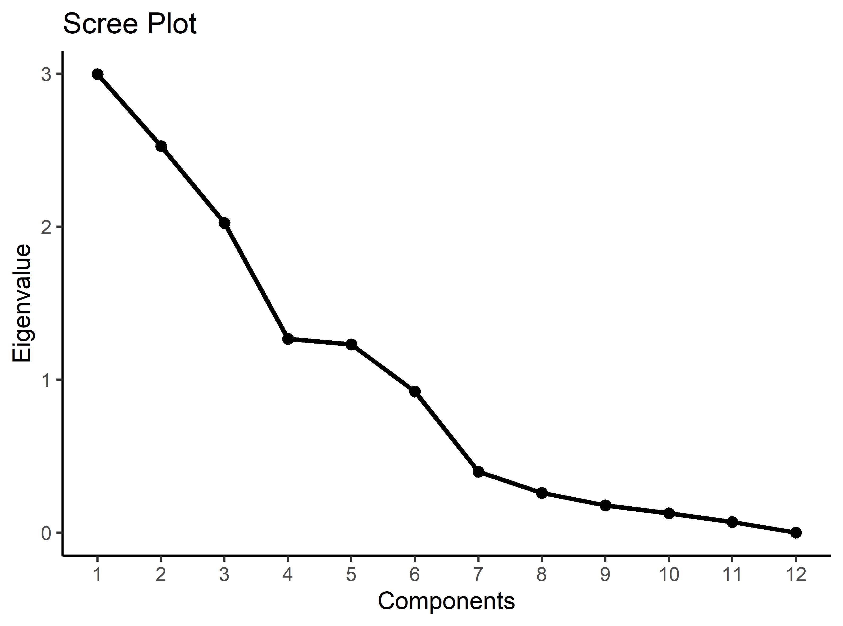

Supplementary Table 1 Mean factor scores of the clusters evaluated at the lower level (cut at 2,5). Low standard deviations suggesting importance of the mean score are highlighted in bold.
 |  | Wrestling vs. inactivity | Vocalising | Chasing | Non-interacting | Recurring interactivity | Prolonged interactivity
A1 | Mean | 0.258 | -0.052 | 0.041 | -0.085 | 0.097 | 0.073
 | SD | 0.188 | 0.081 | 0.039 | 0.090 | 0.099 | 0.125
A2 | Mean | 0.697 | -0.194 | 0.037 | -0.152 | -0.128 | -0.111
 | SD | 0.096 | 0.036 | 0.030 | 0.082 | 0.075 | 0.115
B1 | Mean | -0.101 | -0.012 | 0.016 | 0.344 | 0.153 | 0.128
 | SD | 0.208 | 0.091 | 0.057 | 0.134 | 0.124 | 0.154
B2 | Mean | -0.012 | 0.129 | 0.045 | -0.090 | 0.171 | 0.513
 | SD | 0.169 | 0.234 | 0.041 | 0.075 | 0.083 | 0.187
C1 | Mean | -0.402 | 0.287 | 0.004 | -0.088 | 0.283 | -0.112
 | SD | 0.191 | 0.152 | 0.085 | 0.123 | 0.087 | 0.223
C2 | Mean | -0.674 | 1.026 | -0.041 | -0.255 | 0.284 | -0.149
 | SD | 0.172 | 0.217 | 0.062 | 0.044 | 0.116 | 0.253

Supplementary Table 2 ANOVA and Tukey pairwise comparisons between the three clusters, separately for each factor.
 |  | Wrestling vs. inactivity | Vocalising | Chasing | Non-interacting | Recurring Interactivity | Prolonged Interactivity
A | M | 0.395 | -0.097 | 0.040 | -0.106 | 0.026 | 0.015
A | SD | 0.263 | 0.096 | 0.036 | 0.093 | 0.139 | 0.148
B | M | -0.051 | 0.067 | 0.032 | 0.101 | 0.163 | 0.344
B | SD | 0.191 | 0.197 | 0.051 | 0.241 | 0.102 | 0.258
C | M | -0.478 | 0.494 | -0.009 | -0.135 | 0.283 | -0.122
C | SD | 0.222 | 0.375 | 0.082 | 0.131 | 0.095 | 0.230
 | F(2, 207) | 267.62 | 111.96 | 14.17 | 41.48 | 91.73 | 80.39
 | p | < .001 | < .001 | < .001 | < .001 | < .001 | < .001
B vs A | M_{B} - M_{A} | -0.45 | 0.16 | -0.01 | 0.21 | 0.14 | 0.33
B vs A |  | [-0.54, -0.35] | [0.07, 0.26] | [-0.03, 0.02] | [0.14, 0.27] | [0.09, 0.18] | [0.24, 0.41]
B vs A | p _{(Tukey adj.)} | < .001 | < .001 | 0.70 | < .001 | < .001 | < .001
C vs A | M_{C} - M_{A} | -0.87 | 0.59 | -0.05 | -0.03 | 0.26 | -0.14
C vs A |  | [-0.96, -0.78] | [0.50, 0.68] | [-0.07, -0.03] | [-0.09, 0.03] | [0.21, 0.30] | [-0.22, -0.06]
C vs A | p _{(Tukey adj.)} | < .001 | < .001 | < .001 | 0.51 | < .001 | < .001
C vs B | M_{C} - M_{B} | -0.43 | 0.43 | -0.04 | -0.24 | 0.12 | -0.47
C vs B |  | [-0.52, -0.33] | [0.32, 0.53] | [-0.07, -0.02] | [-0.30, -0.17] | [0.07, 0.17] | [-0.55, -0.38]
C vs B | p _{(Tukey adj.)} | < .001 | < .001 | < .001 | < .001 | < .001 | < .001

Supplementary Table 3 T-test (Welch test) comparisons between subclusters: A1 vs A2, B1 vs B2 and C1 vs C2.
 |  | Wrestling vs. inactivity | Vocalising | Chasing | Non-interacting | Recurring Interactivity | Prolonged Interactivity
A1 | M | 0.26 | -0.05 | 0.04 | -0.09 | 0.10 | 0.07
A1 | SD | 0.19 | 0.08 | 0.04 | 0.09 | 0.10 | 0.12
A2 | M | 0.70 | -0.19 | 0.04 | -0.15 | -0.13 | -0.11
A2 | SD | 0.10 | 0.04 | 0.03 | 0.08 | 0.08 | 0.11
 | M₂ - M₁ | 0.44 | -0.14 | 0.00 | -0.07 | -0.22 | -0.18
 |  | [-0.50, -0.38] | [0.12, 0.17] | [-0.01, 0.02] | [0.03, 0.11] | [0.19, 0.26] | [0.13, 0.24]
 | t | -14.06 | 11.04 | 0.49 | 3.36 | 11.41 | 6.60
 | df | 79.90 | 80.99 | 62.59 | 52.94 | 62.79 | 52.24
 | p | <.001 | <.001 | .627 | .001 | <.001 | <.001
B1 | M | -0.10 | -0.01 | 0.02 | 0.34 | 0.15 | 0.13
B1 | SD | 0.21 | 0.09 | 0.06 | 0.13 | 0.12 | 0.15
B2 | M | -0.01 | 0.13 | 0.04 | -0.09 | 0.17 | 0.51
B2 | SD | 0.17 | 0.23 | 0.04 | 0.08 | 0.08 | 0.19
 | M₂ - M₁ | 0.09 | 0.14 | 0.03 | -0.43 | 0.02 | 0.38
 |  | [-.019, 0.01] | [-0.23, -0.05] | [-0.06, 0.00] | [0.37, 0.49] | [-0.08, 0.04] | [-0.47, -0.30]
 | t | -1.78 | -3.17 | -2.15 | 14.72 | -0.66 | -8.66
 | df | 47.62 | 43.43 | 43.97 | 37.12 | 41.61 | 56.84
 | p | .081 | .003 | .037 | <.001 | .510 | <.001
C1 | M | -0.40 | 0.29 | 0.00 | -0.09 | 0.28 | -0.11
C1 | SD | 0.19 | 0.15 | 0.09 | 0.12 | 0.09 | 0.22
C2 | M | -0.67 | 1.03 | -0.04 | -0.25 | 0.28 | -0.15
C2 | SD | 0.17 | 0.22 | 0.06 | 0.04 | 0.12 | 0.25
 | M₂ - M₁ | -0.27 | 0.74 | -0.05 | -0.17 | 0.00 | -0.04
 |  | [0.17, 0.37] | [-0.85, -0.63] | [0.01, 0.08] | [0.13, 0.21] | [-0.06, 0.06] | [-0.10, 0.17]
 | t | 5.67 | -13.61 | 2.40 | 8.22 | -0.06 | 0.57
 | df | 36.23 | 25.16 | 44.62 | 65.80 | 26.27 | 29.45
 | p | <.001 | <.001 | .021 | <.001 | .954 | .572
Supplementary Table 4 Pearson chi-square tests for categorical variables of lower level hierarchical analysis´s clusters – L3, 2 d.f., * p≤0.05, ** p≤0.01, *** p≤0.001
L3 |  |  | A1 | A2 | B1 | B2 | C1 | C2 | Results (χ²,p value)
Kittens | Kittens | Observed (% of group) | 15 (26.3%) | 10 (38.5%) | 9 (34.6%) | 2 (6.1%) | 2 (4.1%) | 0 | χ2=28.578
Kittens | Kittens | Expected | 10.3 | 4.7 | 4.7 | 6.0 | 8.9 | 3.4 | χ2=28.578
Kittens | Kittens | Standardised residual | 1.89 | 2.88 | 2.34 | -1.96 | -2.91 | -2.15 | χ2=28.578
Kittens | Kittens | p value on Standardised residual | 0.0589 | 0.0040** | 0.0194* | 0.0505 | 0.0036** | 0.0317* | χ2=28.578
Kittens | Adults | Observed | 42 (73.7%) | 16 (61.5%) | 17 (65.4%) | 31 (93.9%) | 47 (95.9%) | 19 (100%) | p≤0.001
Kittens | Adults | Expected | 46.7 | 21.3 | 21,3 | 27,0 | 40,1 | 15,6 | p≤0.001
Kittens | Adults | Standardised residual | -1.89 | -2.88 | -2.34 | 1.96 | 2.91 | 2.15 | p≤0.001
Kittens | Adults | p value on Standardised residual | 0.0589 | 0.0040** | 0.0194* | 0.0505 | 0.0036** | 0.0317* | p≤0.001
Cats in original dyads | In dyad | Observed | 44 (77.2%) | 22 (84.6%) | 10 (38.5%) | 14 (42.4%) | 24 (49.0%) | 8 (42.1%) | χ2=27.165
Cats in original dyads | In dyad | Expected | 33.1 | 15.1 | 15.1 | 19.2 | 28.5 | 11.0 | χ2=27.165
Cats in original dyads | In dyad | Standardised residual | 3.42 | 2.93 | -2.17 | -1.99 | -1.48 | -1.48 | χ2=27.165
Cats in original dyads | In dyad | p value on Standardised residual | 0.0006*** | 0.0034** | 0.0302** | 0.0469* | 0.1397 | 0.1386 | χ2=27.165
Cats in original dyads | Not in dyad | Observed | 13 (22.8%) | 4  (15.4%) | 16 (61.5%) | 19 (57.6%) | 25 (51.0%) | 11 (57.9%) | p≤0.001
Cats in original dyads | Not in dyad | Expected | 23.9 | 10.9 | 10.9 | 13.8 | 20.5 | 8.0 | p≤0.001
Cats in original dyads | Not in dyad | Standardised residual | -3.42 | -2.93 | 2.17 | 1.99 | 1.48 | 1.48 | p≤0.001
Cats in original dyads | Not in dyad | p value on Standardised residual | 0.0006*** | 0.0034** | 0.0302** | 0.0469* | 0.1397 | 0.1386 | p≤0.001
Playful vs. Intermediate vs. Agonistic interaction | Playful | Observed | 49 (86.0%) | 20 (76.9%) | 20 (76.9%) | 14 (42.4%) | 15 (30.6%) | 0 | χ2=101.02
Playful vs. Intermediate vs. Agonistic interaction | Playful | Expected | 32.0 | 14.6 | 14.6 | 18.5 | 27.5 | 10.7
Playful vs. Intermediate vs. Agonistic interaction | Playful | Standardised residual | 5.31 | 2.28 | 2.28 | -1.74 | -4.12 | -5.18
Playful vs. Intermediate vs. Agonistic interaction | Playful | p value on Standardised residual | 1.108468e-07*** | 0.0228* | 0.0228* | 0.0825 | 3.765014e-05*** | 2.263668e-07***
Playful vs. Intermediate vs. Agonistic interaction | Intermediate | Observed | 5 (8.8%) | 2 (7.7%) | 5 (19.2%) | 10 (30.3%) | 10 (20.4%) | 0
Playful vs. Intermediate vs. Agonistic interaction | Intermediate | Expected | 8.7 | 4.0 | 4.0 | 5.0 | 7.5 | 2.9
Playful vs. Intermediate vs. Agonistic interaction | Intermediate | Standardised residual | -1.59 | -1.14 | 0.61 | 2.62 | 1.15 | -1.94 | p≤0.001
Playful vs. Intermediate vs. Agonistic interaction | Intermediate | p value on Standardised residual | 0.1112 | 0.2537 | 0.5451 | 0.0087** | 0.2501 | 0.0526
Playful vs. Intermediate vs. Agonistic interaction | Agonistic | Observed | 3 (5.3%) | 4 (15.4%) | 1 (3.8%) | 9 (27.3%) | 24 (49.0%) | 19 (100%)
Playful vs. Intermediate vs. Agonistic interaction | Agonistic | Expected | 16.3 | 7.4 | 7.4 | 9.4 | 14.0 | 5.4
Playful vs. Intermediate vs. Agonistic interaction | Agonistic | Standardised residual | -4.56 | -1.59 | -2.98 | -0.18 | 3.61 | 7.23
Playful vs. Intermediate vs. Agonistic interaction | Agonistic | p value on Standardised residual | 5.027911e-06*** | 0.1118 | 0.0029** | 0.8572 | 0.0003*** | 4.949374e-13***
Total (N) |  |  | 57 | 26 | 26 | 33 | 49 | 19

