Molecular and Metabolic Alterations of 2,3-Dihydroquinazolin-4(1H)-one Derivatives in Prostate Cancer Cell Lines
Lina A. Dahabiyeh^{1*}, Wafa Hourani², Wesam Darwish¹, Farah Hudaib³, Bashaer Abu-Irmaileh⁴, Pran Kishore Deb², Katharigatta N. Venugopala^{5,6}, Viresh Mohanlall⁶, Rana Abu-Dahab⁷, Mohammad H. Semreen⁸​, Yasser Bustanji⁹

¹Department of Pharmaceutical Sciences, School of Pharmacy, The University of Jordan, Amman, 11942, Jordan
²Department of Pharmaceutical Sciences, Faculty of Pharmacy, Philadelphia University, Amman 19392, Jordan
³Depatment of Pharmaceutical Chemistry, School of Pharmaceutical Sciences, the Hashemite University, Zarqa, 13133, Jordan
⁴Hamdi Mango Center for Scientific Research, The University of Jordan, 11942 Amman, Jordan
⁵Department of Pharmaceutical Sciences, College of Clinical Pharmacy, King Faisal University, Al-Ahsa 31982, Saudi Arabia
⁶Department of Biotechnology and Food Science, Faculty of Applied Sciences, Durban University of Technology, Durban 4000, South Africa
⁷Department of Biopharmaceutics and Clinical Pharmacy, School of Pharmacy, The University of Jordan, Amman 11942, Jordan
⁸Department of Medicinal Chemistry, College of Pharmacy, University of Sharjah, Sharjah 27272, UAE
⁹Department of Basic Medical Sciences, College of Medicine, University of Sharjah, Sharjah 27272, UAE

*Correspondence
Lina A. Dahabiyeh
Department of Pharmaceutical Sciences, School of Pharmacy, The University of Jordan
Queen Rania St, Amman 11942, Jordan.
Telephone: 00962 6 5355000 ext. 23304
Email: l.dahabiyeh@ju.edu.jo

List of Supplementary Figures

 | 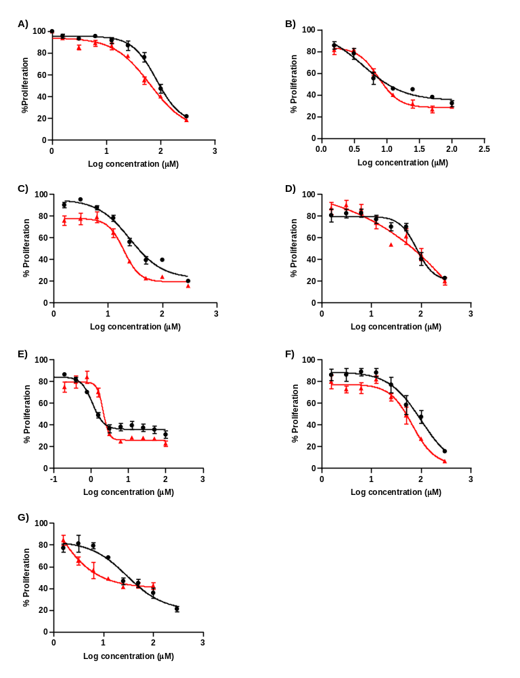
 | Figure S1: Dose-response curves of the seven derivatives against PC3 (black) and DU450 (Red) cell lines. A, B, C, D, E, F, and G refer to compounds 1, 2, 3, 4, 5, 6, and 7 as indicated in Table 1. Each concentration point represents the average of three experimental replicates.
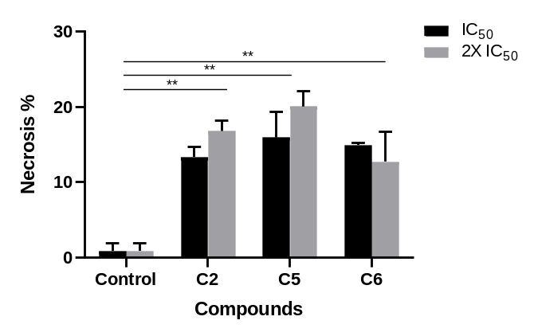
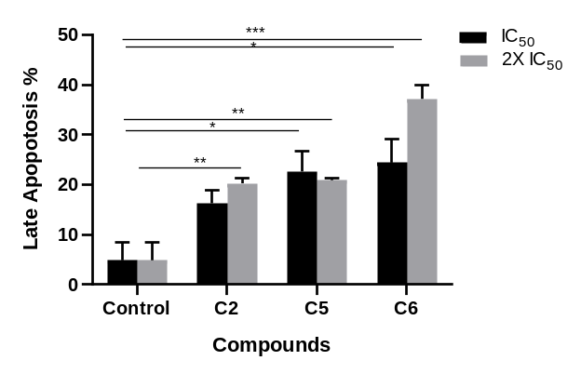 |  | 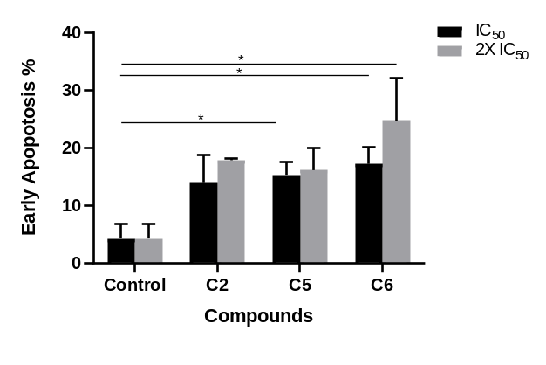
Figure S2. Dihydroquinazolins (C2, C5, and C6) induced apoptosis and necrosis in DU145 cells. Data presented as mean% of cells ± SEM in each group of necrotic cells (A), cells in late apoptosis (B), and cells in early apoptosis (C). ANOVA test followed by Tukey’s test was performed. * P-value ≤ 0.05, ** P-value ≤ 0.01, *** P-value ≤ 0.001.

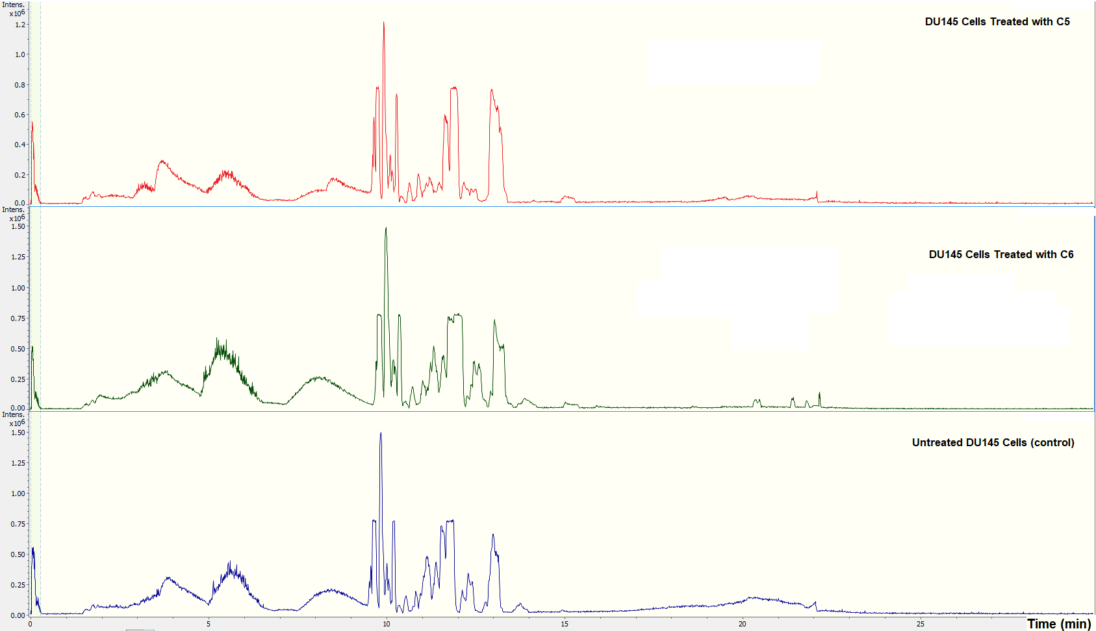
Figure S3. Representative total ion chromatograms (TIC) of LC-MS/MS metabolomics study. TIC from DU145 cells treated with C5, C6 and untreated controls are presented in red, green and blue respectively.

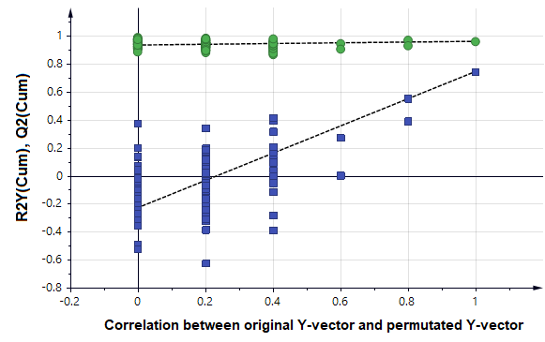
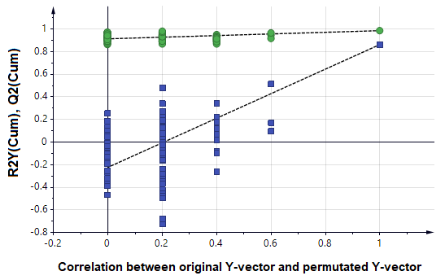
Figure S4. Permutation test for the validation of the OPLS-DA model generated from the binary comparison between (A) C5 treated DU145 group and control (untreated) group, and (B) C6 treated DU145 group and control (untreated) group. Q² (blue squares) and R²Y (green circles). Values from the permuted analysis models (left- side) should be less than the initial generated model values (right- corner).

