Air quality, meteorological variability and pediatric respiratory syncytial virus infections in Singapore
Meng Han Lee^{a+}, Diyar Mailepessov^{a+}, Khairunnisa Yahya^{b}, Liat Hui Loo^{c}, Matthias Maiwald^{c,d,e} and Joel Aik^{a,f}

Appendix

Table 1: Pearson correlation coefficients for environmental factors
 | MaxT | AH | PM_{2.5} | PM₁₀ | O₃ | NO₂ | SO₂ | CO
MaxT | 1 | 0.13 | 0.15 | 0.17 | 0.25 | 0.05 | 0.07 | 0.03
AH |  | 1 | -0.01 | -0.05 | -0.38 | 0.38 | 0.18 | 0.17
PM_{2.5} |  |  | 1 | 0.98 | 0.30 | 0.30 | 0.20 | 0.77
PM₁₀ |  |  |  | 1 | 0.36 | 0.26 | 0.14 | 0.76
O₃ |  |  |  |  | 1 | -0.18 | -0.16 | 0.07
NO₂ |  |  |  |  |  | 1 | 0.56 | 0.48
SO₂ |  |  |  |  |  |  | 1 | 0.14
CO |  |  |  |  |  |  |  | 1

Table 2: Generalized variance inflation factors for factors in final PM_{2.5} model.
Covariate | GVIF | df | GVIF^(1/2*Df)
MaxT | 4.28 | 15 | 1.05
AH | 8.45 | 15 | 1.07
PM_{2.5} | 6.26 | 15 | 1.06
SO₂ | 22.63 | 15 | 1.11

Table 3: Generalized variance inflation factors for factors in final PM₁₀ model.
Covariate | GVIF | df | GVIF^(1/2*Df)
MaxT | 4.65 | 15 | 1.05
AH | 8.30 | 15 | 1.07
PM₁₀ | 5.43 | 15 | 1.06
SO₂ | 19.74 | 15 | 1.10

Table 4: Generalized variance inflation factors for factors in final CO model.
Covariate | GVIF | df | GVIF^(1/2*Df)
MaxT | 3.78 | 15 | 1.05
AH | 9.03 | 15 | 1.08
CO | 5.81 | 15 | 1.07
SO₂ | 18.01 | 15 | 1.10

Note: GVIF – generalized variance inflation factor, df – degrees of freedom.

Table 5: Adjusted associations between public holidays and day-of-week with RSV infections in Singapore from PM₁₀ model, 2009 to 2019
Variable | β coefficient | RR | 95% CI | p-value  (Wald test) | LRT  p-value
Seasonal variation of RSV infections
12-monthly |  |  |  |  | <0.001
Sine function | -0.24 | – | -0.29 to -0.19 | <0.001
Cosine function | -0.62 | – | -0.68 to -0.56 | <0.001
6-monthly |  |  |  |  | <0.001
Sine function | -0.03 | – | -0.06 to 0.01 | 0.206
Cosine function | 0.07 | – | 0.04 to 0.10 | <0.001
4-monthly |  |  |  |  | <0.001
Sine function | 0.04 | – | 0.02 to 0.07 | 0.002
Cosine function | 0.04 | – | 0.01 to 0.06 | 0.008
Long-term trend of RSV infections
Linear function | 0.00* | 1.00* | 1.00 to 1.00 | <0.001
Quadratic function | 0.00* | 1.00* | 1.00 to 1.00 | <0.001
Cubic function | 0.00* | 1.00* | 1.00 to 1.00 | <0.001
Day-of-week
Monday | Referent
Tuesday | -0.09 | 0.92 | 0.86 to 0.97 | 0.005
Wednesday | -0.15 | 0.86 | 0.81 to 0.92 | <0.001
Thursday | -0.22 | 0.80 | 0.75 to 0.86 | <0.001
Friday | -0.23 | 0.79 | 0.74 to 0.84 | <0.001
Saturday | -0.41 | 0.66 | 0.62 to 0.71 | <0.001
Public holiday
No | Referent
Yes | -0.15 | 0.86 | 0.78 to 0.96 | 0.007
Change in Multiplex PCR
Seegene RV12 | Referent
Seegene RV15 | 0.24 | 1.27 | 1.15 to 1.39 | <0.001
Biofire RP1.0 | 0.24 | 1.27 | 1.11 to 1.45 | <0.001
Biofire RP2.0 | -0.18 | 0.83 | 0.69 to 1.01 | 0.061

*For the long-term trend of RSV infections, beta coefficients are above 0.00 for the linear and cubic terms, and below 0.00 for the quadratic term. Point estimates are above 1.00 for the linear and cubic terms, and below 1.00 for the quadratic term. LRT: Likelihood Ratio Test
Table 6: Adjusted associations between public holidays and day-of-week with RSV infections in Singapore from CO model, 2009 to 2019
Variable | β coefficient | RR | 95% CI | p-value  (Wald test) | LRT  p-value
Seasonal variation of RSV infections
12-monthly |  |  |  |  | <0.001
Sine function | -0.21 | – | -0.26 to -0.17 | <0.001
Cosine function | -0.60 | – | -0.66 to -0.54 | <0.001
6-monthly |  |  |  |  | <0.001
Sine function | -0.06 | – | -0.10 to -0.01 | 0.009
Cosine function | 0.08 | – | 0.04 to 0.11 | <0.001
4-monthly |  |  |  |  | <0.001
Sine function | 0.03 | – | 0.00 to 0.06 | 0.027
Cosine function | 0.04 | – | 0.01 to 0.07 | 0.002
Long-term trend of RSV infections
Linear function | 0.00* | 1.00* | 1.00 to 1.00 | <0.001
Quadratic function | 0.00* | 1.00* | 1.00 to 1.00 | <0.001
Cubic function | 0.00* | 1.00* | 1.00 to 1.00 | <0.001
Day-of-week
Monday | Referent
Tuesday | -0.08 | 0.92 | 0.87 to 0.98 | 0.007
Wednesday | -0.14 | 0.87 | 0.82 to 0.93 | <0.001
Thursday | -0.21 | 0.81 | 0.76 to 0.86 | <0.001
Friday | -0.22 | 0.80 | 0.75 to 0.85 | <0.001
Saturday | -0.40 | 0.67 | 0.63 to 0.72 | <0.001
Sunday | -0.36 | 0.70 | 0.66 to 0.75 | <0.001
Public holiday
No | Referent
Yes | -0.15 | 0.86 | 0.77 to 0.96 | 0.005
Change in Multiplex PCR
Seegene RV12 | Referent
Seegene RV15 | 0.23 | 1.26 | 1.14 to 1.38 | <0.001
Biofire RP1.0 | 0.21 | 1.23 | 1.08 to 1.41 | 0.002
Biofire RP2.0 | -0.28 | 0.76 | 0.62 to 0.92 | 0.006

*For the long-term trend of RSV infections, beta coefficients are above 0.00 for the linear and cubic terms, and below 0.00 for the quadratic term. Point estimates are above 1.00 for the linear and cubic terms, and below 1.00 for the quadratic term. LRT: Likelihood Ratio Test.

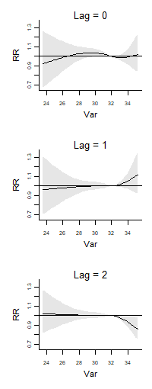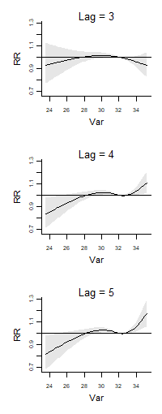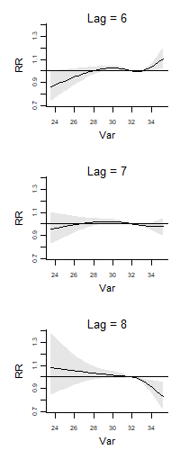Figure 1. The lagged effect of maximum temperature on RSV from the final PM_{2.5} model. The RRs are derived from comparing each value on x-axis against its median. Shaded grey area denotes 95% CI.
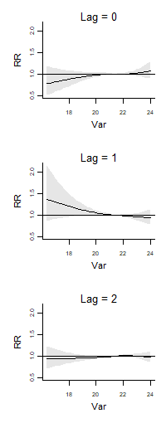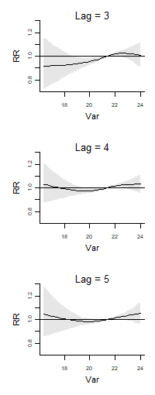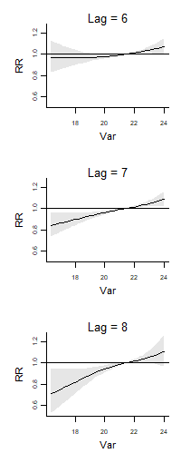 Figure 2. The lagged effect of absolute humidity on RSV from the final PM_{2.5} model. The RRs are derived from comparing each value on x-axis against its median. Shaded grey area denotes 95% CI.
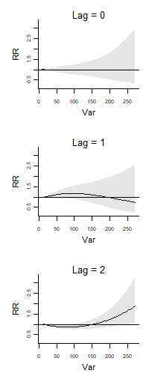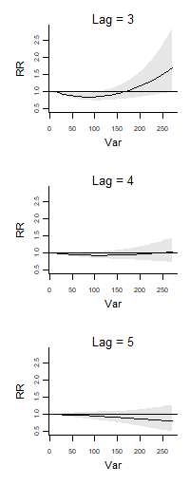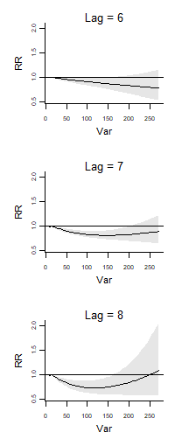 Figure 3. The lagged effect of PM_{2.5} on RSV from the final PM_{2.5} model. The RRs are derived from comparing each value on x-axis against its median. Shaded grey area denotes 95% CI.
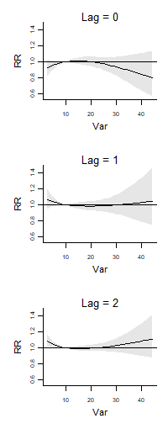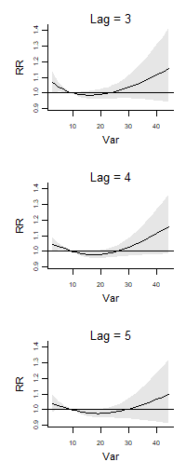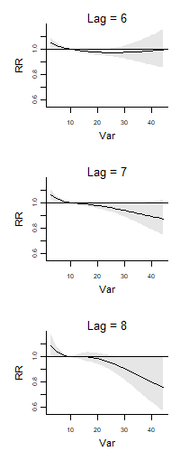 Figure 4. The lagged effect of SO₂ on RSV from the final PM_{2.5} model. The RRs are derived from comparing each value on x-axis against its median. Shaded grey area denotes 95% CI.
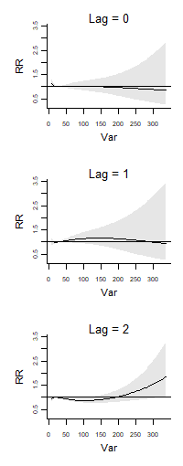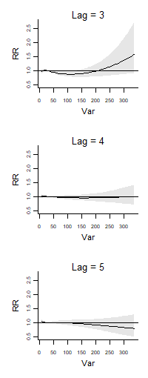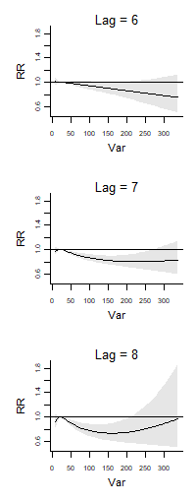 Figure 5. The lagged effect of PM₁₀ on RSV from the final PM₁₀ model. The RRs are derived from comparing each value on x-axis against its median. Shaded grey area denotes 95% CI.
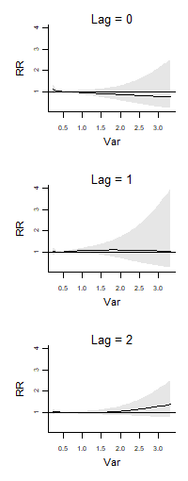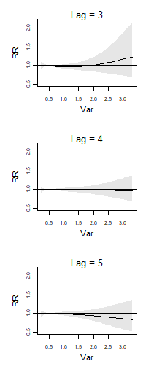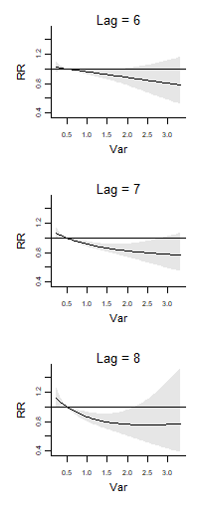 Figure 6. The lagged effect of CO on RSV from the final CO model. The RRs are derived from comparing each value on x-axis against its median. Shaded grey area denotes 95% CI.
4 df | 5 df
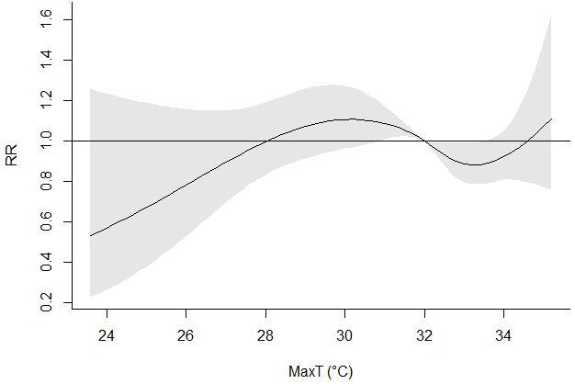 | 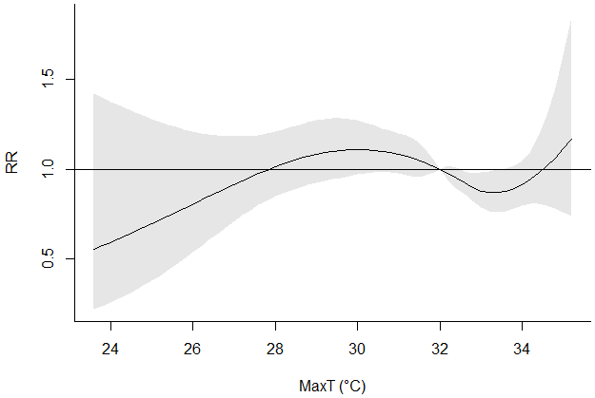
[A] | [B]
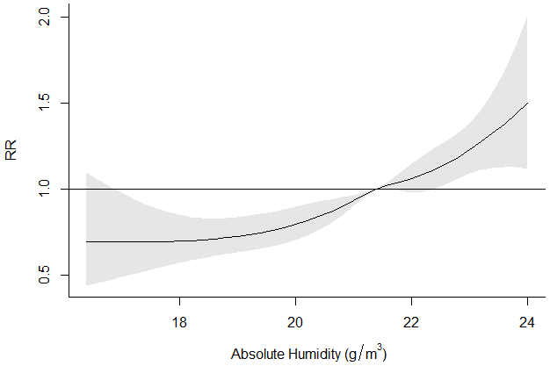 | 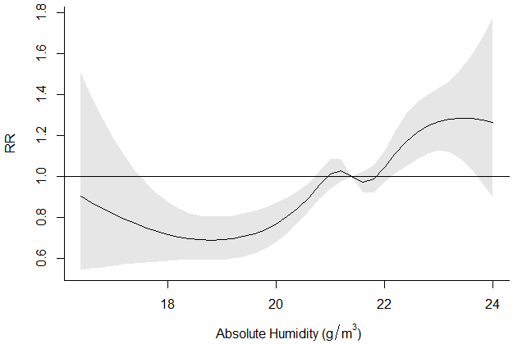
[C] | [D]
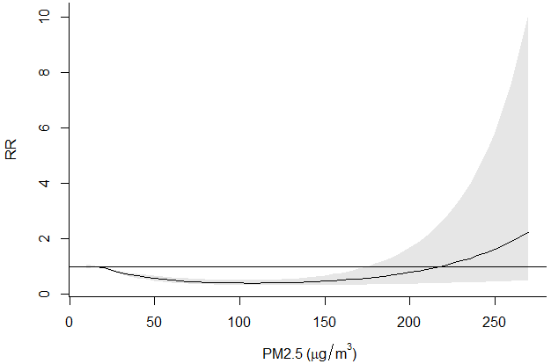 | 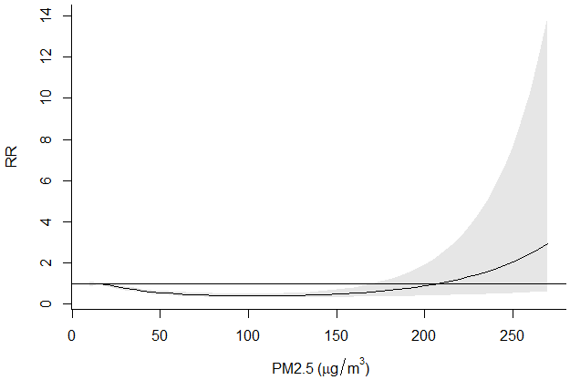
[E] | [F]
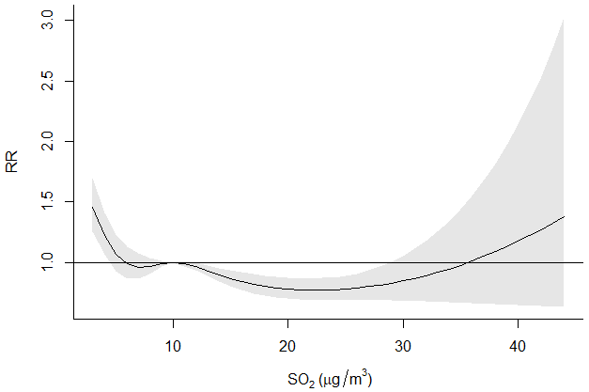 | 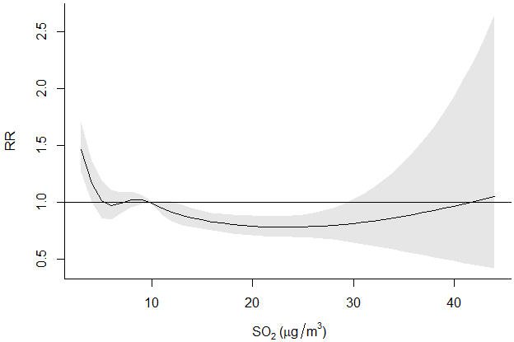
[G] | [H]

Figure 7. Sensitivity analysis using 4 and 5 degrees of freedom (df) for maximum temperature (A, B), absolute humidity (C, D), PM2.5 (E, F) and SO₂ (G, H). Solid lines represent relative risk (RR), grey shaded areas represent 95% confidence intervals (CIs).
Before Adjusting for Autocorrelation | After Adjusting for Autocorrelation
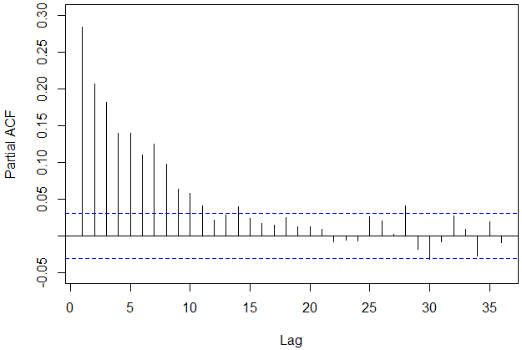 | 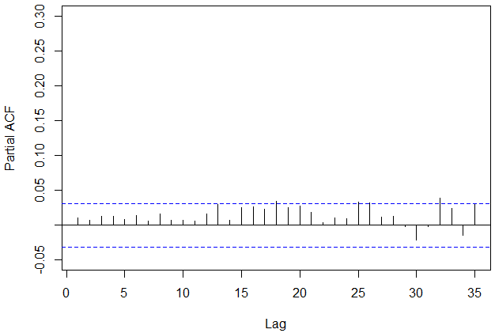
[A] AIC: 17501 | [B] AIC: 16412
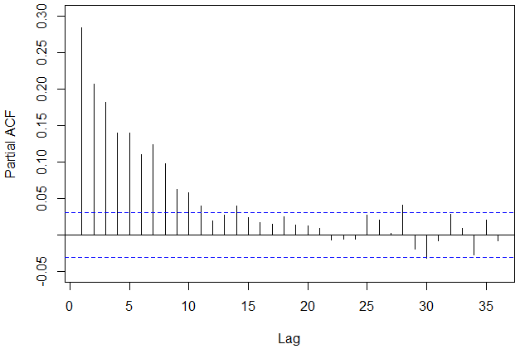 | 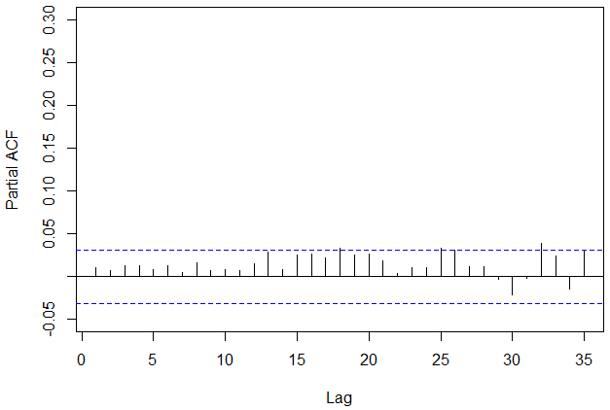
[C] AIC: 17504 | [D] AIC: 16415
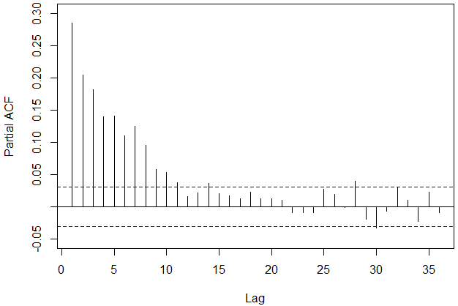 | 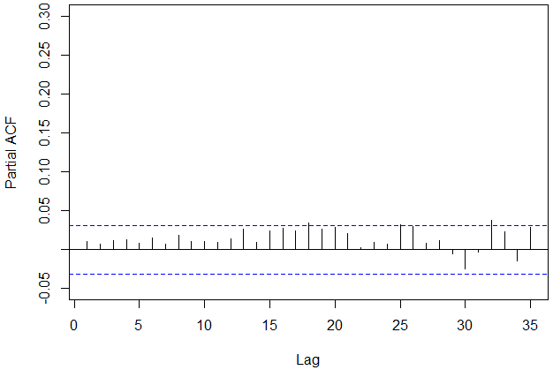
[E] AIC: 17506 | [F] AIC: 16426

Figure 8. Partial autocorrelation plots (PACF) for deviance residual and Akaike information criterion (AIC) values from final PM_{2.5} (A, B), PM₁₀ (C, D) and CO (E, F) models before (A, C, E) and after (B, D, F) adjusting for autocorrelation. The vertical lines represent the extent of correlation (y-axis) between reported RSV infections on the present day and the specified lag (in days) on the x-axis. The area bounded by the horizontal blue dashed lines represents the 95% confidence bands. Autocorrelation is present when any of the vertical lines lie outside the area denoted by the blue dashed lines. The presence of autocorrelation, if not adequately addressed, could lead to potential confounding that results in inaccurate effect estimates.

