Supplementary information

Mapping the functional expression of auxiliary subunits of K_{Ca}1.1 in glioblastoma

Adam Feher1#, Zoltán Petho˝1,2#, Tibor G. Szanto1, Álmos Klekner3, Gabor Tajti1, Gyula Batta4, Tibor Hortobágyi^{5,6}, Zoltan Varga1, Albrecht Schwab2 and Gyorgy Panyi1*

1Department of Biophysics and Cell Biology, Faculty of Medicine, University Debrecen, Debrecen, Hungary
2Institute of Physiology II, University Münster, Münster, Germany
3Department of Neurosurgery, Faculty of Medicine, University Debrecen, Debrecen, Hungary
4Department of Genetics and Applied Microbiology, University Debrecen, Debrecen,
Hungary
⁵Institute of Pathology, Faculty of Medicine, University of Szeged, Szeged, Hungary.
⁶ELKH-DE Cerebrovascular and Neurodegenerative Research Group, Department of Neurology, Faculty of Medicine, University Debrecen, Debrecen, Hungary

*Corresponding author, Tel.: +36 52 411 717 / 65617, E-mail: panyi@med.unideb.hu
# These authors contributed equally to the manuscript

Supplementary Methods

- RT-PCR and gel electrophoresis
The cDNA of primary GBM patients was obtained as described in section 2.4 and was used as a template for PCR using Biozym Red HS Taq Master Mix (Biozym, Hessisch Oldendorf, Germany), with the primers detailed in Supp. Table 2. PCR conditions were following: 40 cycles of denaturation at 95 °C for 30 s, annealing at 55 °C for 45 s, and extension at 72 °C for 60 s in an Eppendorf® Mastercycler (Eppendorf, Hamburg, Germany). PCR products were separated by 1.5% agarose gel electrophoresis and images were acquired under UV light. Product band intensities were evaluated by ImageJ.

Supplementary Figures

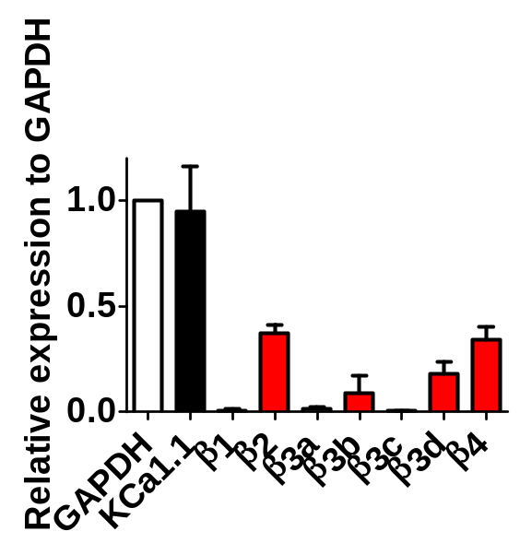
Supp. Figure 1: Primary patient-derived GBM cells express β subunits of K_{Ca}1.1.
Band intensities of KCNMA1 (K_{Ca}1.1) and the respective beta-subunit encoding genes were normalized to the intensity of GAPDH after gel electrophoresis of RT-PCR products (N=3).
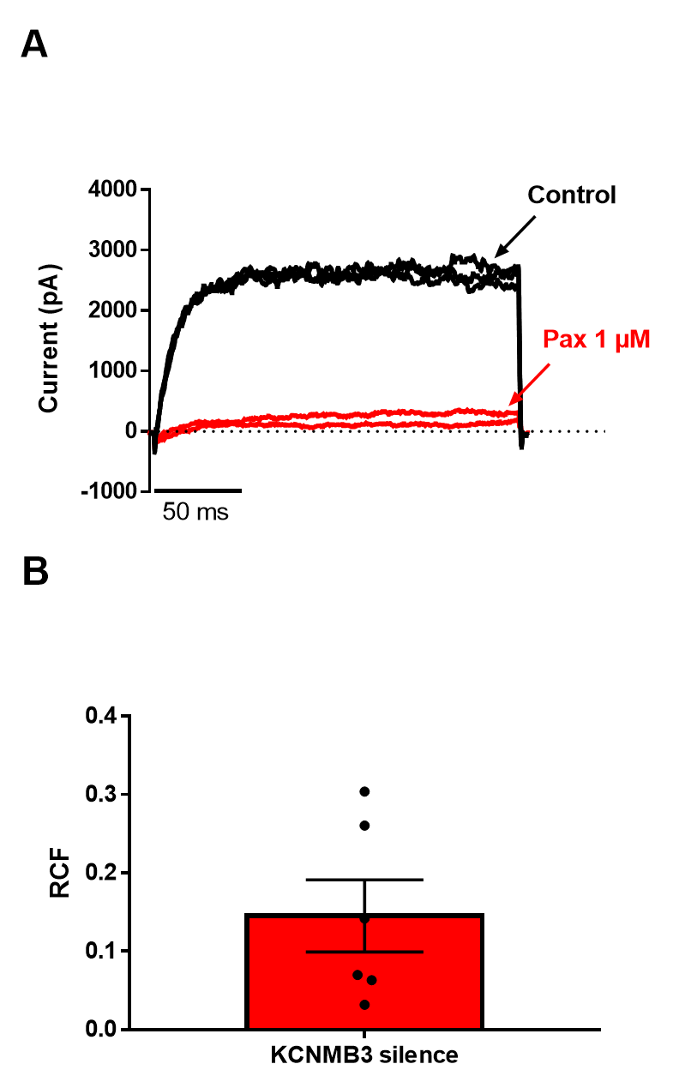

Supp. Figure 2: The effect of paxilline on KCNMB3 silenced U-87 MG cells
The KCNMB3 gene encoding the beta3 subunit was silenced in U-87 MG cells using siRNA as described in the Materials and Methods section. A) Representative measurement of the KCa1.1 current using whole-cell patch clamp in a KCNMB3 silenced U-87 MG cell. Currents were evoked by repeated depolarizations to +100 mV from a holding potential of -100 mV every 15 s in control extracellular solution (black) and upon reaching equilibrium block in the presence of 1 µM paxilline (red). The pipette filling solution contained 1 µM Ca²⁺ concentration. B) Column chart of the remaining current fraction (RCF = I/I₀, where I₀ and I are the peak currents in the absence and in the presence of the inhibitor, respectively) upon 1 µM paxilline administration. Black dots represent individual measurements, horizontal line and error bars indicate mean ± SEM.
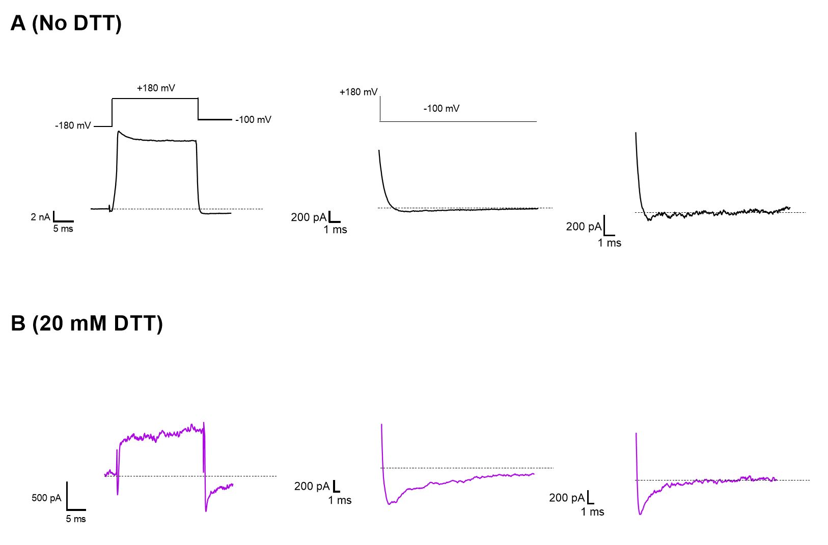

Supp. Figure 3: DTT treatment results in the appearance of the instantaneous current at -100 mV
This figure shows the 3-3 individual measurements displayed in the scatter plot in Fig. 4F. Whole-cell currents were recorded in U-87 MG cells using whole-cell patch clamp. The pulse protocol is shown in the left panel of A. The pipette filling solution contained 10 µM free Ca²⁺ concentration, other conditions are explained in Fig. 4 of the main text. A.) The left panel shows the current at full scale, the middle and right panels display the currents upon stepping the membrane potential to -100 mV from +180 mV to evoke the tail currents at an extended time scale. B.) The same set of experiment as in A except the cell was incubated with 20 mM DTT for 20 min.

Supplementary Tables

Supp. Table 1. Primer sequences used for RT-qPCR of U-87 MG cells
Primers used for qPCR of U-87 MG cells (as described in Ref [42])
Gene Name | RefSeq | Forward/reverse | Sequence
KCNMA1 | NM_001014797 | FW | GCT CAA GTA CCT GTG GAC CG
 |  | Rev | CTG GTT TGA GAG TGC CAT CC
KCNMB1 | NM_004137.4 | FW | CTG TAC CAC ACG GAG GAC ACT
 |  | Rev | AGG TGC GGA GAA GTA GA
KCNMB2a | NM_181361.3 | FW | TGA CAA CTA CCG GAG GTC TT
 |  | Rev | GGA GGT CAT GGT CCC TGA TT
KCNMB2b | NM_001278911.2 | FW | GAG AAA GAG CAA CAA AGC GG
 |  | Rev | TTA GCA AAT CCC AGA CAT TGC
KCNMB3a | NM_171828.2 | FW | AAA TCA CAC TTC AGG GCA GC
 |  | Rev | GCA CAT CTA GTG GGT CTC CA
KCNMB3b | NM_171829.2 | FW | TCT GAG TGT GAG GGG CTC TT
 |  | Rev | GCA CAT CTA GTG GGT CTC CA
KCNMB3c | NM_171830.1 | FW | TCA CGA GAC ACA GGT AGG CAG CAA
 |  | Rev | TGG CAA ACC CCA GCA TCA CGG
KCNMB3d | NM_014407.3 | FW | GCT CAC GAG ACA CAG GAC AGC CTT
 |  | Rev | TGG CAA ACC CCA GCA TCA CGG

Supp. Table 2. Primer sequences used for RT-PCR of primary patient-derived GBM cells
Gene Name | RefSeq | Forward/reverse | Sequence
KCNMA1 | NM_001014797 | FW | CGG TGA CCA TGG AGG T
 |  | Rev | AGA GAA GGA AGA ACA CGT TG
KCNMB1 (β1) | NM_004137.4 | FW | CAC CTA CTA CAT CCT GGT CAC
 |  | Rev | TGG ATG GAT GGC TCT ACT TC
KCNMB2 (β2) | NM_181361.3 | FW | GTC ACT CCT ATT GTC CTT CC
 |  | Rev | CAA GGT GCA TTG AGA CTC TT
KCNMB3a (β3a) | NM_171828.2 | FW | TGT CTA AGC TTC ACC TTT CTT G
 |  | Rev | CAA ACA CCT GAA GAC ACG G
KCNMB3b (β3b) | NM_171829.2 | FW | TGT CAG AAC ATC CAA GTC AG
 |  | Rev | CAG GTC GAT TCT TCT CTC TG
KCNMB3c (β3c) | NM_171830.1 | FW | CAT TTC TTA GGC TTG TTT GCT
 |  | Rev | GGT CGA TTC TTC TCT CTG AA
KCNMB3d (β3d) | NM_014407.3 | FW | GCA TGA GGC AAC ATT TCT TA
 |  | Rev | AGC CAG TCG TCC ATG ATA
KCNMB4 (β4) | NM_014505.6 | FW | TCG GCT TGT TTC TCA TCA TCT
 |  | Rev | GAA GCA CAT CAT CTG GTC TTT
GAPDH | NM_002046.5 | FW | TGA AGG TCG GAG TCA ACG GATT
 |  | Rev | CAT GTG GGC CAT GAG GTC CAC CAC

Supp. Table 3. Cell cycle analysis of U-87 MG cells following synchronization

Unsynchronized | % Cells (mean ± SEM)
G₀/G₁ | 57.3 ± 3.2
S | 26.6 ± 2.4
G₂/M | 16.1 ± 0.9
Serum Starvation | % Cells (mean ± SEM)
G₀/G₁ | 77.8 ± 1.3
S | 12.2 ± 0.8
G₂/M | 10 ± 0.6
Colchicine | % Cells (mean ± SEM)
G₀/G₁ | 33.9 ± 6.3
S | 31 ± 2.3
G₂/M | 35.1 ± 4
Paxilline | % Cells (mean ± SEM)
G₀/G₁ | 54.4 ± 3.1
S | 30 ± 2.2
G₂/M | 15.6 ± 0.9

Western blot images:
(Fig. 3B top box)
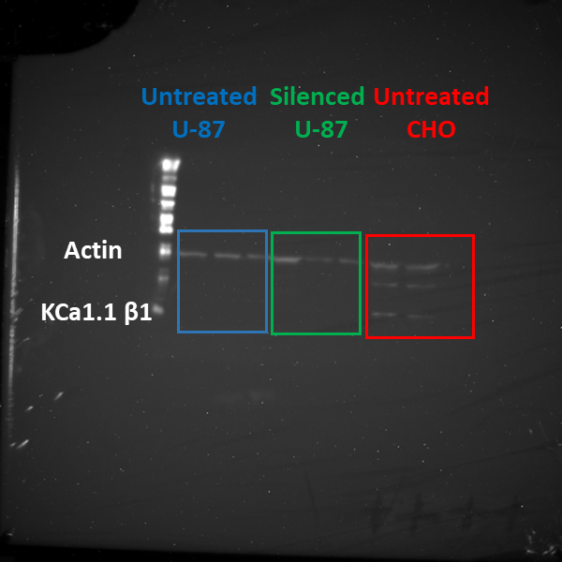

(Fig. 3B second box)
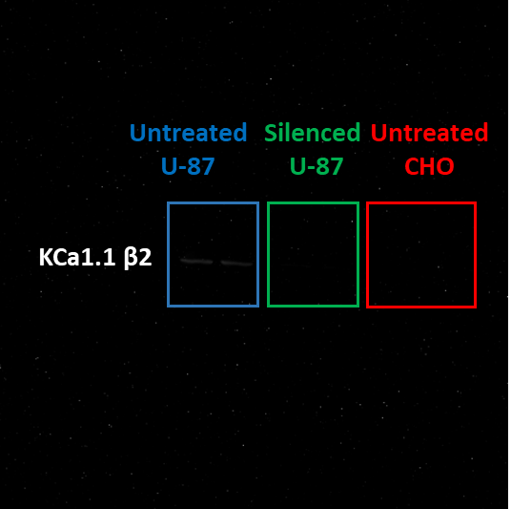

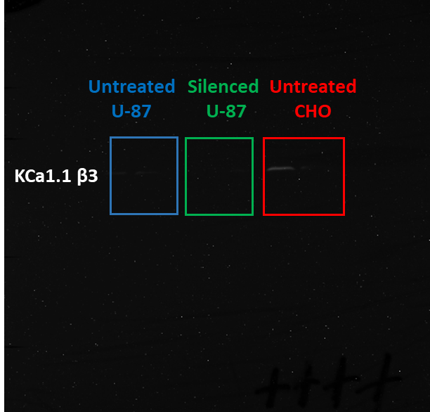
(Fig. 3B third box)

