Improving the performance of machine learning algorithms for health outcomes predictions in multicentric cohorts

*Roberta Moreira Wichmann, Ph.D^{1,2}
Fernando Timoteo Fernandes, Ph.D ^{1,3}
Alexandre Dias Porto Chiavegatto Filho, Ph.D ¹
IACOV-BR Network¹
¹ University of São Paulo, School of Public Health, São Paulo, SP, Brazil
² Brazilian Institute of Education, Development and Research – IDP. Economics Graduate Program, Brasilia, DF, Brazil.
³ Fundacentro, São Paulo, SP, Brazil

Correspondence to: roberta.wichmann@idp.edu.br

Supplementary Table 1 - List of participating hospitals.
Hospital | CNES | State | Type of legal entity | Level of government | Type of hospital | Delivery | Teaching and research | N. of beds
Hospital Universitário Getúlio Vargas | 2017644 | AM | Government-owned corporation | Federal | General hospital | Tertiary care | Teaching Hospital | 246
Hospital Santa Julia | 2018055 | AM | Business entity | State | General hospital | Tertiary care | Has no teaching activity | 176
Real Sociedade Portuguesa de Beneficência Dezesseis De Setembro - Hospital Português da Bahia | 0004251 | BA | Not-for-profit | State and municipal | General hospital | Tertiary care | Teaching Hospital | 344
Hospital Unimed Fortaleza | 3242587 | CE | Business entity | State | General hospital | Tertiary care | Teaching Hospital | 400
Hospital Universitário Walter Cantídio - Complexo Hospitalar da Universidade Federal do Ceará - EBSERH | 2561492 | CE | Government-owned corporation | Federal | General hospital | Tertiary care | Teaching Hospital | 197
Hospital Universitário HC | 0000396 | PE | Business entity | State | General hospital | Tertiary care | Teaching Hospital | 290
Hospital Estadual de Luziânia - HEL | 2340429 | GO | Government-owned corporation | State | General hospital | Tertiary care | Has no teaching activity | 60
Hospital Estadual de Trindade - HETRIN | 5095808 | GO | Government-owned corporation | State | General hospital | Tertiary care | Has no teaching activity | 60
Hospital Santa Lúcia | 2815966 | DF | Business entity | State | General hospital | Tertiary care | Has no teaching activity | 418
Hospital Universitário Clementino Fraga Filho | 2280167 | RJ | Government-owned corporation | Federal | General hospital | Tertiary care | Teaching Hospital | 364
Hospital Unimed-Rio | 7251491 | RJ | Business entity | Municipal | General hospital | Tertiary care | Teaching Hospital | 192
Hospital Santa Casa de São Paulo | 2688689 | SP | Not-for-profit | State | General hospital | Tertiary care | Teaching Hospital | 568
Hospital São Francisco de Mogi Guaçú | 2081016 | SP | Business entity | Municipal | General hospital | Secondary care | Has no teaching activity | 138
Hospital Evangélico de Vila Velha - HEVV | 2494442 | ES | Not-for-profit | State | General hospital | Tertiary care | Has no teaching activity | 187
Hospital das Clínicas da Faculdade de Medicina da USP - HCFMUSP | 2078015 | SP | Government-owned corporation | State | General hospital | Tertiary care | Teaching Hospital | 2500
Hospital Santa Catarina Blumenau | 2522101 | SC | Not-for-profit | Municipal | General hospital | Tertiary care | Has no teaching activity | 153
Hospital Moinhos de Vento | 3006522 | RS | Not-for-profit | Municipal | General hospital | Tertiary care | Has no teaching activity | 445
Hospital Escola da UFPel | 2252694 | RS | Government-owned corporation | Municipal | General hospital | Tertiary care | Teaching Hospital | 161

Supplementary Table 2 - Descriptive statistics of the demographics characteristics per Hospital
 | Death
Variable | No | Yes | Total
 | Mean (SD) | Mean (SD) | Mean (SD)
Age (years) - All | 55.2(17.0) | 66.7(15.1) | 58.4(17.3)
SE-1 | 56.2(14.9) | 64.0(14.2) | 59.5(15.1)
SE-2 | 55.5(15.9) | 66.2(13.6) | 59.3(16.0)
SE-3 | 62.7(16.9) | 77.5(11.6) | 66.2(17.0)
SE-4 | 60.3(14.3) | 66.6(14.1) | 62.6(14.6)
SE-5 | 51.7(14.8) | 63.2(16.1) | 53.3(15.5)
SE-6 | 66.3(17.9) | 69.1(16.1) | 67.0(17.5)
NE-1 | 47.6(17.1) | 74.0(14.7) | 49.4(18.2)
NE-2 | 61.0(17.6) | 73.3(14.3) | 62.6(17.7)
NE-3 | 53.6(17.0) | 62.9(16.1) | 57.0(17.3)
NE-4 | 52.8(15.7) | 64.3(13.9) | 56.2(16.0)
MW-1 | 52.8(14.0) | 61.3(16.0) | 58.0(15.8)
MW-2 | 61.5(16.5) | 81.5(9.7) | 65.6(17.4)
MW-3 | 52.0(14.2) | 64.2(15.9) | 58.6(16.3)
S-1 | 57.4(16.7) | 83.5(8.2) | 60.1(17.9)
S-2 | 47.7(16.4) | 76.6(12.3) | 49.6(17.7)
S-3 | 57.5(16.0) | 65.9(14.5) | 60.7(16.0)
N-1 | 53.7(16.1) | 72.6(12.8) | 56.6(17.0)
N-2 | 56.2(16.3) | 59.1(13.4) | 57.1(15.4)
Hospital time | 13.2(17.3) | 16.4(16.5) | 14.2(17.1)
SE-1 | 15.1(21.6) | 15.4(14.0) | 15.2(18.8)
SE-2 | 19.1(17.2) | 17.0(12.6) | 18.3(15.7)
SE-3 | 14.1(19.5) | 20.0(19.2) | 15.5(19.6)
SE-4 | 13.9(17.3) | 19.5(22.7) | 15.9(19.6)
SE-5 | N/A | N/A | N/A
SE-6 | 9.3(9.4) | 7.5(7.7) | 8.8(9.1)
NE-1 | N/A | N/A | N/A
NE-2 | 4.3(6.5) | 11.9(7.4) | 5.3(7.1)
NE-3 | 13.3(9.2) | 14.7(8.8) | 13.8(9.1)
NE-4 | 32.3(27.8) | 26.3(19.2) | 30.6(25.7)
MW-1 | 16.9(11.6) | 12.4(12.3) | 13.9(12.3)
MW-2 | 12.0(14.8) | 21.5(33.9) | 14.0(20.5)
MW-3 | 9.4(6.7) | 11.4(7.3) | 10.5(7.1)
S-1 | 12.3(14.3) | 28.9(25.5) | 14.0(16.6)
S-2 | 3.3(8.0) | 44.8(61.5) | 6.1(20.6)
S-3 | N/A | N/A | N/A
N-1 | 9.5(11.5) | 18.8(19.0) | 11.0(13.4)
N-2 | 21.5(20.6) | 23.7(30.6) | 22.2(24.5)
Male (%) | 53.3 | 60.0 | 55.1
SE-1 | 59.7 | 62.2 | 60.8
SE-2 | 52.3 | 62.0 | 55.8
SE-3 | 56.9 | 61.3 | 57.9
SE-4 | 49.2 | 57.0 | 52.0
SE-5 | 52.3 | 58.8 | 53.2
SE-6 | 60.5 | 53.8 | 58.9
NE-1 | 43.1 | 52.1 | 43.7
NE-2 | 56.5 | 48.2 | 55.4
NE-3 | 47.9 | 48.8 | 48.2
NE-4 | 59.6 | 51.9 | 60.3
MW-1 | 63.5 | 61.3 | 62.2
MW-2 | 48.2 | 49.1 | 48.4
MW-3 | 55.6 | 65.9 | 61.0
S-1 | 58.4 | 53.2 | 57.9
S-2 | 51.4 | 60.0 | 52.0
S-3 | 63.2 | 61.8 | 62.6
N-1 | 55.5 | 57.9 | 55.9
N-2 | 54.8 | 75.0 | 61.7
Race – White (%) | 68.3 | 50.6 | 62.1
SE-1 | N/A | N/A | N/A
SE-2 | 61.2 | 60.5 | 60.9
SE-3 | N/A | N/A | N/A
SE-4 | 42.3 | 27.1 | 36.8
SE-5 | 92.5 | 100.0 | 93.5
SE-6 | N/A | N/A | N/A
NE-1 | N/A | N/A | N/A
NE-2 | N/A | N/A | N/A
NE-3 | 45.1 | 41.5 | 43.8
NE-4 | 0.7 | 4.8 | 6.8
MW-1 | N/A | 25.0 | 15.2
MW-2 | N/A | N/A | N/A
MW-3 | 2.8 | 11.9 | 8.9
S-1 | 92.7 | 95.7 | 93.0
S-2 | 84.1 | 100.0 | 85.1
S-3 | N/A | N/A | N/A
N-1 | N/A | N/A | N/A
N-2 | 12.9 | 6.2 | 10.6
Race – Black/Mixed/Asian (%) | 31.7 | 49.5 | 38.0
SE-1 | N/A | N/A | N/A
SE-2 | 38.8 | 39.5 | 39.1
SE-3 | N/A | N/A | N/A
SE-4 | 57.7 | 72.9 | 63.2
SE-5 | 7.5 | 50.5 | 62.0
SE-6 | N/A | N/A | N/A
NE-1 | N/A | N/A | N/A
NE-2 | N/A | N/A | N/A
NE-3 | 54.9 | 58.5 | 56.2
NE-4 | 92.3 | 95.2 | 93.2
MW-1 | N/A | 75.0 | 84.8
MW-2 | N/A | N/A | N/A
MW-3 | 97.2 | 88.1 | 91.1
S-1 | 7.3 | 4.3 | 7.0
S-2 | 15.9 | 0 | 14.9
S-3 | N/A | N/A | N/A
N-1 | N/A | N/A | N/A
N-2 | 87.1 | 93.8 | 89.4

Supplementary Table 3 - Hyperparameters of the best machine learning algorithms for each final hospital.
Hospital  (Strategy) | Best algorithm | Hyperparameters
SE-1  (Local Training) | XGBoost | base_score=0.5, colsample_bylevel=1, colsample_bynode=1, colsample_bytree=0.85, gamma=0.65, importance_type='gain'  learning_rate=0.11, min_child_weight=3.0, subsample=0.8, missing=nan, max_delta_step=0, max_depth=7  n_estimators=100, reg_alpha=1.0, reg_lambda=1, scale_pos_weight=3
SE-2  (Local Training) | Catboost | learning_rate: 0.16, n_estimators: 125  l2_leaf_reg: 10.0, border_count: 50, max_depth: 12
SE-3  (Local Training) | XGBoost | base_score=0.5, colsample_bylevel=1, colsample_bynode=1, colsample_bytree=0.45, gamma=0.9, importance_type='gain'  learning_rate=0.30, min_child_weight=3.0, subsample=0.85, missing=nan, max_delta_step=0, max_depth=7  n_estimators=75, reg_alpha=0.5, reg_lambda=1, scale_pos_weight=3
SE-4  (Local Training) | XGBoost | base_score=0.5, colsample_bylevel=1, colsample_bynode=1, colsample_bytree=0.85, gamma=0.5, importance_type='gain'  learning_rate=0.11, min_child_weight=3.0, subsample=0.8, missing=nan, max_delta_step=0, max_depth=7  n_estimators=100, reg_alpha=1.0, reg_lambda=1, scale_pos_weight=3
SE-5  (Local Training) | Light GBM | colsample_bytree=0.85, n_estimators=1200,  num_leaves=101, reg_alpha=0.25,  reg_lambda=0.087, scale_pos_weight=5
SE-6  (Local Training) | CatBoost | learning_rate: 0.46, n_estimators: 50  l2_leaf_reg: 2.0, border_count: 50, max_depth: 8
NE-1  (Local Training) | XGBoost | base_score=0.5, colsample_bylevel=1, colsample_bynode=1, colsample_bytree=0.45, gamma=0.9, importance_type='gain'  learning_rate=0.30, min_child_weight=3.0, subsample=0.85, missing=nan, max_delta_step=0, max_depth=7  n_estimators=75, reg_alpha=0.5, reg_lambda=1, scale_pos_weight=3
NE-2  (Local Training) | CatBoost | learning_rate: 0.19, n_estimators: 150  l2_leaf_reg: 5.0, border_count: 200, max_depth: 10
NE-3  (Local Training) | Light GBM | colsample_bytree=0.88, n_estimators=1067,  num_leaves=101, reg_alpha=0.42,  reg_lambda=0.87, scale_pos_weight=11
NE-4  (Other regions except specifc) | Light GBM | colsample_bytree=0.85, n_estimators=1200,  num_leaves=101, reg_alpha=0.25,  reg_lambda=0.09, scale_pos_weight=5
MW-1  (All except specific) | XGBoost | base_score=0.5, colsample_bylevel=1, colsample_bynode=1, colsample_bytree=0.85, gamma=0.7, importance_type='gain'  learning_rate=0.26, min_child_weight=2.0, subsample=0.80, missing=nan, max_delta_step=0, max_depth=7  n_estimators=225, reg_alpha=1.0, reg_lambda=1, scale_pos_weight=1
MW-2  (Same region except specific) | Light GBM | colsample_bytree=0.88, n_estimators=1067,  num_leaves=101, reg_alpha=0.42,  reg_lambda=0.87, scale_pos_weight=11
MW-3  (Same region except specific) | XGBoost | base_score=0.5, colsample_bylevel=1, colsample_bynode=1, colsample_bytree=0.85, gamma=0.5, importance_type='gain'  learning_rate=0.11, min_child_weight=3.0, subsample=0.80, missing=nan, max_delta_step=0, max_depth=7  n_estimators=100, reg_alpha=1.0, reg_lambda=1, scale_pos_weight=3
S-1  (Local Training) | CatBoost | learning_rate: 0.39, n_estimators: 200  l2_leaf_reg: 4.0, border_count: 10, max_depth: 14
S-2  (Local Training) | Light GBM | colsample_bytree=0.86, n_estimators=803,  num_leaves=147, reg_alpha=0.56,  reg_lambda=0.60, scale_pos_weight=1
S-3  (Same region except specific) | XGBoost | base_score=0.5, colsample_bylevel=1, colsample_bynode=1, colsample_bytree=0.45, gamma=0.9, importance_type='gain'  learning_rate=0.30, min_child_weight=3.0, subsample=0.85, missing=nan, max_delta_step=0, max_depth=7  n_estimators=75, reg_alpha=0.5, reg_lambda=1, scale_pos_weight=3
N-1  (Reference plus same region absolute number) | Light GBM | colsample_bytree=0.85, n_estimators=1200,  num_leaves=101, reg_alpha=0.25,  reg_lambda=0.09, scale_pos_weight=5
N-2  (All hospitals plus reference) | XGBoost | base_score=0.5, colsample_bylevel=1, colsample_bynode=1, colsample_bytree=0.85, gamma=0.7, importance_type='gain'  learning_rate=0.26, min_child_weight=2.0, subsample=0.80, missing=nan, max_delta_step=0, max_depth=7  n_estimators=225, reg_alpha=1.0, reg_lambda=1, scale_pos_weight=1

Supplementary Table 4 – Calibration for each algorithm.
Hospital (Strategy) | Best algorithm | Scaled Brier Score
SE-1 (Local Training) | XGBoost | -0.04
SE-2 (Local Training) | Catboost | 0.23
SE-3 (Local Training) | XGBoost | 0.16
SE-4 (Local Training) | XGBoost | 0.04
SE-5 (Local Training) | Light GBM | 0.40
SE-6 (Local Training) | CatBoost | -0.31
NE-1 (Local Training) | XGBoost | -0.03
NE-2 (Local Training) | CatBoost | 0.27
NE-3 (Local Training) | Light GBM | 0.32
NE-4 (Other regions except specifc) | Light GBM | -0.54
MW-1 (All except specific) | XGBoost | -0.62
MW-2 (Same region except specific) | Light GBM | -1.05
MW-3 (Same region except specific) | XGBoost | 0.29
S-1 (Local Training) | CatBoost | 0.24
S-2 (Local Training) | Light GBM | 0.40
S-3(Same region except specific) | XGBoost | -0.12
N-1 (Reference plus same region absolute number) | Light GBM | -0.07
N-2 (All hospitals plus reference) | XGBoost | 0.46

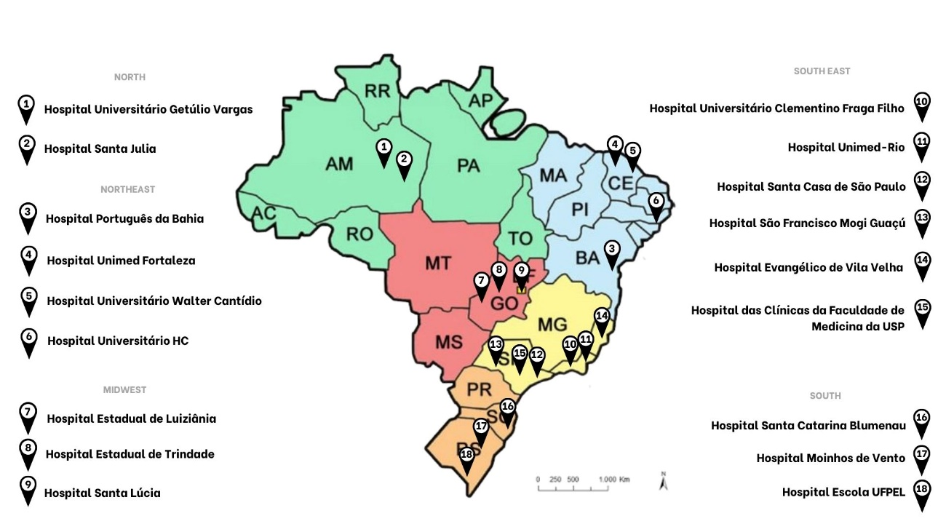
Supplementary Figure 1. Map of Brazil with the hospitals that participated in the study, according to geographic region.

Note: Figure was generated by the authors of this manuscript in Canva which is a free online graphic design tool. Please follow the link to access the original figure: https://www.canva.com/design/DAFNoZ6To38/R6jZK32feOsblUaM9wKIFw/edit?utm_content=DAFNoZ6To38&utm_campaign=designshare&utm_medium=link2&utm_source=sharebutton

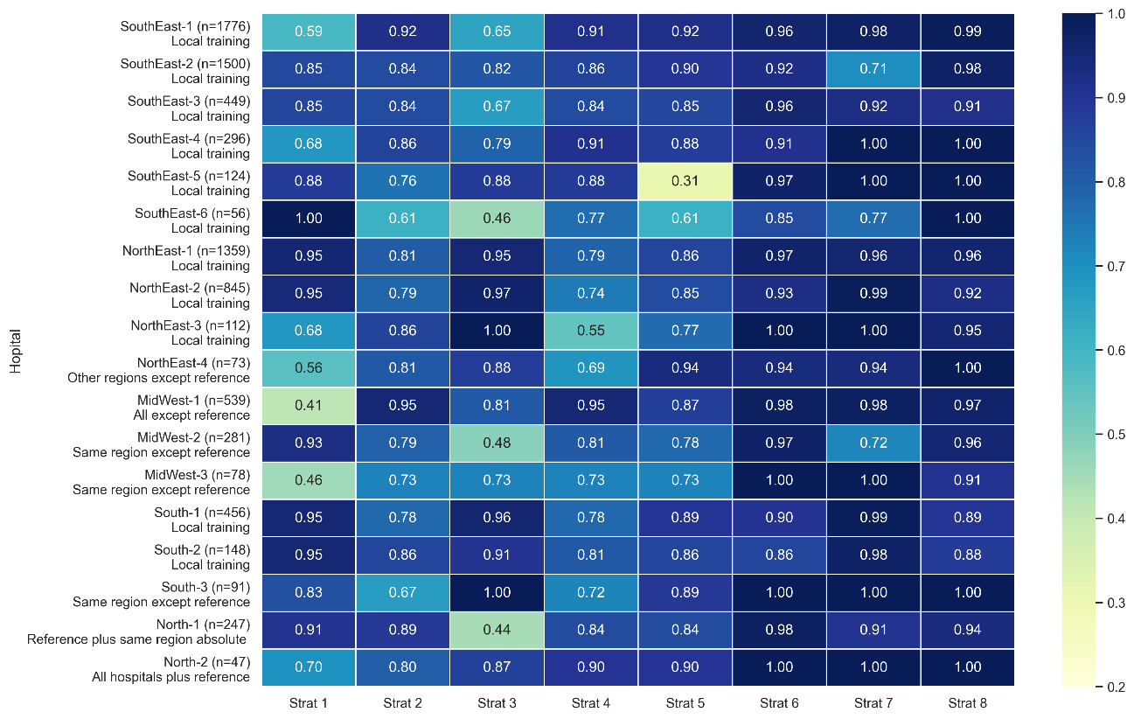
Supplementary Figure 2. Best specificities according to strategy, region and hospital with the best strategy highlighted.

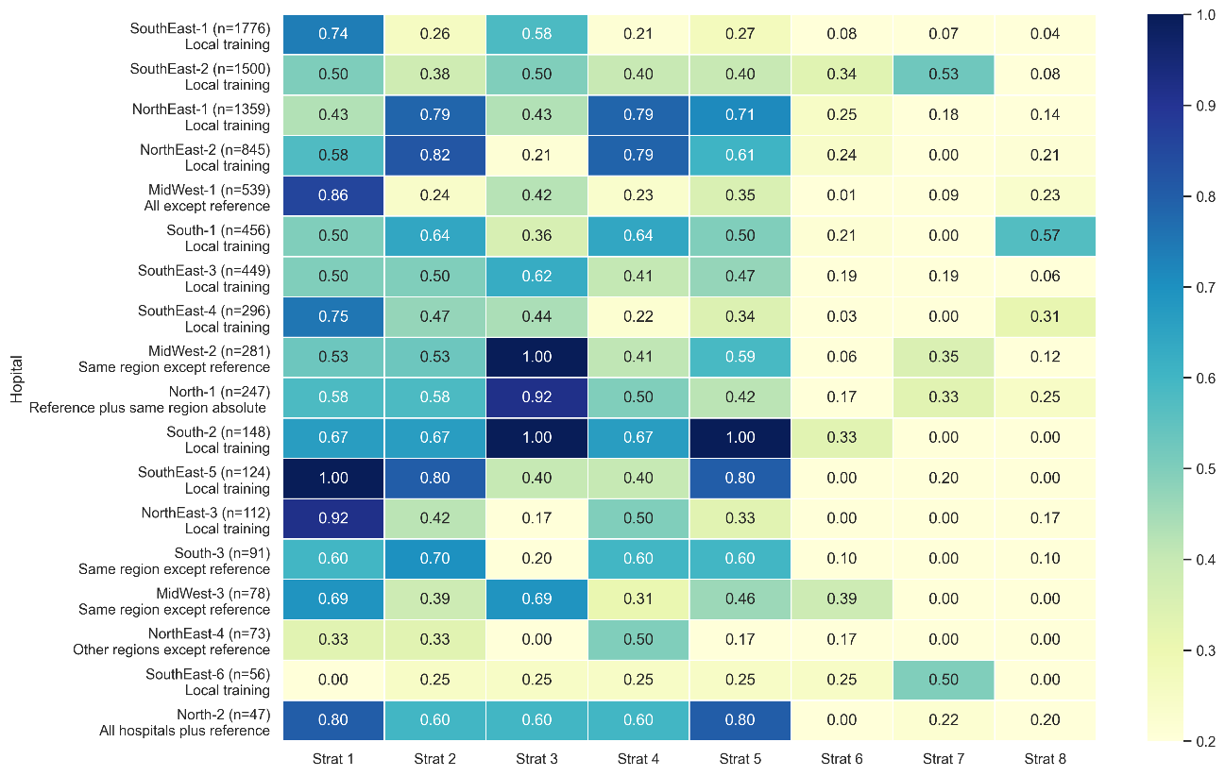
Supplementary Figure 3. Best recalls according to strategy, region and hospital with the best strategy highlighted.

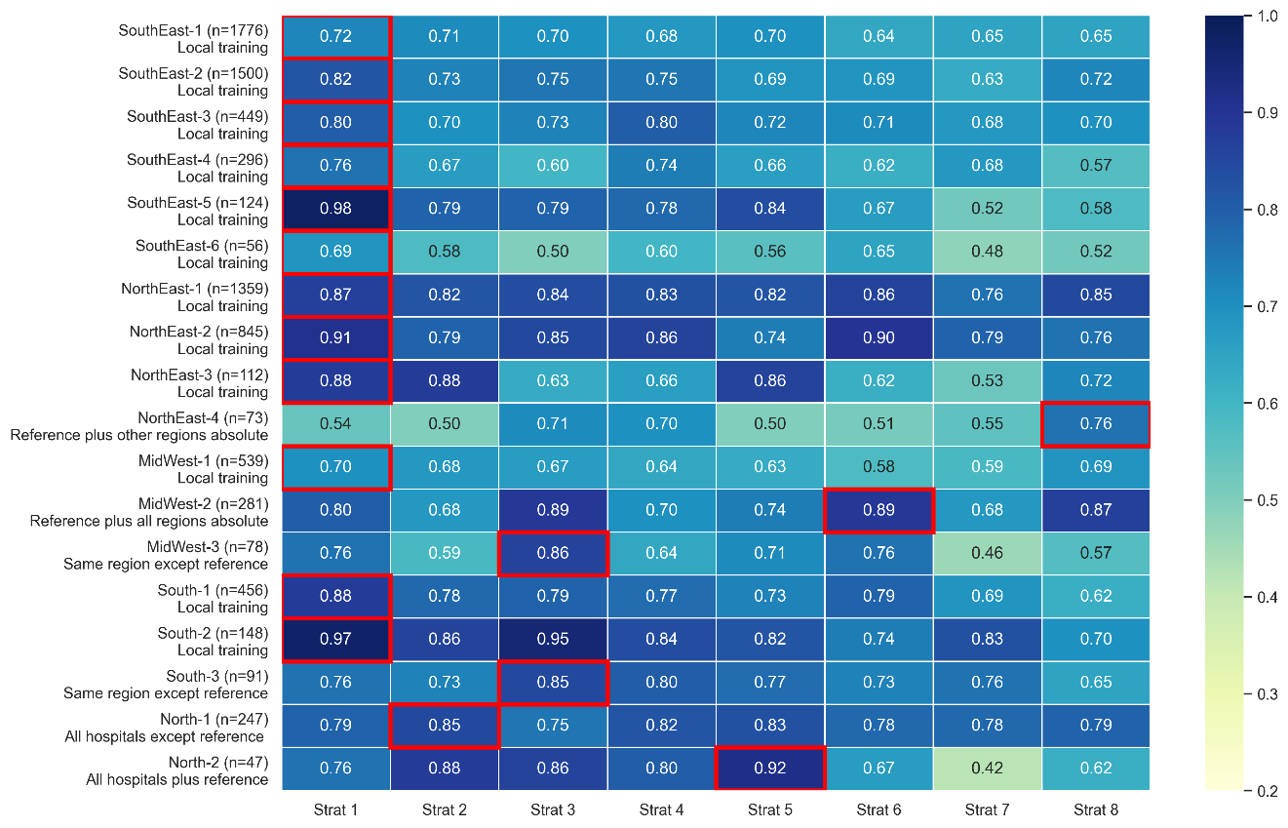
Supplementary Figure 4. Best AUROCs using the MICE imputation technique, with the region and hospital with the best strategy highlighted.

