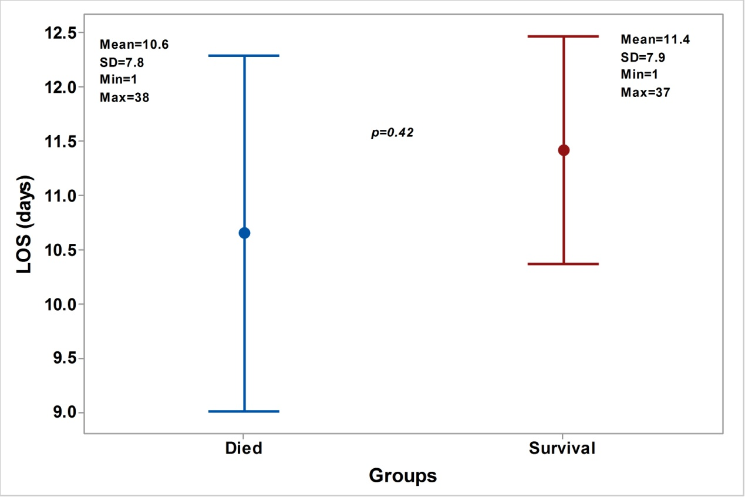
Supplementary Fig.1: Length of stay (LOS) in hospital for patients with COVID-19 pneumonia. The test of significant: independent t-test, P < 0.05 considered significant.

