Supplementary material figure captions:
Fig. S1: Optimization of delta wavelength (Δλ) for synchronous fluorescence spectra of 0.50 μg/mL for each of REM and SIM.
Fig. S2: Effect of diluting solvent on synchronous fluorescence intensity of 0.50 μg/mL for each of REM and SIM.
Fig. S3: Effect of surfactants on synchronous fluorescence intensity of 0.50 μg/mL for each of REM and SIM.

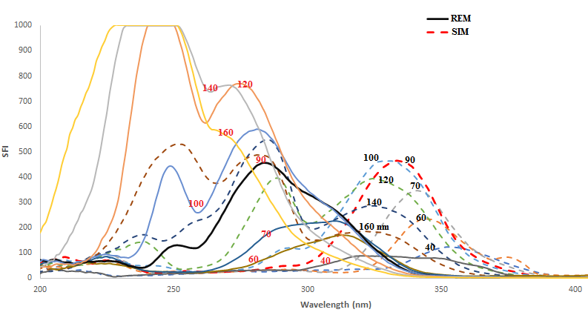
Supplementary material Fig. S1

Supplementary material Fig. S2

Supplementary material Fig. S3

