Fecal Cognition Assessment Test
Name: Score:
Single choice questions (2 points for each question, 30 questions in total, 60 points in total)
- Which of the following feces is melena (tarry stool)（）？
A.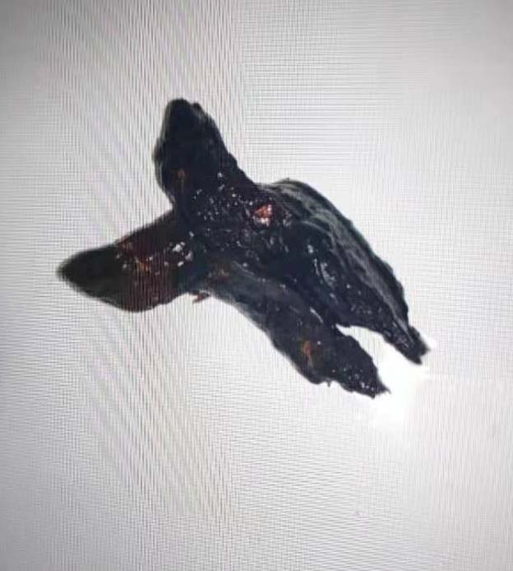
B.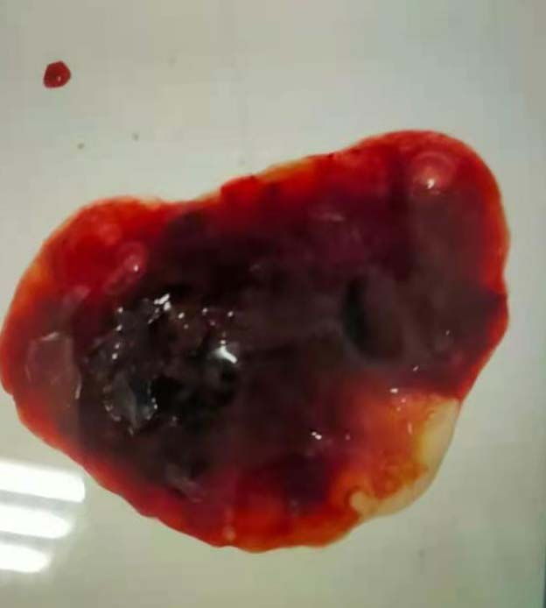
C.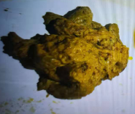
D.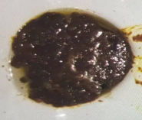
- Under pathological conditions, what are the reasons for melena?（）
- Upper gastrointestinal bleeding
- Lower gastrointestinal bleeding
- Eating chocolate
- Gastritis
- Which of the following foods can cause black stool：（）
- Duck blood
- Pork
- Glutinous rice
- Chicken gizzard
- What are the causes of black stool in patients with a history of liver cirrhosis or chronic liver disease（）
- Esophagogastric variceal hemorrhage
- Gastric ulcer or duodenal ulcer
- Acute gastritis
- Gastric cancer
- No history of liver, regular history of epigastric pain (such as hunger pain), the cause of black stool may be（）
- Esophagogastric variceal hemorrhage
- Gastric ulcer or duodenal ulcer
- Acute gastritis
- Gastric cancer
- What should an elderly people without history of liver disease vigilant in case of black stool（）
- Esophagogastric variceal hemorrhage
- Gastric ulcer or duodenal ulcer
- Acute gastritis
- Gastric cancer
- What measures should be taken in time after the occurrence of black stool?（）
- Temporary fasting and water, while reducing activity
- Normal eating
- Neglect of feces
- Normal activity or even vigorous activity
- What is the best way to check the cause of black stool?（）
- Gastroscope
- Gastrointestinal radiography
- Abdominal CT
- Ultrasound
- Which of the following situations can consider no active bleeding?（）
- No black stool for 3 days or yellow stool
- No black stool for 1 day or yellow stool
- Normal blood pressure and heart rate
- The patient felt that the bleeding had stopped
- Which of the following stool shapes is considered to be caused by constipation?（）
- 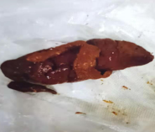
- 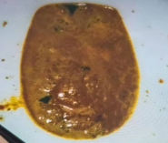
- 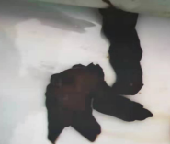
- 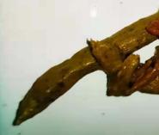
- Which of the following stool shapes is considered to be caused by diarrhea?（）
- 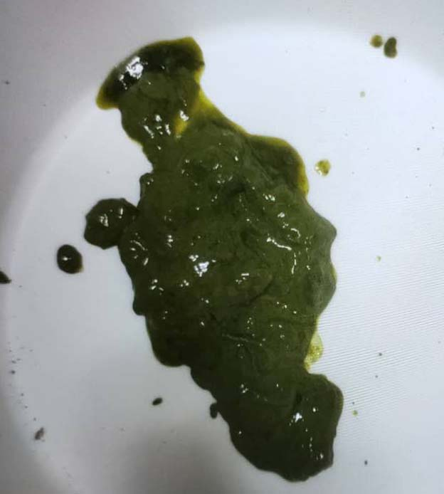
- 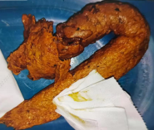
- 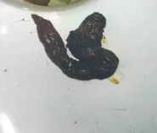
- 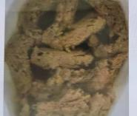
- Which of the following stool shapes is a normal stool?（）
- 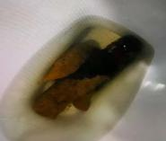
- 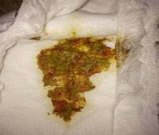
- Which of the following stool colors is abnormal?（）
- 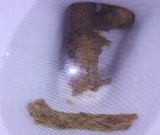
- 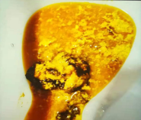
- 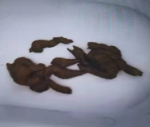
- 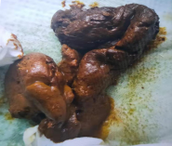
- What is the most common type of constipation?（）
- Functional constipation
- Intestinal tuberculosis
- Drug induced constipation
- Crohn's disease
- When constipation occurs, which of the following is wrong?（）
- Increase the intake of vegetables, melons and fruits
- Form the habit of defecating regularly
- Improve mood
- Reduce meat and fat intake
- Where does the color of normal feces come from?（）
- Food
- Bilirubin produced by human body
- Bile acids produced by the human body
- Produced by intestinal bacteria
- When diarrhea occurs, which of the following is wrong?（）
- Light liquid food and less residue diet
- Supplement water, mainly salty
- Temperance
- Increase the intake of vegetables, melons and fruits
- What's wrong with green manure?（）
- It's the normal stool color
- It's a manifestation of disease
- It is caused by the rapid passage of intestinal content through the intestine
- If it persists, seek medical attention in time
- When constipation, which laxative may cause melanosis coli?（）
- Irritant laxative
- Lactulose
- Polyethylene glycol
- Glycerin enema
- Which drug is not recommended for routine use in diarrhea?（）
- Loperamide
- Montmorillonite powder
- Bifidobacterium
- Lactobacillus
- Which of the following feces is abnormal?（）
- 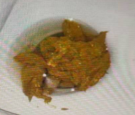
- 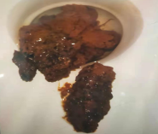
- 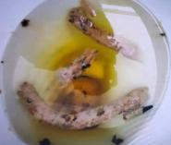
- 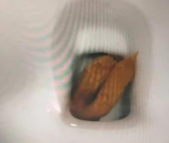
- What are the reasons for the appearance of white feces or the lightening of feces?（）
- Decreased bilirubin entering the intestine
- Decreased bile acids entering the intestine
- Reduction of intestinal bacteria
- Eat a lot of white food
- What is the disease that excretes white feces?（）
- Bile duct stone
- Inflammatory bowel disease
- Cholecystitis
- Gastric ulcer
- Which of the following symptoms are associated with white feces or light feces?（）
- Jaundice
- Gastrointestinal bleeding
- Fever
- Constipation
- When white feces appear, what is the purpose of MRCP?（）
- Determine whether there is biliary obstruction
- Determine if there is enteritis
- Determine if there is cholecystitis
- Determine if there is cirrhosis
- When white feces appear, which of the following methods has the role of both examination and treatment?（）
- ERCP
- MRCP
- CT
- Ultrasound
- The elderly people with bloody stool, accompanied by recent changes in defecation habits, must be alert to what diseases?（）
- Colon cancer
- Hemorrhoids
- Ulcerative colitis
- Colonic polyp
- Bloody stool is accompanied by thinning of feces. What disease should we be vigilant against?（）
- Colon cancer
- Hemorrhoids
- Ulcerative colitis
- Colonic polyp
- There is blood in the stool during defecation and blood drops after defecation. The blood is not mixed with feces. May it be?（）
- Colon cancer
- Hemorrhoids
- Ulcerative colitis
- Colonic polyp
- In case of bloody stool, what tests should be improved?（）
- Colonoscopy
- Abdominal CT
- Gastrointestinal radiography
- Ultrasound

