A
B

C

D
E

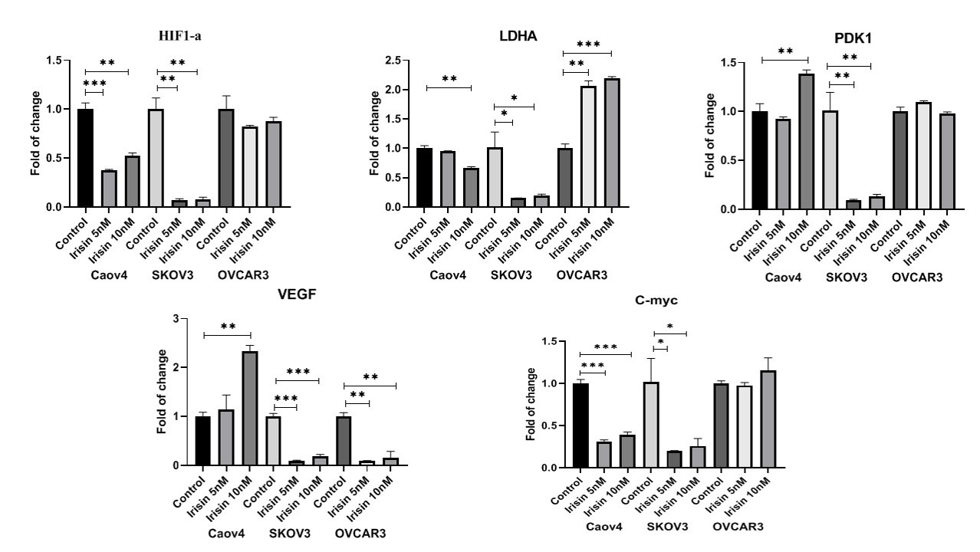
Effect of Irisin on HIF-1α signaling pathway genes that were normalized with GAPDH 48h after treatment with 5nM and 10nM of irisin. Data expressed as mean ± standard deviation; *P ≤ 0.05 **P ≤ 0.01; ***P ≤ 0.001 compared to control.

