Short-term sedimentation dynamics in mesotidal marshes
A. Rita Carrasco^{(1)*}, Katerina Kombiadou⁽¹⁾, Ana Matias⁽¹⁾
⁽¹⁾ Centre for Marine and Environmental Research (CIMA), University of Algarve, Campus of Gambelas, Faro, Portugal, *corresponding author: azarcos@ualg.pt

Supplementary material

Table S1. Selection of Suspended Sediment Concentration (SSC) and Deposition Rate (DR) measurements in meso- and macrotidal marshes.
Authors | Location | Environment | DR* | SSC (mg/l) | Observations  Vegetation
¹ | Ramalhete Channel, Ria Formosa, Portugal | Mid-low marsh | 7-14 g/m²/tide | - | Spring and neap tides
 |  |  |  |  | Spartina maritima
¹ | Ramalhete Channel, Ria Formosa, Portugal | Tidal flat | 1-5 g/m²/tide | - | Spring and neap tides
 |  |  |  |  | Zostera Noltei
¹ | Ramalhete Channel, Ria Formosa, Portugal | Channel bank | - | 3-15 | Average over 2-3 days
 |  |  |  |  | non-vegetated
² | St. Jones River, Delaware, USA | Low marsh | 22.3 g/m²/h | 10 to 1900 | Spring tides
 |  |  |  |  | Spartina alterniflora
² | St. Jones River, Delaware, USA | Upper marsh | 3.6  g/m²/h | - | Spring tides
 |  |  |  |  | Phragmites australis
³ | Kingsport marsh, Minas Basin, Canada | Low marsh | 30.9±17.7 g/m²/tide | 106±66 | Average of 62 tides
 |  |  |  |  | Spartina alterniflora
³ | Kingsport marsh, Minas Basin, Canada | Marsh edge | 15.5±5.9 g/m²/tide | 53±24 | Average of 62 tides
 |  |  |  |  | Spartina patens
³ | Kingsport marsh, Minas Basin, Canada | Upper edge | 15.3±6.1 g/m²/tide | - | Average of 62 tides
 |  |  |  |  | Spartina patens
⁴ | Rattekaai marsh, the Netherlands | Low marsh | 53.0±11.0 g/m²/h | 576 ± 137 (averaged across transect) | Spring tides
 |  |  |  |  | Spartina anglica, Halimione portulacoides, Elymus athericus and Puccinellia maritima
⁴ | Rattekaai marsh, the Netherlands | Upper marsh | 31.4±8.7 g/m²/h | 576 ± 137 (averaged across transect) | Spring tides
 |  |  |  |  | Spartina anglica, Halimione portulacoides, Elymus athericus and Puccinellia maritima
⁴ | Sint Annaland, the Netherlands | Upper marsh | 7.3±17.5 g/m²/h | 34 ± 5 (averaged across transect) | Spring tides
 |  |  |  |  | Halimione portulacoides, Elymus athericus and Festuca rubra
⁵ | Phillips creek, Hog Island Bay, USA | Upper marsh | - | 31 | Spring tides
 |  |  |  |  | Spartina Alterniflora
⁶ | Paulina marsh, the Netherlands | Upper marsh | - | 50 | Spring- neap tides cycle
 |  |  |  |  | Puccinellia Towsendii, Aster Tripolium, Atriplex Portulacoides, and Elytrigia Pungens
⁷ | Wanggang, China | Upper marsh | - | 340 | Average over the year
 |  |  |  |  | Suaeda salsa, Spartina angelica, and Spartina alterniflora
⁸ | Blackwater River, Chesapeake Bay, USA | Low marsh | - | 54 | Measured during flood
 |  |  |  |  | Spartina patens and Schoenoplectus americanus
⁹ | Europe and North America | Tidal marshes** | - | [10-500] | not available
* Please note that units of DRs vary for the several studies, either g/m²/h or g/m²/tide.
** no specific reference to upper or low marsh.

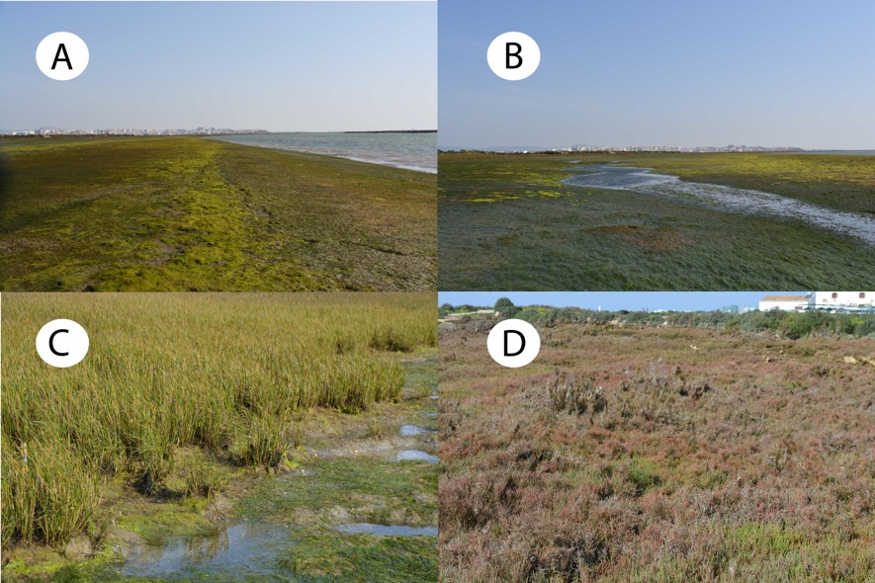
Figure S1. Illustrations of the studied salt-marsh vegetation. (A) Zostera noltei near Ramalhete channel; (B) view of the tidal creek cutting the tidal flat; (C) pioneer Spartina maritima; and (D) dominant Sarcocornia perennis in the mid-upper marsh.

Table S2. Maximum water depths, near-bed current velocities and tidal asymmetry derived by the skewness of the tidal currents (calculated from eq. (2)).
 | Neap tide |  |  | Spring tide
Parameter | S2 | S3 | S4* | S2 | S3 | S4
Maximum  water depth (m) | 1.23 | 1.05 | - | 1.76 | 1.56 | 0.94
Mean alongshore velocity (cm/s) | 1.57 | 0.41 | - | 2.32 | 5.02 | 0.49
Mean cross-shore velocity (cm/s) | 0.77 | 0.33 | - | 1.11 | 1.52 | 1.38
Current skewness [dominance] | 0.21 [flood] | 0.11 [flood] | - | 0.54 [flood] | 0.36 [flood] | 0.19 [flood]
^{*not reached during neap tide}

References for supplementary material
1. Neumeier, U. & Ciavola, P. Flow Resistance and Associated Sedimentary Processes in a Spartina maritima Salt-Marsh. J Coast Res 20, 435–447 (2004).
2. Moskalski, S. M. & Sommerfield, C. K. Suspended sediment deposition and trapping efficiency in a Delaware salt marsh. Geomorphology 139–140, 195–204 (2012).
3. Poirier, E., van Proosdij, D. & Milligan, T. G. The effect of source suspended sediment concentration on the sediment dynamics of a macrotidal creek and salt marsh. Cont Shelf Res 148, 130–138 (2017).
4. Ma, Z., Ysebaert, T., van der Wal, D. & Herman, P. M. J. Conditional effects of tides and waves on short-term marsh sedimentation dynamics. Earth Surf Process Landf 43, 2243–2255 (2018).
5. Christiansen, T., Wiberg, P. L. & Milligan, T. G. Flow and sediment transport on a tidal salt marsh surface. Estuar Coast Shelf Sci 50, 315–331 (2000).
6. Temmerman, S., Govers, G., Wartel, S. & Meire, P. Spatial and temporal factors controlling short-term sedimentation in a salt and freshwater tidal marsh, scheldt estuary, Belgium, SW Netherlands. Earth Surf Process Landf 28, 739–755 (2003).
7. Wang, A. A simplified conception model for salt marsh sedimentation rate calculation: Response to changing suspended sediment concentration-A case study of Wanggang salt marsh, Jiangsu Province, China. Frontiers of Earth Science in China 4, 403–409 (2010).
8. Ganju, N. K. et al. Sediment transport-based metrics of wetland stability. Geophysical Research Letters 42, 7992–8000 (2015).
9. Coleman, D. J. et al. Reconciling models and measurements of marsh vulnerability to sea level rise. Limnol Oceanogr Lett 7, 140–149 (2022).

