Supporting Information

Titanium-Protein Nanocomposites as New Biomaterials Produced by
High-Pressure Torsion

Ricardo Floriano^{1,*}; Kaveh Edalati²; Karina Danielle Pereira¹; Augusto Ducati Luchessi^{1,3}

¹ School of Applied Sciences, University of Campinas (FCA-UNICAMP), Pedro Zaccaria, 1300, 13484-350, Limeira, Brazil
² WPI, International Institute for Carbon-Neutral Energy Research (WPI-I2CNER), Kyushu University, Fukuoka 819-0395, Japan
³ Institute of Biosciences, São Paulo State University (UNESP), Rio Claro, São Paulo, Brazil.

*Corresponding author:
Ricardo Folriano (E-mail: rflorian@unicamp.br)

Figure S1 shows that the Vickers microhardness increases with increasing the distance from the disc center due to increasing shear strain. While the hardness of pure titanium reasonably saturates to a steady state at radiad distances of larger than 1 mm, the hardness for the composites containing 2 and 5 vol% of BSA do not reach the steady states after 5 turns of HPT. Therefore, larger numbers of HPT turns (i.e. larger shear strains) should be applied in future studies to achieve a steady-state microstructure and constant hardness in the Ti-BSA composite discs. Despite the difference in the evolution of hardness with the shear strain of the three samples, their hardness is quite similar at 4 mm away from the disc center, where the applied shear strain is maximum.

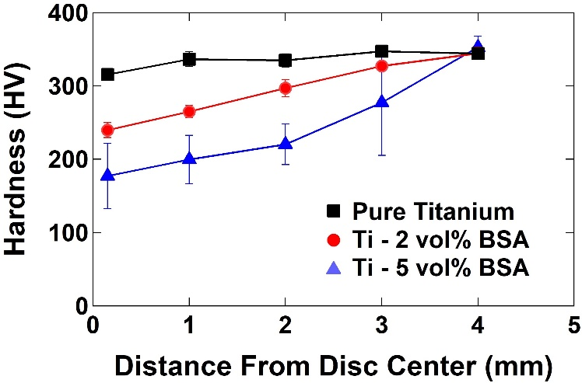

Figure S1. Variations of hardness versus distance from disc center for pure titanium and for the composites containing 2 and 5 vol% of BSA after 5 turns of HPT under 2 GPa.

