SUPPLEMENTARY FILE

Table S1. The MS/MS fragmentation spectra of the components that were identified in the studied Acorus calamus essential oil by HPLC-MS
2-Allyl-5-ethoxy-4-methoxyphenol isomer 1 | 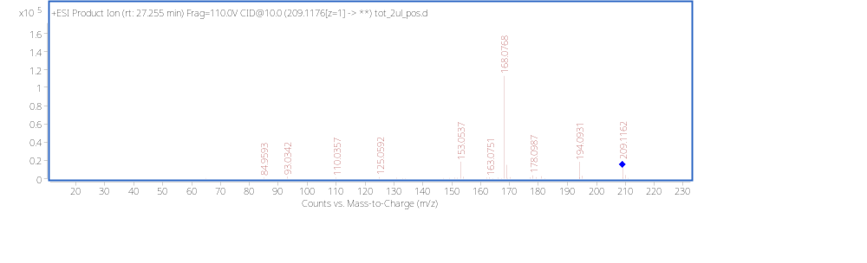
2-Allyl-5-ethoxy-4-methoxyphenol isomer 2 | 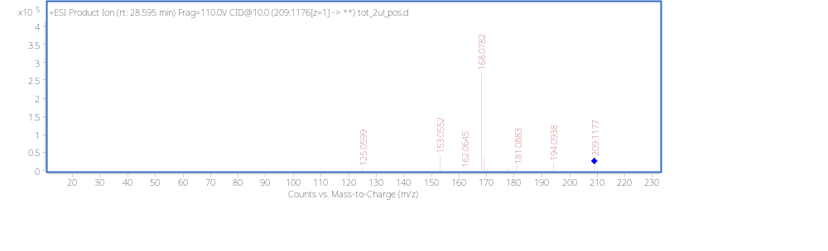
2-Allyl-5-ethoxy-4-methoxyphenol isomer 3 | 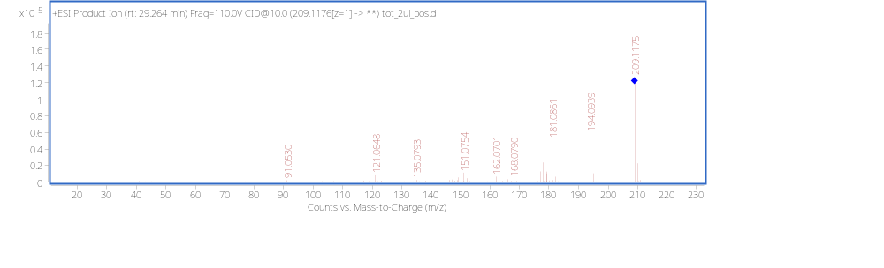
a-Cedrene | 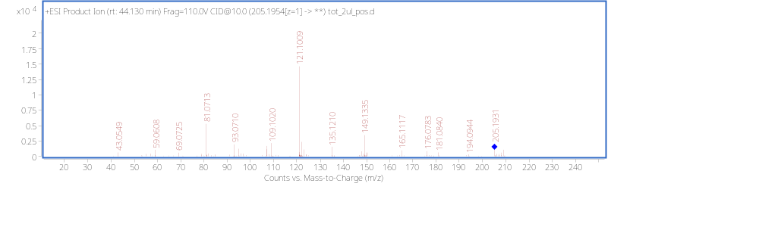
Acoronene | 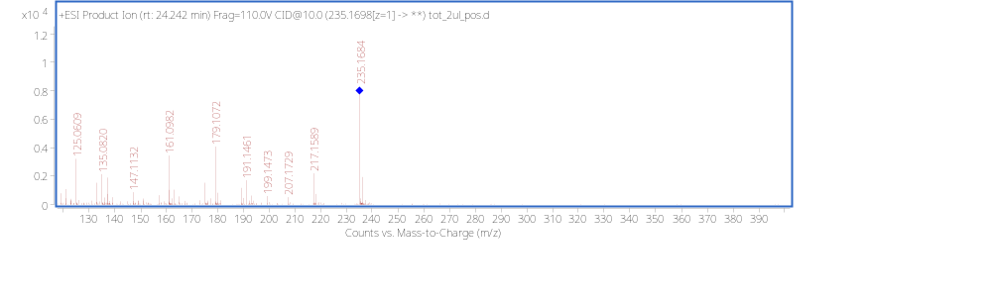
Acorusnol | 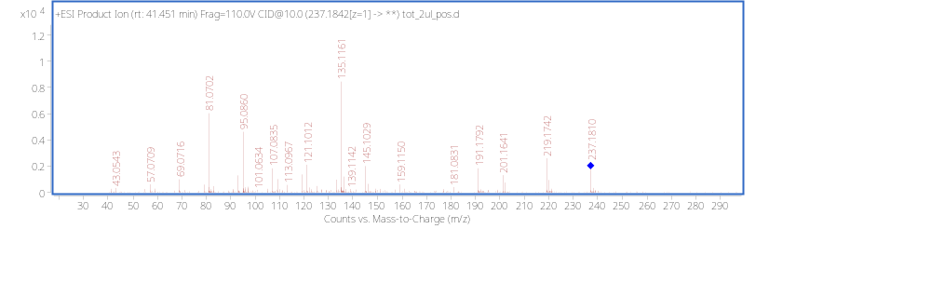
Asaronaldehyde | 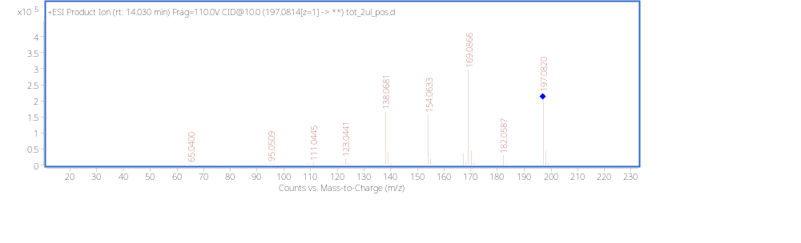
Aspidinol | 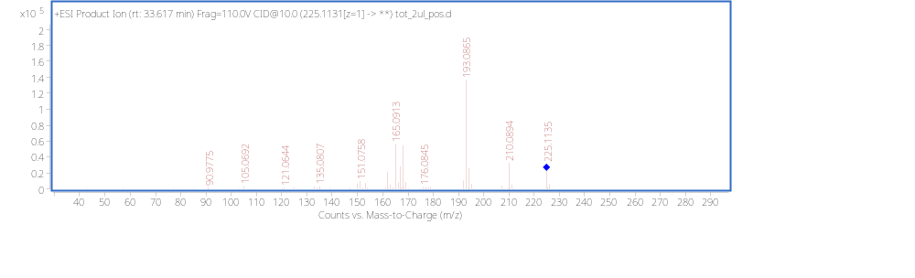
Calamenene | 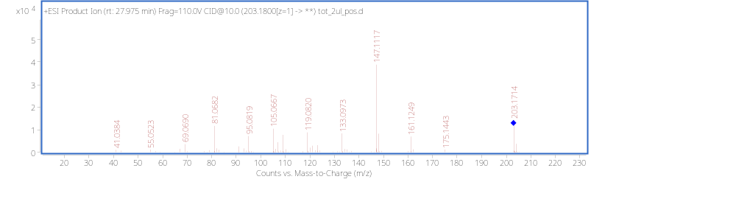
Calamenene isomer | 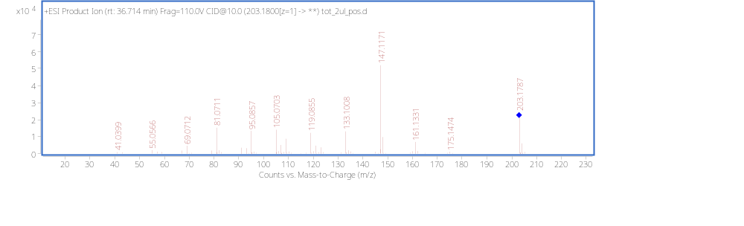
Calarene | 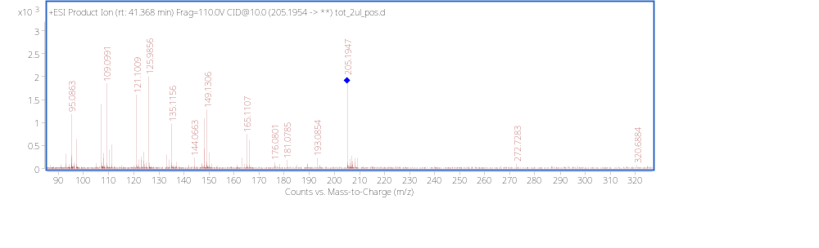
Gluconic acid | 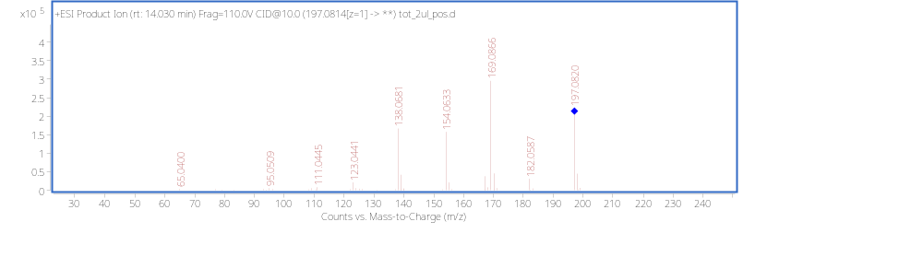
Isoacoramone | 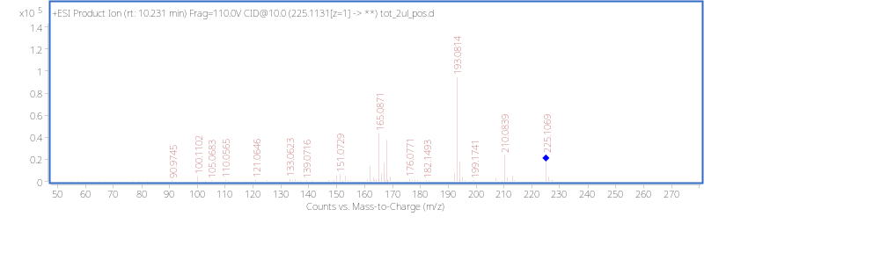
Methyl eugenol | 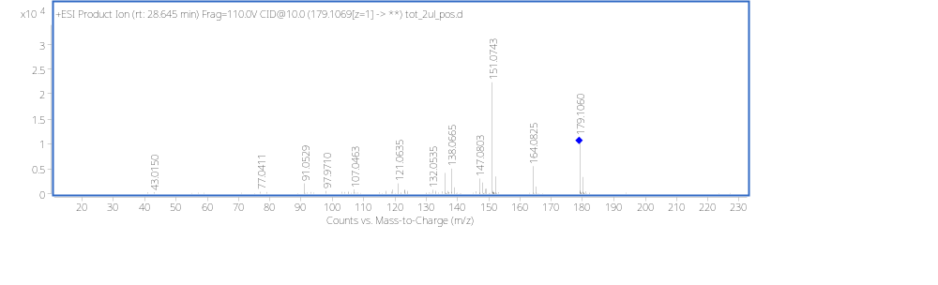
Shyobunone | 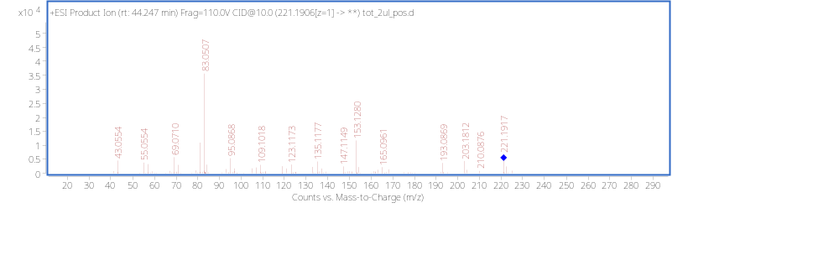
Squamulosone isomer 1 | 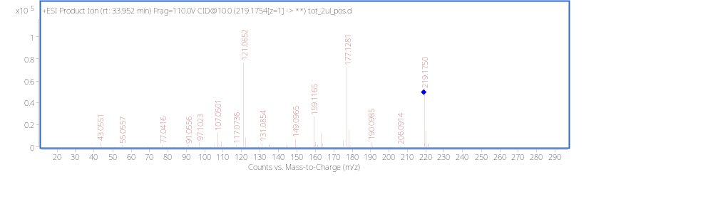
Squamulosone isomer 2 | 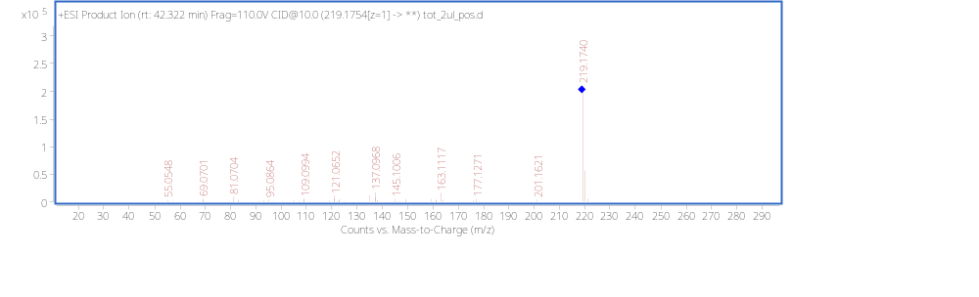
Isoacoramone isomer2 | 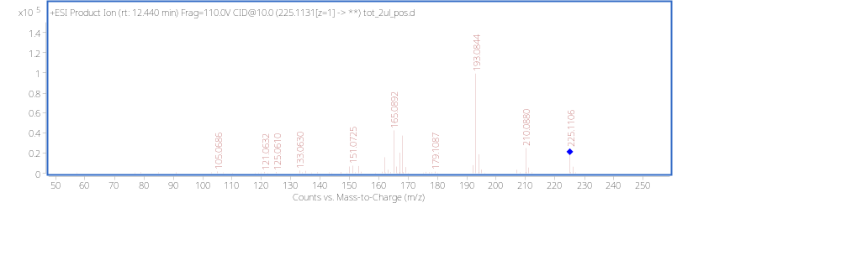

Table S2. Original variables’ loadings in the space of the first two dimensions (varivectors, i.e. principal components after the VARIMAX rotation).

 | Dimension 1 | Dimension 2
β-asarone | -0,99991 | 0,013181
γ-asarone | -0,02275 | 0,999741
α-asarone | 0,995484 | -0,09493

Table S3. Samples’ (=sources’) scores in the space of the first two dimensions.

 | Dimension 1 | Dimension 2
S4 | 1,226921 | 0,404046
S5 | 0,354334 | 0,13808
S6 | 3,900486 | 0,564937
S7 | -2,46135 | 0,855178
S8 | -1,47784 | 1,038685
S9 | -2,41469 | 0,677813
S1 | 0,96468 | -0,70188
S2 | -0,10416 | -0,94954
S3 | 0,011629 | -2,02732

Table S4. Purity of the isolates after CPC fractionation.

Sample |  | Standard EO | α – asarone fraction | β – asarone fraction
Asarone content [%] | α | 4.7 | 93.7 | 3.5
Asarone content [%] | β | 94.1 | 1.0 | 95.5
Asarone content [%] | γ | 1.1 | 2.2 | 1.0

