Supplementary Materials

Supplementary Figure S1. Quality scores (Phred score) of (A) forward and (B) reverse reads.

Supplementary Figure S2. Comparison of the taxonomic composition between samples from (A-B) homogenized stools and (C) non-homogenized stools at baseline. Stool samples were obtained from 10 healthy volunteers.

Supplementary Figure S3. Pairwise distances of Bray–Curtis dissimilarity based on the predicted MetaCyc pathways between the baseline and 18 months. DNA/RNA Shield, DNA/RNA shield fecal collection tube; OMNIgene, OMNIgene-Gut; RT, room temperature.

Supplementary Figure S4. Relative abundances of the inferred MetaCyc pathways at the baseline and 18 months after storage. (A) Pentose phosphate pathway (nonoxidative branch) I, (B) gondoate biosynthesis (anaerobic), (C) adenosine ribonucleotides de novo biosynthesis, and (D) UMP biosynthesis I.

Supplementary Table S1. Pairwise comparison of beta diversity from baseline and 18 months samples by PERMANOVA

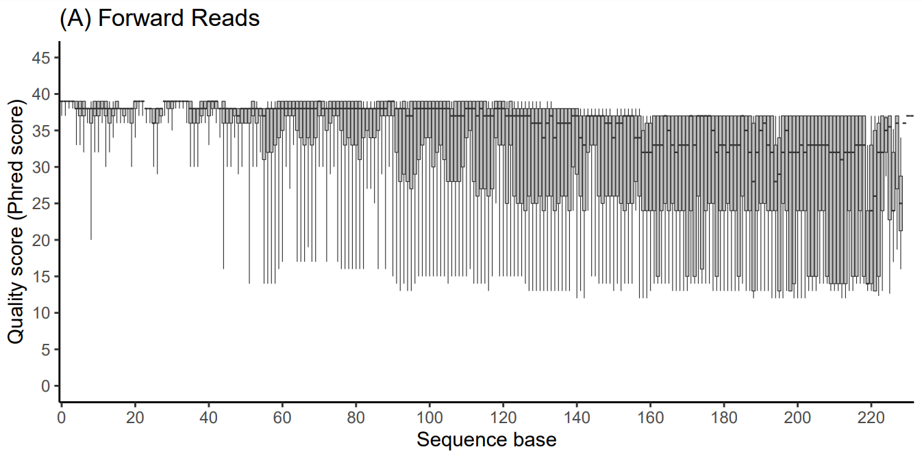
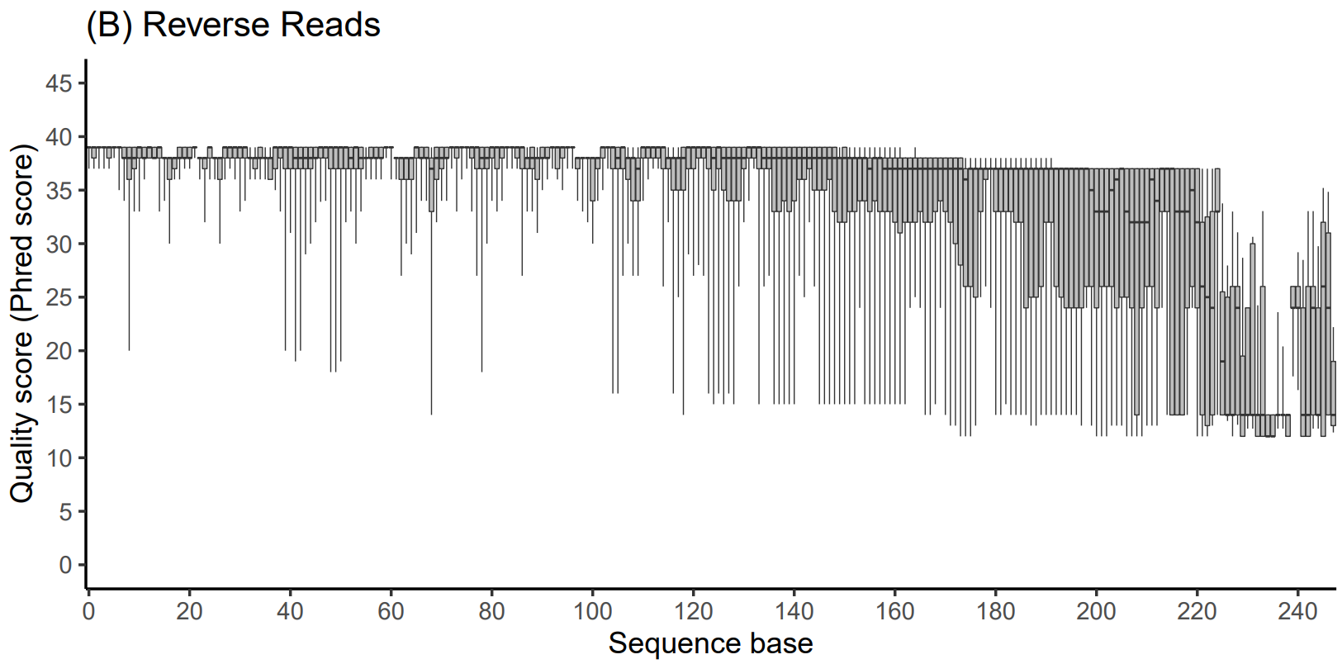
Supplementary Figure S1. Quality scores (Phred score) of (A) forward and (B) reverse reads.

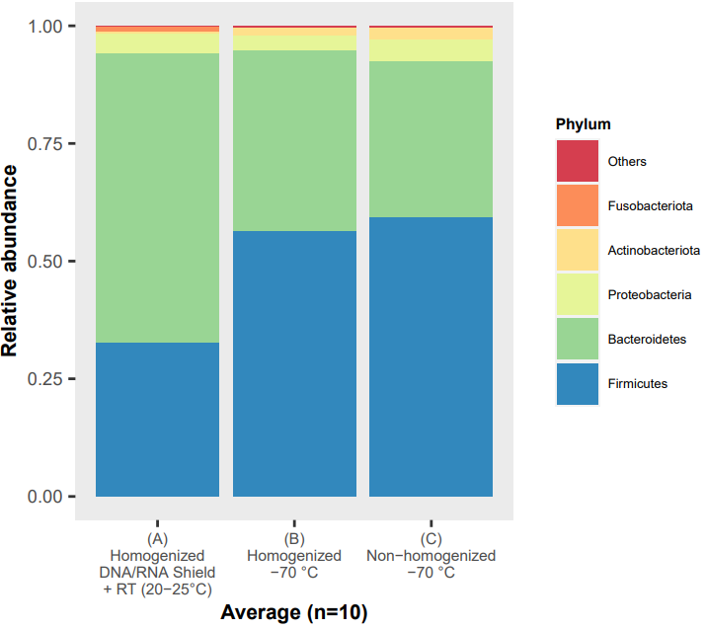
Supplementary Figure S2. Comparison of the taxonomic composition between samples from (A-B) homogenized stools and (C) non-homogenized stools obtained at baseline. Stool samples were obtained from 10 healthy volunteers. (A) Samples were stored in the DNA/RNA shield fecal collection tube at RT until 16s rRNA sequencing. (B-C) Samples were stored under -70 ℃ until 16S rRNA sequencing.

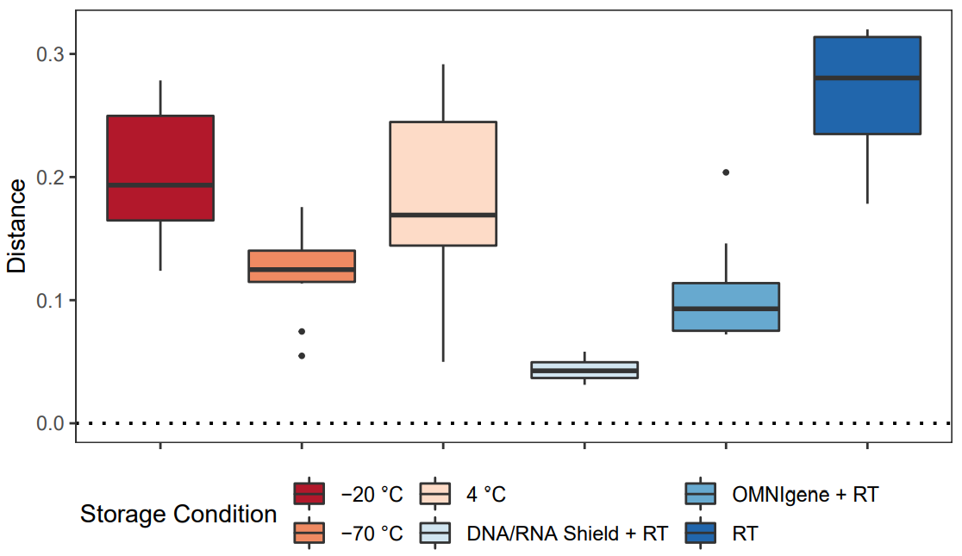
Supplementary Figure S3. Pairwise distances of Bray–Curtis dissimilarity based on the predicted MetaCyc pathways between the baseline and 18 months. DNA/RNA Shield, DNA/RNA shield fecal collection tube; OMNIgene, OMNIgene-Gut; RT, room temperature.

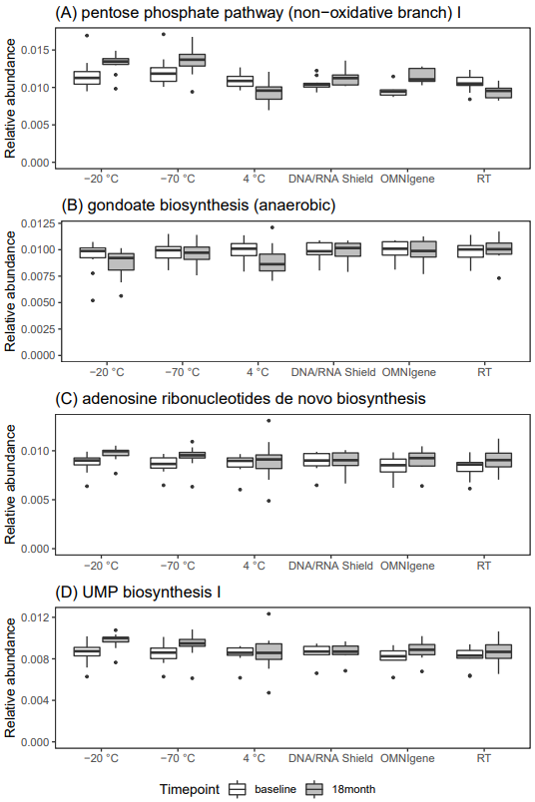
Supplementary Figure S4. Relative abundances of the inferred MetaCyc pathways at the baseline and 18 months after storage. (A) Pentose phosphate pathway (nonoxidative branch) I, (B) gondoate biosynthesis (anaerobic), (C) adenosine ribonucleotides de novo biosynthesis, and (D) UMP biosynthesis I.

Supplementary Table S1. Pairwise comparison of beta diversity from baseline and 18 months samples by PERMANOVA
Metric | Group | Sample size | q-value
Unweighted Unifrac | -20 ℃ | 20 | 0.013
Unweighted Unifrac | -70 ℃ | 20 | 0.584
Unweighted Unifrac | 4 ℃ | 20 | 0.02
Unweighted Unifrac | DNA/RNA Shield + RT | 18 | 0.268
Unweighted Unifrac | OMNIgene + RT | 18 | 0.449
Unweighted Unifrac | RT (20-25 ℃) | 20 | 0.001
Weighted Unifrac | -20 ℃ | 20 | 0.001
Weighted Unifrac | -70 ℃ | 20 | 0.011
Weighted Unifrac | 4 ℃ | 20 | 0.001
Weighted Unifrac | DNA/RNA Shield + RT | 18 | 0.848
Weighted Unifrac | OMNIgene + RT | 18 | 0.012
Weighted Unifrac | RT (20-25 ℃) | 20 | 0.001
RT, Room temperature

