Supplementary material 1
The summary results derived from the additional matched data set (1st)
Clinical characteristics after the matching
 | After matching
 | Desflurane | Sevoflurane | SMD
 | (n =231) | (n =231) | SMD
Age (yr) | 53.0 [44.5, 65.0] | 52.0 [40.0, 66.5] | 0.080
Sex (male) | 90 (39.0) | 80 (34.6) | 0.090
BMI (kg m^{–2}) | 24.4 [21.9, 27.1] | 24.0 [21.6, 27.0] | 0.020
CCI* | 5.0 [4.0, 7.0] | 5.0 [3.0, 7.0] | 0.054
ASA>2 | 33 (14.3) | 28 (12.1) | 0.064
Duration of anesthesia (min) | 1.6 [1.1, 2.2] | 1.4 [1.0, 2.3] | 0.056
Hypertension | 68 (29.4) | 65 (28.1) | 0.029
Diabetes mellitus | 31 (13.4) | 35 (15.2) | 0.049
Coronary artery disease | 3 (1.3) | 1 (0.4) | 0.094
Chronic obstructive pulmonary disease | 3 (1.3) | 1 (0.4) | 0.094
Liver cirrhosis | 3 (1.3) | 5 (2.2) | 0.066
Chronic renal dysfunction |  |  | <0.001
On hemodialysis | 4 (1.7) | 4 (1.7)
No hemodialysis | 4 (1.7) | 4 (1.7)
Emergency | 19 (8.2) | 14 (6.1) | 0.084
Type of surgery |  |  | 0.062
Otolaryngology | 19 (8.2) | 17 (7.4)
General | 121 (52.4) | 125 (54.1)
Gynecology | 59 (25.5) | 56 (24.2)
Plastic | 11 (4.8) | 13 (5.6)
Urology | 21 (9.1) | 20 (8.7)
Vasopressor infusion | 6 (2.6) | 6 (2.6) | <0.001
Transfusion | 7 (3.0) | 5 (2.2) | 0.054
Intraoperative fluid intake (L) | 0.5 [0.4, 0.7] | 0.6 [0.4, 0.8] | 0.032
Intraoperative remifentanil  (μg kg–1 min–1) | 0.1 [0.1, 0.1] | 0.1 [0.1, 0.1] | 0.051
Mean MAC | 0.7 [0.7, 0.8] | 0.7 [0.7, 0.8] | 0.027
SMD, standardized mean difference; BMI, body mass index; CCI, Charlson comorbidity index; ASA, American Society of Anesthesiologists physical status; MAC, minimum alveolar concentration. *Before index date (day of surgery). Data are reported as median (interquartile range) or number (%).
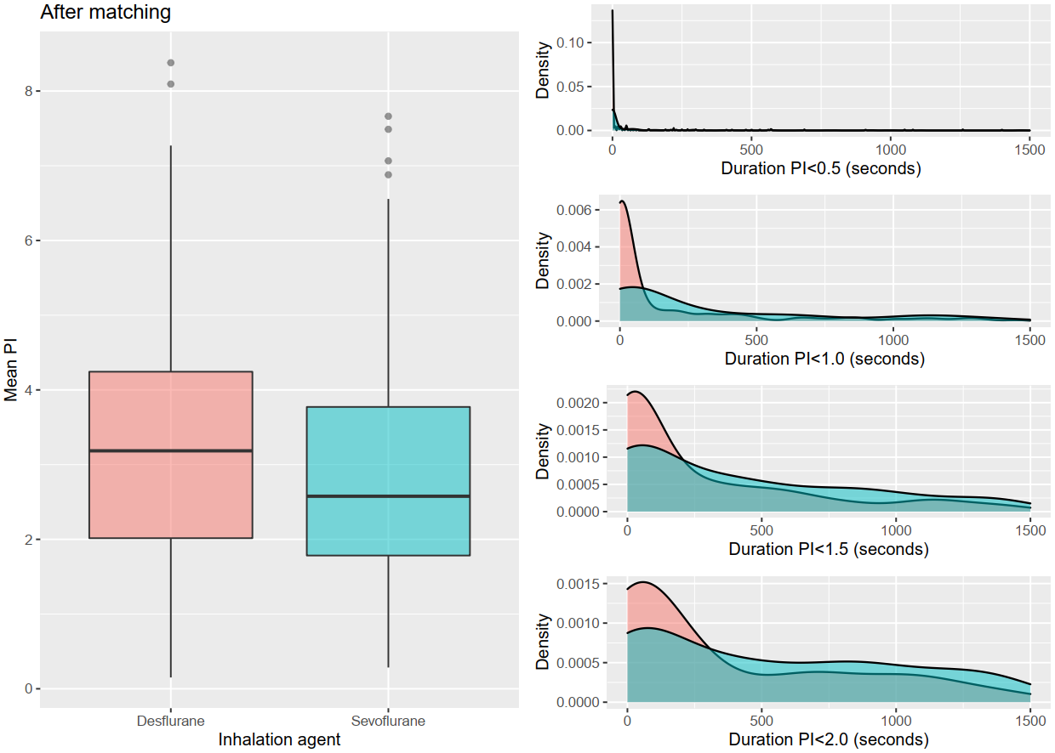
Box-and-whisker plot for mean perfusion index (PI) and kernel density plot for the duration of below threshold PIs stratified by the type of inhalation agent after propensity score matching.

 | Desflurane | Sevoflurane | P*
 | (n=231) | (n=231) | P*
Baseline PI | 3.5 [2.3, 4.3] | 3.3 [1.9, 4.4] | 0.302
Mean PI | 3.2 [2.0, 4.2] | 2.6 [1.8, 3.8] | 0.001
* Result of paired test. Data are given as median [IQR]

Summary of the generalized linear mixed model
Predictors | Exp (estimate)* | 95% CI | P
Inhalation agent (sevoflurane) | 0.85 | 0.79 – 0.92 | <0.001
Mean MAP (10 mmHg)** | 0.92 | 0.88 – 0.97 | 0.001
Mean HR (10 BPM)** | 0.95 | 0.92 – 0.99 | 0.017
Age (yr) | 1 | 0.99 – 1.00 | 0.011
Sex (male) | 0.95 | 0.86 – 1.06 | 0.365
BMI (kg m^{–2}) | 0.99 | 0.98 – 1.00 | 0.084
CCI | 1 | 0.98 – 1.02 | 0.886
ASA (>2) | 0.84 | 0.72 – 0.99 | 0.036
Duration of anesthesia (hr) | 0.85 | 0.80 – 0.91 | <0.001
Hypertension | 0.96 | 0.86 – 1.07 | 0.471
Diabetes mellitus | 1.12 | 0.98 – 1.28 | 0.091
Coronary artery disease | 1.53 | 1.02 – 2.28 | 0.039
Chronic obstructive pulmonary disease | 1.54 | 1.03 – 2.30 | 0.035
Liver cirrhosis | 1.14 | 0.83 – 1.55 | 0.42
Chronic renal dysfunction
- On hemodialysis | 1.2 | 0.82 – 1.75 | 0.358
- No hemodialysis | 1.17 | 0.84 – 1.64 | 0.357
Emergency | 0.87 | 0.73 – 1.04 | 0.121
Type of surgery***
- General | 0.95 | 0.81 – 1.11 | 0.509
- Gynecology | 0.84 | 0.70 – 1.01 | 0.064
- Plastic | 1.16 | 0.93 – 1.46 | 0.186
- Urology | 0.83 | 0.67 – 1.02 | 0.078
Vasopressor infusion | 0.74 | 0.52 – 1.05 | 0.089
Transfusion | 0.59 | 0.39 – 0.89 | 0.012
Intraoperative fluid intake (mL) | 1.08 | 0.97 – 1.21 | 0.170
Remifentanil (μg kg^{–1} min^{–1}) | 0.48 | 0.09 – 2.47 | 0.382
Mean MAC | 2.39 | 1.32 – 4.34 | 0.004
MAP, mean arterial pressure; HR, heart rate; BPM, beat per minute; BMI, body mass index; CCI, Charlson comorbidity index; ASA, American Society of Anesthesiologists physical status; MAC, minimum alveolar concentration *Exponential of the estimate. **Re-scaled using 10-fold multiplication. ***Otolaryngological surgery was considered reference.

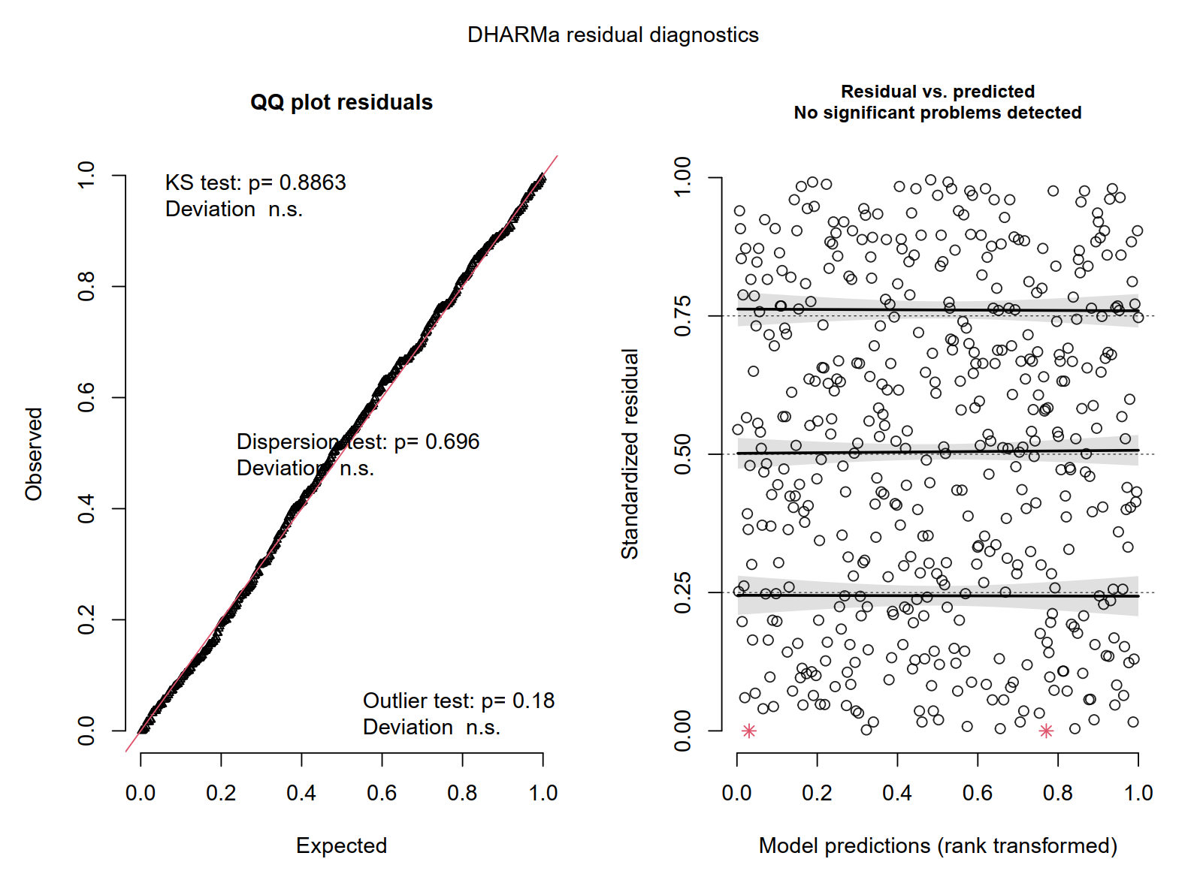
Result of the model diagnostics using DHARMa package
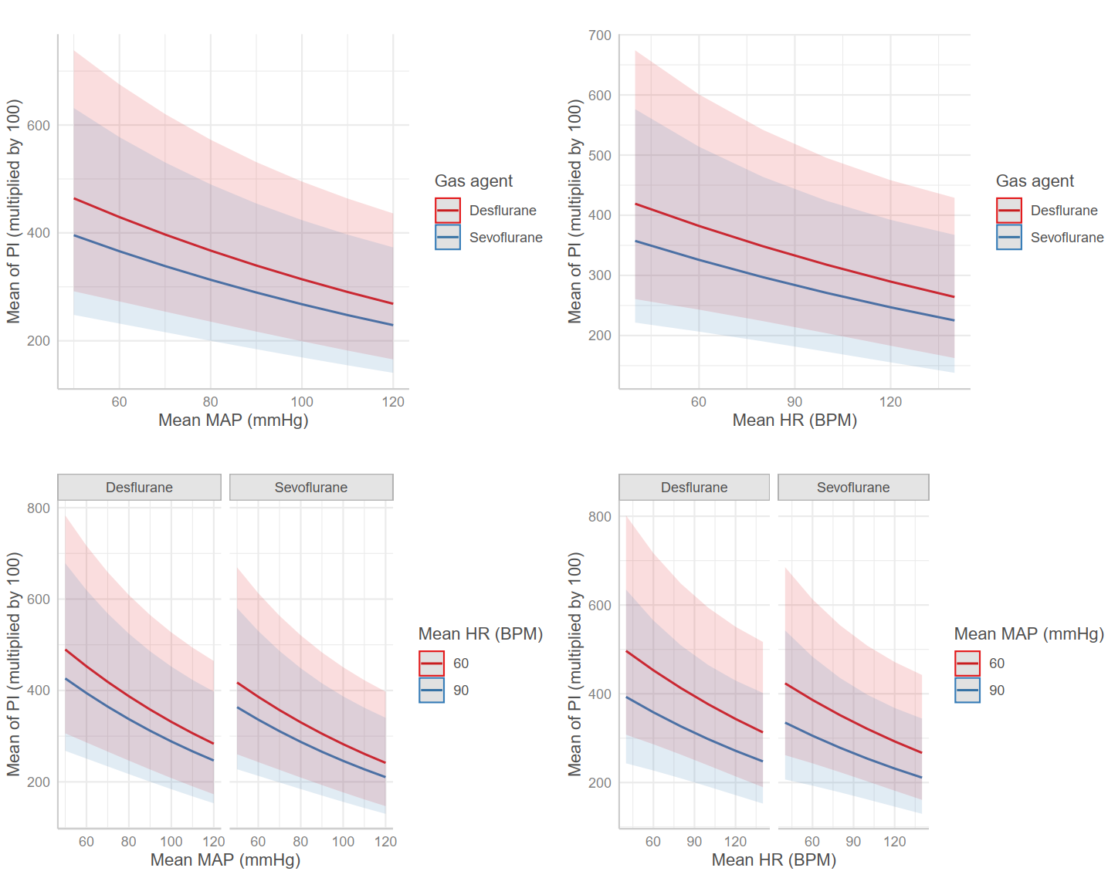
The relationship between mean MAP, mean heart rate, and mean PI stratified by the type of inhalation agent
The plot presents the estimated marginal mean of the mean PI derived from the mixed effect model. The shaded areas represent the 95% confidence interval of the estimated means. Note that the perfusion index on y-axis is multiplied by 100.

