Supplementary material 2
The summary results derived from the additional matched data set (2nd)
Clinical characteristics after the matching
 | After matching
 | Desflurane | Sevoflurane | SMD
 | (n =231) | (n =231) | SMD
Age (yr) | 53.0 [43.0, 65.0] | 51.0 [40.0, 66.0] | 0.055
Sex (male) | 78 (33.8) | 78 (33.8) | <0.001
BMI (kg m^{–2}) | 24.2 [22.0, 27.0] | 24.0 [21.6, 27.0] | 0.016
CCI* | 5.0 [4.0, 7.0] | 5.0 [ 3.0, 7.0] | 0.020
ASA>2 | 33 (14.3) | 27 (11.7) | 0.077
Duration of anesthesia (min) | 1.6 [1.1, 2.3] | 1.4 [1.0, 2.2] | 0.003
Hypertension | 65 (28.1) | 64 (27.7) | 0.010
Diabetes mellitus | 30 (13.0) | 34 (14.7) | 0.050
Coronary artery disease | 2 (0.9) | 1 (0.4) | 0.054
Chronic obstructive pulmonary disease | 3 (1.3) | 1 (0.4) | 0.094
Liver cirrhosis | 1 (0.4) | 4 (1.7) | 0.126
Chronic renal dysfunction |  |  | 0.066
On hemodialysis | 4 (1.7) | 4 (1.7)
No hemodialysis | 5 (2.2) | 3 (1.3)
Emergency | 18 (7.8) | 14 (6.1) | 0.068
Type of surgery |  |  | 0.129
Otolaryngology | 21 (9.1) | 17 (7.4)
General | 119 (51.5) | 124 (53.7)
Gynecology | 63 (27.3) | 57 (24.7)
Plastic | 14 (6.1) | 13 (5.6)
Urology | 14 (6.1) | 20 (8.7)
Vasopressor infusion | 7 (3.0) | 6 (2.6) | 0.026
Transfusion | 6 (2.6) | 4 (1.7) | 0.060
Intraoperative fluid intake (L) | 0.6 [0.4, 0.8] | 0.6 [0.4, 0.8] | 0.007
Intraoperative remifentanil  (μg kg–1 min–1) | 0.1 [0.1, 0.1] | 0.1 [0.1, 0.1] | 0.048
Mean MAC | 0.7 [ 0.7; 0.8] | 0.7 [ 0.7; 0.8] | 0.014
SMD, standardized mean difference; BMI, body mass index; CCI, Charlson comorbidity index; ASA, American Society of Anesthesiologists physical status; MAC, minimum alveolar concentration. *Before index date (day of surgery). Data are reported as median (interquartile range) or number (%).
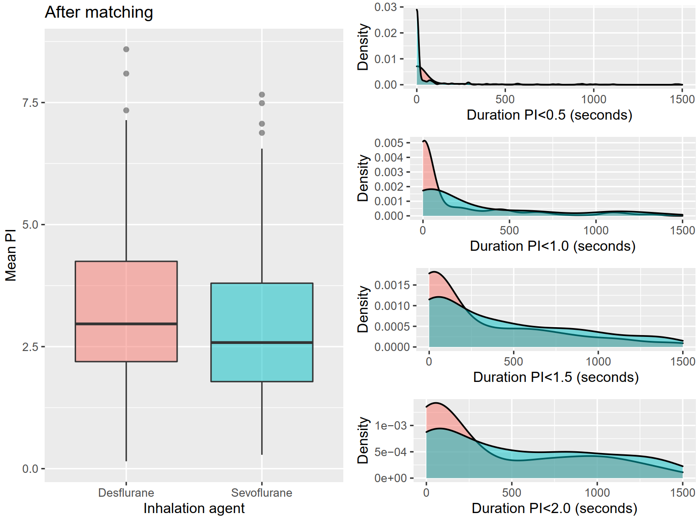
Box-and-whisker plot for mean perfusion index (PI) and kernel density plot for the duration of below threshold PIs stratified by the type of inhalation agent after propensity score matching.

 | Desflurane | Sevoflurane | P*
 | (n=231) | (n=231) | P*
Baseline PI | 3.3 [2.3, 4.3] | 3.2 [1.9, 4.4] | 0.386
Mean PI | 3.0 [2.2, 4.2] | 2.6 [1.8, 3.8] | 0.005
* Result of paired test. Data are given as median [IQR]

Summary of the generalized linear mixed model
Predictors | Exp (estimate)* | 95% CI | P
Inhalation agent (sevoflurane) | 0.85 | 0.79 – 0.92 | <0.001
Mean MAP (10 mmHg)** | 0.92 | 0.88 – 0.96 | 0.001
Mean HR (10 BPM)** | 0.95 | 0.92 – 0.99 | 0.012
Age (yr) | 0.99 | 0.99 – 1.00 | 0.008
Sex (male) | 0.95 | 0.85 – 1.05 | 0.322
BMI (kg m^{–2}) | 1 | 0.98 – 1.01 | 0.547
CCI | 1 | 0.98 – 1.03 | 0.937
ASA (>2) | 0.9 | 0.77 – 1.05 | 0.192
Duration of anesthesia (hr) | 0.86 | 0.81 – 0.91 | <0.001
Hypertension | 0.94 | 0.84 – 1.06 | 0.307
Diabetes mellitus | 1.13 | 0.98 – 1.29 | 0.085
Coronary artery disease | 1.21 | 0.75 – 1.94 | 0.441
Chronic obstructive pulmonary disease | 1.48 | 0.99 – 2.21 | 0.054
Liver cirrhosis | 1.11 | 0.75 – 1.65 | 0.599
Chronic renal dysfunction
- On hemodialysis | 1.14 | 0.78 – 1.66 | 0.506
- No hemodialysis | 1.3 | 0.95 – 1.79 | 0.096
Emergency | 0.89 | 0.75 – 1.07 | 0.221
Type of surgery***
- General | 0.84 | 0.73 – 0.98 | 0.029
- Gynecology | 0.75 | 0.63 – 0.89 | 0.001
- Plastic | 1.11 | 0.90 – 1.37 | 0.351
- Urology | 0.77 | 0.62 – 0.95 | 0.017
Vasopressor infusion | 0.74 | 0.53 – 1.02 | 0.070
Transfusion | 0.51 | 0.32 – 0.81 | 0.004
Intraoperative fluid intake (mL) | 1.07 | 0.95 – 1.20 | 0.292
Remifentanil (μg kg^{–1} min^{–1}) | 1.15 | 0.24 – 5.54 | 0.859
Mean MAC | 1.95 | 1.09 – 3.50 | 0.025
MAP, mean arterial pressure; HR, heart rate; BPM, beat per minute; BMI, body mass index; CCI, Charlson comorbidity index; ASA, American Society of Anesthesiologists physical status; MAC, minimum alveolar concentration *Exponential of the estimate. **Re-scaled using 10-fold multiplication. ***Otolaryngological surgery was considered reference.

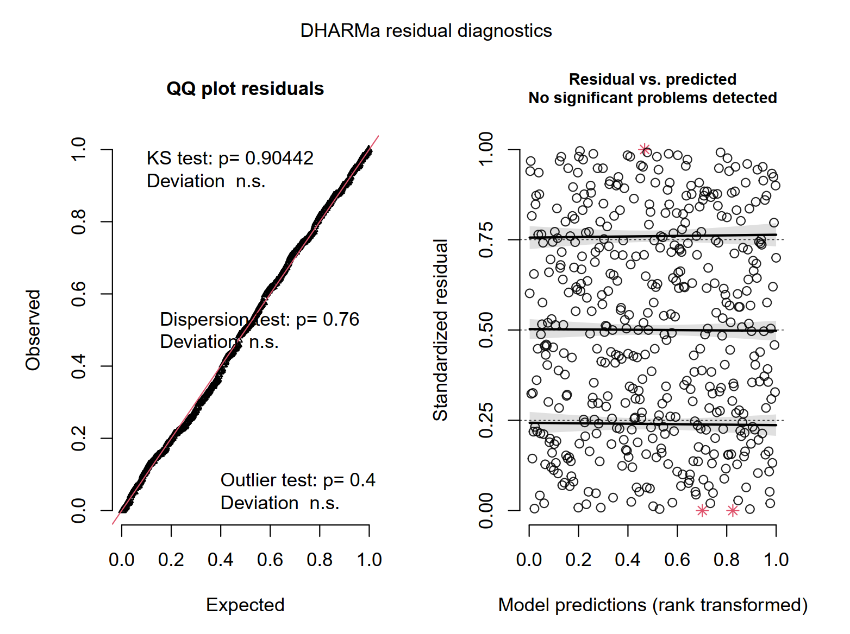
Result of the model diagnostics using DHARMa package
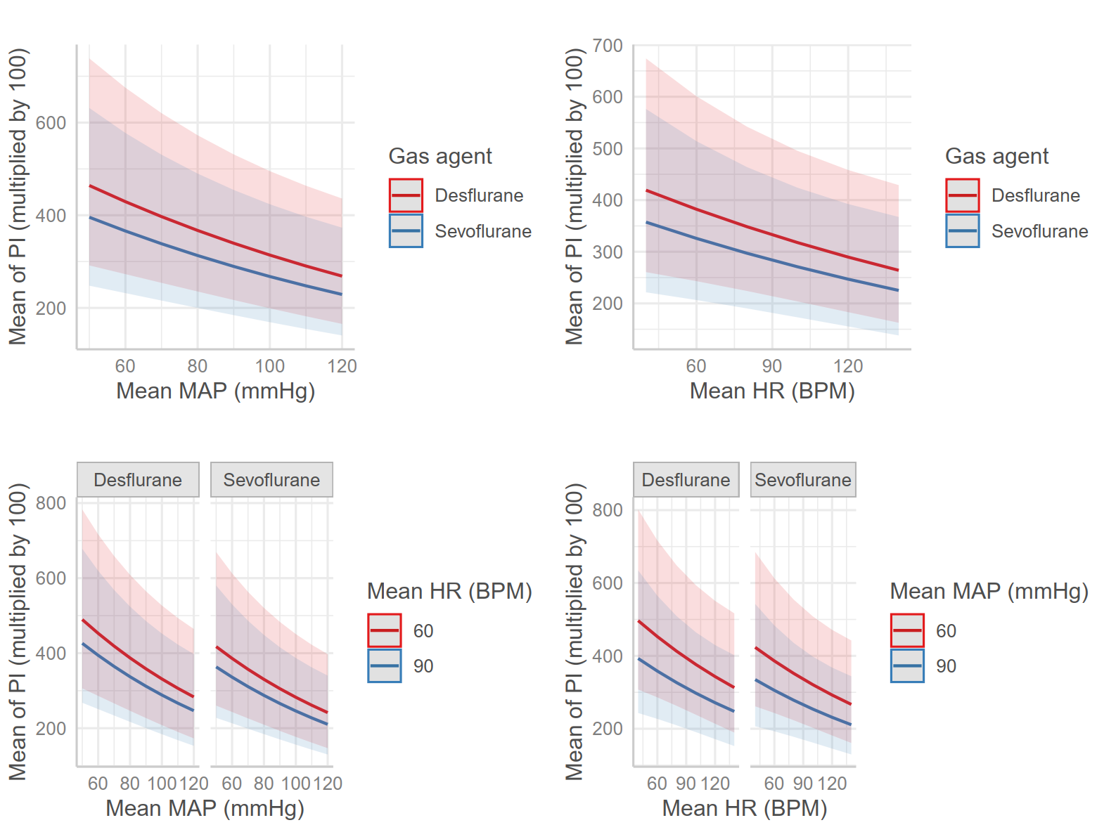
The relationship between mean MAP, mean heart rate, and mean PI stratified by the type of inhalation agent
The plot presents the estimated marginal mean of the mean PI derived from the mixed effect model. The shaded areas represent the 95% confidence interval of the estimated means. Note that the perfusion index on y-axis is multiplied by 100.

