Supplementary Fig. 1

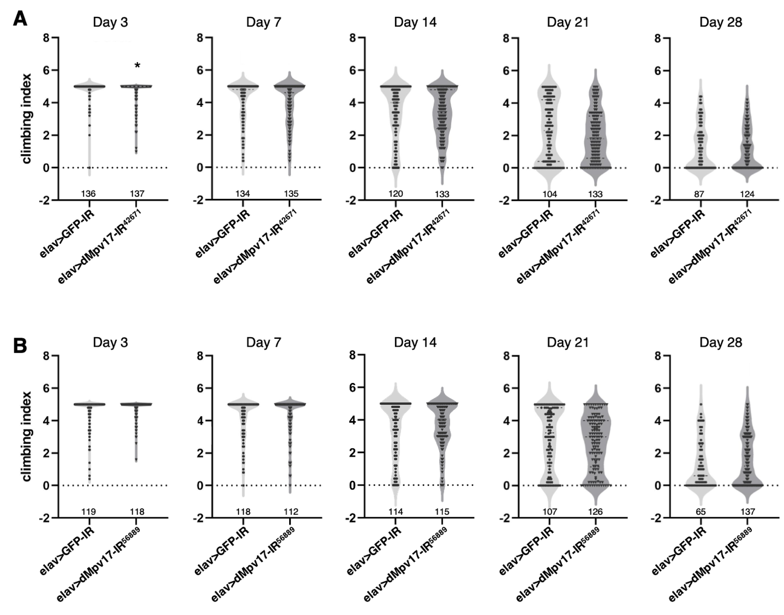
Supplementary Fig. 1 Knockdown of dMpv17 did not affect climbing ability. (A) The climbing score of elav>dMpv17-IR⁴²⁶⁷¹ (A) or elav>dMpv17-IR⁵⁶⁸⁸⁹ (B) on various days after eclosion was compared with that of the control elav>GFP-IR fly. *P<0.05, statistical analysis was performed using Student’s t-test vs elav>GFP-IR.

Supplementary Fig. 2
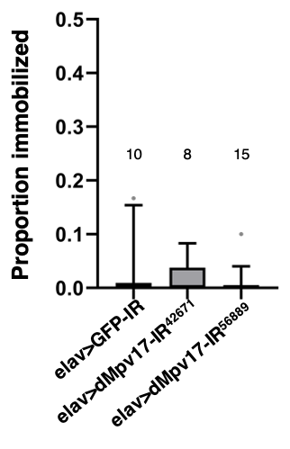
Supplementary Fig. 2 Knockdown of dMpv17 did not induce seizures. The dot plot shows the proportion of adult flies immobilized for more than 3 s after vortexing at the highest speed. The statistical analysis was performed using one-way ANOVA followed by Dunnett’s multiple comparisons test vs elav>GFP-IR. The number of replicate experiments is shown above each genotype. The bar graph shows the mean ± SEM.

Supplementary Fig. 3
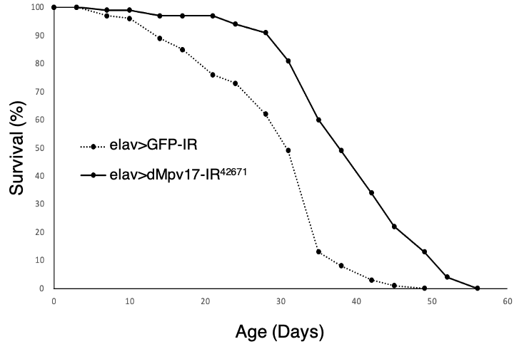
Supplementary Fig. 3 Knockdown of dMpv17 did not affect the life span of adult male flies. The percentage survival of adult male flies carrying UAS-GFP-IR/+; elav-GAL4/+ (n=136) or UAS-dMpv17-IR⁴²⁶⁷¹/+; elav-GAL4/+ (n=137) The median lifespan for each strain is 31 days and 38 days, respectively.

