Supplementary Table 1
(A) Comparison of descriptive statistics between observed and predicted knowledge scores (%)
 | Observed knowledge %  (N=6466) | Predicted knowledge %  (N=6238)
Mean (SD) | 54.73 (13.33) | 54.49 (9.58)
Median | 60.00 | 56.92
Percentiles
25 | 52.00 | 50.62
50 | 60.00 | 56.92
75  100 | 64.00  88.00 | 61.09  75.26

(B) Comparison of descriptive statistics between observed and predicted behaviour scores (%)
 | Observed knowledge %  N=6466 | Predicted knowledge %  N=6238
Mean (SD) | 67.62 (14.97) | 67.47 (11.62)
Median | 65.85 | 66.98
Percentiles
25 | 58.54 | 60.37
50 | 65.85 | 66.98
75  100 | 78.05  100.0 | 76.27  97.78

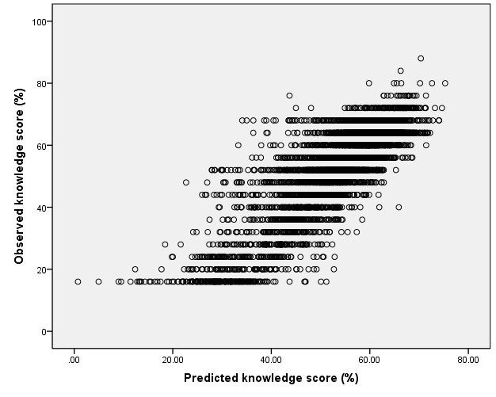
rho= 0.847
P<0.001
Supplementary Figure 1 Correlation between observed and predicted knowledge scores (%)

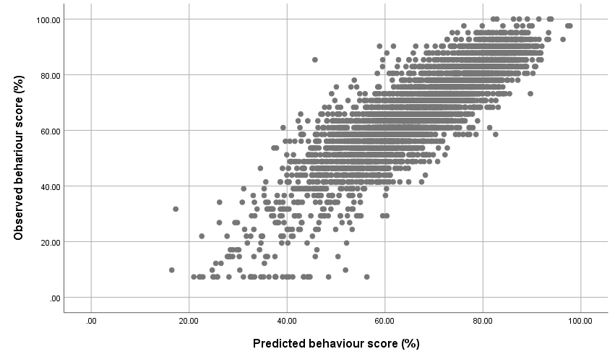
rho= 0.883
P<0.001
Supplementary Figure 2 Correlation between observed and predicted behaviour scores (%)

