Supplement Figure 1. Picture of camerasss setting
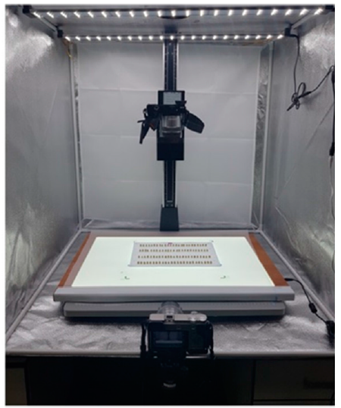

Supplement Figure 2. Data conversion from image to digital figures
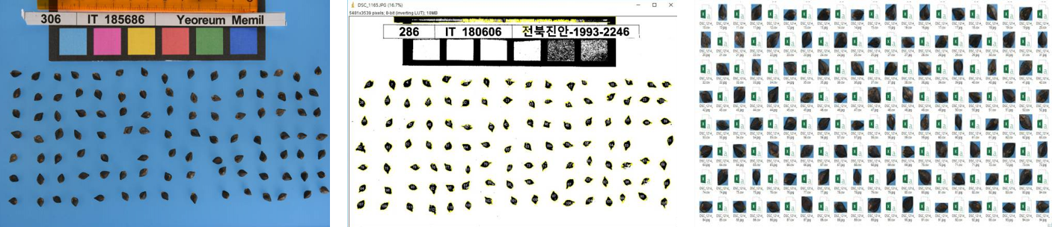

Supplement Figure 3. The distortion value varying the number of clusters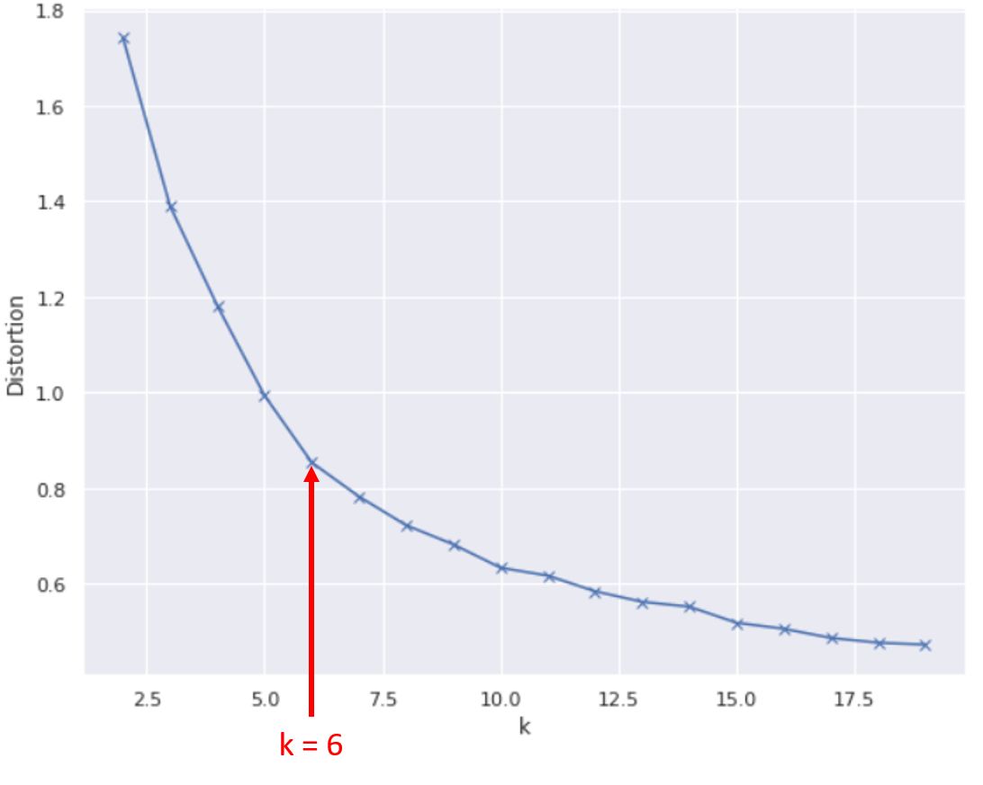

Supplement Figure 4. The kernel density estimate plots for each variables
