Supplementary Figure 1
Verification of transgenic events and quantification of GmmiR156b expression in Arabidopsis seedlings. (a) PCR confirmation of positive transgenic Arabidopsis plants carrying GmmiR156b by gene-specific primers. (b) RT-PCR analysis of pri-GmmiR156b in the leaf of the wild type (WT) and eight independent transgenic lines. Lanes 1-8, transgenic lines; lane 9, the WT. M, DNA marker DL2000.
1 2 3 4 5 6 7 8 M
- miR156B
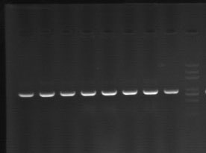
-201 bp

Tublin
1 2 3 4 5 6 7 8 9 M
Pri-miR156b
1 2 3 4 5 6 7 8 9 M

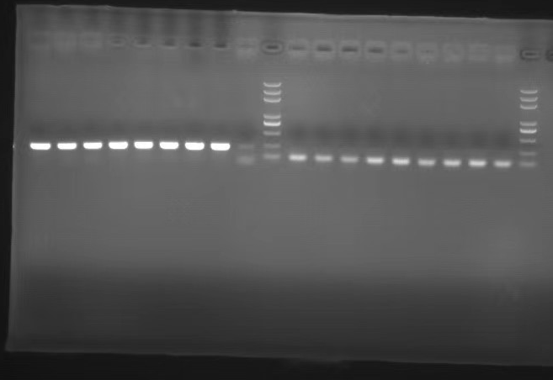
-201 bp

