Supporting Information
(Scientific Reports)
Synthesis, properties, and application of the new nanocatalyst of double layer hydroxides in the one-pot multicomponent synthesis of 2-amino-3-cyanopyridine derivativesp
Sarieh Momeni, Ramin Ghorbani-Vaghei*
Department of Organic Chemistry, Faculty of Chemistry, Bu-Ali Sina University, Hamedan, 6517838683, Iran
*Corresponding author; E-mail: rgvaghei@yahoo.com & ghorbani@basu.ac.ir
Contents Pages
Spectra data ..3
2-amino-4-(4-chlorophenyl)-6-cyclopropylnicotinonitrile (5g) 3
2-amino-6-cyclopropyl-4-(2,4-dichlorophenyl)nicotinonitrile (5k)……………………………3
2-amino-6-cyclopropyl-4-(4-methoxyphenyl)nicotinonitrile (5h) 3
2-amino-6-cyclopropyl-4-(2-fluorophenyl)nicotinonitrile (5i) 3
2-amino-4-(4-fluorophenyl)-6-phenylnicotinonitrile (5d) 3
Figure 1. HNMR Spectrum of 2-amino-4-(4-chlorophenyl)-6-
cyclopropylnicotinonitrile (5g). 4
Figure 2. CNMR Spectrum of 2-amino-4-(4-chlorophenyl)-6-
cyclopropylnicotinonitrile (5g). 5
Figure 3. FTIR Spectrum of 2-amino-4-(4-chlorophenyl)-6-
cyclopropylnicotinonitrile (5g). 6
Figure 4. HNMR Spectrum of 2-amino-6-cyclopropyl-4-
(2,4-dichlorophenyl)nicotinonitrile (5k). 7
Figure 5. CNMR Spectrum of 2-amino-6-cyclopropyl-4-
(2,4-dichlorophenyl)nicotinonitrile (5k). 8
Figure 6. FTIR Spectrum of 2-amino-6-cyclopropyl-4-
(2,4-dichlorophenylFT)nicotinonitrile (5k). ……………..…….9
Figure 7. HNMR Spectrum of 2-amino-6-cyclopropyl-4-
(4-methoxyphenyl)nicotinonitrile (5h) 10
Figure 8. CNMR Spectrum of 2-amino-6-cyclopropyl-4-
(4-methoxyphenyl)nicotinonitrile (5h) 11
Figure 9. FTIR Spectrum of 2-amino-6-cyclopropyl-4-
(4-methoxyphenyl)nicotinonitrile (5h). 12
Figure 10. HNMR Spectrum of 2-amino-6-cyclopropyl-4-
(2-fluorophenyl)nicotinonitrile in chloroform solvent (5i)……………………….……………...…13
Figure 11. HNMR Spectrum of 2-amino-6-cyclopropyl-4-
(2-fluorophenyl)nicotinonitrile in DMSO solvent(5i)…………………….………….….14
Figure 12. CNMR Spectrum of 2-amino-6-cyclopropyl-4-
(2-fluorophenyl)nicotinonitrile in DMSO solvent (5i).…….................................................15
Figure 13. FTIR Spectrum of 2-amino-6-cyclopropyl-4-
(2-fluorophenyl)nicotinonitrile(5i)……………………… ………………………………16
Figure 14. HNMR Spectrum of 2-amino-4-(4-fluorophenyl)-6-
phenylnicotinonitrile(5d)……………………………..………………………………….17
Figure 15. CNMR Spectrum of 2-amino-4-(4-fluorophenyl)-6-
phenylnicotinonitrile (5d) ………………………………………………………………18
Figure 16. FTIR Spectrum of 2-amino-4-(4-fluorophenyl)-6-
phenylnicotinonitrile(5d)….....................……………………………………………….19

Spectra data
2-amino-4-(4-chlorophenyl)-6-cyclopropylnicotinonitrile (5g)
M.p. 178-180 °C, FT-IR (KBr, ν cm⁻¹): 3419, 3317, 3168, 2208, 1646, 1495, 1382, 1257, 818. 1H NMR (300 MHz, Chloroform-d): δ (ppm) 7.60-7.39 (s, 5H), 6.54 (s, 1H), 5.16 (s, 1H), 1.94 (s, 1H), 1.08 (s, 4H). 13C NMR (63 MHz, DMSO): δ (ppm) 167.56, 161.40, 152.75, 136.07, 135.17, 130.47, 129.34, 118.02, 111.36, 85.07, 17.71, 10.75.
2-amino-6-cyclopropyl-4-(2,4-dichlorophenyl)nicotinonitrile (5k)
M.p. 156-158 °C, FT-IR (KBr, ν cm⁻¹): 3407, 3314, 3175, 2211, 1647, 1557, 1471, 1389, 1267, 1101, 818. 1H NMR (300 MHz, Chloroform-d): δ (ppm) 7.57 (s, 1H), 7.35 (s, 2H), 6.57 (s, 1H), 5.09 (s, 2H), 1.97 (s, 1H), 1.13 – 0.99 (m, 4H). 13C NMR (63 MHz, DMSO): δ (ppm) 167.82, 160.93, 151.27, 135.64, 134.94, 132.86, 129.61, 128.14, 116.93, 111.54, 86.73, 17.73, 10.95.
2-amino-6-cyclopropyl-4-(4-methoxyphenyl)nicotinonitrile (5h)
M.p. 128-130 °C, FT-IR (KBr, ν cm⁻¹): 3433, 3351, 3238, 2211, 1640, 1574, 1455, 1382, 1249, 828. 1H NMR (250 MHz, DMSO-d6): δ (ppm) 7.52 (d, 2H), 7.02 (d, 2H), 7.00 – 6.60 (m, 2H), 6.59 (s, 1H), 3.87 (s, 3H), 1.97 (s, 1H), 1.06 (d, J = 65.4 Hz, 4H). 13C NMR (63 MHz, DMSO): δ (ppm) 167.14, 161.19, 160.50, 153.65, 130.02, 117.80, 114.57, 110.91, 102.92, 85.29, 55.50, 17.66, 11.30.
2-amino-6-cyclopropyl-4-(2-fluorophenyl)nicotinonitrile (5i)
M.p. 132-134 °C, FT-IR (KBr, ν cm⁻¹): 3409, 3311, 3164, 2215, 1647, 1494, 1389, 1258,1000, 881, 756. 1H NMR (300 MHz, DMSO-d6): δ (ppm) 7.50 – 7.31 (m, 4H, ArH), 6.81 (s, 2H, NH2), 6.63 (s, 1H, pyridine ring), 2.01 (p, J = 6.4 Hz, 1H, C-H), 0.96 (d, J = 6.4 Hz, 4H, 2 C-H2). 13C NMR (63 MHz, DMSO): δ (ppm) 167.56, 160.98, 148.92, 132.40, 131.22, 125.28, 116.62, 116.14, 111.57, 86.73, 17.68, 10.82.
2-amino-4-(4-fluorophenyl)-6-phenylnicotinonitrile (5d)
M.p. 208-211 °C, FT-IR (KBr, ν cm⁻¹): 3475, 3311, 3195, 2207, 1645, 1575, 1511, 1448, 1372, 1234, 1159, 831, 767. 1H NMR (300 MHz, Chloroform-d): δ (ppm) 8.00 (dt, J = 6.3, 4.0 Hz, H), 7.64 (s, 2H), 7.50 (s, 2H), 7.22 (d, J = 8.6 Hz, 2H), 5.39 (s, 2H), 1.26 (s, 1H), 0.93 (s, 4H).

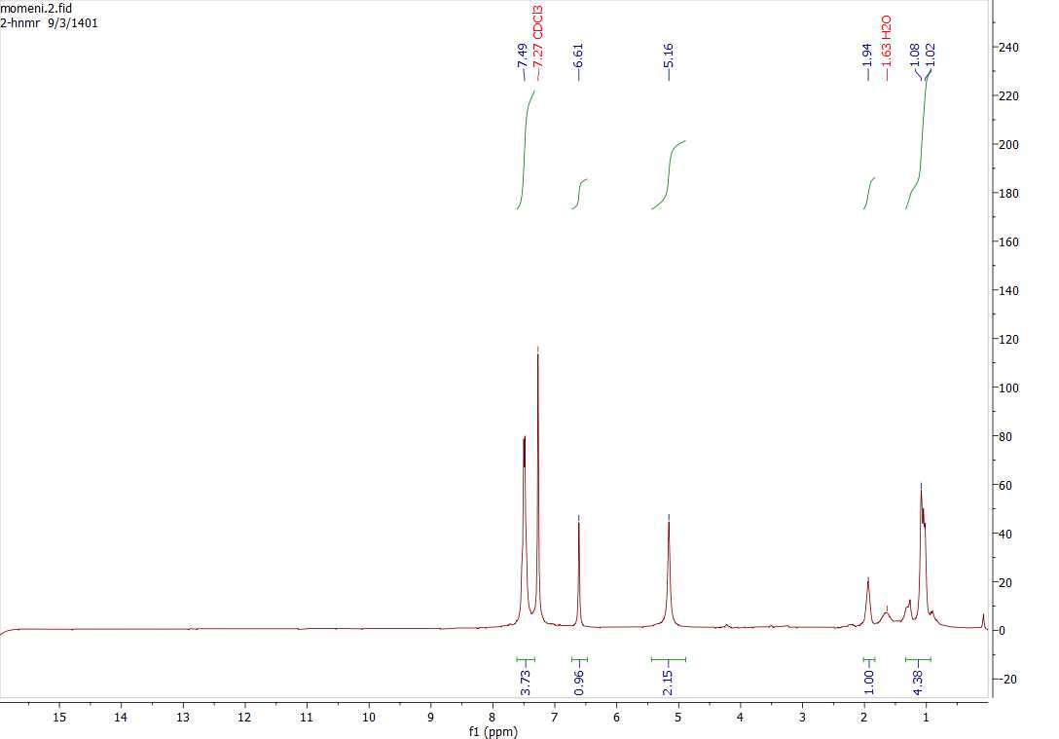
Figure 1. HNMR Spectrum of 2-amino-4-(4-chlorophenyl)-6-cyclopropylnicotinonitrile (5g)

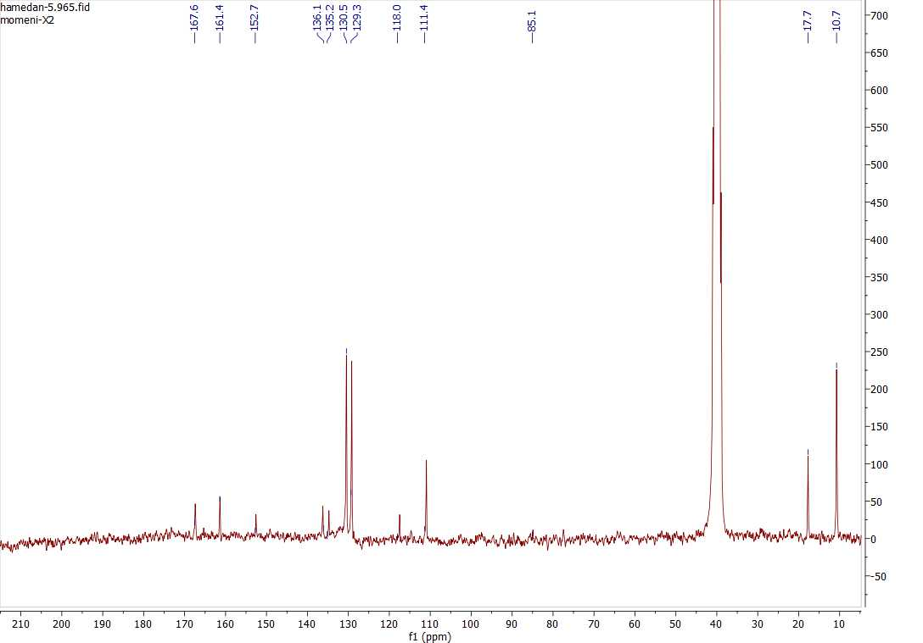
Figure 2. CNMR Spectrum of 2-amino-4-(4-chlorophenyl)-6-cyclopropylnicotinonitrile (5g)

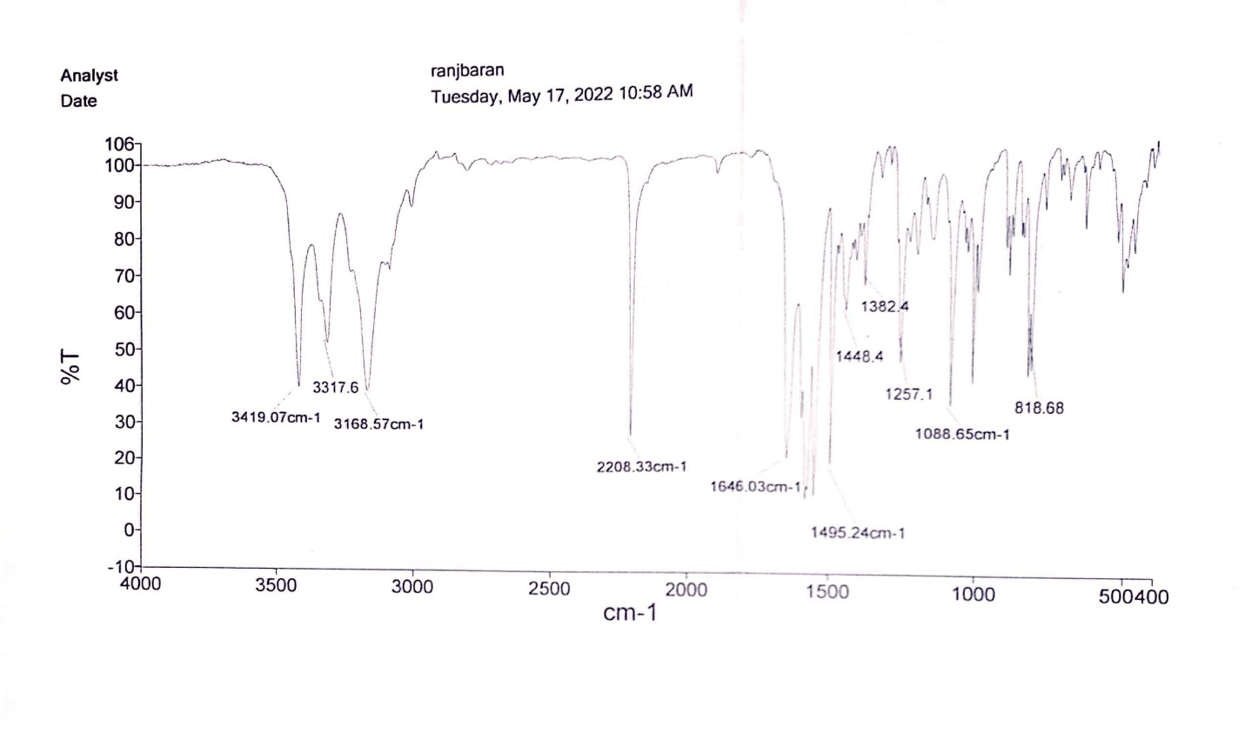
Figure 3. FTIR Spectrum of 2-amino-4-(4-chlorophenyl)-6-cyclopropylnicotinonitrile (5g)

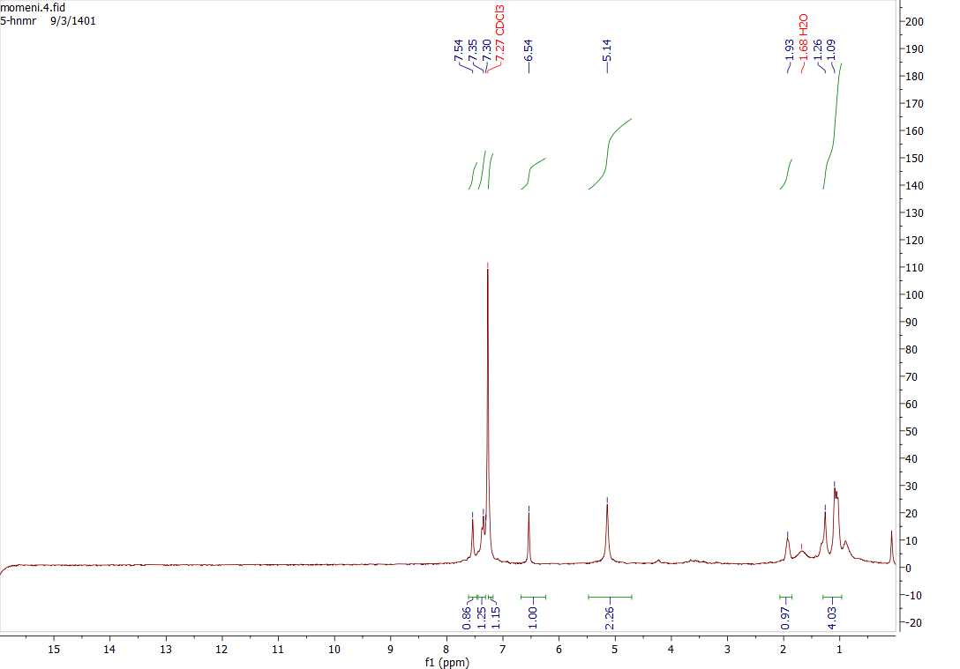
Figure 4. HNMR Spectrum of 2-amino-6-cyclopropyl-4-(2,4-dichlorophenyl)nicotinonitrile (5k)

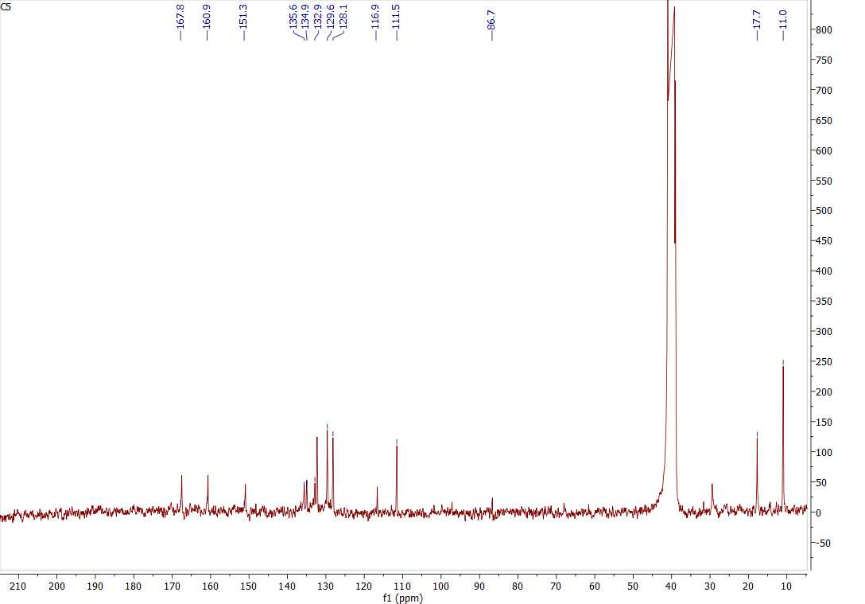
Figure 5. CNMR Spectrum of 2-amino-6-cyclopropyl-4-(2,4-dichlorophenyl)nicotinonitrile (5k)

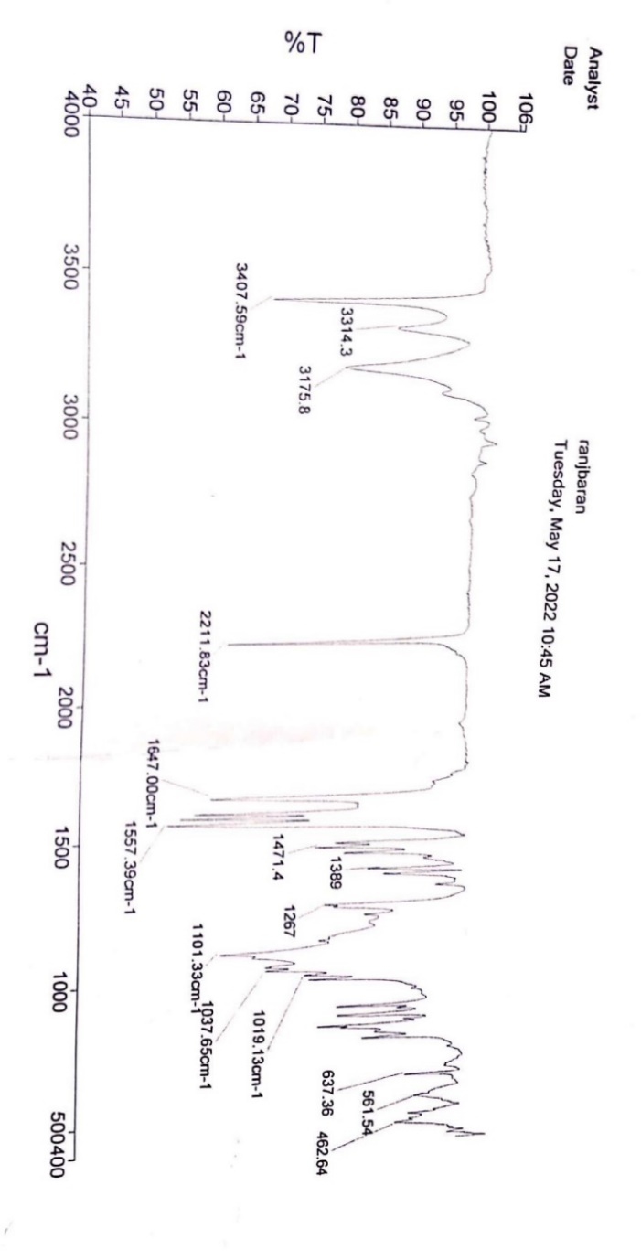

Figure 6. FTIR Spectrum of 2-amino-6-cyclopropyl-4-(2,4-dichlorophenyl)nicotinonitrile (5k)

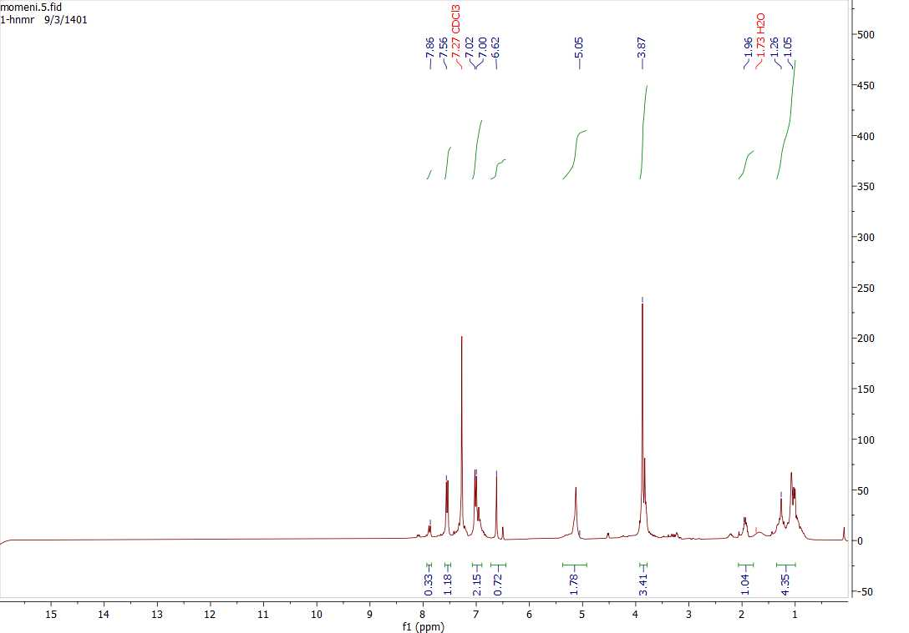
Figure 7. HNMR Spectrum of 2-amino-6-cyclopropyl-4-(4-methoxyphenyl)nicotinonitrile (5h)

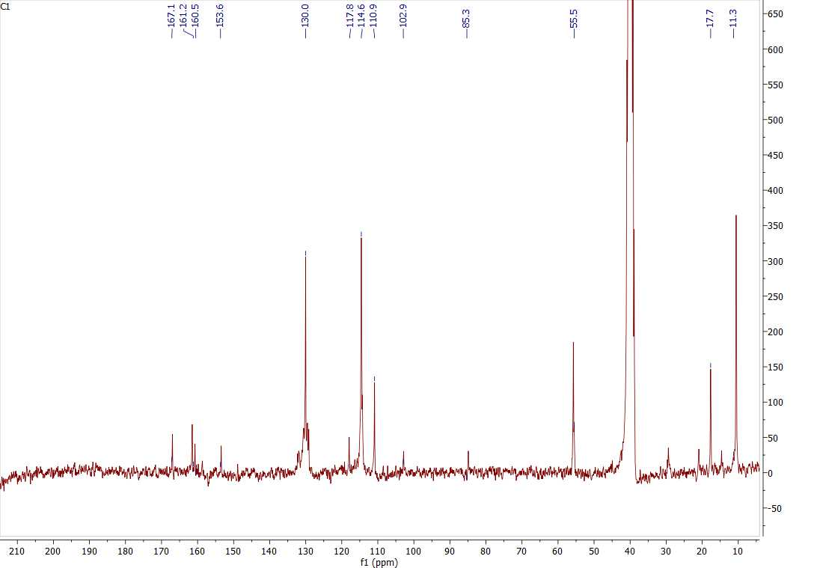
Figure 8. CNMR Spectrum of 2-amino-6-cyclopropyl-4-(4-methoxyphenyl)nicotinonitrile (5h)

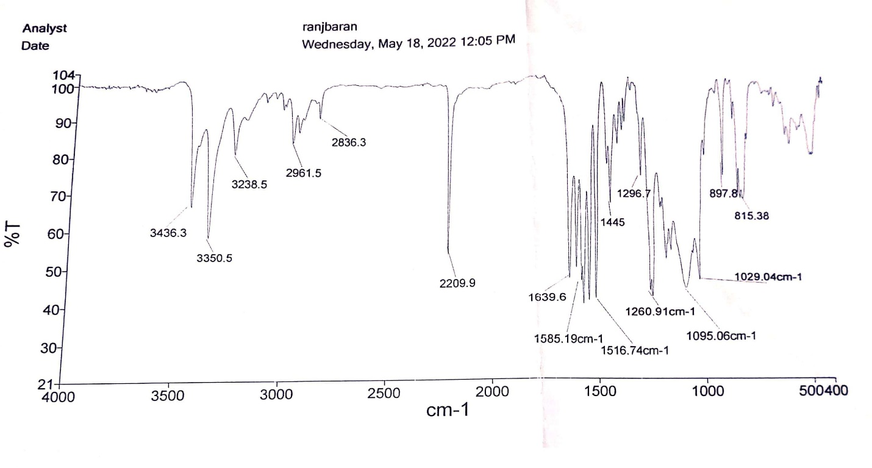
Figure 9. FTIR Spectrum of 2-amino-6-cyclopropyl-4-(4-methoxyphenyl)nicotinonitrile (5h)

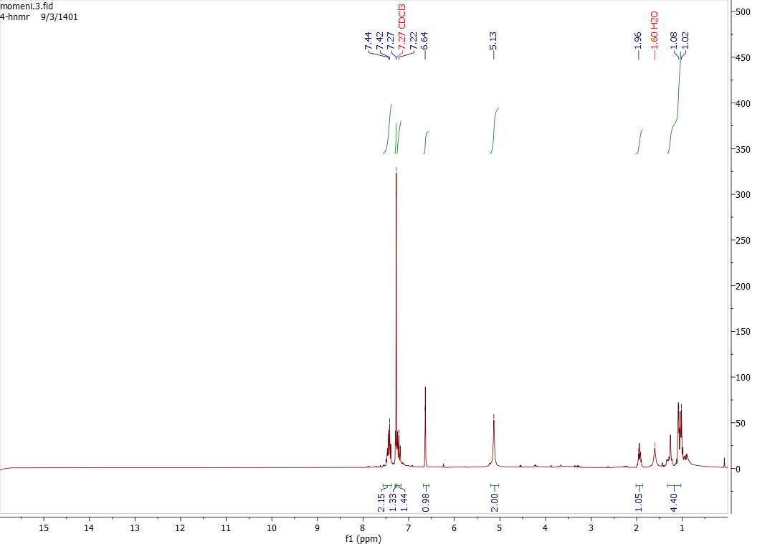
Figure 10. HNMR Spectrum of 2-amino-6-cyclopropyl-4-(2-fluorophenyl)nicotinonitrile in chloroform solvent (5i)

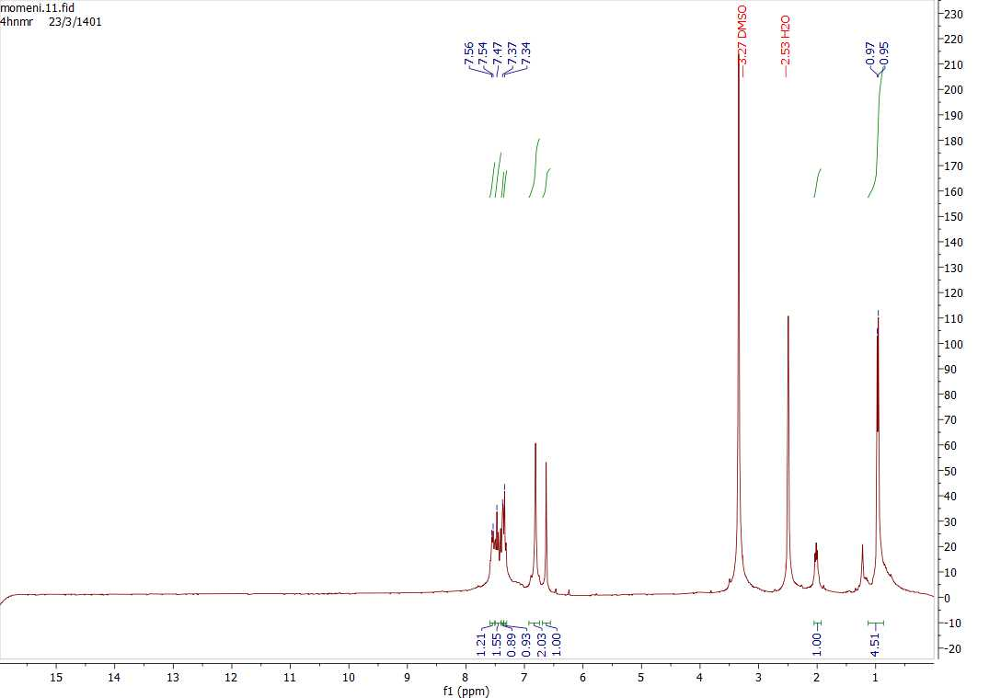
Figure 11. HNMR Spectrum of 2-amino-6-cyclopropyl-4-(2-fluorophenyl)nicotinonitrile in DMSO solvent (5i)

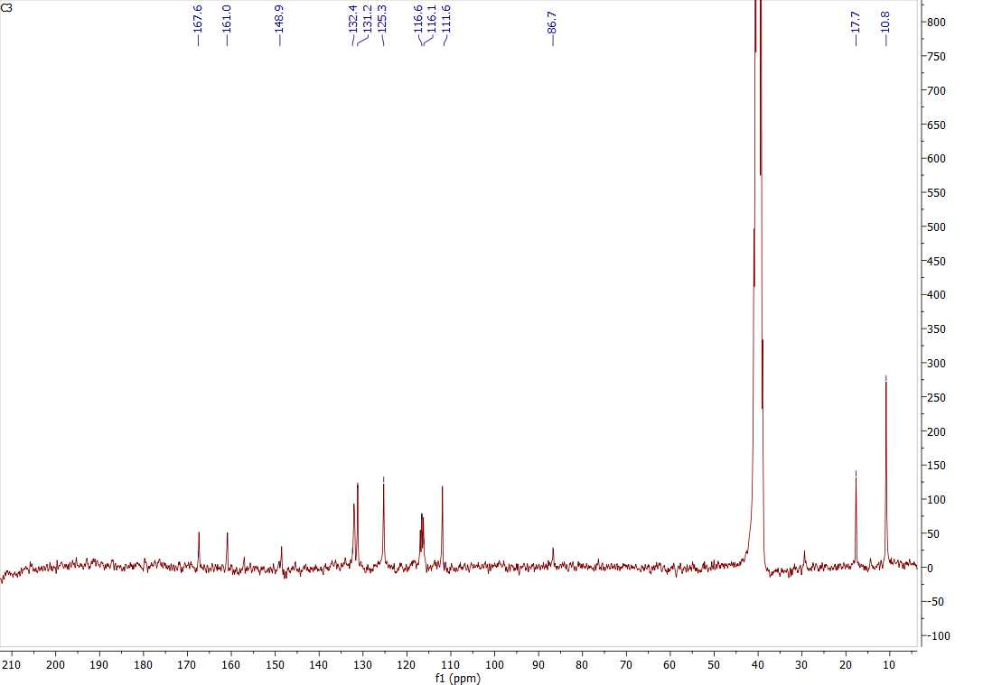
Figure 12. CNMR Spectrum of 2-amino-6-cyclopropyl-4-(2-fluorophenyl)nicotinonitrile in DMSO solvent (5i)

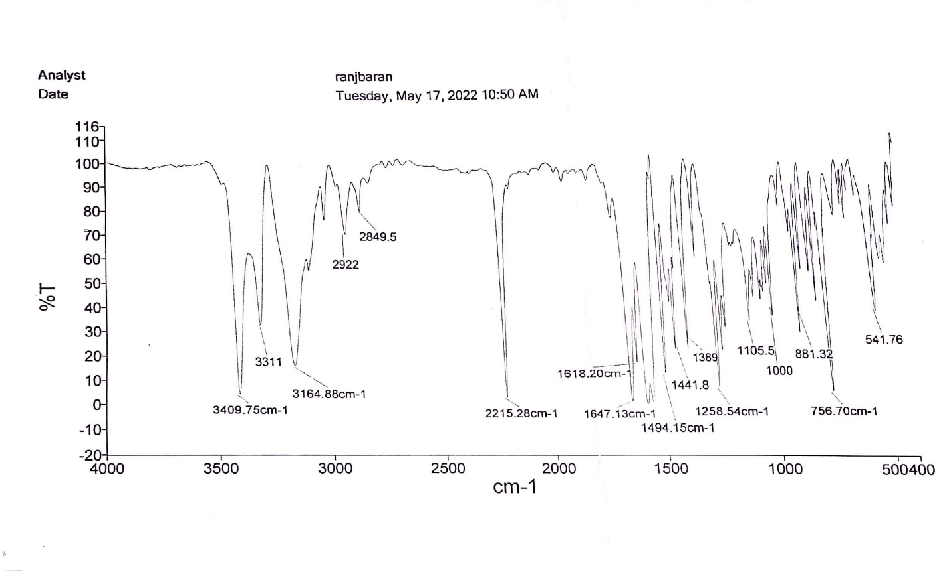

Figure 13. FTIR Spectrum of 2-amino-6-cyclopropyl-4-(2-fluorophenyl)nicotinonitrile (5i)

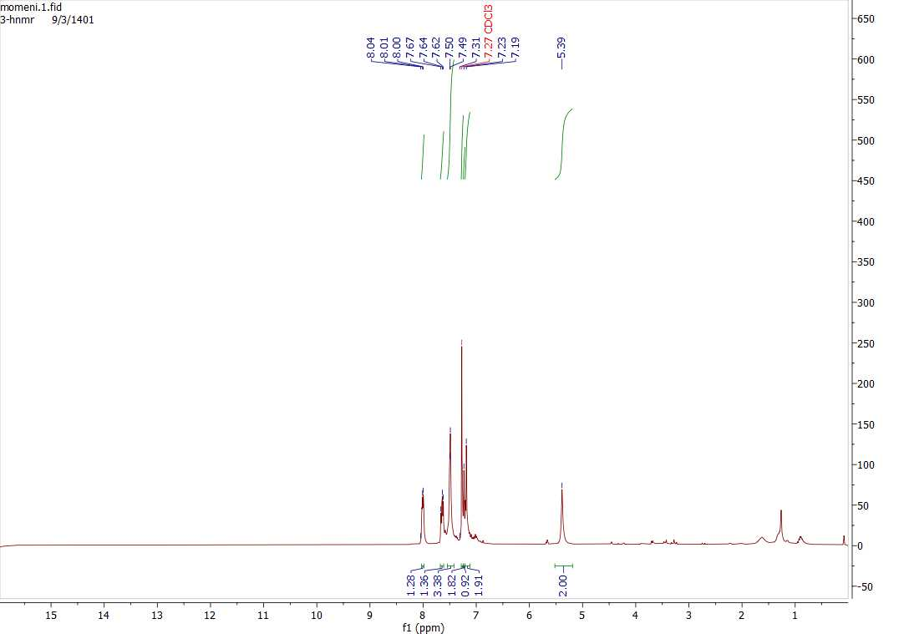
Figure 14. HNMR Spectrum of 2-amino-4-(4-fluorophenyl)-6-phenylnicotinonitrile (5d)

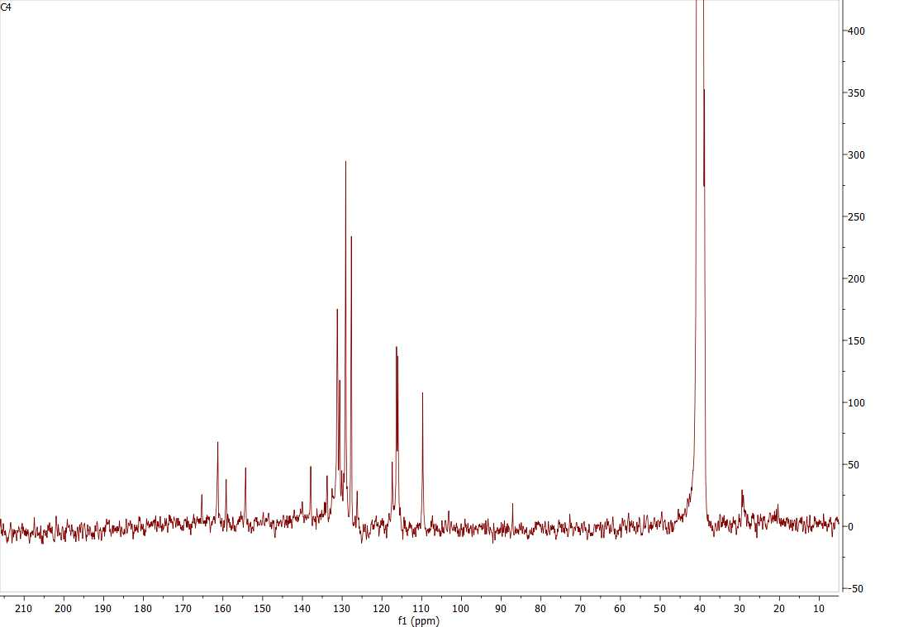
Figure 15. CNMR Spectrum of 2-amino-4-(4-fluorophenyl)-6-phenylnicotinonitrile (5d)

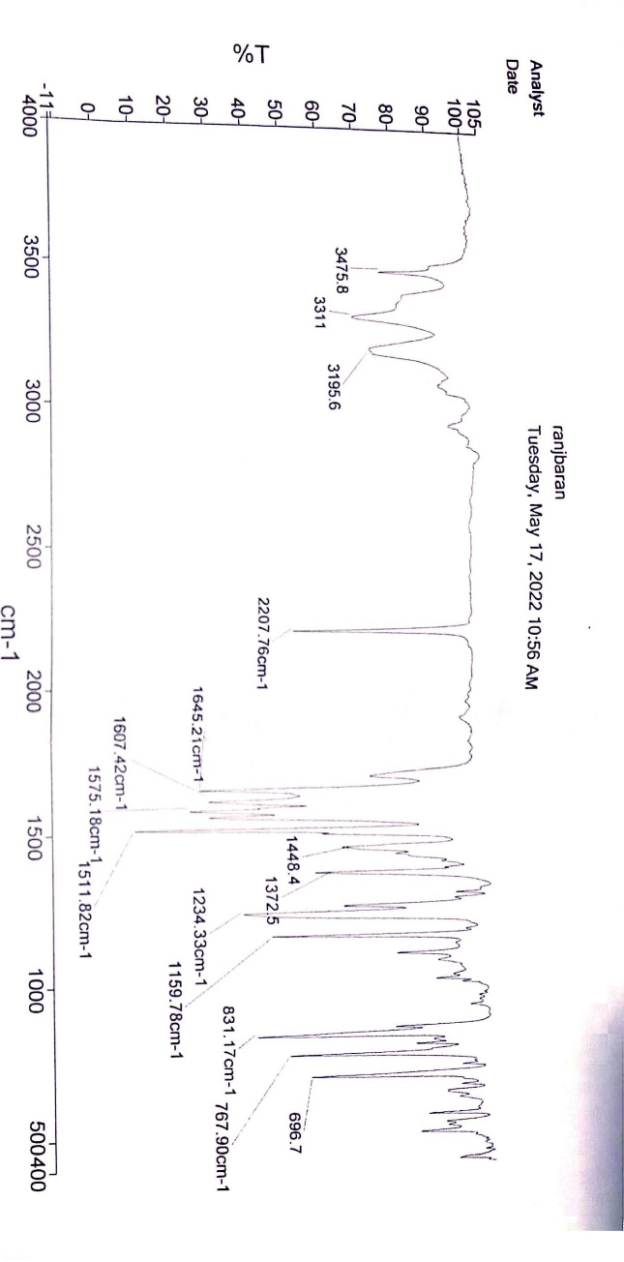
Figure 16. FTIR Spectrum of 2-amino-4-(4-fluorophenyl)-6-phenylnicotinonitrile (5d)

