Appendix:
A: PV Loop for Obstructive & non-obstructive HCM cohorts
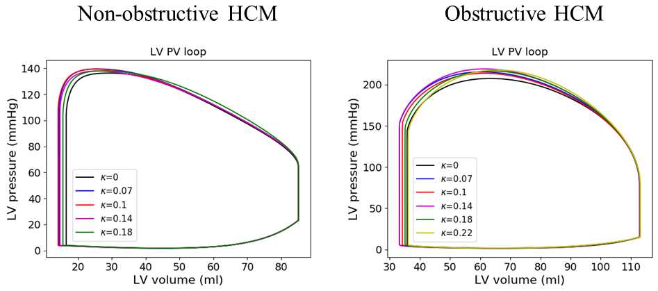
B. Model parameters without disarray
The calibrated passive and active material described in Eq. 10 and Eq. 11, respectively, are enlisted in Table B.1.
B.1: Material parameters
Parameters | Unit | Control | Non-obstructive | Obstructive
Holzapfel-Ogden model
a | $$Pa$$ | 46 | 400 | 200
b |  | 12 | 5 | 4
$$a_{f}$$ | $$Pa$$ | 7.51e03 | 37.5 | 15
$$b_{f}$$ |  | 5.893 | 1.47325 | 22.1
$$a_{s}$$ | $$Pa$$ | 492 | 492 | 492
$$b_{s}$$ |  | 3.393 | 3.393 | 3.393
$$a_{fs}$$ | $$Pa$$ | 70 | 70 | 70
$$b_{fs}$$ |  | 3.929 | 3.929 | 3.929
Guccione model
$$T_{max}$$ | $$kPa$$ | 620 | 400 | 99.75
$$τ$$ | $$ms$$ | 20 | 35 | 35
$$t_{trans}$$ | $$ms$$ | 385 | 430 | 420
B |  | 4.75 | 4.75 | 4.75
$$t_{0}$$ | $$ms$$ | 350 | 400 | 350
$$l_{0}$$ | $$μm$$ | 1.55 | 1.55 | 1.55
$${Ca}_{0}$$ | $$μM$$ | 4.35 | 4.35 | 4.35
$${Ca}_{0max}$$ | $$μM$$ | 4.35 | 4.35 | 4.35
$$l_{r}$$ | $$μm$$ | 1.85 | 1.85 | 1.85
BCL | $$ms$$ | 1000 | 910 | 1180
The model parameters prescribed in circulatory model and time varying elastance model are enlisted in Table B.2.
B.2: Circulatory and left atrium model parameters
Parameter | Unit | Control | Non-obstructive | Obstructive
Circulatory model
$$C_{a,p}$$ | $$ml Pa$$ | 0.00208 | 0.00544 | 0.0048
$$C_{a,d}$$ | $$ml Pa$$ | 0.02145 | 0.0561 | 0.0495
$$C_{ven}$$ | $$ml Pa$$ | 0.196 | 0.378 | 0.014
$$V_{a,p,0}$$ | $$ml$$ | 144 | 144 | 306
$$V_{a,d,0}$$ | $$ml$$ | 160 | 160 | 160
$$V_{ven,0}$$ | $$ml$$ | 4500 | 3100 | 4525
$$R_{ao}$$ | $$Pa ms {ml}^{-1}$$ | 3000 | 3000 | 31500
$$R_{ven}$$ | $$Pa ms {ml}^{-1}$$ | 10 | 10 | 100
$$R_{a,p}$$ | $$Pa ms {ml}^{-1}$$ | 108000 | 90000 | 45000
$$R_{a,d}$$ | $$Pa ms {ml}^{-1}$$ | 127200 | 84800 | 159000
$$R_{mv}$$ | $$Pa ms {ml}^{-1}$$ | 1000 | 1000 | 1000
Time varying elastance model
$$E_{es,la}$$ | $$Pa/ml$$ | 9 | 7 | 10
$$A_{la}$$ | $$Pa$$ | 0.801 | 0.6675 | 4.005
$$B_{la}$$ | $${ml}^{-1}$$ | 0.0152 | 0.00475 | 0.021
$$V_{0,la}$$ | $$ml$$ | 10 | 10 | 10
$$T_{max, la}$$ | $$ms$$ | 120 | 120 | 150
$$τ_{la}$$ | $$ms$$ | 25 | 25 | 25
$$t_{delay,la}$$ | $$ms$$ | 140 | 140 | 140

C. Model parameters with disarray
The model parameters calibrated to match with clinical volume waveform and blood pressure with varying degree of disarray for 2 HCM subjects are listed below. Noted, the rest of the model parameters are same as described in Appendix B.
Parameter | Unit | $$κ=0.07$$ | $$κ=0.1$$ | $$κ=0.14$$ | $$κ=0.18$$ | $$κ=0.22$$
Obstructive HCM
$$T_{max}$$ | $$kPa$$ | 106.8 | 109.25 | 123.5 | 137.75 | 166.25
$$V_{ven,0}$$ | $$ml$$ | 4550 | 4640 | 4660 | 4660 | 4660
Non-obstructive HCM
$$T_{max}$$ | $$kPa$$ | 420 | 440 | 500 | 840

