Unraveling the electronic influence and nature of covalent bonding of aryl and alkyl radicals on the B₁₂N₁₂ nanocage cluster
Avni Berisha *
Department of Chemistry, Faculty of Natural and Mathematics Science, University of Prishtina, 10000 Prishtina, Kosovo (email: avni.berisha@uni-pr.edu; orcid.org/0000-0002-3876-1345)

Supporting Information
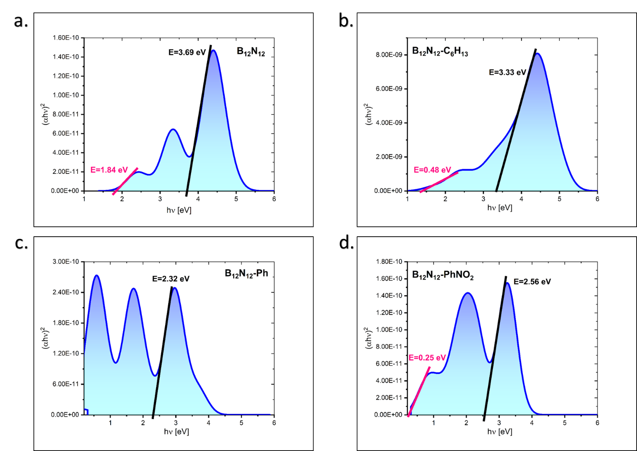
Figure S1. Determination of the optical band gap of bare and grafted B₁₂N₁₂ nanocage cluster.

Table S1. Band gap and threshold wavelengths value for the bare and grafted B₁₂N₁₂ nanocage cluster.

Molecular system | E_{g} [ev]
Molecular system | (First peak) | (Second peak)
B₁₂N₁₂ | 3.69 | 1.84
B₁₂N₁₂-PhNO₂ | 3.33 | 0.48
B₁₂N₁₂-Ph | 2.32 | 0
B₁₂N₁₂-C₆H₁₃ | 2.56 | 0.25

