SVCT2-GLUT1-mediated ascorbic acid transport pathway in rat dental pulp and its effects during wound healing

*Naoto Ohkura¹, Kunihiko Yoshiba², Nagako Yoshiba¹, Naoki Edanami¹, Hayato Ohshima³, Shoji Takenaka¹, Yuichiro Noiri¹

Affiliations
¹Division of Cariology, Operative Dentistry and Endodontics, Department of Oral Health Science, Niigata University Graduate School of Medical and Dental Sciences, Niigata, Japan.

²Division of Oral Science for Health Promotion, Department of Oral Health and Welfare, Niigata University Graduate School of Medical and Dental Sciences, Niigata, Japan

³Division of Anatomy and Cell Biology of the Hard Tissue, Department of Tissue Regeneration and Reconstruction, Niigata University Graduate School of Medical and Dental Sciences, Niigata, Japan.

*Correspondence: ohkura@dent.niigata-u.ac.jp

Supplementary Figure 1.
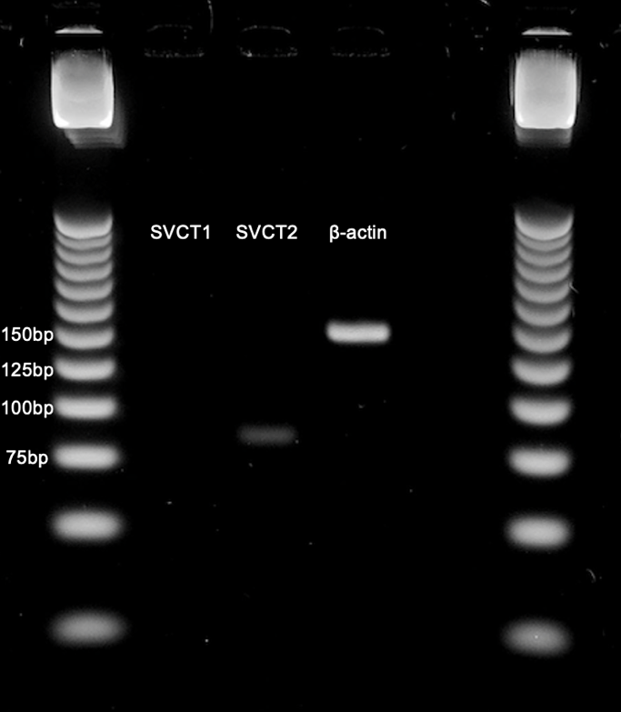
Expression of sodium-dependent vitamin C transporters (SVCTs) mRNA with RT-PCR in rat molar dental pulp. This picture shows a full-length gel from Figure 1a.
Supplementary Table 1. Number of rats used in this study
Wistar Rats
1 day after pulpotomy | 3 days after pulpotomy | 5 days after pulpotomy | 7 days after pulpotomy | 14 days after pulpotomy
Immunostaining, 3 | Immunostaining, 3 | Immunostaining, 3 | Immunostaining, 3 | Immunostaining, 0
Real-time PCR, 3 | Real-time PCR, 3 | Real-time PCR, 3 | Real-time PCR, 3 | Real-time PCR, 3
ODS rats
7 days after pulpotomy
Group 1 (AA＋), 3
Group 2 (AA−), 3

Supplementary Table 2. Antibodies used in this study
Antibody | Clone | Dilution | Source
Goat anti-SVCT2 | G-19 | 1: 50 | Santa Cruz Biotechnology, Dallas, TX, USA
Rabbit anti-GLUT1 | Plolyclonal | 1: 100 | Proteintech, Rosemont, IL, USA
Mouse anti-Nestin | Rat-401 | 1: 100 | Millipore, Darmstadt, Germany
Rabbit anti-OPN | O-17 | 1 µg/mL | Immuno-Biological Laboratories, Gumma, Japan
Mouse anti-α-SMA | 1A4 | 1: 100 | Sigma-Aldrich, St Louis, MO, USA
Rabbit anti-Col I | Polyclonal | 1: 100 | Abcam, Cambridge, United Kingdom
Rabbit anti-Col III | Polyclonal | 1: 100 | Abcam, Cambridge, United Kingdom
Mouse anti-CD68 | ED-1 | 1: 250 | Novus Biologicals, Centennial, CO, USA
Rabbit anti-CD206 | Polyclonal | 1: 1000 | Abcam, Cambridge, United Kingdom
Mouse anti-RECA-1 | HIS52 | 1: 50 | AbD Serotec, Oxford, UK
Rabbit anti-PGP9.5 | Polyclonal | 1: 300 | UltraClone Limited, UK
Supplementary Table 3. Primers used in this study
Molecular | Accession Number | Primer
name |  | Name of oligomers | Sequence | Expected size
Slc2a1 | NM_138827.1 | Sense primer | tggctttgtggccttctttg | 140bp
 |  | Anti-sense primer | tgcccacgatgaagtttgag
Slc32a1 | NM_031782 | Sense primer | ttcggcttgctccattctac | 74bp
 |  | Anti-sense primer | aaacaggcaacaggaaggtg | 74bp
Slc32a2 | NM_017316 | Sense primer | cggaacctatttgtgcttgg | 84bp
 |  | Anti-sense primer | gcctgtaaccagagggttttg
Nestin | AF538924.1 | Sense primer | tccttagccacaaccctcaac | 109bp
 |  | Anti-sense primer | agatttgcccctcatcttcc
Beta-actin | NM_031144.2 | Sense primer | cagggtgtgatggtgggtat | 146bp
 |  | Anti-sense primer | gtgtggtgccaaatcttctc

