Supplementary

Table S1: Female/male gonad lipid content (% wet weight) and sample size (n).

Sex | Lipid Content (%) | N
Female | 10.0 ± 1.9 | 26
Male | 0.68 ± 0.4 | 15

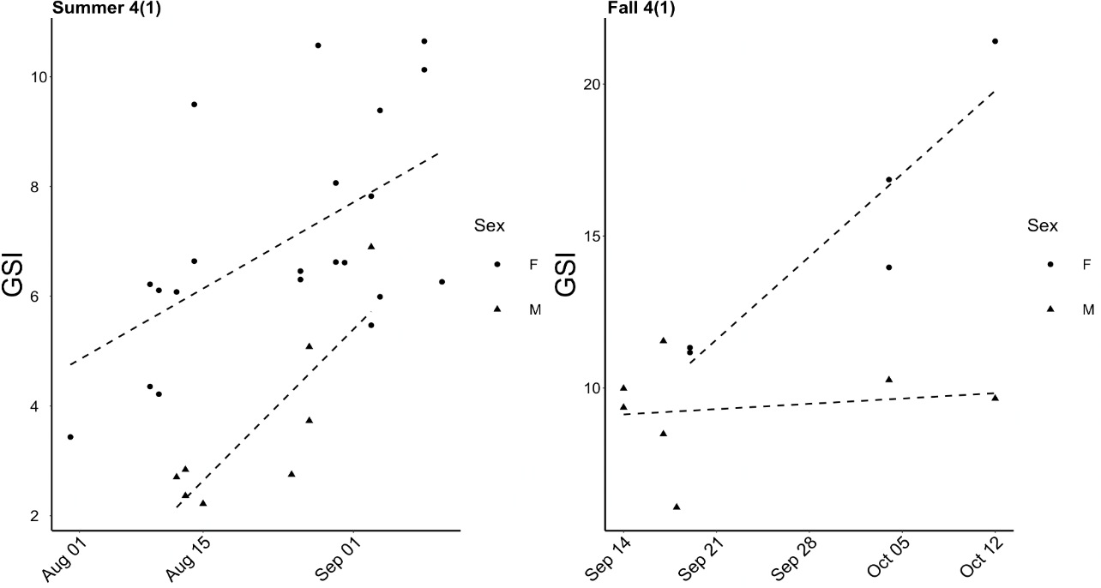

Figure S1: GSI over time for male and female Chinook from the Summer 4(1) and Fall 4(1) MUs.

Table S3: Adjusted R² and slope of relationships between Fraser River Chinook Management Unit Lipid Content (% wet weight) and day of arrival, weight (kg), and Fork length (mm).

 | Day of arrival |  | Weight |  | Fork length
 | R² | slope | R² | slope | R² | slope
Spring 5₂ | 0.4 | -0.07 | -0.03 | 0.03 | -0.002 | -0.03
Summer 5₂ | 0.2 | -0.07 | .007 | -0.09 | -0.01 | -.001
Summer 4₁ | 0.3 | -0.09 | .002 | .03 | -0.001 | -.00005
Fall 4₁ | 0.1 | -0.04 | 0.001 | -0.02 | -.00003 | -0.001

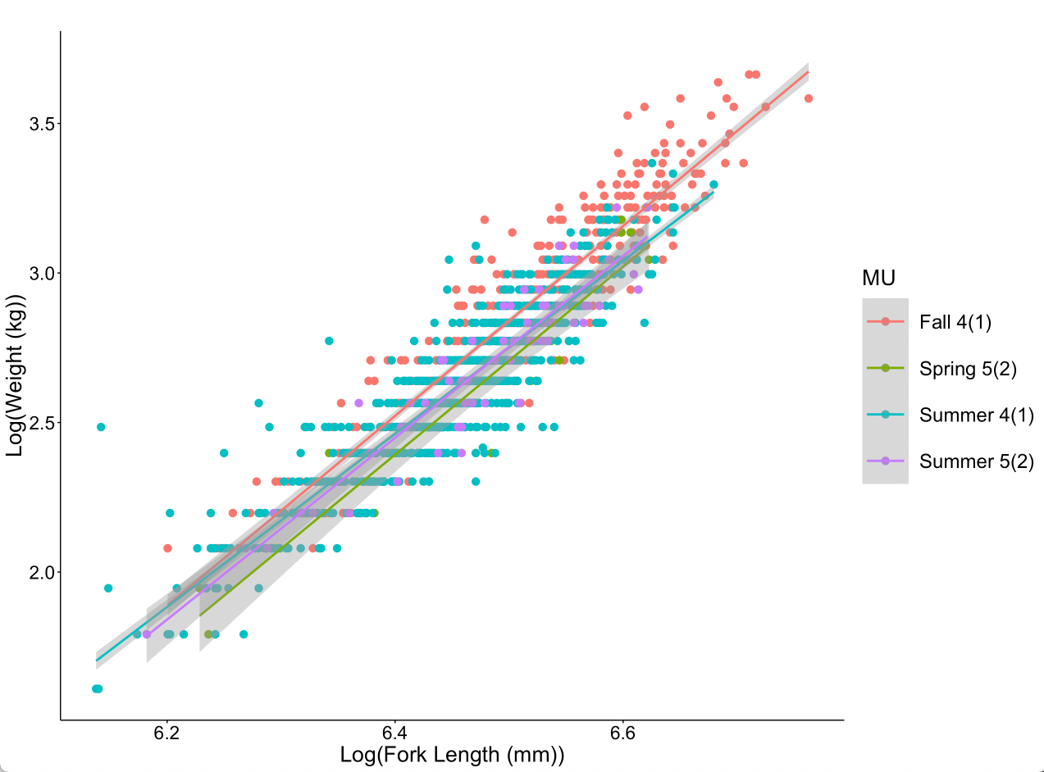

Figure S2: Plot of log(Fork Length (mm)) and Log(Weight (kg)) for four Fraser River Chinook MUs (Fall 4₁, Summer 4₁, Summer 5_{2,} and Spring 5₂) fit with best-fit linear models.

