Genetic Diversity and Local Adaption of Alfalfa Populations (Medicago sativa L.) under Long-Term Grazing

Hu Wang¹, Bruce Coulman¹, Yuguang Bai¹, Bunyamin Tarˈan¹ & Bill Biligetu¹
¹Department of Plant Sciences, College of Agriculture and Bioresources, University of Saskatchewan, Saskatoon, Saskatchewan, Canada. email: Bill.Biligetu@usask.ca

Supporting information

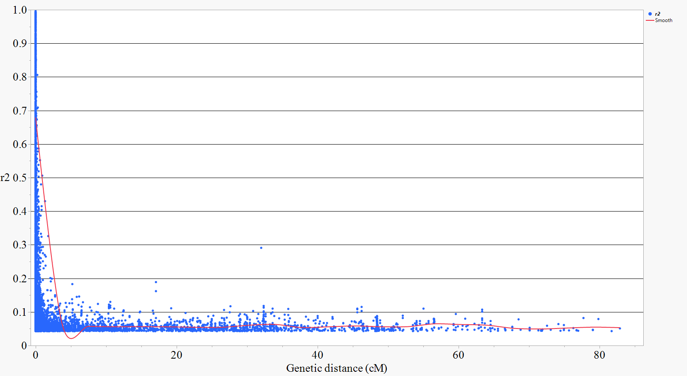
Figure 1S. A pairwise LD values (r²) are plotted against a genetic distance (cM). Inner fitted trend line is a nonlinear logarithmic regression curve of r² on genetic distance.

Figure 2S. Linkage disequilibrium for SNPs within the same gene for (A) Winter extreme temperature; (B) soil sulfur; (C) Summer extreme temperature; and (D and E) soil potassium (K). Pairwise LD values (R²) were indicated by R² color key legend bar.
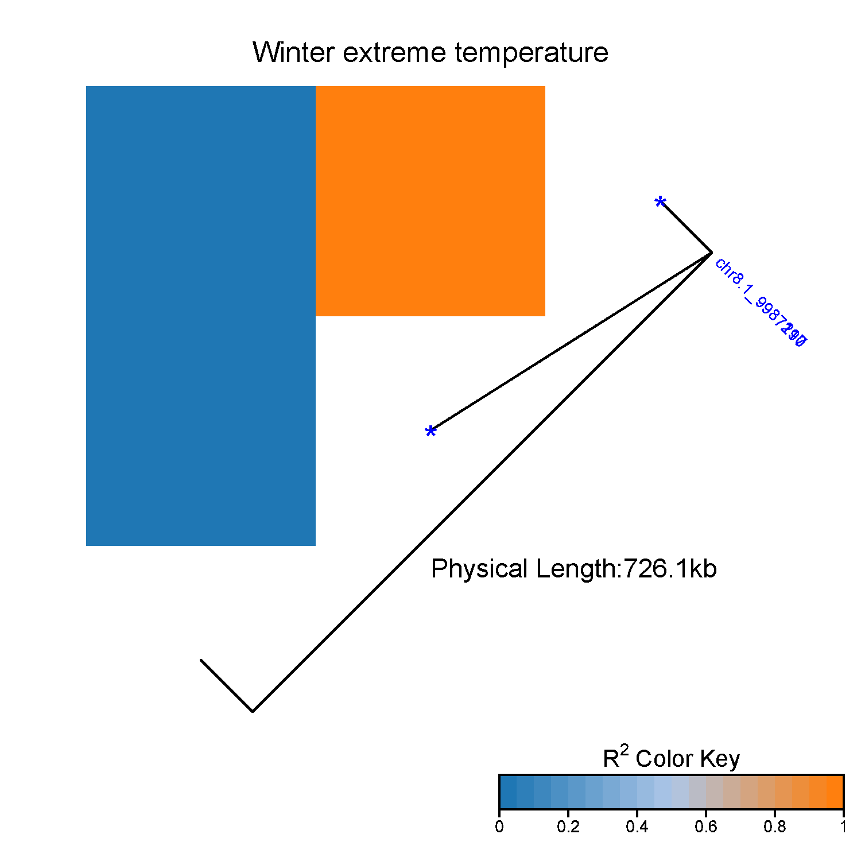
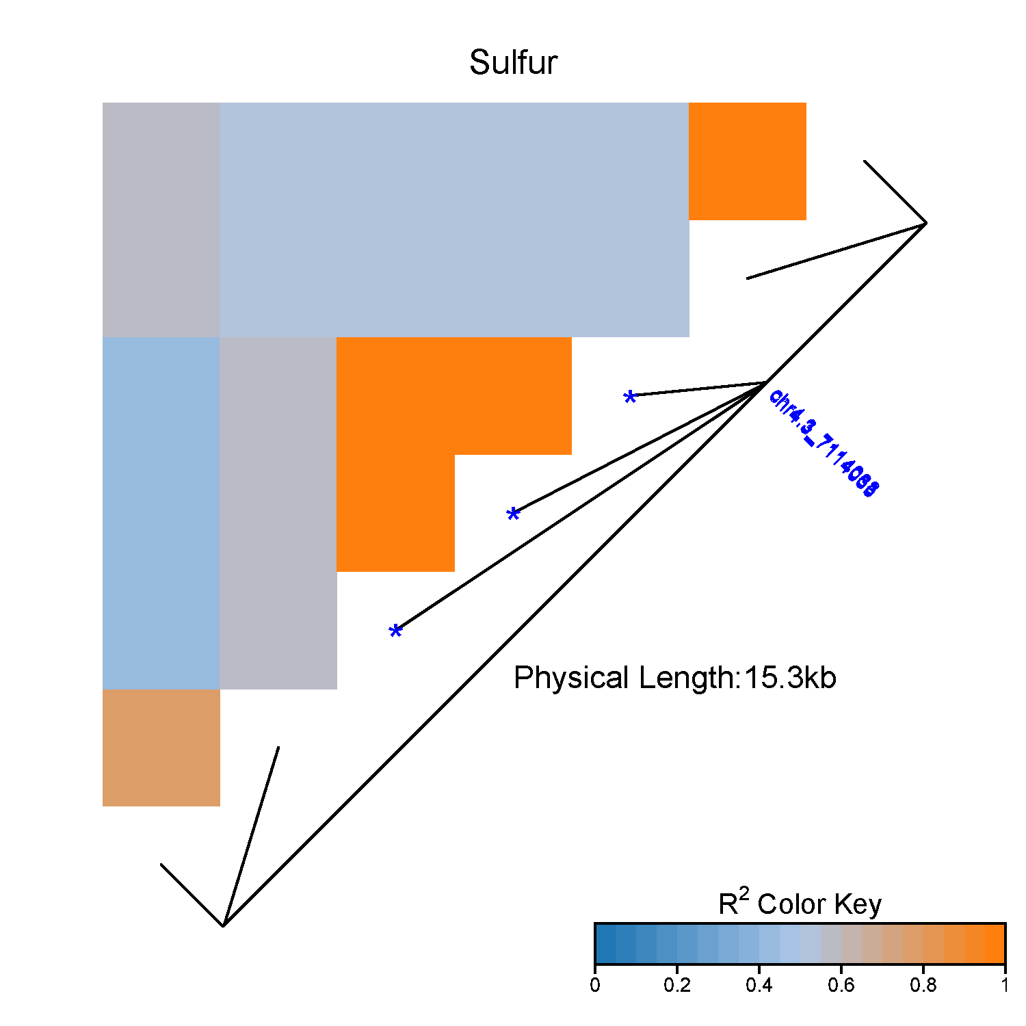
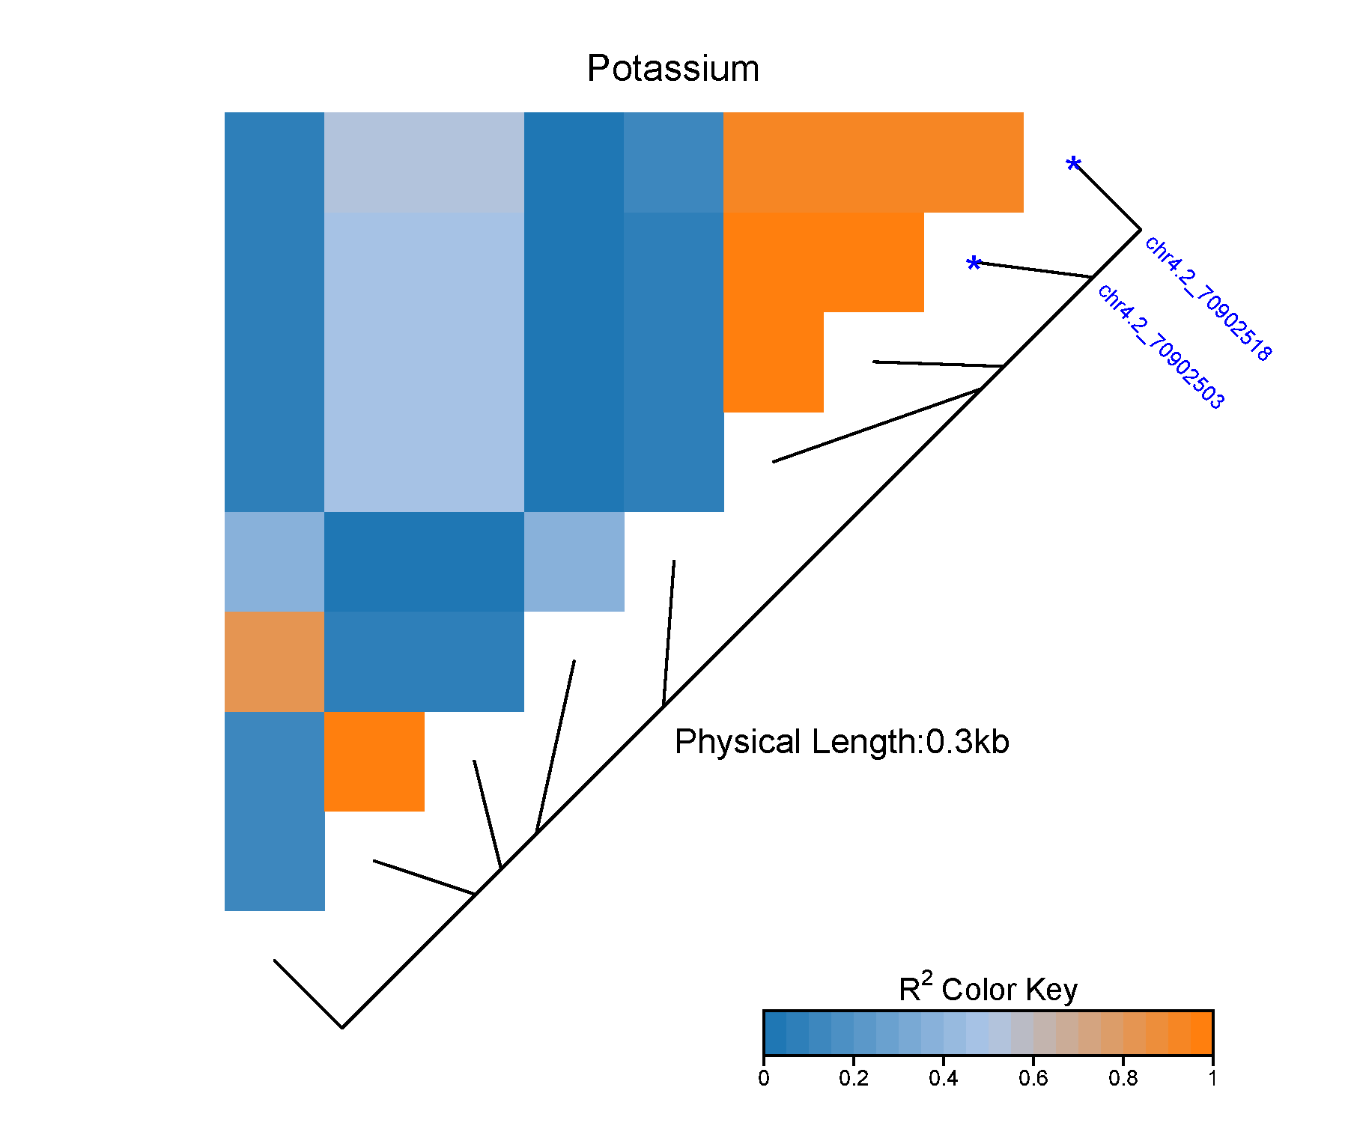
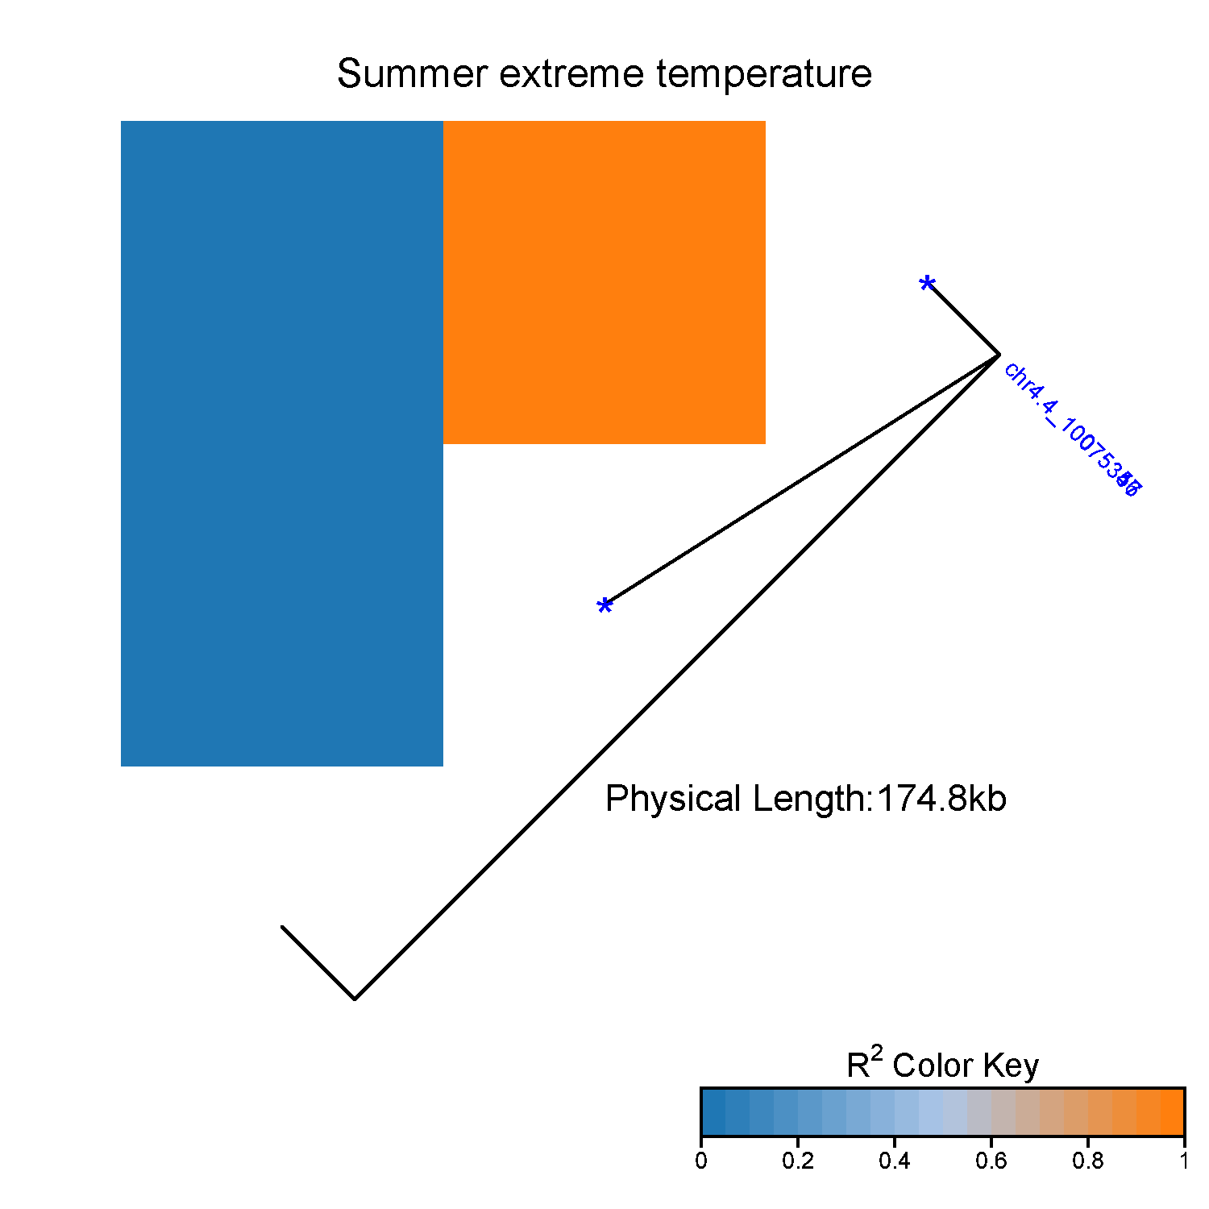
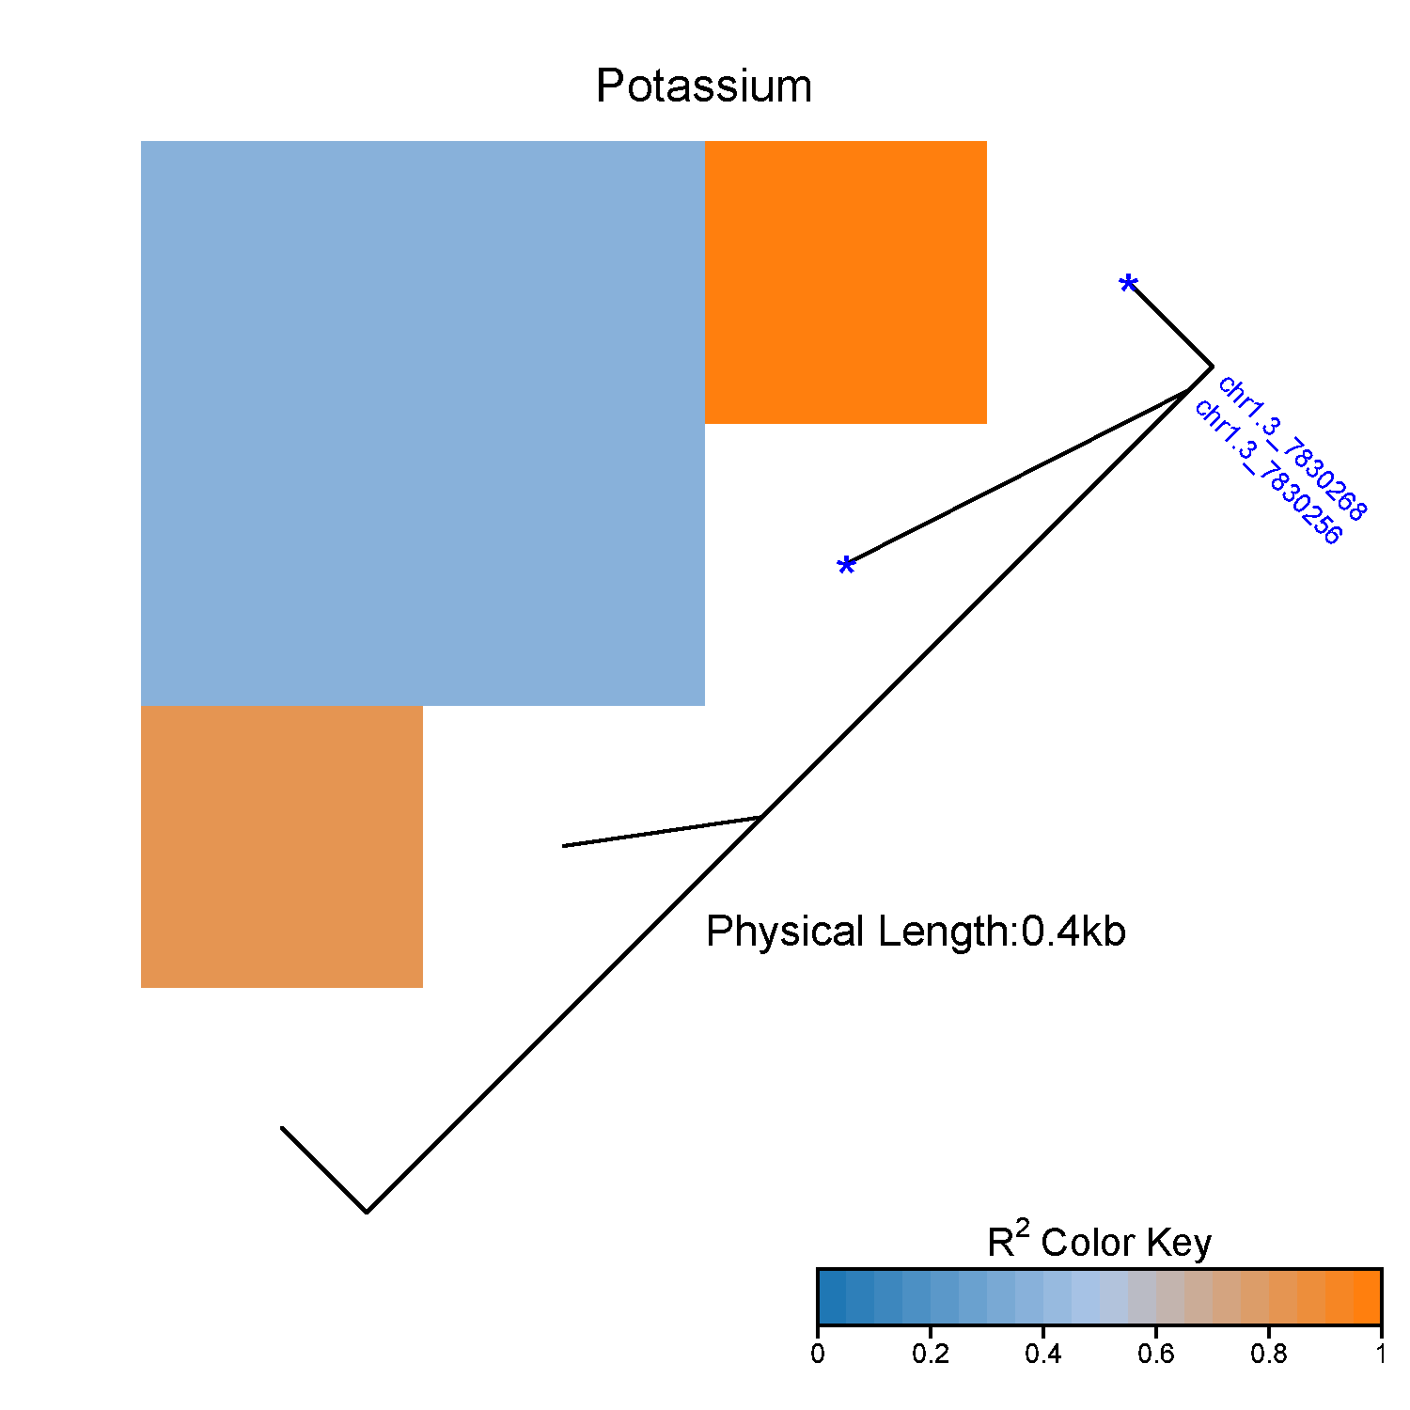
chr8.1_9987179
chr8.1_9987210
chr4.3_7114035
chr4.3_7114063
chr4.3_7114088

chr4.4_10075347
chr4.4_10075356
chr4.2_70902503
chr4.2_70902518
chr1.3_7830256
chr1.3_7830268
B
A
C
D
E

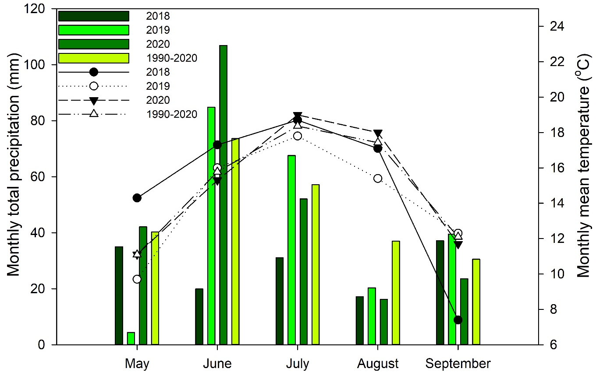
Figure 3S. Monthly mean air temperature (˚C) and monthly total precipitation (mm) during the growing seasons from 2018 to 2020 at Saskatoon, SK (Source: Environment Canada’s weather database).

