Title: A comparative analysis of urban forests for storm-water management

Mohammad A. Rahmanª*, Yanin Pawijitª, Chao Xu^{b}, Astrid Moser-Reischl^{c}, Hans Pretzsch^{c}, Thomas Rötzer^{c}, Stephan Pauleitª,
ªStrategic Landscape Planning and Management, School of Life Sciences, Weihenstephan, Technische Universität München, Emil-Ramann-Str. 6, 85354 Freising, Germany
^{b}Research Center for Eco-Environmental Engineering, Dongguan University of Technology, Daxue Road 1, 523808 Dongguan, China
^{c}Forest Growth and Yield Science, School of Life Sciences, Weihenstephan, Technische Universität München, Hans-Carl-von-Carlowitz-Platz 2, 85354 Freising, Germany

*Corresponding author, Mohammad A RAHMAN, Email: ma.rahman@tum.de, Tel: +49 (0)8161 71 4661

Email address of co-authors:
Yanin PAWIJIT: yaninpawijit@gmail.com

Chao XU: chaoxu@dgut.edu.cn

Astrid MOSER-REISCHL: astrid.moser@tum.de
Hans PRETZSCH: hans.pretzsch@tum.de
Thomas RÖTZER: thomas.roetzer@tum.de
Stephan PAULEIT: pauleit@tum.de

S Table 1: Summary of runoff, soil hydraulic conductivity, interception and transpiration data points investigated in this review. Here, climate: according to updated Köppen climate classification, Land use, Mif: Mif: Mixed forest; Af: Afforestation; MiC: Mixed coniferous; MiD: Mixed deciduous; Ag: Agriculture; Sh: Shrub land; Gr: Grassland; Bs: Bare soil; MoF: Mono-Fir stand; MoS: Mono-Spruce stand; MoP: Mono-Pine stand; Ev: Evergreen; MoB: Mono-Beech stand; MoO: Mono-Oak stand; MoBr: Mono-Broadleaved stand; MoE: Mono-Eucalyptus stand; De: Deciduous; TD: Total data points, NA: not applicable, Mo: Modelling, Me: Measured.
- Run-off
Study** | Cli-mate | Description of land use /  City* | Land use |  |  |  |  |  | coniferous |  | broadleaved |  |  | TD | Type of investig-ation
Study** | Cli-mate | Description of land use /  City* | Mif  (C / D) | Af | Ag | Sh | Gr | Bs | Mono  F / S / P | Ev | Mono  B / O / Br / E | De | Ev | TD
Hartanto et al., 2003¹ | A | Tropical rainforest | 4  - | - | - | - | - | - | - / - / - | - | - / - / - / - | - | - | 4 | Me
Patin et al., 2012² | A | Cropland and mixed forest | -  - | - | - | - | 5 | 5 | - / - / - | - | - / - / - / - | - | - | 10 | Me
Cerdà et al., 2017³ | B | Secondary forest | - | - | - | - | - | - | - / - / 1 | - | - / 1 / - / - | - | - | 2 | Me
Chirino et al., 2006⁴ | B | Bare soil, grass and shrub land | - | - | - | 1 | 1 | 1 | - / - / 2 | - | - / - / - / - | - | - | 5 | Me
del Campo et al., 2019⁵ | B | Secondary forest | - | - | - | - | - | - | - / - / 1 | - | - / 1 / - / - | - | - | 2 | Me
Descheemaeker et al., 2006⁶ | B | Urban forest | 1  - | - | - | - | 9 | - | - / - / - | - | - / - / - / 1 | - | - | 11 | Me
Quinton et al., 1997⁷ | B | Secondary forest | - | - | - | - | 9 | 2 | - / - / - | - | - / - / - / - | - | - | 11 | Me
Stone et al., 2008⁸ | B | Shrub-grass land | - | - | - | - | 19 | - | - / - / - | - | - / - / - / - | - | - | 19 | Me
Cao et al., 2015⁹ | Cf | Secondary forest | - | - | - | - | - | - | - / - / 5 | - | - / - / - / - | - | - | 5 | Me
Chen et al., 2010¹⁰ | Cf | Forest stand | 2  - | - | - | - | - | - | - / - / - | - | - / - / - / - | - | - | 2 | Me
El Kateb et al., 2013¹¹ | Cf | Maize and tea plantation | -  (- / 5) | - | 5 | - | 3 | - | - / - / 3 | - | - / 3 / - / - | - | - | 14 | Me
Huang et al., 2010¹² | Cf | Regenerated forest | 1  - | 1 | 1 | - | - | - | - / - / 1 | - | - / - / - / - | - | - | 4 | Me
Hümann et al., 2011¹³ | Cf | Low Alpine afforestation | -  (1 / -) | 2 | 1 | - | - | - | 1 /2 / - | - | 3 / - / - / - | - | - | 11 | Me
Jiang et al., 2019¹⁴ | Cf | Secondary forest | 1  - | - | - | - | - | - | 1 / - / - | - | - / - / - / - | - | - | 2 | Me
Luo et al., 2020¹⁵ | Cf | Cropland | 3  - | - | 1 | 1 | - | 1 | - / - / 1 | - | - / - / 3 / - | - | - | 10 | Me
Zheng et al., 2008¹⁶ | Cf | Afforestation | 1  - | - | - | - | 1 | - | 1 / - | - | - / - / - / 1 | - | - | 5 | Me
Malvar et al., 201317¹⁷ | Cs | Afforestation | - | - | - | - | - | - | - / - / 1 | - | - / - / - / 6 | - | - | 6 | Me
Mohammad & Adam, 2010¹⁸ | Cs | Afforestation, natural forest, bare soil | - | - | - | - | 3 | 1 | - / - / - | - | - / - / - / - | - | - | 5 | Me
Nunes et al., 2011¹⁹ | Cs | Bare soil, grass and shrub land, afforestation | - | - | 1 | 1 | 1 | 1 | - / - / 1 | - | - / 1 / - / - | - | - | 6 | Me
Prats et al., 2012²⁰ | Cs | Afforestation | - | - | - | - | - | - | - / - / 2 | - | - / - / - / 2 | - | - | 4 | Me
Thompson et al., 2016²¹ | Cs | Afforestation | - | - | - | - | - | - | - / - / - | - | - / - / - / - | - | - | 2 | Me
Vacca et al., 2000²² | Cs | Grass and shrub land, afforestation | - | - | - | - | 3 | - | - / - / - | - | - / - / - / - | - | - | 3 | Me
Gu et al., 2020²³ | Cw | Crop and shrub land, afforestation | - | - | - | 2 | 2 | - | - / - / - | - | - / - / 2 / - | - | - | 6 | Me
Oliviera et al., 2014²⁴ | Cw | Urban woodland | 1  - | - | - | - | - | 1 | - / - / - | - | - / - / - / - | - | - | 2 | Me
Sheridan et al., 2007²⁵ | Cw | Eucalyptus forest | - | - | - | - | - | - | - / - / - | - | - / - / - / 2 | - | - | 2 | Me
Sun et al., 2018²⁶ | Cw | Afforestation | 3  - | 3 | - | - | - | - | - / - / 1 | - | - / - / - / 2 | - | - | 9 | Me
Wei et al., 2007²⁷ | Cw | Cropland | - | - | 1 | 1 | 2 | - | - / - / 1 | - | - / - / - / - | - | - | 5 | Me
Zhang et al., 2006²⁸ | Cw | Forest stand | - | - | - | - | - | - | - / - / - | - | - / - / 5 / - | - | - | 5 | Me
Zhou et al., 2002²⁹ | Cw | Afforestation | - | - | - | - | - | 1 | - / - / - | - | - / - / 1 / - | - | - | 2 | Me
Holzmann & Sereinig, 1997³⁰ | Df | Alpine catchment | 1  - | - | - | - | - | - | - / - / 1 | - | - / - / - / - | - | - | 2 | Me
Minea et al., 2019³¹ | Df | Grassland | - | - | - | - | 1 | 1 | - / - / - | - | - / - / - / - | - | - | 2 | Me
Onuchin et al., 2017³² | Df | Secondary forest | - | - | - | - | - | - | 1 / - / - | - | - / - / 2 / - | - | - | 3 | Me
Jost et al., 2012³³ | Df | Forest stand | - | - | - | - | - | - | - / 1 / - | - | 1 / - / - / - | - | - | 2 | Me
Kim et al., 2014³⁴ | Dw | Forest stand | 1  - | - | - | 1 | - | - | - / - / 1 | - | - / 1 / - / - | - | - | 4 | Me
Alaoui et al., 2011³⁵ | E | Forest stand | 3  - | - | - | - | 3 | - | - / - / - | - | - / - / - / - | - | - | 6 | Me
Mayerhofer et al., 2017³⁶ | E | Grassland | -  (1 / -) | - | - | - | 7 | - | - / - / - | - | - / - / - / - | - | - | 8 | Me
SUM Runoff |  |  | 22  (2 / 1) | 6 | 10 | 7 | 69 | 14 | 4 / 3 / 23 | 0 | 4 / 8 / 13 / 15 | 0 | 0 | 201

- Hydraulic conductivity
Study** | Cli-mate | Description of land use /  City* | Land use |  |  |  |  |  | coniferous |  | broadleaved |  |  | TD | Type of investig-ation
Study** | Cli-mate | Description of land use /  City* | Mif  (C / D) | Af | Ag | Sh | Gr | Bs | Mono  F / S / P | Ev | Mono  B / O / Br / E | De | Ev | TD | Type of investig-ation
Johnson-Maynard et al., 2002³⁷ | B | Forest stand | - | - | - | 2 | - | - | - / - / 1 | - | - / - / - / - | - | - | 3 | Me
Descheemaeker et al., 2006⁶ | B | Urban forest | 1 | - | - | - | 9 | - | - / - / - | - | - / - / - / 1 | - | - | 11 | Me
Chandler et al., 2008³⁸ | Cf | Urban forest | - | - | - | - | - | - | - / - / - | - | - / 1 / - / - | - | - | 1 | Me
Buczko et al., 2006³⁹ | Cf | Forest stand | 2 | - | - | - | - | - | - / - / 1 | - | 1 / - / - / - | - | - | 4 | Me
Huemann et al., 2011¹³ | Cf | Low Alpine afforestation | -  (1 / 1)) | 2 | 1 | - | - | - | 1 / 2 / - | - | 3 / - / - / - | - | - | 11 | Me
Neirynck et al., 2000⁴⁰ | Cf | Forest stand | - | - | - | - | - | - | - / - / - | - | - / 1 / 5 / - | - | - | 6 | Me
Hao et al., 2019⁴¹ | Cf | Forest stand | 2 | - | - | - | - | - | - / - / - | - | - / - / - / 1 | - | - | 2 | Me
Sheridan et al., 2007²⁵ | Cw | Eucalyptus forest | - | - | - | - | - | - | - / - / - | - | - / - / - / 2 | - | - | 2 | Me
Jost et al., 2012³³ | Db | Forest stand | - | - | - | - | - | - | - / 1 / - | - | - / - / 1 / - | - | - | 2 | Me
SUM Hydraulic Conductivity |  |  | 5  (1 / 1) | 2 | 1 | 2 | 9 | 0 | 1 / 3 / 2 | 0 | 4 / 2 / 6 / 3 | 0 | 0 | 42

(c) Interception
Study** | Cli-mate | Description of land use /  City* | Land use |  |  |  |  |  | coniferous |  | broadleaved |  |  | TD | Type of investig-ation
Study** | Cli-mate | Description of land use /  City* | Mif  (C / D) | Af | Ag | Sh | Gr | Bs | Mono  F / S / P | Ev | Mono  B / O / Br / E | De | Ev | TD | Type of investig-ation
Nytch et al., 2018⁴² | A | San Juan, Puerto Rico | - | - | - | - | - | - | - / - / - | - | - / - / - / - | 1 | 1 | 2 | Me
Park et al., 2008⁴³ | A | Afforestation, Soberania, Panama | - | - | - | - | - | - | - / - / - | - | - / - / - / - | 1 | 4 | 5 | Me
Guevara-Escobar et al., 2007⁴⁴ | B | Queretaro City, Mexico | - | - | - | - | - | - | - / - / - | - | - / - / - / - | - | 1 | 1 | Mo
Sadeghi et al., 2016⁴⁵ | B | Afforestation, Tehran, Iran | - | - | - | - | - | - | - / - / - | 2 | - / - / - / - | 2 | - | 4 | Me
Véliz-Chávez et al., 2014⁴⁶ | B | Queretaro City, Mexico | - | - | - | - | - | - | - / - / - | - | - / - / - / - | - | 1 | 1 | Me
Fan et al., 2014⁴⁷ | Cf | Afforestation, southeast  Queensland, Australia | - | - | - | 1 | - | - | - / - / - | 1 | - / - / - / - | - | - | 2 | Mo
Ford et al., 2011⁴⁸ | Cf | Forest stand, North Carolina, USA | - | - | - | - | - | - | - / - / - | 1 | - / - / - / - | 4 | - | 5 | Me
Jiang et al., 2019¹⁴ | Cf | Secondary forest Sanming City, China | - | - | - | - | - | - | - / - / - | 1 | - / - / - / - | - | 1 | 2 | Me
Livesley et al., 2014⁴⁹ | Cf | Melbourne, Australia | - | - | - | - | - | - | - / - / - | - | - / - / - / - | - | 2 | 2 | Mo
Ringgaard et al., 2014⁵⁰ | Cf | Forest land, Jutland, Denmark | - | - | - | - | - | - | - / - / - | 3 | - / - / - / - | - | - | 3 | Mo
Staelens et al., 2008⁵¹ | Cf | Forest land, Ghent, Belgium | - | - | - | - | - | - | - / - / - | - | - / - / - / - | 1 | - | 1 | Me
Vanstan et al., 2014⁵² | Cf | Forest land, Maryland, USA | - | - | - | - | - | - | - / - / - | - | - / - / - / - | - | 2 | 2 | Me
Zabret et al., 2018⁵³ | Cf | Ljubljana, Slovenia | - | - | - | - | - | - | - / - / - | 1 | - / - / - / - | 1 | - | 2 | Me
Zabret & Šraj, 2019⁵⁴ | Cf | Ljubljana, Slovenia | - | - | - | - | - | - | - / - / - | 1 | - / - / - / - | 1 | - | 2 | Me
Asadian et al., 2009⁵⁵ | Cs | British Columbia, Canada | - | - | - | - | - | - | - / - / - | 6 | - / - / - / - | - | - | 6 | Me
David et al., 2006⁵⁶ | Cs | Alentejo region, Portugal | - | - | - | - | - | - | - / - / - | - | - / - / - / - | - | 1 | 1 | Me
Fathizadeh et al., 2017⁵⁷ | Cs | Forest stand, Southern Zagros, Iran | - | - | - | - | - | - | - / - / - | - | - / - / - / - | 1 | - | 1 | Mo
Pereira et al., 2009⁵⁸ | Cs | Herdade da Mitra, Portgual | - | - | - | - | - | - | - / - / - | - | - / - / - / - | - | 2 | 2 | Mo
Pypker et al., 2005⁵⁹ | Cs | Forest stand, Gifford Pinchot, USA | - | - | - | - | - | - | - / - / - | 2 | - / - / - / - | - | - | 2 | Mo
Xiao et al., 2000⁶⁰ | Cs | California, USA | - | - | - | - | - | - | - / - / - | - | - / - / - / - | 1 | 1 | 2 | Me
Xiao & McPherson, 2002⁶¹ | Cs | Santa Monica, USA | - | - | - | - | - | - | - / - / - | - | - / - / - / - | 3 | 4 | 7 | Mo
Xiao & McPherson, 2011⁶² | Cs | California, USA | - | - | - | - | - | - | - / - / - | - | - / - / - / - | 2 | 1 | 3 | Me
Ghimire et al., 2012⁶³ | Cw | Forest land and afforestation, Nepal | - | - | - | - | - | - | - / - / - | 1 | - / - / - / - | - | 1 | 2 | Mo
Negi et al., 1998⁶⁴ | Cw | Forest stand, Central Himalaya, India | - | - | - | - | - | - | - / - / - | 1 | - / - / - / - | 1 | 1 | 3 | Me
Buttle et al., 2012⁶⁵ | Df | Forest stand, Ontario, Canada | - | - | - | - | - | - | - / - / - | 2 | - / - / - / - | 1 | - | 3 | Me
Price et al., 2003⁶⁶ | Df | Forest stand, Ontario, Canada | - | - | - | - | - | - | - / - / - | - | - / - / - / - | 1 | - | 1 | Mo
Liu et al., 2018⁶⁷ | Dw | Forest stand, Beijing, China | - | - | - | 2 | - | - | - / - / - | 3 | - / - / - / - | 5 | - | 10 | Me
Yang et al., 2019⁶⁸ | Dw | Seoul, Korea | - | - | - | - | - | - | - / - / - | - | - / - / - / - | 4 | - | 4 | Me
SUM Interception |  |  | 0  (0 / 0) | 0 | 0 | 3 | 0 | 0 | 0 / 0 / 0 | 25 | 0 / 0 / 0 / 0 | 30 | 23 | 81

(d) Transpiration
Study** | Cli-mate | Description of land use /  City* | Land use |  |  |  |  |  | coniferous |  | broadleaved |  |  | TD | Type of investig-ation
Study** | Cli-mate | Description of land use /  City* | Mif  (C / D) | Af | Ag | Sh | Gr | Bs | Mono  F / S / P | Ev | Mono  B / O / Br / E | De | Ev | TD | Type of investig-ation
Ford et al., 2011⁴⁸ | Cf | Forest stands, North Carolina, USA | - | - | - | - | - | - | - / - / - | 1 | - / - / - / - | 4 | - | 5 | Me
Jacobs et al., 2015⁶⁹ | Cf | Rotterdam, Netherlands | - | - | - | - | - | - | - / - / - | - | - / - / - / - | 1 | - | 1 | Me
Rahman et al., 2019⁷⁰ | Cf | Munich, Germany | - | - | - | - | - | - | - / - / - | - | - / - / - / - | 2 | - | 2 | Me
Pataki et al., 2011⁷¹ | Cs | Los Angeles, USA | - | - | - | - | - | - | - / - / - | 4 | - / - / - / - | 10 | 4 | 18 | Me
Raz-Yaseef et al., 2012⁷² | Cs | Forest stand, Israel | - | - | - | - | - | - | - / - / - | 1 | - / - / - / - |  | - | 1 | Me
Ghimire et al., 2014⁷³ | Cw | Forest stand, Nepal | - | - | - | - | - | - | - / - / - | 1 | - / - / - / - | 1 | - | 2 | Mo
Zhu & Zhao, 2013⁷⁴ | Cw | Guangzhou, China | - | - | - | - | - | - | - / - / - | - | - / - / - / - |  | 1 | 1 | Me
Matasov et al., 2020⁷⁵ | Df | Moscow, Russia | - | - | - | 1 | - | - | - / - / - | - | - / - / - / - | 3 | - | 4 | Me
Peters et al., 2010⁷⁶ | Df | Minnesota, USA | - | - | - | - | - | - | - / - / - | 2 | - / - / - / - | 4 | - | 6 | Me
Riikonen et al., 2016⁷⁷ | Df | Helsinki, Finland | - | - | - | - | - | - | - / - / - | - | - / - / - / - | 2 | - | 2 | Me
Chen et al., 2011⁷⁸ | Dw | Dalian, China | - | - | - | 1 | - | - | - / - / - | 1 | - / - / - / - | 2 | - | 4 | Me
Chen et al., 2012⁷⁹ | Dw | Dalian, China | - | - | - | 1 | - | - | - / - / - | 1 | - / - / - / - | 2 | - | 4 | Me
Wang et al., 2011⁸⁰ | Dw | Beijing, China | - | - | - | - | - | - | - / - / - | 2 | - / - / - / - | 4 | - | 6 | Me
Wang et al., 2012⁸¹ | Dw | Beijing, China | - | - | - | - | - | - | - / - / - | - | - / - / - / - | 1 | - | 1 | Me
Qiu et al., 2021⁸² | Cw | Shenzhen, China | - | - | - | 3 | - | - | - / - / - | - | - / - / - / - |  | - | - | Me
Ji et al., 2016⁸³ | Ds | Shrub land, Gansu, China | - | - | - | 3 | - | - | - / - / - | - | - / - / - / - | - | - | - | Me
Huang and Zhang, 2016⁸⁴ | B | Shrub land, Zhongwei, China | - | - | - | 2 | - | - | - / - / - | - | - / - / - / - | - | - | - | Me
Cavanaugh et al., 2011⁸⁵ | B | Shrub land, Arizona, USA | - | - | - | 1 | - | - | - / - / - | - | - / - / - / - | - | - | - | Me
Allen and Grime, 1995⁸⁶ | B | Shrub land, Niger, West Africa. | - | - | - | 1 | - | - | - / - / - | - | - / - / - / - | - | - | - | Me
SUM Transpiration |  |  | 0  (0 / 0) | 0 | 0 | 13 | 0 | 0 | 0 / 0 / 0 | 13 | 0 / 0 / 0 / 0 | 36 | 5 | 67
*Description of the land use for runoff, soil hydralic conductivity and name of the city for the interception and transpiration urban forest {Patin, 2012 #1318}
** ¹Hartanto H, Prabhu R, Widayat ASE, et al. 2003. Factors affecting runoff and soil erosion: Plot-level soil loss monitoring for assessing sustainability of forest management Forest Ecology and Management 180: 361-374.
²Patin J, Mouche E, Ribolzi O, et al. 2012. Analysis of runoff production at the plot scale during a long-term survey of a small agricultural catchment in lao pdr J Hydrol 426-427: 79-92.
³Cerdà A, Lucas Borja ME, Úbeda X, et al. 2017. Pinus halepensis m. Versus quercus ilex subsp. Rotundifolia l. Runoff and soil erosion at pedon scale under natural rainfall in eastern spain three decades after a forest fire Forest Ecology and Management 400: 447-456.
⁴Chirino E, Bonet A, Bellot J, et al. 2006. Effects of 30-year-old aleppo pine plantations on runoff, soil erosion, and plant diversity in a semi-arid landscape in south eastern spain CATENA 65: 19-29.
⁵del Campo AD, González-Sanchis M, Molina AJ, et al. 2019. Effectiveness of water-oriented thinning in two semiarid forests: The redistribution of increased net rainfall into soil water, drainage and runoff Forest Ecology and Management 438: 163-175.
⁶Descheemaeker K, Nyssen J, Poesen J, et al. 2006. Runoff on slopes with restoring vegetation: A case study from the tigray highlands, ethiopia J Hydrol 331: 219-241.
⁷Quinton JN, Edwards GM and Morgan RPC. 1997. The influence of vegetation species and plant properties on runoff and soil erosion: Results from a rainfall simulation study in south east spain Soil Use and Management 13: 143-148.
⁸Stone JJ, Paige GB, and Hawkins RH. 2008. Rainfall intensity-dependent infiltration rates on rangeland rainfall simulator plots Transactions of the ASABE 51: 45-53.
⁹Cao L, Liang Y, Wang Y, et al. 2015. Runoff and soil loss from pinus massoniana forest in southern china after simulated rainfall CATENA 129: 1-8.
¹⁰Chen X, Cheng Q, Chen YD, et al. 2010. Simulating the integrated effects of topography and soil properties on runoff generation in hilly forested catchments, south china Hydrol Process 24: 714-725.
¹¹El Kateb H, Zhang H, Zhang P, et al. 2013. Soil erosion and surface runoff on different vegetation covers and slope gradients: A field experiment in southern shaanxi province, china CATENA 105: 1-10.
¹²Huang P and Pretzsch H. 2010. Using terrestrial laser scanner for estimating leaf areas of individual trees in a conifer forest Trees-Struct Funct 24: 609-619.
¹³Hümann M, Schüler G, Müller C, et al. 2011. Identification of runoff processes – the impact of different forest types and soil properties on runoff formation and floods J Hydrol 409: 637-649.
¹⁴Jiang M-H, Lin T-C, Shaner P-JL, et al. 2019. Understory interception contributed to the convergence of surface runoff between a chinese fir plantation and a secondary broadleaf forest J Hydrol 574: 862-871.
¹⁵Luo J, Zhou X, Rubinato M, et al. 2020. Impact of multiple vegetation covers on surface runoff and sediment yield in the small basin of nverzhai, hunan province, china Forests 11: 329.
¹⁶Zheng H, Chen F, Ouyang Z, et al. 2008. Impacts of reforestation approaches on runoff control in the hilly red soil region of southern china J Hydrol 356: 174-184.
¹⁷Malvar MC, Martins MAS, Nunes JP, et al. 2013. Assessing the role of pre-fire ground preparation operations and soil water repellency in post-fire runoff and inter-rill erosion by repeated rainfall simulation experiments in portuguese eucalypt plantations CATENA 108: 69-83.
¹⁸Mohammad AG and Adam MA. 2010. The impact of vegetative cover type on runoff and soil erosion under different land uses CATENA 81: 97-103.
¹⁹Nunes AN, de Almeida AC and Coelho COA. 2011. Impacts of land use and cover type on runoff and soil erosion in a marginal area of portugal Applied Geography 31: 687-699.
²⁰Prats SA, MacDonald LH, Monteiro M, et al. 2012. Effectiveness of forest residue mulching in reducing post-fire runoff and erosion in a pine and a eucalypt plantation in north-central portugal Geoderma 191: 115-124.
²¹Thompson A, Davis JD and Oliphant AJ. 2016. Surface runoff and soil erosion under eucalyptus and oak canopy Earth Surface Processes and Landforms 41: 1018-1026.
²²Vacca A, Loddo S, Ollesch G, et al. 2000. Measurement of runoff and soil erosion in three areas under different land use in sardinia (italy) CATENA 40: 69-92.
²³Gu C, Mu X, Gao P, et al. 2020. Distinguishing the effects of vegetation restoration on runoff and sediment generation on simulated rainfall on the hillslopes of the loess plateau of china Plant and Soil 447: 393-412.
²⁴Oliveira PTS, Wendland EC, Nearing MA, et al. 2014. The water balance components of undisturbed tropical woodlands in the brazilian cerrado Hydrology and Earth System Sciences 19: 2899-2910.
²⁵Sheridan GJ, Lane PNJ and Noske PJ. 2007. Quantification of hillslope runoff and erosion processes before and after wildfire in a wet eucalyptus forest J Hydrol 343: 12-28.
²⁶Sun D, Zhang W, Lin Y, et al. 2018. Soil erosion and water retention varies with plantation type and age Forest Ecology and Management 422: 1-10.
²⁷Wei W, Chen L, Fu B, et al. 2007. The effect of land uses and rainfall regimes on runoff and soil erosion in the semi-arid loess hilly area, china J Hydrol 335: 247-258.
²⁸Zhang X, Yu X, Wu S, et al. 2006. Effect of forest vegetation on runoff and sediment production in sloping lands of loess area Frontiers of Forestry in China 1: 336-342.
²⁹Zhou GY, Morris JD, Yan JH, et al. 2002. Hydrological impacts of reafforestation with eucalypts and indigenous species: A case study in southern china Forest Ecology and Management 167: 209-222.
³⁰Holzmann H and Sereinig N. 1997. In situ measurements of hill slope run off components with different types of forest vegetation. In situ measurements of hill slope run off components with different types of forest vegetation. Oxford, UK: International Association of Hydrological Sciences 1997.
³¹Minea G, Ioana-Toroimac G and Moroşanu G. 2019. The dominant runoff processes on grassland versus bare soil hillslopes in a temperate environment - an experimental study Journal of Hydrology and Hydromechanics 67: 297-304.
³²Onuchin A, Burenina T and Pavlov I. 2017. Hydrological consequences of timber harvesting in landscape zones of siberia Environments 4: 51.
³³Jost G, Schume H, Hager H, et al. 2012. A hillslope scale comparison of tree species influence on soil moisture dynamics and runoff processes during intense rainfall J Hydrol 420-421: 112-124.
³⁴Kim JK, Onda Y, Kim MS, et al. 2014. Plot-scale study of surface runoff on well-covered forest floors under different canopy species Quaternary International 344: 75-85.
³⁵Alaoui A, Caduff U, Gerke HH, et al. 2011. Preferential flow effects on infiltration and runoff in grassland and forest soils Vadose Zone Journal 10: 367-377.
³⁶Mayerhofer C, Meißl G, Klebinder K, et al. 2017. Comparison of the results of a small-plot and a large-plot rainfall simulator – effects of land use and land cover on surface runoff in alpine catchments CATENA 156: 184-196.
³⁷Johnson-Maynard JL, Graham RC, Wu L, et al. 2002. Modification of soil structural and hydraulic properties after 50 years of imposed chaparral and pine vegetation Geoderma 110: 227-240.
³⁸Chandler KR and Chappell NA. 2008. Influence of individual oak (quercus robur) trees on saturated hydraulic conductivity Forest Ecology and Management 256: 1222-1229.
³⁹Buczko U, Bens O and Hüttl RF. 2006. Water infiltration and hydrophobicity in forest soils of a pine–beech transformation chronosequence J Hydrol 331: 383-395.
⁴⁰Neirynck J, Mirtcheva S, Sioen G, et al. 2000. Impact of tilia platyphyllos scop., fraxinus excelsior l., acer pseudoplatanus l., quercus robur l. And fagus sylvatica l. On earthworm biomass and physico-chemical properties of a loamy topsoil Forest Ecology and Management 133: 275-286.
⁴¹Hao M, Zhang J, Meng M, et al. 2019. Impacts of changes in vegetation on saturated hydraulic conductivity of soil in subtropical forests Scientific Reports 9: 8372.
⁴²Nytch CJ, Meléndez-Ackerman EJ, Pérez ME, et al. 2018. Rainfall interception by six urban trees in san juan, puerto rico Urban Ecosystems 22: 103-115.
⁴³Park A and Cameron JL. 2008. The influence of canopy traits on throughfall and stemflow in five tropical trees growing in a panamanian plantation Forest Ecology and Management 255: 1915-1925.
⁴⁴Guevara-Escobar A, González-Sosa E, Véliz-Chávez C, et al. 2007. Rainfall interception and distribution patterns of gross precipitation around an isolated ficus benjamina tree in an urban area J Hydrol 333: 532-541.
⁴⁵Sadeghi SMM, Attarod P, Van Stan JT, et al. 2016. The importance of considering rainfall partitioning in afforestation initiatives in semiarid climates: A comparison of common planted tree species in tehran, iran Sci Total Environ 568: 845-855.
⁴⁶Véliz-Chávez C, Mastachi-Loza CA, Gonz¨¢lez-Sosa E, et al. 2014. Canopy storage implications on interception loss modeling American Journal of Plant Sciences Vol.05No.20: 17.
⁴⁷Fan J, Oestergaard KT, Guyot A, et al. 2014. Measuring and modeling rainfall interception losses by a native banksia woodland and an exotic pine plantation in subtropical coastal australia J Hydrol 515: 156-165.
⁴⁸Ford CR, Hubbard RM and Vose JM. 2011. Quantifying structural and physiological controls on variation in canopy transpiration among planted pine and hardwood species in the southern appalachians Ecohydrology 4: 183-195.
⁴⁹Livesley SJ, Baudinette B and Glover D. 2014. Rainfall interception and stem flow by eucalypt street trees - the impacts of canopy density and bark type Urban Forestry & Urban Greening 13: 192-197.
⁵⁰Ringgaard R, Herbst M and Friborg T. 2014. Partitioning forest evapotranspiration: Interception evaporation and the impact of canopy structure, local and regional advection J Hydrol 517: 677-690.
⁵¹Staelens J, De Schrijver A, Verheyen K, et al. 2008. Rainfall partitioning into throughfall, stemflow, and interception within a single beech (fagus sylvatica l.) canopy: Influence of foliation, rain event characteristics, and meteorology Hydrol Process 22: 33-45.
⁵²Van Stan JT, Van Stan JH and Levia DF. 2014. Meteorological influences on stemflow generation across diameter size classes of two morphologically distinct deciduous species International Journal of Biometeorology 58: 2059-2069.
⁵³Zabret K, Rakovec J and Šraj M. 2018. Influence of meteorological variables on rainfall partitioning for deciduous and coniferous tree species in urban area J Hydrol 558: 29-41.
⁵⁴Zabret K and Šraj M. 2019. Rainfall interception by urban trees and their impact on potential surface runoff CLEAN – Soil, Air, Water 47: 1800327.
⁵⁵Asadian Y and Weiler M. 2009. A new approach in measuring rainfall interception by urban trees in coastal british columbia Water Quality Research Journal of Canada 44: 16-25.
⁵⁶David TS, Gash JHC, Valente F, et al. 2006. Rainfall interception by an isolated evergreen oak tree in a mediterranean savannah Hydrol Process 20: 2713-2726.
⁵⁷Fathizadeh O, Hosseini SM, Zimmermann A, et al. 2017. Estimating linkages between forest structural variables and rainfall interception parameters in semi-arid deciduous oak forest stands Sci Total Environ 601-602: 1824-1837.
⁵⁸Pereira F, Gash JHC, David JS, et al. 2009. Evaporation of intercepted rainfall from isolated evergreen oak trees: Do the crowns behave as wet bulbs? Agric For Meteorol 149: 667-679.
⁵⁹Pypker TG, Bond BJ, Link TE, et al. 2005. The importance of canopy structure in controlling the interception loss of rainfall: Examples from a young and an old-growth douglas-fir forest Agric For Meteorol 130: 113-129.
⁶⁰Xiao Q, McPherson EG, Ustin SL, et al. 2000. Winter rainfall interception by two mature open-grown trees in davis, california Hydrol Process 14: 763-784.
⁶¹Xiao Q and McPherson EG. 2002. Rainfall interception by santa monica's municipal urban forest Urban Ecosystems 6: 291-302.
⁶²Xiao QF and McPherson EG. 2011. Rainfall interception of three trees in oakland, california Urban Ecosystems 14: 755-769.
⁶³Ghimire CP, Bruijnzeel LA, Lubczynski MW, et al. 2012. Rainfall interception by natural and planted forests in the middle mountains of central nepal J Hydrol 475: 270-280.
⁶⁴Negi GCS, Rikhari HC and Garkoti SC. 1998. The hydrology of three high-altitude forests in central himalaya, india: A reconnaissance study Hydrol Process 12: 343-350.
⁶⁵Buttle JM and Farnsworth AG. 2012. Measurement and modeling of canopy water partitioning in a reforested landscape: The ganaraska forest, southern ontario, canada J Hydrol 466-467: 103-114.
⁶⁶Price AG and Carlyle-Moses DE. 2003. Measurement and modelling of growing-season canopy water fluxes in a mature mixed deciduous forest stand, southern ontario, canada Agric For Meteorol 119: 69-85.
⁶⁷Liu J, Gao G, Wang S, et al. 2018. Combined effects of rainfall regime and plot length on runoff and soil loss in the loess plateau of china Earth and Environmental Science Transactions of the Royal Society of Edinburgh 109: 397-406.
⁶⁸Yang B, Lee DK, Heo HK, et al. 2019. The effects of tree characteristics on rainfall interception in urban areas Landscape and Ecological Engineering 15: 289-296.
⁶⁹Jacobs C, Elbers J, Brolsma R, et al. 2015. Assessment of evaporative water loss from dutch cities Building and Environment 83: 27-38.
⁷⁰Rahman MA, Moser A, Rötzer T, et al. 2019. Comparing the transpirational and shading effects of two contrasting urban tree species Urban Ecosystems:
⁷¹Pataki DE, McCarthy HR, Litvak E, et al. 2011. Transpiration of urban forests in the los angeles metropolitan area Ecological Applications 21: 661-677.
⁷²Raz-Yaseef N, Yakir D, Schiller G, et al. 2012. Dynamics of evapotranspiration partitioning in a semi-arid forest as affected by temporal rainfall patterns Agric For Meteorol 157: 77-85.
⁷³Ghimire CP, Lubczynski MW, Bruijnzeel LA, et al. 2014. Transpiration and canopy conductance of two contrasting forest types in the lesser himalaya of central nepal Agric For Meteorol 197: 76-90.
⁷⁴Zhu L-w and Zhao P. 2013. Temporal variation in sap-flux-scaled transpiration and cooling effect of a subtropical schima superba plantation in the urban area of guangzhou Journal of Integrative Agriculture 12: 1350-1356.
⁷⁵Matasov V, Belelli Marchesini L, Yaroslavtsev A, et al. 2020. Iot monitoring of urban tree ecosystem services: Possibilities and challenges Forests 11: 775.
⁷⁶Peters EB, McFadden JP and Montgomery RA. 2010. Biological and environmental controls on tree transpiration in a suburban landscape Journal of Geophysical Research-Biogeosciences 115:
⁷⁷Riikonen A, Järvi L and Nikinmaa E. 2016. Environmental and crown related factors affecting street tree transpiration in helsinki, finland Urban Ecosystems 19: 1693-1715.
⁷⁸Chen L, Zhang Z, Li Z, et al. 2011. Biophysical control of whole tree transpiration under an urban environment in northern china J Hydrol 402: 388-400.
⁷⁹Chen L, Zhang Z and Ewers BE. 2012. Urban tree species show the same hydraulic response to vapor pressure deficit across varying tree size and environmental conditions Plos One 7:
⁸⁰Wang H, Ouyang Z, Chen W, et al. 2011. Water, heat, and airborne pollutants effects on transpiration of urban trees Environ Pollut 159:
⁸¹Wang H, Wang X, Zhao P, et al. 2012. Transpiration rates of urban trees, aesculus chinensis Journal of Environmental Sciences 24: 1278-1287.
⁸²Qiu GY, Wang B, Li T, et al. 2021. Estimation of the transpiration of urban shrubs using the modified three-dimensional three-temperature model and infrared remote sensing J Hydrol 594: 125940.
⁸³Ji X, Zhao W, Kang E, et al. 2016. Transpiration from three dominant shrub species in a desert-oasis ecotone of arid regions of northwestern china Hydrol Process 30: 4841-4854.
⁸⁴Huang L and Zhang Z. 2016. Effect of rainfall pulses on plant growth and transpiration of two xerophytic shrubs in a revegetated desert area: Tengger desert, china CATENA 137: 269-276.
⁸⁵Cavanaugh ML, Kurc SA and Scott RL. 2011. Evapotranspiration partitioning in semiarid shrubland ecosystems: A two-site evaluation of soil moisture control on transpiration Ecohydrology 4: 671-681.
⁸⁶Allen SJ and Grime VL. 1995. Measurements of transpiration from savannah shrubs using sap flow gauges Agric For Meteorol 75: 23-41.

S Table 2: Values for plot size normalization (Moreno-de las Heras et al., 2010). Plot names as in the study, here G stands for Gerlach plots (a named method) and MC for ‘microcatchment’.

Degraded slopes (slopes 1-3) |  |  |  | Less-degraded slopes (4-5)
Plot lengths | Runoff coefficient (%) | Reduction of runoff coefficient (%) |  | Plot lengths | Runoff coefficient (%) | Reduction of runoff coefficient (%)
G1 (1m) | 79 | 13.92 |  | G1 (1m) | 43 | 55.81
G2 (2m) | 68 | 11.76 |  | G2 (2m) | 19 | 15.79
G3 (3m) | 60 | 3.33 |  | G3 (3m) | 16 | 18.75
MC (15m) | 58 | - |  | MC (15m) | 13 | -
MC to G1 |  | 26.58 |  | MC to G1 |  | 69.77
MC to G2 |  | 14.71 |  | MC to G2 |  | 31.58
Runoff coefficient: sum of all plot with the same lengths under degraded or less-degraded slopes; Reduction of runoff coefficient: in comparison to the previous shorter length (e.g. from G2 to G1, or G3 to G2)

S Table 3: Values for rainfall intensity normalization (Wu et al., 2018)

rainfall intensity (mm/hr) | 45 | 60 | 75 | 90 | 105 | 120 |  | 45 to 120 | 45 to 75 | 45 to 105
increased rate (of runoff) | - | 1.29 | 1.58 | 1.51 | 1.05 | 1.23 |  | 3.97 | 2.04 | 3.23

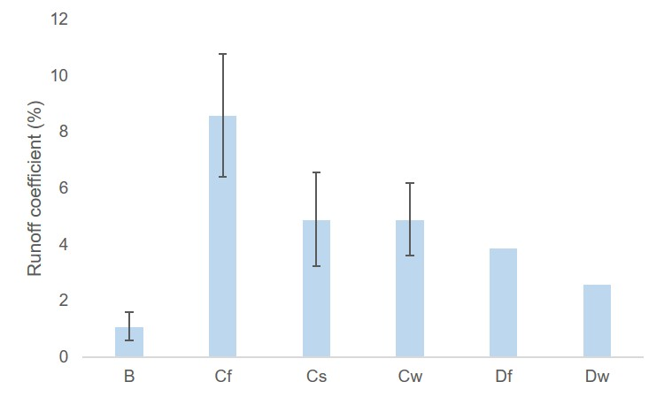

S-Figure 1: Runoff coefficient of Mono-Pine stand (MoP) across climatic zones. Line above bar show standard error

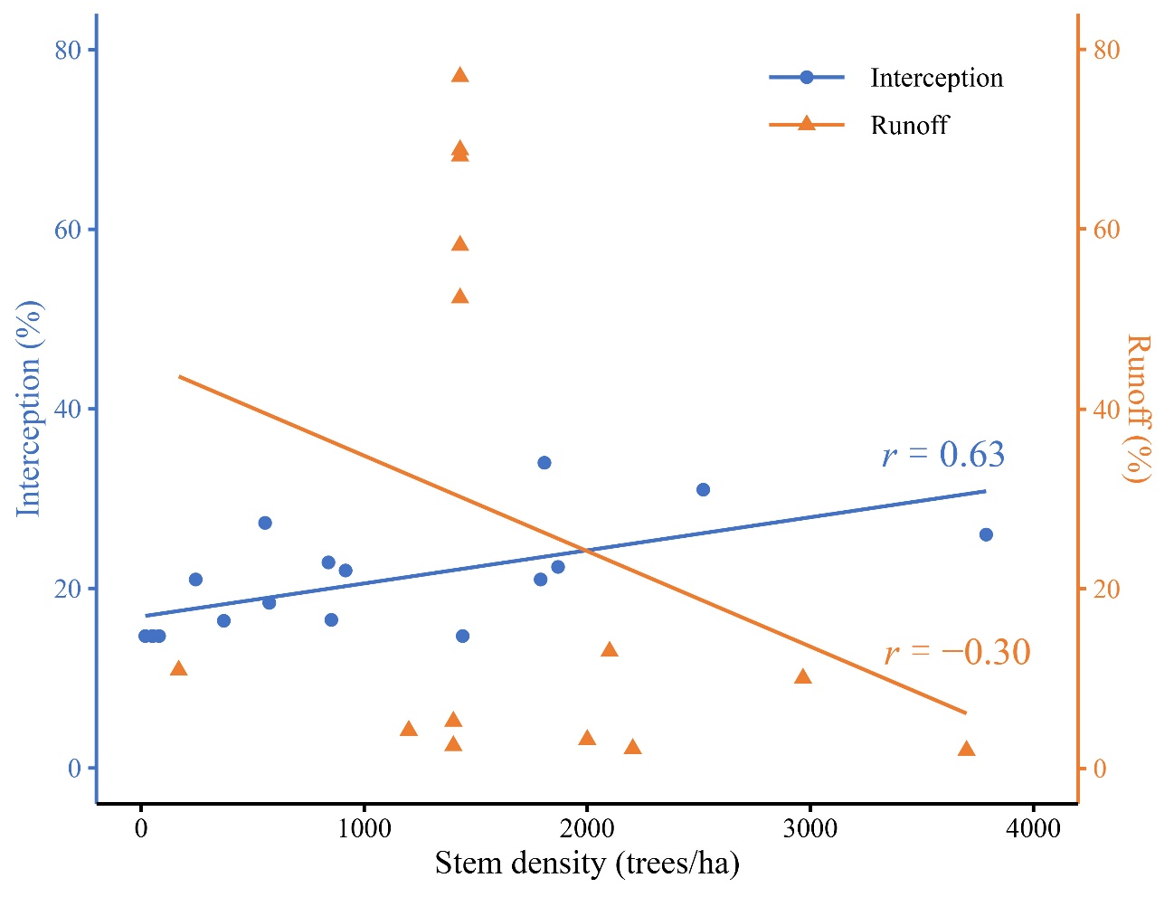
S-Figure 2: Relationship (Pearson correlation coefficient, r) between interception, runoff and stem density.

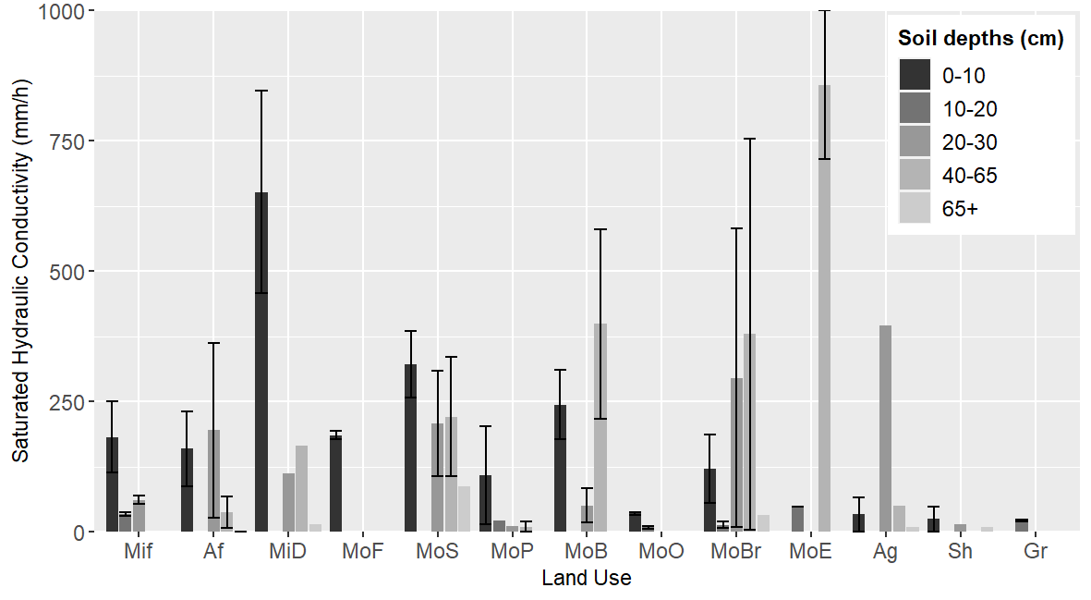

S-Figure 3: Bar chart showing the saturated hydraulic conductivity by land use types at different soil depths with standard error bar. Here, Mif: Mixed forest; Af: Afforestation; MiC: Mixed coniferous; MiD: Mixed deciduous; MoF: Mono-Fir stand; MoS: Mono-Spruce stand; MoP: Mono-Pine stand; MoB: Mono-Beech stand; MoO: Mono-Oak stand; MoBr: Mono-Broadleaved stand; MoE: Mono-Eucalyptus stand; Ag: Agriculture; Sh: Shrubland; Gr: Grassland; Bs: Bare soil.

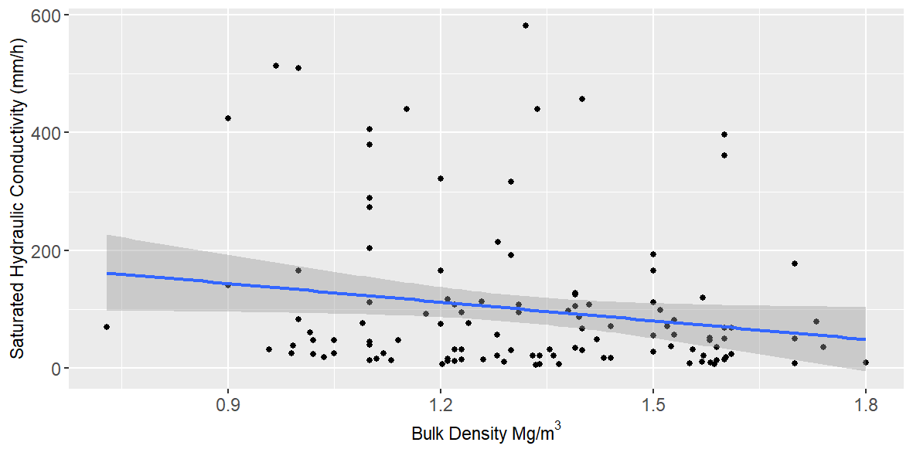
S-Figure 4: Linear regression showing saturated hydraulic conductivity in relation to bulk density

