SUPPLEMENTARY MATERIAL for
African Coastal Camera Network efforts at monitoring Ocean, Climate, and Human Impacts
G. O. Abessolo^{1*}, D. B. Angnuureng², R. Almar³, F. Bonou^{4,5}, Z. Sohou⁶, I. Camara⁷, A. Diouf⁸, G. Alory³, R. Onguéné⁹, A. C. Mama¹, C. O. T. Cissé¹⁰, B. A. Sy¹⁰, I. Sakho^{11,12}, S. Djakouré¹³, S. Yao¹⁴, A. R. Tano¹⁵, E. W.J. Bergsma¹⁶, O. Dada^{3,17}
¹ Ecosystems and Fishery Resources Laboratory, Institute of Fisheries and Aquatic Sciences, University of Douala, BP 2701 Douala, Cameroon
² Africa Centre of Excellence in Coastal Resilience, CCM, University of Cape Coast, Ghana
³ LEGOS, OMP, UMR 5566 (CNES-CNRS-IRD-University of Toulouse), Toulouse, France
⁴ Laboratoire d’Hydrologie Marine et Côtière, Institut de Recherches Halieutiques et Océanologiques du Bénin (IRHOB)/ Laboratoire de Physiques et Applications, LPA/ Université Nationale Des Sciences Technologies, Ingénierie Et Mathématiques (UNSTIM)
⁵ Chaire Internationale de Physique, Mathématiques et Applications
⁶ Laboratoire d’Hydrologie Marine et Côtière, Institut de Recherche Halieutique et Océanologique du Benin (LHMC-IRHOB), Cotonou, Benin.
⁷ Cheikh Anta Diop University, Dakar, Senegal
⁸ Laboratoire d’Océanographie, des Sciences de l’Environnement et de Climat (LOSEC), Université Assane Seck, BP 523, Ziguinchor, Sénégal
⁹ Technology and Applied Science Laboratory, University Institute of Technology, University of Douala, Douala P.O. Box 8698, Cameroon
¹⁰ University Gaston Berger, Laboratory Leïdi "Dynamics of the territories and development", BP 234 Saint-Louis, Senegal
¹¹ Université Amadou Mahtar Mbow de Dakar à Diamnadio, UMR Sciences, Technologies Avancées et Développement Durable, BP 45927. Dakar – Senegal;
¹² Univ Rouen Normandie, UNICAEN, CNRS, M2C UMR 6143, F-76000 Rouen, France
¹³ Laboratoire des Sciences de la Matière, de l'Environnement et de l'Energie Solaire (LASMES)/UFR SSMT/Université Félix Houphouët-Boigny, Cocody, Côte d'Ivoire
¹⁴ Laboratoire de Physique et de Géologie Marine, Centre de Recherches Océanologiques –Abidjan / Côte d’Ivoire
¹⁵ Laboratoire de Physique Fondamentale et Appliquée, Université NANGUI ABROGOUA, Abidjan, Côte d'Ivoire
¹⁶ CNES, 18 Avenue Edouard Bélin, 31400 Toulouse, France
¹⁷ Department of Marine Science and Technology, Federal University of Technology, Akure, Nigeria

* Corresponding author: gregoireabessolo@ish.cm / gregsolo55@yahoo.fr
Table S1: Technical, morphological, and hydrodynamic characteristics of video camera system stations in Africa. The RTR parameter represents the Relative Tidal Range (see [1]). The morphological data of the beaches were collected during field measurement campaigns (e.g., [2-6]). The characteristics of waves were derived from European Re-Analysis ERA5 datasets. ERA5 waves were propagated to the shore using the formula by [7]. ERA 5 data are freely available at www.ecmwf.int/en/forecasts/datasets/reanalysis-datasets/era5. Tidal data were collected from the available literature review.
Video camera station |  | 1 |  | 2 | 3 | 4 | 5 | 6 | 7 | 8
Site | Country | Benin |  | Ghana | Senegal | Cameroon | Ghana | Ghana | Senegal | Côte d’Ivoire
Site | Town | Grand Popo |  | James Town | Mbour | Kribi | Dzita | Elmina | Saint Louis | Assounidé
Site | Location | 6.2°N  1.7°E |  | 5.5°N  0.2°W | 14.4°N  16.9°W | 2.9°N  9.9°E | 5.7°N  0.8°W | 5.1°N  1.3°W | 16.0°N  16.5°W | 5.2°N 3.5°W
Setup | Number of cameras | 2 |  | 1 | 1 | 1 | 1 | 1 | 1 | 1
Setup | Activity period (until 2022/08) | 2013/02 to  2021/03 | 2018/07  to  2021/03 | 2013/08  to  2015/02 | 2014/12  to  2016/12 | 2015/05  to  2018/03 | 2018/04  to  2020/12 | 2018/11  to  2022/01 | 2021/01  to  2022/08 | 2022/07  to  2022/08
Setup | Resolution (pixels) | $$1600×728$$ | $$1920×1080$$ | $$1280×728$$ | $$1176×720$$ | $$1600×1200$$ | $$7552×1416$$ | $$1600×720$$ | $$7552×1416$$ | $$7552×1416$$
Setup | Elevation (m) | 20 |  | 40 | 6 | 8 | 13 | 40 | 20 | 11.5
Setup | Horizontal viewing angle (°) | 93 | 93 | 71.2 | 93 | 71.2 | 180 | 180 | 180 | 180
Setup | Distance to water limit (m) | 70 |  | 90 | 45 | 15 | 5 | 80 | 100 | 50
Setup | Activity (local time) | 7:00 to  18:00 |  | 7:00 to 18:00 | 7:00 to 18:00 | 7:00 to 18:00 | 7:00 to18:00 | 7:00 to 18:00 | 10:00 to 11:00 | 10:00 to 13:00
Setup | Framerate (Hz) | 2 |  | 2 | 2 | 2 | 2 | 2 | 2 | 2
Setup | Data storage | On-site  computer |  | On-site computer | On-site computer | On-site computer | Memory card | Memory card | Memory card | Memory card
Beach | Type | Open |  | Open | Open | Open | Open | Enclosed | Open | Open
Beach | Intertidal slope (rad) | 0.08 |  | 0.03 | 0.05 | 0.03 | 0.1 | 0.08 | 0.05 | 0.03
Beach | D₅₀ (mm) | 0.6 |  | 0.6 | 0.4 | 0.5 | 0.8 | 1 | 0.3 | 0.6
Waves | H_{S} (m) | 1.4 |  | 1.4 | 1.5 | 0.9 | 1.3 | 1.2 | 1.5 | 1.2
Waves | T_{p} (s) | 9.4 |  | 10.9 | 9.2 | 11 | 10.9 | 10.9 | 9.2 | 9.1
Waves | Direction | S-SW |  | S-SW | NW-SW | SW | S-SW | S-SW | NW | S-SW
RTR |  | 1 |  | 1 | 1.1 | 1 | 1.1 | 1 | 1.1 | 1.2

Table S2: Correlations r, root mean square (RMS) differences and mean errors (ME) synthesis of video-derived morphological and hydrodynamic parameters with Grand Popo (Benin) 2014 field measurements [2], CTOH X-TRACK and SSALTO/DUACS altimetry products, European Re-Analysis ERA5 data, and WaveWatch III model outputs. WaveWatch III and ERA-Interim waves were propagated to the shore using the formula by [7]. Grand Popo (Benin) 2014 field measurements consist of wave characteristics and tide collected with an Acoustic Doppler Current Profiler (ADCP) moored at 10-m depth, beach topography collected with a Differential Global Positioning System (DGPS), and bathymetry collected with a bathymetric sonar (From [8-12]).
Video-derived parameters | Field data  (March 11-19, 2014 ) | SSALTO/DUACS  (February 2013 - August 2016) | CTOH-XTRACK  (February 2013 - August 2016) | WaveWatch III  (February 2013 - August 2016)
$H_{s}$ (m) | RMS: 0.14  ME: - 0.02 | // | // | r: 0.89  RMS: 0.3  ME: 0.3
$T_{m}$ (s) | RMS: 1.31  ME: - 0.18 | // | // | r: 0.66  RMS: 2.4  ME: 2.3
Wave direction (°) | RMS: 9.25  ME: 2.25 | // | // | r: 0.44  RMS: 9.4  ME: 8.5
Intertidal topography (m) | RMS: 0.28  ME: 0.23 | // | // | //
Bathymetry (m) | RMS: 1.62  ME: 0.27 | // | // | //
Water level variations (m) | r: 0.90  RMS: 0.20  ME: 0.02 | r: 0.58  RMS: 0.05 | r: 0.56  RMS: 0.06 | //

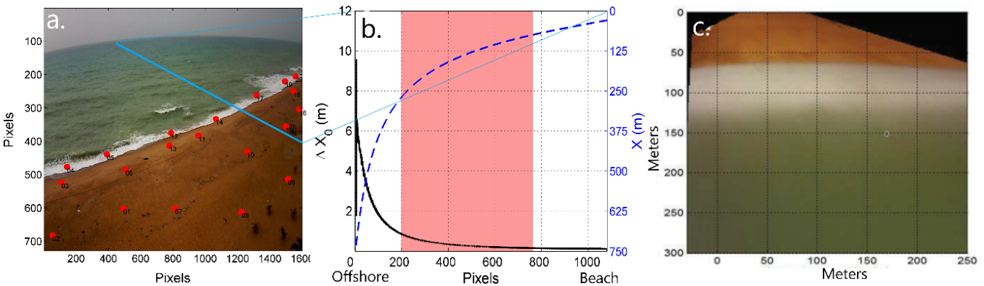
Figure S1: Image rectification at Grand Popo, Benin: (a) Grounds control points in red on a snapshot derived from the video camera. The blue line indicates the cross-shore time-stack location. (b) Averaged pixel footprint ∆X₀ and cross-shore coordinate X in meters relative to the camera location, versus pixel coordinate on the cross-shore stack. The shaded area in red indicates the considered area, which corresponds to the submerged part of the stack with a pixel footprint of less than 1 m. (c) Rectified timex showing the camera field of view.
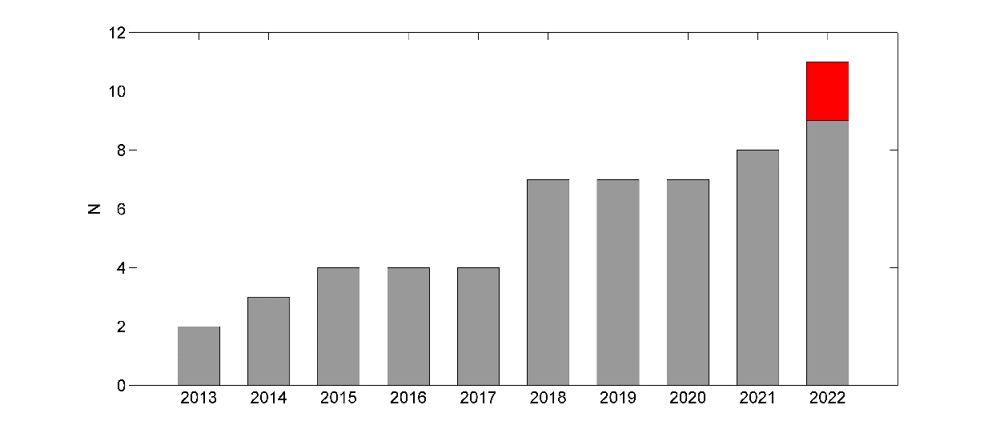
Figure S2: Cumulative number of cameras (N) installed along the African coast per year. The section in red represents the cameras that are being installed in 2022 and are not yet active.
References
[1] Masselink, G. & Short, A.D. The effect of tidal range on beach morphodynamics and morphology: a conceptual beach model. Journal of Coastal research, 9(3), 785-800 (1993).
[2] Almar, R. et al. The Grand Popo beach 2013 experiment, Benin, West Africa: from short timescale processes to their integrated impact over long-term coastal evolution. Journal of Coastal Research, 70, 651–656, (2014).
[3] Ndour, A. et al. On the natural and anthropogenic drivers of the Senegalese (West Africa) low coast evolution: Saint Louis beach 2016 COASTVAR experiment and 3D modeling of short term coastal protection measures. In: Malvárez, G. and Navas, F. (eds.), Global Coastal Issues of 2020, Journal of Coastal Research, Special Issue 95, 583-587 (2020).
[4] Angnuureng, D. B., Addo, K. A., Almar, R. & Dieng, H. Influence of sea level variability on a micro-tidal beach. Nat Hazards, 68, https://doi.org/10.1007/s11069-018-3370-4 (2018).
[5] Angnuureng, D.B. et al. Application of shore-based video and unmanned aerial vehicles (drones): complementary tools for beach studies. Remote Sensing, 12, 394–413 (2020).
[6] Yao, K.S., Dangui, N.P., Gbegbe M. & Abe, J. Caractéristiques du climat de houle au large de la côte ivoirienne entre 1985 et 2015 : impacts sur l'évolution morpho dynamique du rivage. Actes du colloque international XV èmes Journées Nationales Génie Côtier – Génie Civil, 29 - 31 mai 2018, La Rochelle, France, pp. 313-320, https://doi.org/10.5150/jngcgc.2018.035 (2018).
[7] Larson, M., Hoan, L. X. & Hanson, H. A direct formula to compute wave properties at incipient breaking. Journal of Waterway, Port, Coastal and Ocean Engineering, 136(2), 119–122 (2010).
[8] Abessolo, O. G. et al. Potential of video cameras in assessing event and seasonal shoreline behaviour: A case study at Grand Popo, Benin (Gulf of Guinea). Journal of Coastal Research, SI 75, 442–446 (2016).
[9] Abessolo, O. G. et al. Beach response to wave forcing from event to inter-annual time scales at Grand Popo, Benin (Gulf of Guinea). Water, 9, 447; https://doi.org/10.3390/w9060447 (2017).
[10] Abessolo, G.O. et al.. Sea level at the coast from video-sensed waves: comparison to tidal gauges and satellite altimetry. Journal of Atmospheric and Oceanic Technology, 36, 1591-1603 (2019).
[11] Abessolo, O. G., Almar, R., Bonou, F. & Bergsma, E. J. Error proxies in video-based depth inversion: temporal celerity estimation. In: Malvárez, G. and Navas, F. (eds.). Global Coastal Issues of 2020, Journal of Coastal Research, Special Issue 95, 1101–1105 (2020).
[12] Abessolo, G.O., Almar, R., Jouanno, J., Bonou, F., Castelle, B. & Larson, M. Beach adaptation to intraseasonal sea level changes. Environmental Research Communications, 2, 051003; https://doi.org/10.1088/2515-7620/ab8705 (2020).

