SUPPLEMENTARY
Imaging features
Lattice-based texture estimation adopted for lung 3D CT scan was used for feature extraction. Three sets of features were derived: Gray-level histogram, Co-occurrence, Run-length features.
Gray-level histogram features are first-order histogram statistics calculated from the gray-level intensity histogram of each image.
Feature | Mathematical Notation | Qualitative description
Mean | $\frac{\sum_{k}{}k*g(k)}{K}$ | Mean gray-level value
Min | min($k$) | Minimum gray-level value
Max | max($k$) | Maximum gray-level value
5th Percentile | $k$: 5% of values ≤ $k$ | The histogram bin that 5% of gray-level values are less than or equal to.
5th Mean | $\frac{\sum_{k}{}k*g(k)}{\sum_{k}{}g(k)}$ for $k$ ≤ 5th Percentile | Mean value of the gray-level values which less than or equal to the 5th Percentile.
95th Percentile | $k$: 95% of values ≥ $k$ | The histogram bin that 95% of gray-level values are less than or equal to.
95th Mean | $\frac{\sum_{k}{}k*g(k)}{\sum_{k}{}g(k)}$ for $k$ ≥ 95th Percentile | Mean value of the gray-level values which larger than or equal to the 95th Percentile.
Sum | $\sum_{k}{}k*g(k)$ | Sum of gray-level values
Sigma | $\sqrt{\sum_{k}{}{\left(k-Mean\right)}^{2}*g(k)}$ | Variation of gray-level values around the Mean
Entropy | $-\sum_{k}{}g\left(k\right)*log⁡(g(k))$ | Measure of histogram uniformity
Kurtosis | $Sigma^{-4}\sum_{k}{}{\left(k-Mean\right)}^{4}*g(k)-3$ | Measure of histogram flatness
Skewness | $Sigma^{-3}\sum_{k}{}{\left(k-Mean\right)}^{3}*g(k)$ | Measure of histogram symmetry
where $k$ is the histogram bin, g is the frequency of the histogram bin and $K=\sum_{k}{}g(k)$.

Co-occurrence features capture the spatial relationship between pixels and are based on the gray-level co-occurrence matrix (GLCM). In a GLCM, each element, $f(i,j)$, corresponds to the frequency with which two neighboring pixels, one with gray level $i$ and the other with $j$, occur within a specified distance ($d$). In our study, the GLCM matrices were estimated using different $window sizes=4, 6, 8, 10, 12, 14, 16, 18, 20$ pixels.

Feature | Mathematical Notation | Qualitative description
Cluster Shade | $\sum_{ij}{}{\left(i-µ_{i}+j-µ_{j}\right)}^{3}*f(i,j)$ | Asymmetry in gray-level values
Correlation | $\sum_{ij}{}\frac{\left(i-µ_{i}\right)*\left(j-µ_{j}\right)*f(i,j)}{σ_{i}{*σ}_{j}}$ | Linear gray-level dependence
Haralick Correlation | $\sum_{ij}{}\frac{ij*f\left(i,j\right)-µ_{i}*µ_{j}}{σ_{i}{*σ}_{j}}$ | Linear gray-level dependence
Energy | $\sum_{ij}{}f{\left(i,j\right)}^{2}$ | Certainty of gray-level co-occurrence
Entropy | $-\sum_{ij}{}f\left(i,j\right)*log⁡(f\left(i,j\right))$ | Uncertainty of gray-level co-occurrence
Inertia | $\sum_{ij}{}{\left(i-j\right)}^{2}*f(i,j)$ | Local variation of gray-level intensity
Inverse Difference Moment | $\sum_{ij}{}\frac{f(i,j)}{1+{\left(i-j\right)}^{2}}$ | Local homogeneity in gray-level values
where $μ_{i}=\sum_{j}{}i*f(i,j)$, $μ_{j}=\sum_{i}{}j*f(i,j)$, $σ_{i}^{2}=\sum_{j}{}{\left(i-μ_{i}\right)}^{2}*f(i,j)$, and $σ_{j}^{2}=\sum_{i}{}{\left(j-μ_{j}\right)}^{2}*f(i,j)$.

Run-length features capture the coarseness of a texture in specified directions, where a run is defined as a string of consecutive pixels with similar gray-level intensity along specific linear orientation. Similar to GLCMs, a run-length matrix $R$ is defined, with each element, $R\left(i,j\right)$, representing the number of runs with pixels of gray-level intensity equal to $i$ and length of run equal to $j$ along the specific orientation. The size of the matrix $R$ is $M×N$, where $N$ is equal to the maximum run length. The following run-length statistics were estimated using different $window sizes=4, 6, 8, 10, 12, 14, 16, 18, 20$ pixels.

Feature | Mathematical Notation | Qualitative description
Gray Level Non-uniformity | $\frac{1}{n_{r}}{\sum_{i=1}^{M}{}\left(\sum_{j=1}^{N}{}R\left(i,j\right)\right)}^{2}$ | Dissimilarity in runs across gray-level values
High Gray Level Run Emphasis | $\frac{1}{n_{r}}\sum_{i=1}^{M}{}\sum_{j=1}^{N}{}R\left(i,j\right)*i^{2}$ | Runs of high-gray-level values
Long Run Emphasis | $\frac{1}{n_{r}}\sum_{i=1}^{M}{}\sum_{j=1}^{N}{}R\left(i,j\right)*j^{2}$ | Emphasis on the long runs
Low Gray Level Run Emphasis | $\frac{1}{n_{r}}\sum_{i=1}^{M}{}\sum_{j=1}^{N}{}\frac{R\left(i,j\right)}{i^{2}}$ | Runs of low-gray-level values
Run Length Non-uniformity | $\frac{1}{n_{r}}{\sum_{j=1}^{N}{}\left(\sum_{i=1}^{M}{}R\left(i,j\right)\right)}^{2}$ | Dissimilarity in runs across lengths
Run Percentage | $\frac{n_{r}}{\#pixels}$ | Homogeneity and distribution of runs
Short Run Emphasis | $\frac{1}{n_{r}}\sum_{i=1}^{M}{}\sum_{j=1}^{N}{}\frac{R\left(i,j\right)}{j^{2}}$ | Emphasis on the short runs
where $n_{r}=\sum_{i=1}^{M}{}\sum_{j=1}^{N}{}R\left(i,j\right)$ is the total number of runs.

Clustering Analysis
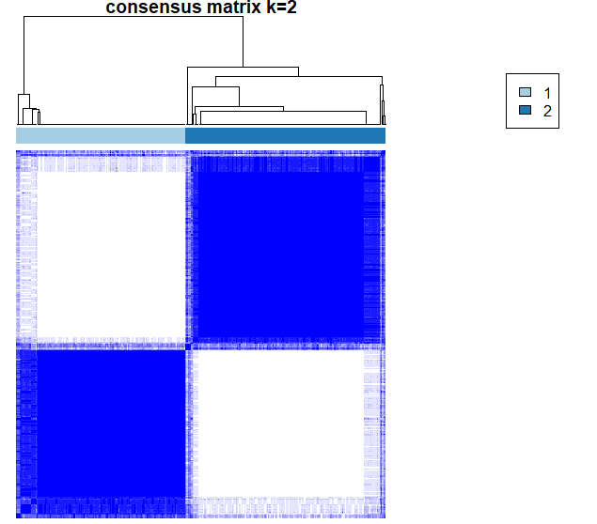 | 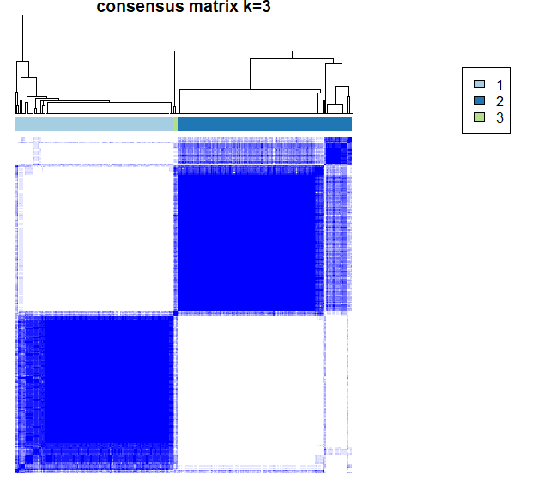 |  | 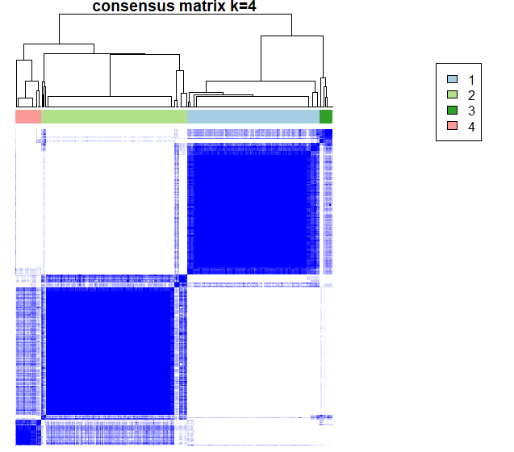
W = 4mm
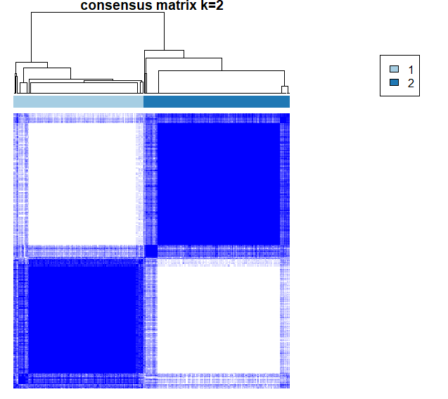 | 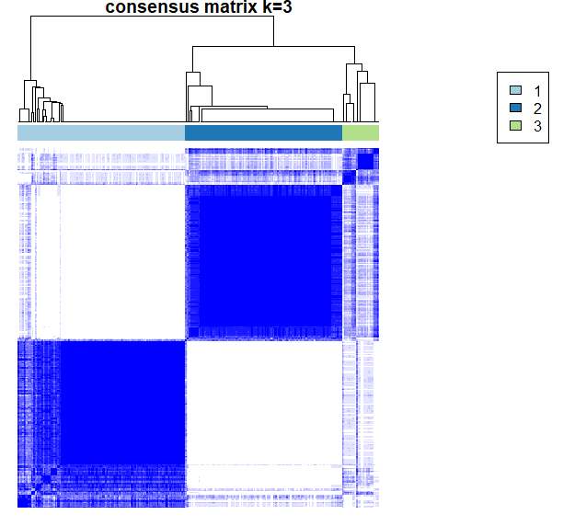 | 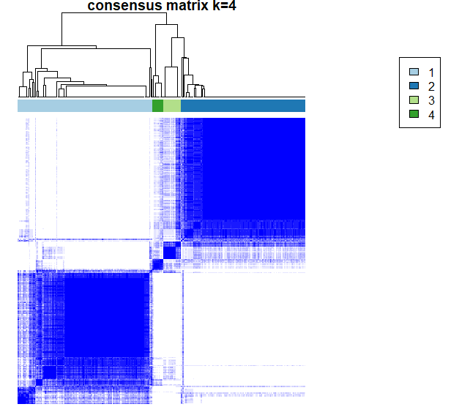
W = 8mm
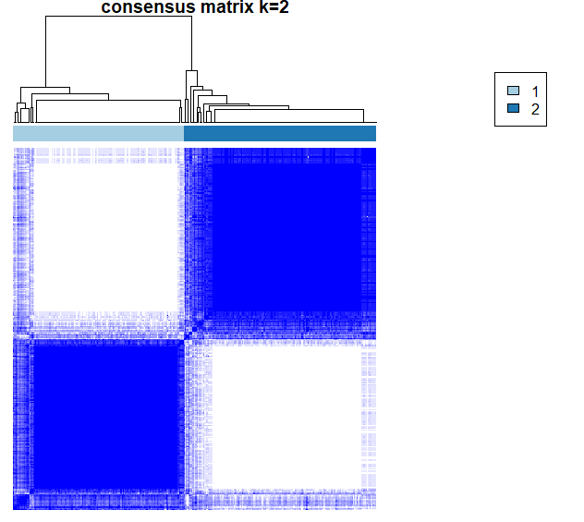 | 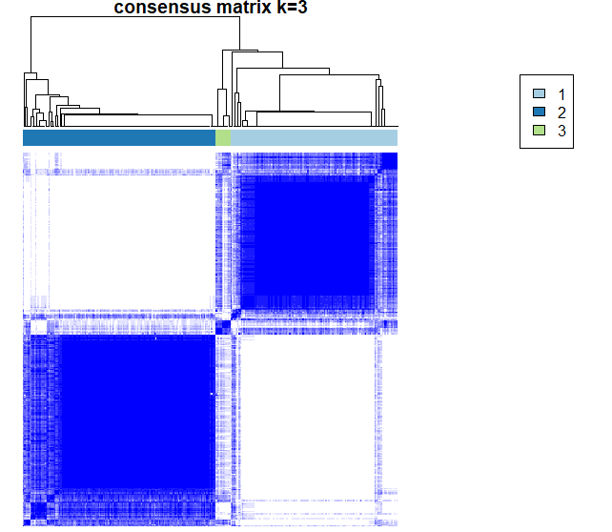 | 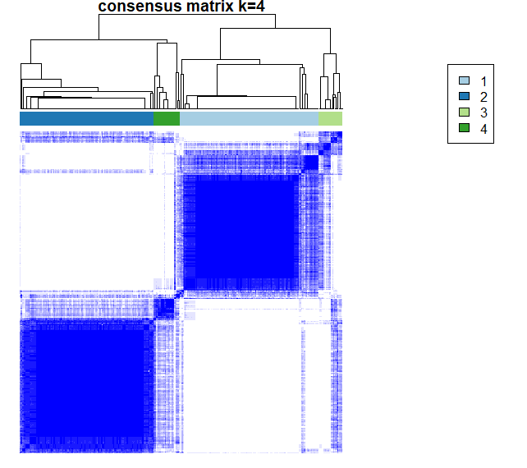
W = 20mm
Fig. S1: Consensus clustering for different number of clusters (K = 2, 3, 4) for finding the best optimal cluster for patients with I130f kernel.

Entanglement
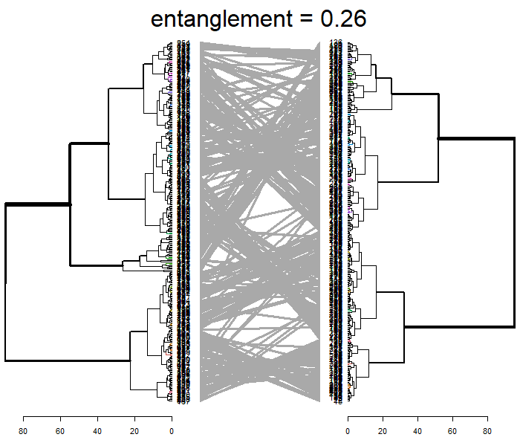 | 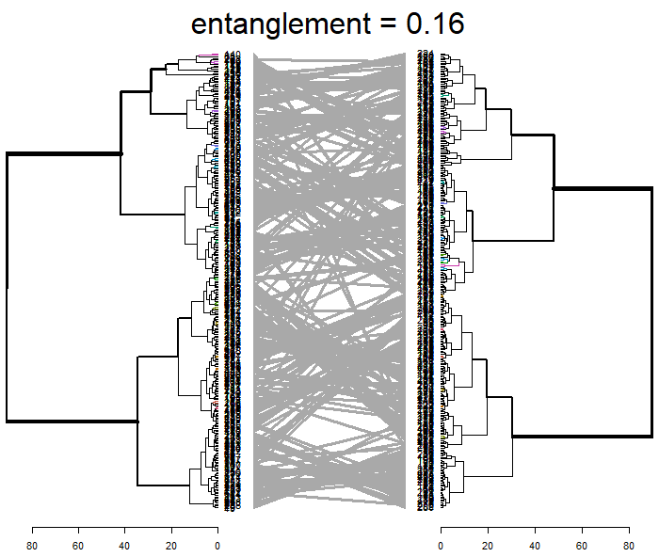 | 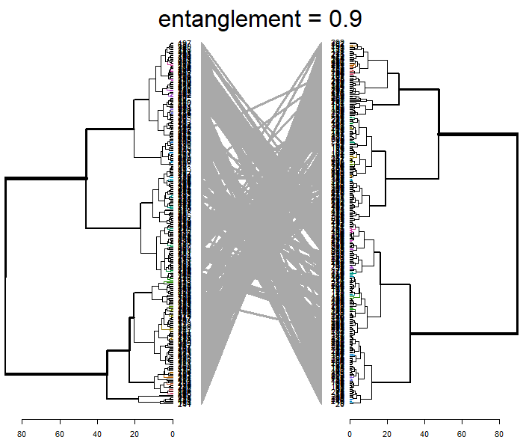
W = 4mm | W = 8mm | W = 20mm
Fig. S2: Entanglement after applying feature harmonization comparing the two clusters between reconstruction kernels.

Feature Harmonization
Outlier detection in the harmonization process resulted in 8 patients (images) being classified as outliers from the W = 4mm, 8mm, and 20mm window sizes in the two-reconstruction kernel dataset. Similarly, 12, 15, and 36 patients were detected as outliers from the W = 4mm, 8mm, and 20mm in the PFT dataset. The effects of dropping scans with residuals classified as outliers are shown for a sample representative feature (gray entropy) and covariate (BMI) from the two-reconstruction kernel dataset in Figure S3. The outlier removal resulted in a more even distribution of imaging features.
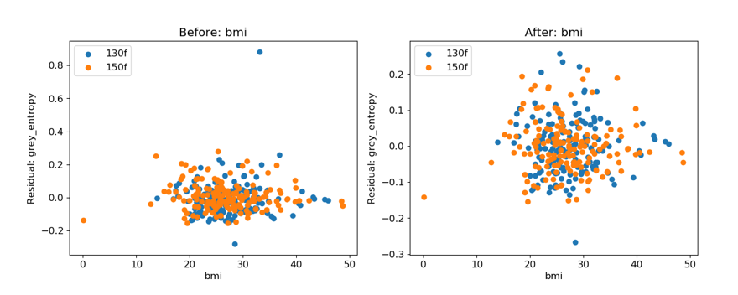
Figure S3. Residual plots for gray entropy versus BMI for the raw features (left) and the ComBat-harmonized features with the outliers dropped (right) for the two-reconstruction kernel dataset with window size 4mm.

Table S1. Number of features with statistically significant differences in distribution due to reconstruction kernel as detected with the KS test (p < 0.05) for the two-reconstruction kernel dataset.
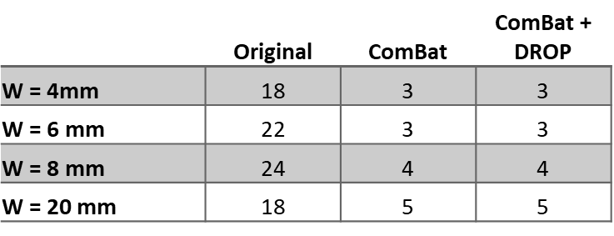
Table S2. Number of features with statistically significant differences in distribution due to the reconstruction kernel as detected with the KS test (p < 0.05) for the PFT dataset.
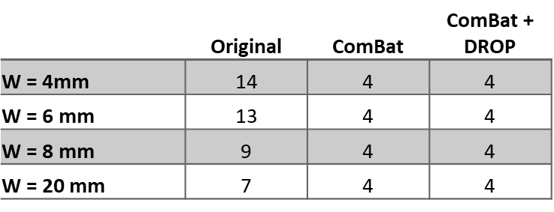

CT Acquisition Parameters
Images used in study have voxel size of 0.5mm x 0.5mm x 0.5mm. Some CT parameters are shown in Figure S4.
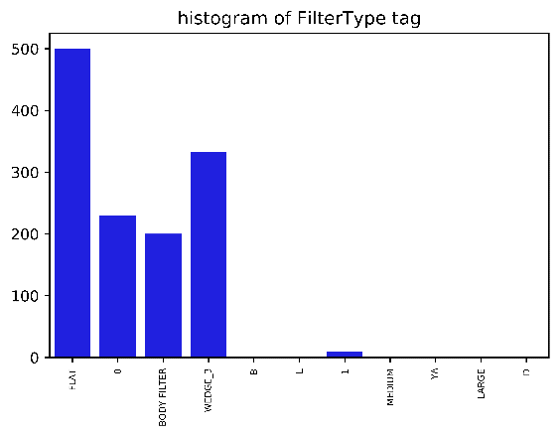 | 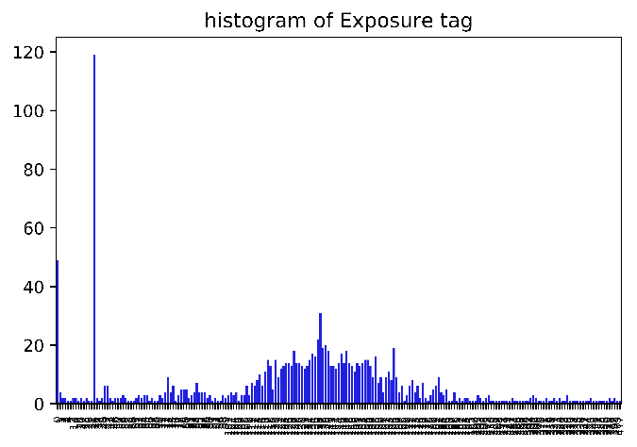
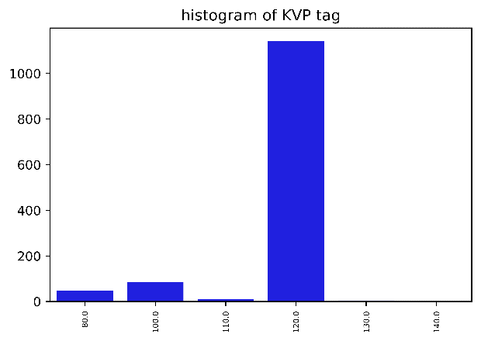 | 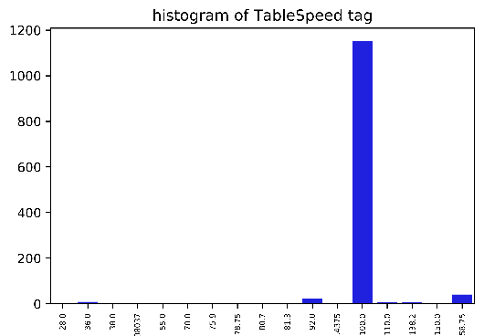
Fig. S4. Some CT acquisition parameters used for image analysis

Availability of Data and Material
The datasets generated and/or analyzed during the current study are not publicly available due to privacy and its proprietary nature but are available from the corresponding author on reasonable request.

