Identification of novel targets and pathways to distinguish suicide dependent or independent on depression diagnosis

Siqi Peng ¹, Yalan Zhou ¹, Lan Xiong^{2#}, Qingzhong Wang ^{1#}
1 Institute of Chinese Materia Medica, Shanghai University of Traditional Chinese Medicine, Shanghai 201203, China
2. Montreal Neurological Institute and Hospital, McGill University, Montreal, QC, Canada.

Contributions
Qingzhong Wang, Lan Xiong designed the project, checked and edited the manuscript. Material preparation and data collection and analysis were performed by Siqi Peng and Yalan Zhou. All authors have read and approved the final version of the manuscript.

# Corresponding authors: Qingzhong Wang and Lan Xiong
Qingzhong Wang: wangqingzhong3@gmail.com; qzwang2018@sibs.ac.cn
Lan Xiong: lan.xiong@mcgill.ca

Supplementary Figure 1. The most significant difference in expression level across three Depression with suicide, depression without suicide and healthy controls. The top altered genes expression from cross-phenotype analysis in the Suicide Group. The heatmap plot were conducted by the heatmap.2 fuction in the gplots package (v3.1.3).
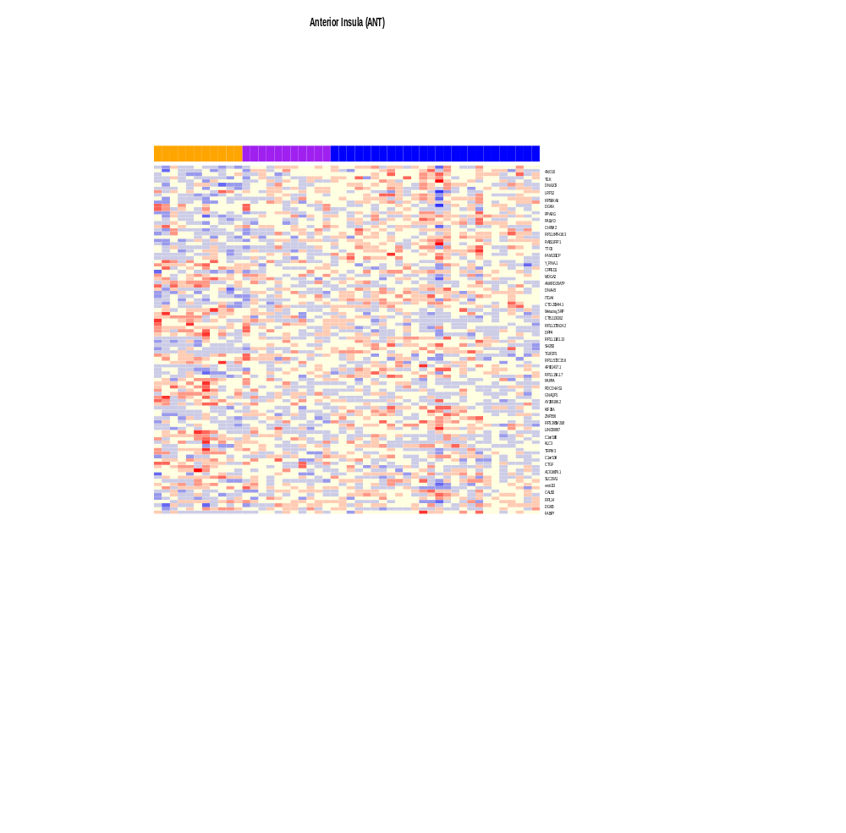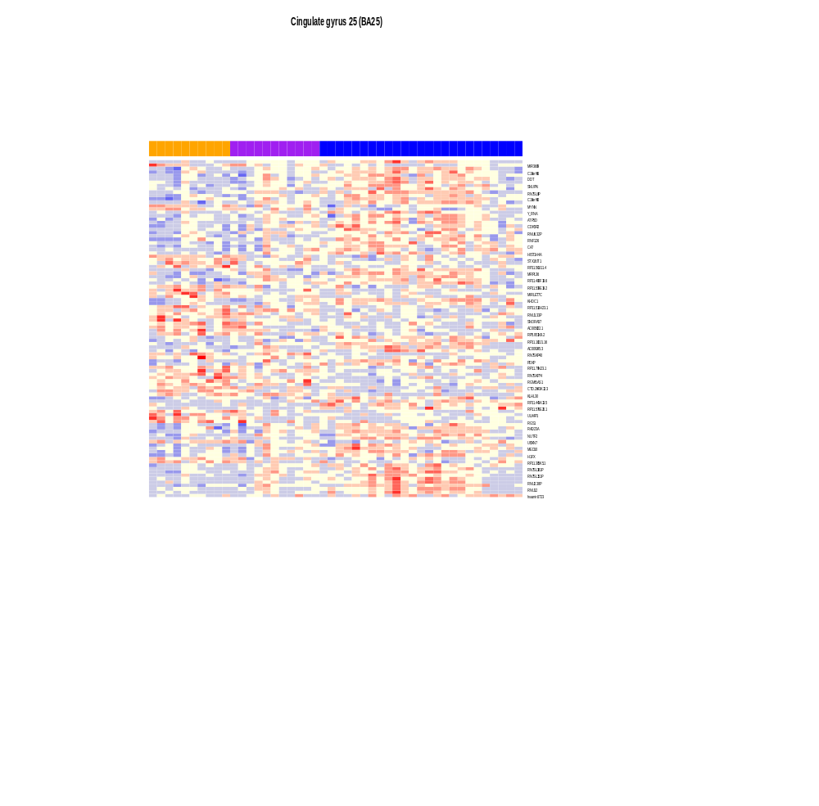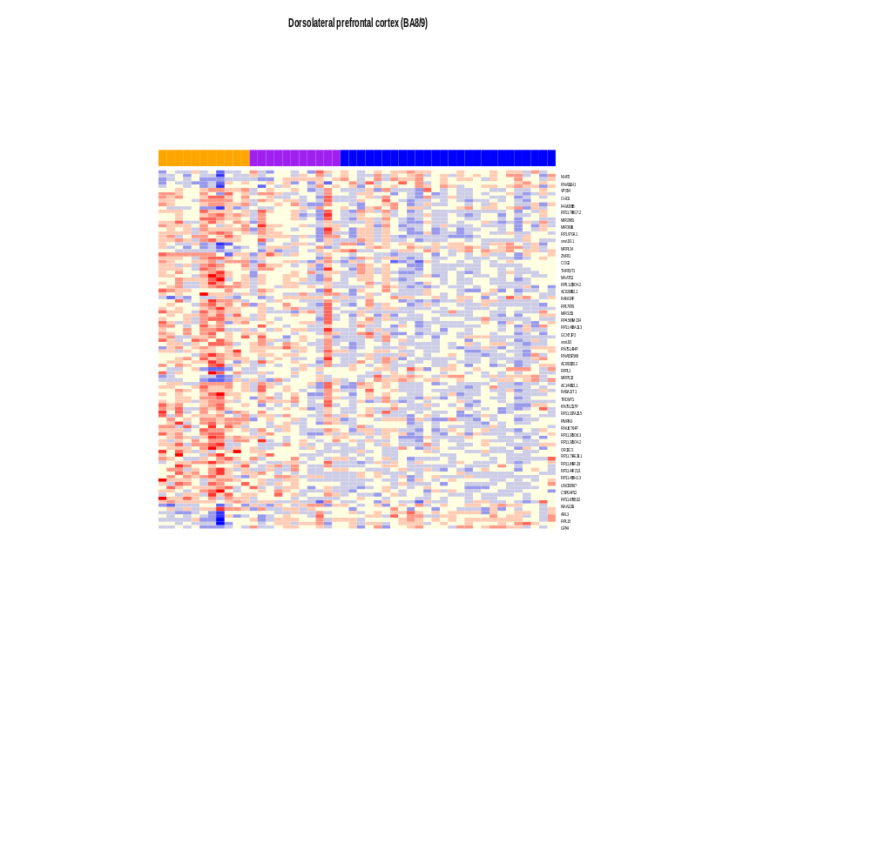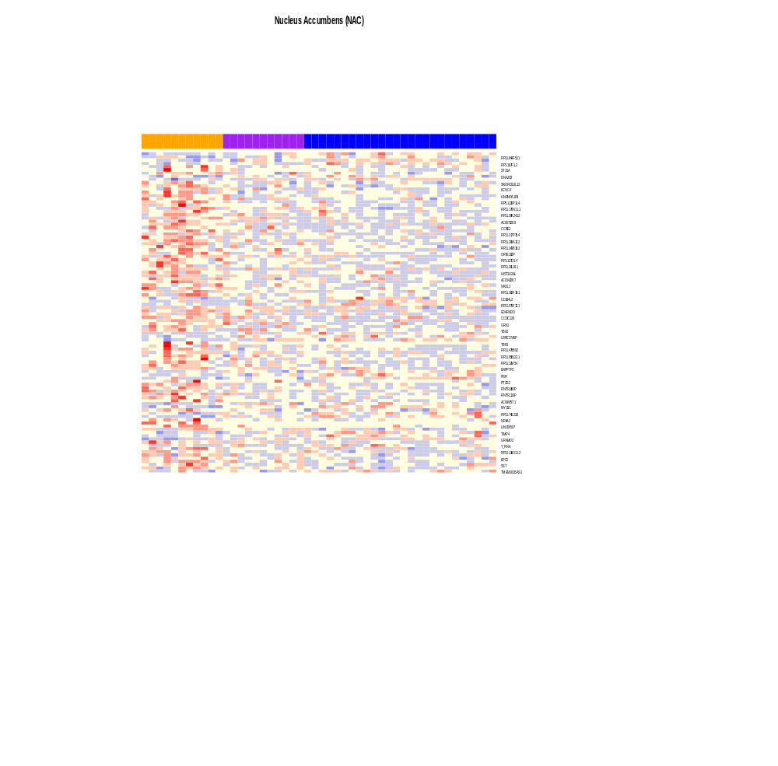
2A
2B
2C
2D
2E
2F
Supplementary Figure 2. Heatmap of the top dysregulated genes that are differentially expressed across three groups by cross-phenotype analysis (Tissue type number =6). A. The top significant gene expression changes in the anterior Insula area(ANT). B. Orbitofrontal (BA 11) of Suicide Group. C. Cingulate gyrus 25 (BA25) of Suicide Group. D. Dorsolateral prefrontal cortex (BA8/9) of Suicide Group. E. Nucleus Accumbens (NAC) of Suicide Group. F. Subiculum (Subic) of Suicide Group. The heatmap figure were plotted by the heatmap.2 fuction in the gplots package (v3.1.3).

Figure 3A
Figure 3B
Figure 3C
Figure 3D
Supplementary Figure 3. Subset of the most connected genes (intra-modular connectivity >0.9) in each associated-phenotypic modules. Red dots represent the hub genes. a. C20orf196 gene in the midnightblue module. b. RP11-349A22.5 gene in the blue module. c. RP11-697N18.2 gene in the orange module. d. MAPK8IP3 gene in the pink module.

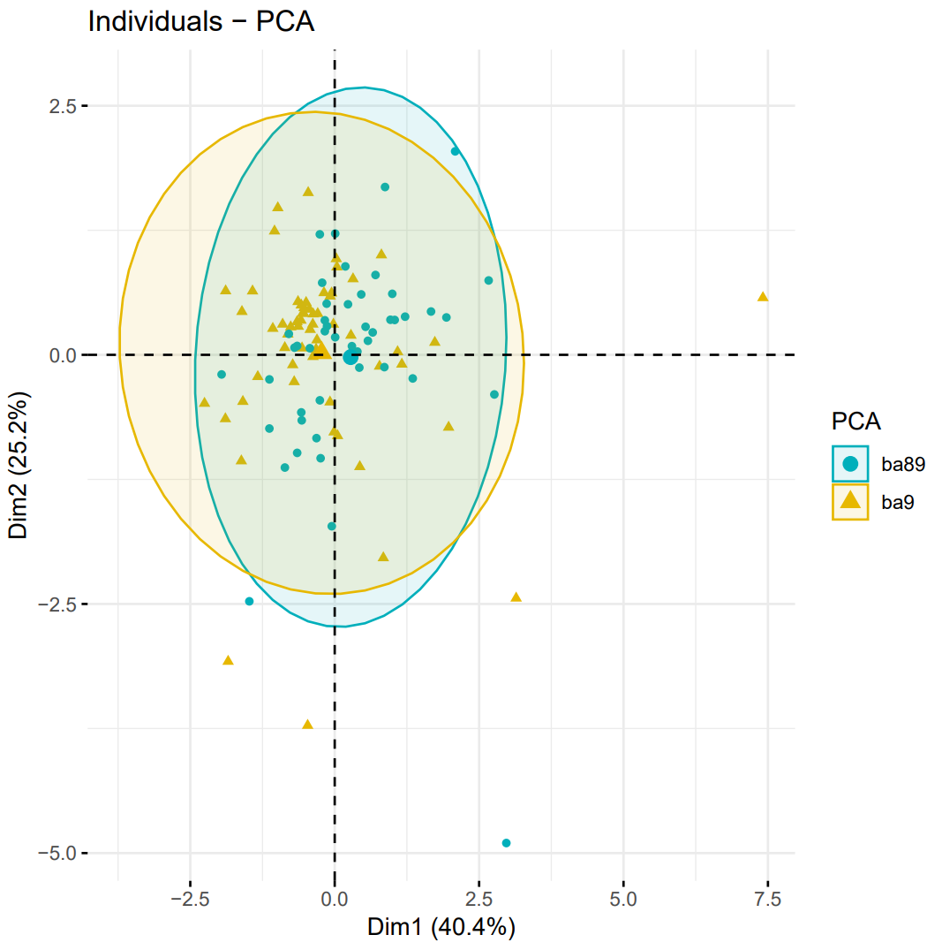
Frontal cortex in the Suicide Group
Frontal cortex in the Depression Group
Supplementary Figure 4. PCA two-dimensional scatter plots represent the differential gene expression patterns of the different human frontal cortex from two groups. Each dot represents a sample and the color its origin: green dots represent frontal cortex of Suicide Group; yellow dots represent frontal cortex of Depression Group.

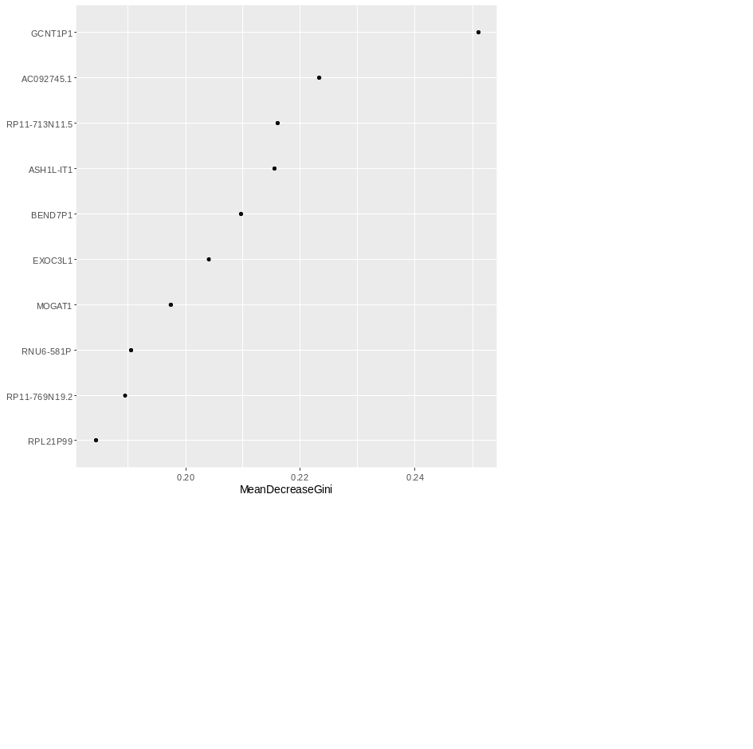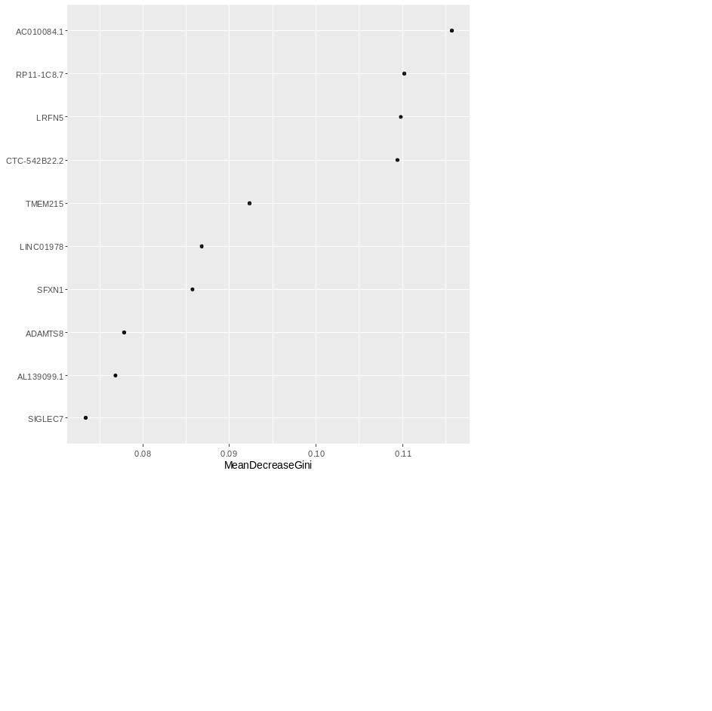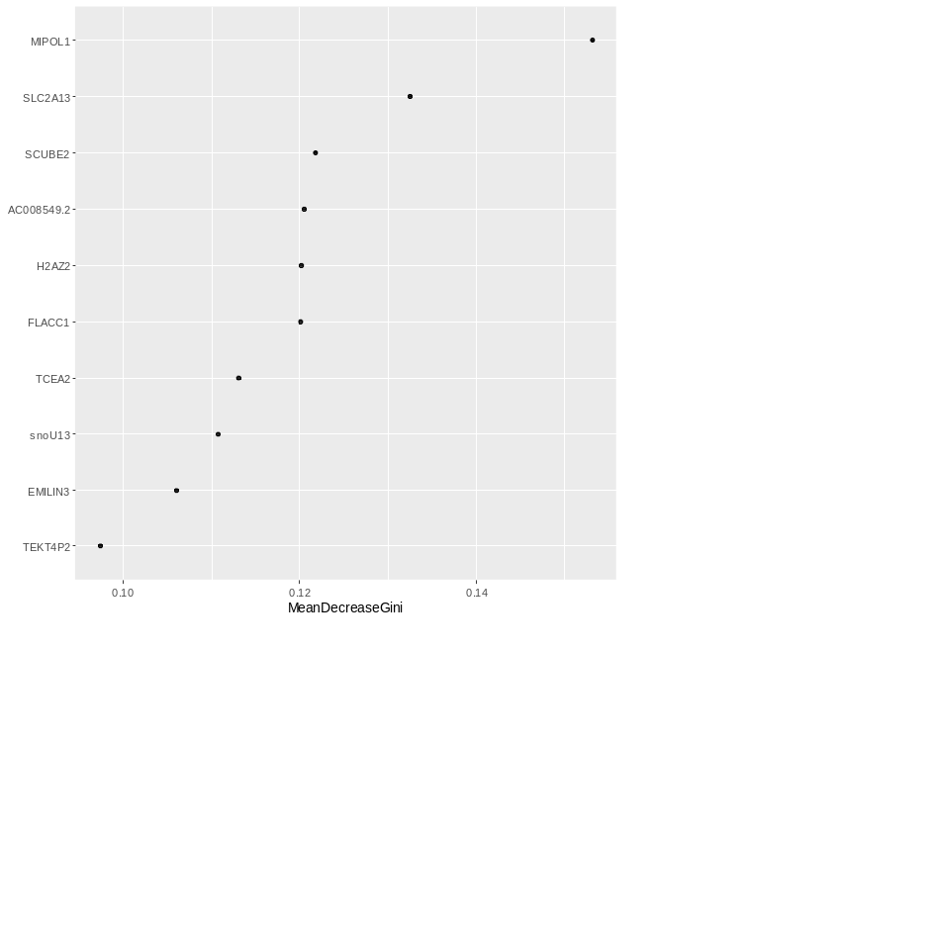
5A
5B
5C
Supplementary Figure 5. Variable importance as measured by mean decrease Gini index using RandomForest model. A mean decrease in Gini index indicates median importance and better classification for the disease state with the selected DEGs. Figure 2A. the group of suicide with MDD; Figure 2B. Suicide without MDD; Figure 2C: MDD without suicide.

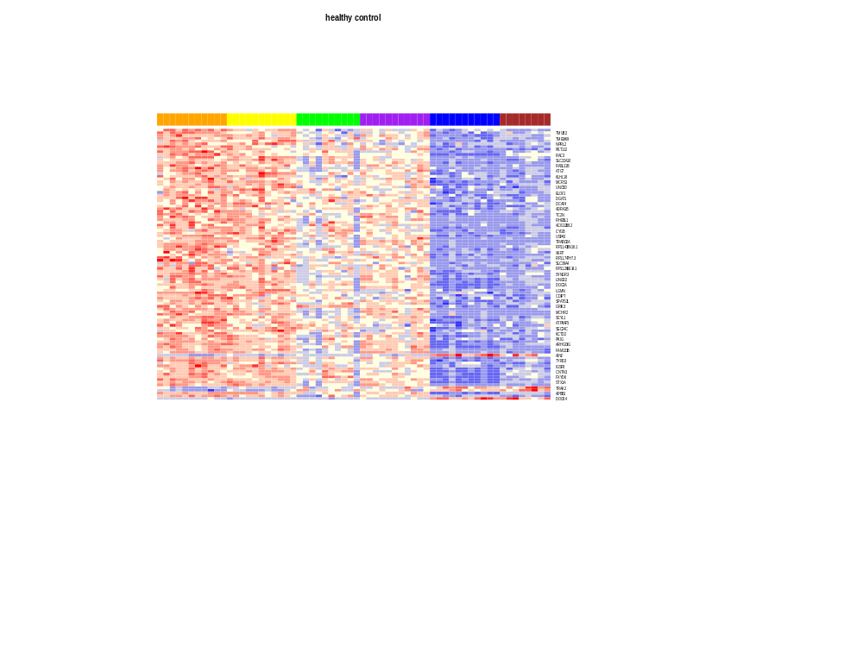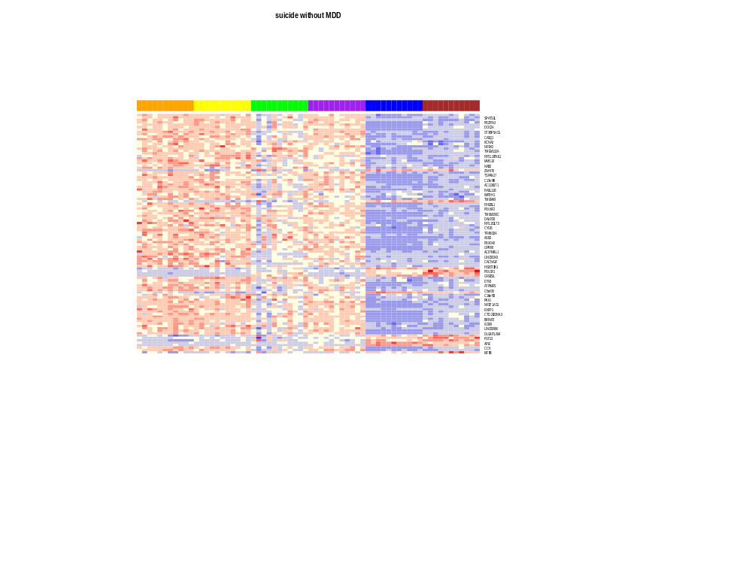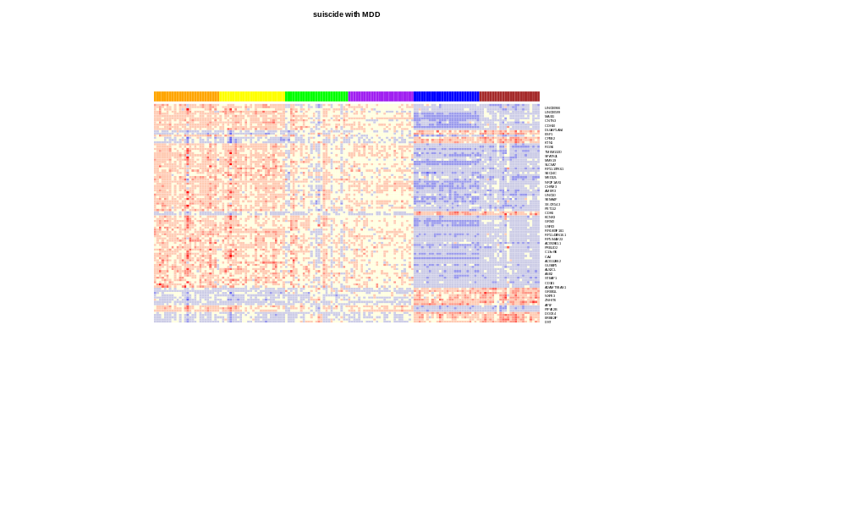
6A
6B
Supplementary Figure 6. The heatmap illustrates the top DGEs expression pattern from the cross-tissue analysis in the three phenotypes groups.
Figure 3A. The heatmap of the significant genes expression profiling in the suicide with MDD. Figure 3B. the heatmap of the suicide without MDD. Figure 3C. the heatmap of healthy control. These figures was performed with the heatmap.2 fuction in the gplots package (v3.1.3).

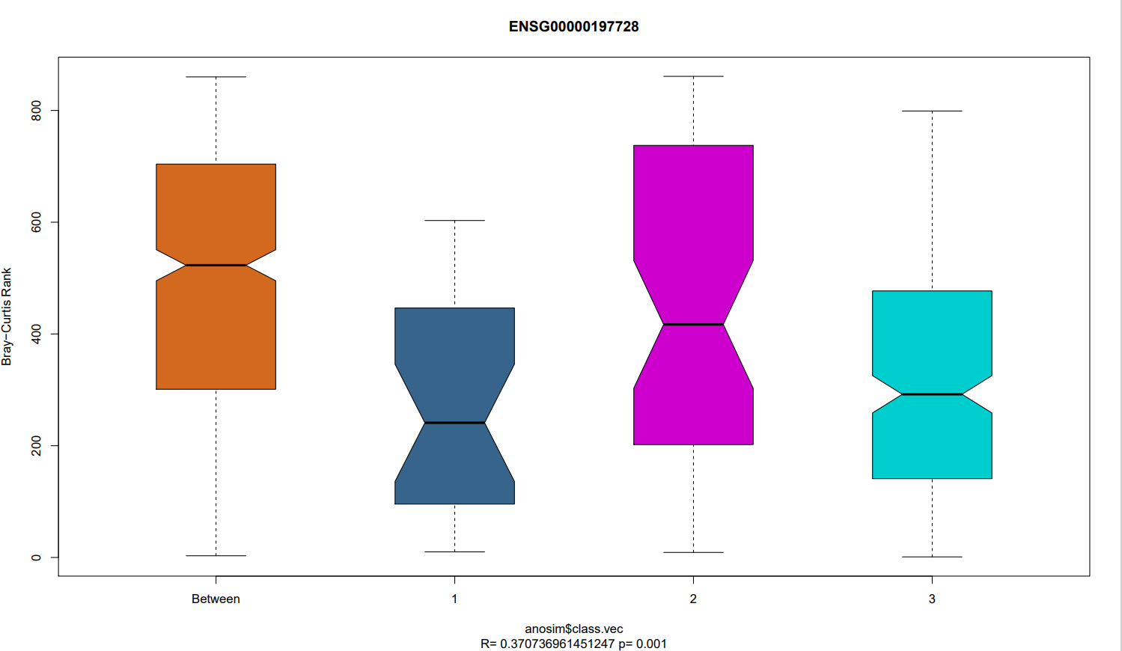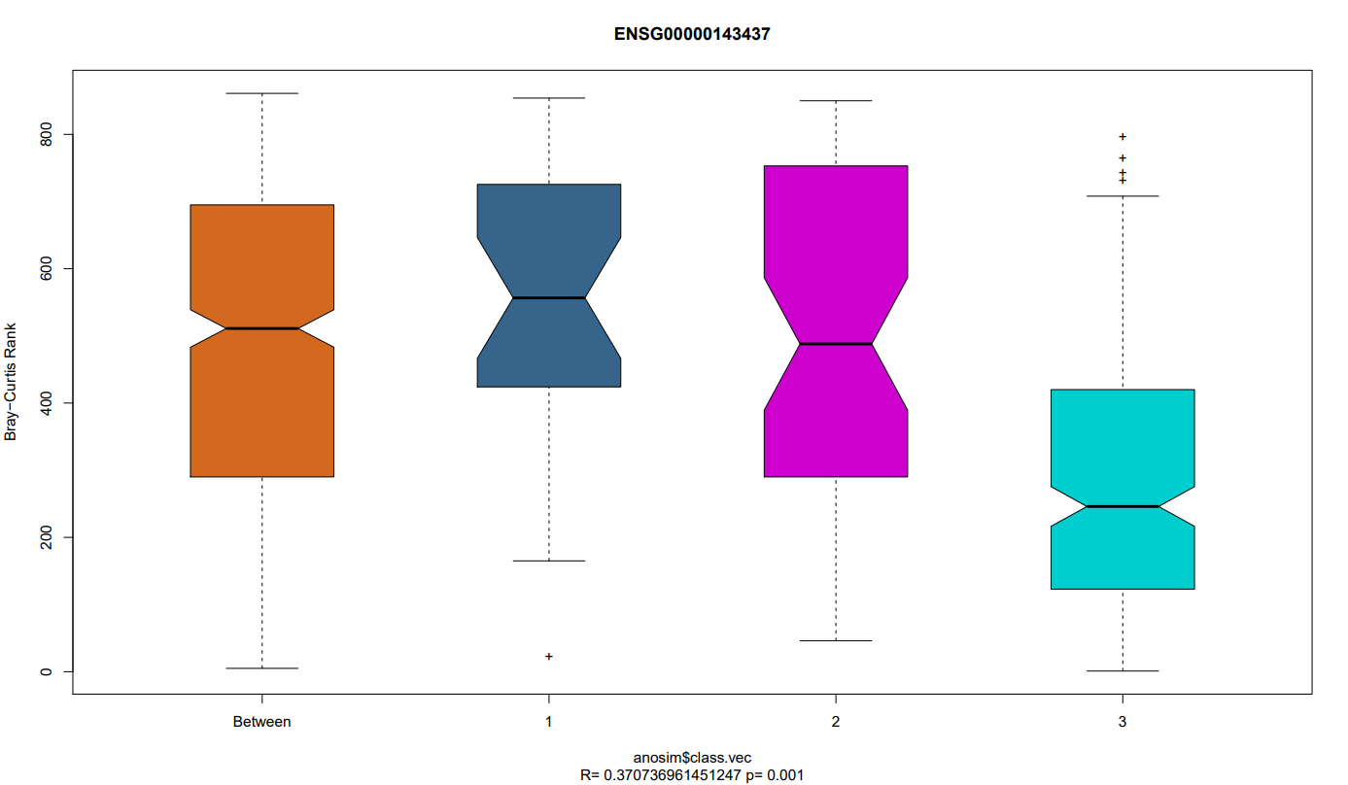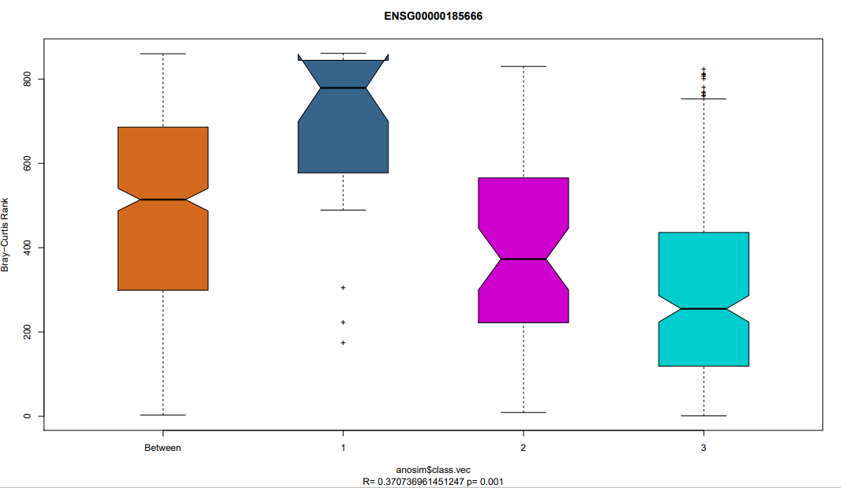
RPS26
ANRT
SYN3
Between
CON
S-M
S+M
Between
CON
S-M
S+M
Between
CON
S-M
S+M
Supplementary Figure 7. Analysis of similarities (ANOSIM) plot of the three top genes by cross-disease-tissue analysis, which have shown dissimilarity between and within groups. Figure 4A. RPS26 gene (R = 0.37, p= 0.001); Figure 4B. ARNT (R= 0.32, p-value = 0.001); Figure 4C. SYN3 (R= 0.32, p-value = 0.001).

male group
Female group

Supplementary Figure 8. Rank-rank hypergeometric overlap (RRHO) maps compare differential expression between males and females (male, row panel; female, column panel).

