SUPPLEMENTARY MATERIAL 1

Text 1. The diagnostic criteria of HFRS cases
HFRS cases were classified as suspected, clinically diagnostic or confirmed cases according to the health industry standard of the People’s Republic of China for diagnostic criteria of HFRS. Briefly, 1) a patient with epidemiological history and clinical manifestations of fever or gastrointestinal symptoms was defined as a suspected case; 2) a suspected case with hypotension, renal function impairment, increased peripheral blood cell counts and thrombocytopenia, and positive urine protein was defined as a clinically diagnosed case; and (3) a clinically diagnosed case with one or more of the following criteria was defined as a confirmed case: positive serum-specific IgM antibody; specific IgG antibody 4 times higher than that in the acute phase; and Hantavirus RNA is positive or Hantavirus is isolated.

Figure 1. General trend of HFRS morbidity in Jiangxi from 2005 to 2021

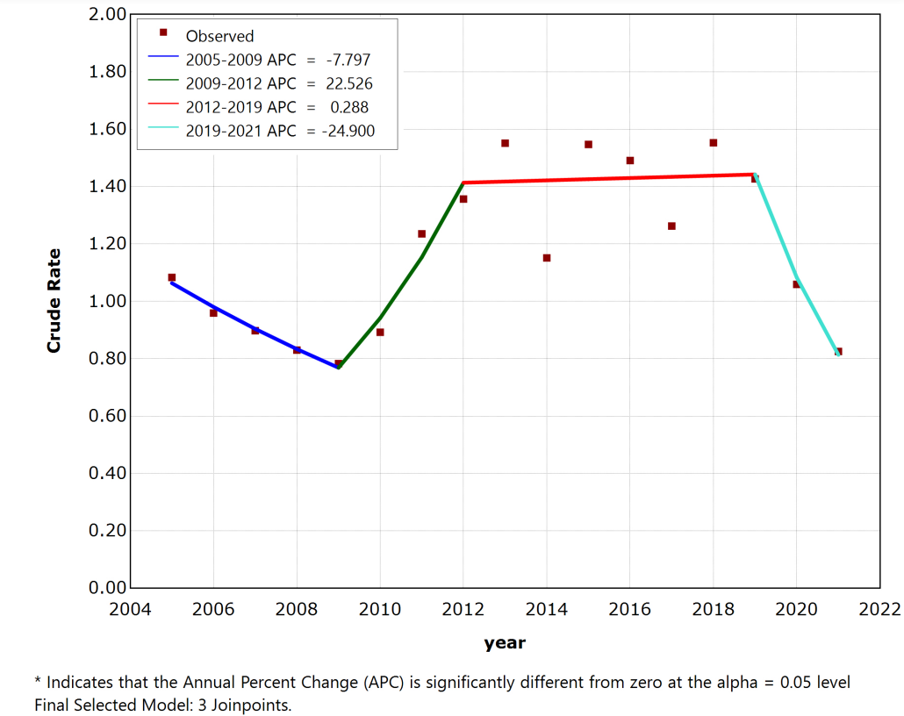

Table 1. Rodent Hantavirus surveillances in Gaoan county from 2005 to 2021.
Year | Mousetraps | Rats captured | Rats’ density (%) | Rats detected | ANP (N) | APA (%) | IRV
2005 | 10600 | 307 | 2.90 | 307 | 0 | 0.00 | 0.00
2006 | 5700 | 219 | 3.84 | 213 | 0 | 0.00 | 0.00
2007 | 6800 | 231 | 3.40 | 231 | 4 | 1.73 | 2.42
2008 | 8000 | 210 | 2.63 | 210 | 1 | 0.48 | 1.12
2009 | 10400 | 232 | 2.23 | 232 | 0 | 0.00 | 0.00
2010 | 11100 | 226 | 2.04 | 226 | 1 | 0.44 | 0.95
2011 | 12000 | 210 | 1.75 | 210 | 9 | 4.29 | 2.74
2012 | 9600 | 254 | 2.65 | 254 | 8 | 3.15 | 2.89
2013 | 9600 | 213 | 2.22 | 213 | 7 | 3.29 | 2.70
2014 | 9600 | 225 | 2.34 | 225 | 8 | 3.56 | 2.89
2015 | 9600 | 204 | 2.13 | 204 | 13 | 6.37 | 3.68
2016 | 9600 | 201 | 2.09 | 201 | 2 | 1.00 | 1.44
2017 | 6400 | 215 | 3.36 | 215 | 7 | 3.26 | 3.31
2018 | 5400 | 275 | 5.09 | 275 | 5 | 1.82 | 3.04
2019 | 3610 | 235 | 6.51 | 221 | 1 | 0.45 | 1.72
2020 | 3540 | 240 | 6.78 | 218 | 3 | 1.38 | 3.05
2021 | 6670 | 236 | 3.54 | 222 | 9 | 4.05 | 3.79
Total | 138220 | 3933 | 2.85 | 3877 | 78 | 2.01 | 2.39
APN: Antigen positive number; APA: Antigen positive rate; Density= Rats captured/ Mousetraps*100%;
IRV: index of rat with virus =√(Density* APA)

Table 2. Summary of Rodents distribution in Gaoan county from 2005 to 2021.

Area | Species | Mousetraps | Rats captured | Rats detected | ANP (N) | APA (%)
Field | Apodemus agrarius | 70897 | 873 | 848 | 20 | 2.36
Field | Rattus losea | 70897 | 915 | 908 | 22 | 2.42
Field | Suncus murinus | 70897 | 140 | 138 | 1 | 0.72
Field | Niviventer niviventer | 70897 | 11 | 11 | 0 | 0
Field | Rattus tanezumi | 70897 | 8 | 8 | 0 | 0
Field | Rattus norvegicus | 70897 | 10 | 10 | 0 | 0
Field | Mus musculus | 70897 | 0 | 0 | 0 | 0
Field | Total | 70897 | 1957 | 1923 | 43 | 2.24
Residential | Apodemus agrarius | 71256 | 0 | 0 | 0 | 0
Residential | Rattus losea | 71256 | 11 | 9 | 0 | 0
Residential | Suncus murinus | 71256 | 4 | 4 | 0 | 0
Residential | Niviventer niviventer | 71256 | 5 | 5 | 0 | 0
Residential | Rattus tanezumi | 71256 | 22 | 18 | 0 | 0
Residential | Rattus norvegicus | 71256 | 1679 | 1665 | 30 | 1.8
Residential | Mus musculus | 71256 | 255 | 253 | 5 | 1.98
Residential | Total | 71256 | 1976 | 1954 | 35 | 1.79
APN: Antigen positive number; APA: Antigen positive rate.

Figure 2. The trends of IRV in Gaoan county from 2005 to 2021. fitted curve was estimated by loess regression.

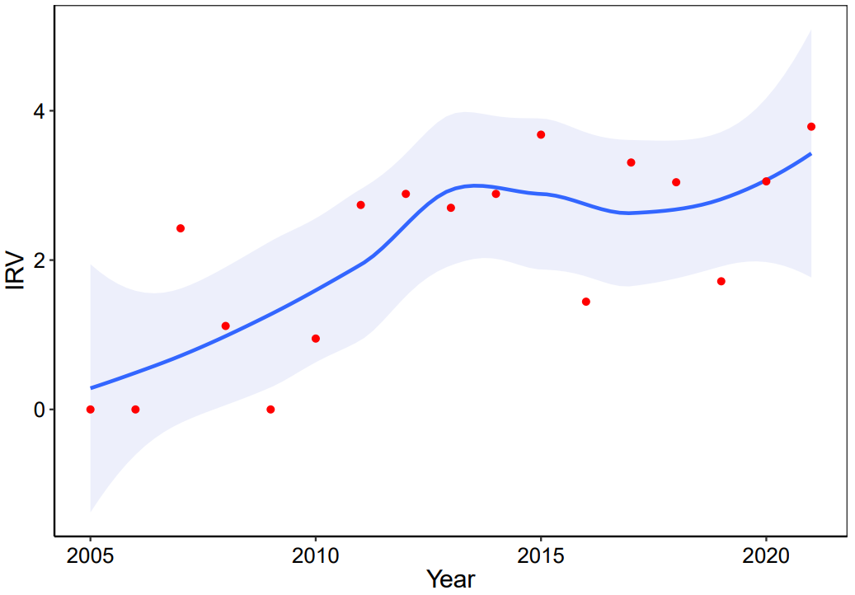
Table 3. Data collection of Hantavirus strain sequences in Jiangxi

Strain | Species | Year | Source | GenBank ID
 |  |  |  | S | M | L
L99 | SEOV | 1986 | Rattus norvegicus | AF288299 | AF288298 | \
AY133/2011 | HTNV | 2011 | Apodemus agrarius | KY807166 | KY817594 | /
GA21/2011 | HTNV | 2011 | Mus musculus | KY807167 | KY817597 | /
GA13/2011 | HTNV | 2011 | Mus musculus | KY807168 | KY817595 | /
XJ2/2011 | SEOV | 2011 | Rattus norvegicus | KY80716 | KY817598 | /
XJ5/2011 | SEOV | 2011 | Rattus norvegicus | KY807170 | KY817599 | /
SG42/2011 | SEOV | 2011 | Apodemus agrarius | KY807171 | KY817600 | /
JiangxiXinjianRn-07-2011 | SEOV | 2011 | Rattus norvegicus | KP859511 | KP859513 | \
JiangxiXinjianRn-09-2011 | SEOV | 2011 | Rattus norvegicus | KP859512 | KP859514 | \
SG40/2012 | HTNV | 2012 | Apodemus agrarius | MF141829 | MF141802 | /
GAW130/2012 | HTNV | 2012 | Apodemus agrarius | MF141827 | MF141799 | /
AYW123/2012 | HTNV | 2012 | Apodemus agrarius | MF141824 | MF141797 | /
AYW124/2012 | HTNV | 2012 | Apodemus agrarius | MF141825 | MF141796 | /
AYW127/2012 | HTNV | 2012 | Apodemus agrarius | MF141826 | MF141798 | /
AYW114/2014 | HTNV | 2014 | Apodemus agrarius | MF141834 | MF141815 | /
AYW117/2014 | HTNV | 2014 | Apodemus agrarius | MF141836 | MF141817 | /
AYW66/2014 | HTNV | 2014 | Apodemus agrarius | MF141830 | MF141810 | /
AYW76/2014 | HTNV | 2014 | Apodemus agrarius | MF141833 | MF141814 | /
AYW71/2015 | HTNV | 2015 | Apodemus agrarius | MF141839 | MF141808 | /
AYW84/2015 | HTNV | 2015 | Apodemus agrarius | MF141837 | MF141819 | /
AYW89-15 | HTNV | 2015 | Apodemus agrarius | KY978755 | KY978756 | KY978757
JXhu04-17 | HTNV | 2017 | Homo sapiens | / | MT782310 | /
JXHu10-17 | HTNV | 2017 | Homo sapiens | / | MT782311 | /
JXHu14-17 | HTNV | 2017 | Homo sapiens | / | MT782312 | /
JXHu27-17 | HTNV | 2017 | Homo sapiens | / | MT782313 | /
JXHu33-17 | HTNV | 2017 | Homo sapiens | / | MT782314 | /
JXHu39-17 | HTNV | 2017 | Homo sapiens | / | MT782316 | /
JXHu46-17 | HTNV | 2017 | Homo sapiens | / | MT782317 | /
JXHu47-17 | HTNV | 2017 | Homo sapiens | / | MT782318 | /
JXHu49-17 | HTNV | 2017 | Homo sapiens | / | MT782319 | /
JXHu50-17 | HTNV | 2017 | Homo sapiens | / | MT782320 | /
JXHu51-17 | HTNV | 2017 | Homo sapiens | / | MT782315 | /
GAW30/2021 | SEOV | 2021 | Rattus norvegicus | MZ504237 | MZ504239 | MZ504241
GAW50/2021 | SEOV | 2021 | Rattus losea | MZ504238 | MZ504240 | \
"/"no sequences or sequences are not available, "\"sequences are not used in this paper

Table 4. Summary of available HV strains in the surrounding provinces of Jiangxi and some other representative reference sequences
Strain | Collection site and date | Host | GenBank ID
Strain | Collection site and date | Host | S | M | L
Shashi11 | Hubei/2017 | Apodemus agrarius | MN608061 | MN608071 | /
Xiantao92 | Hubei/2012 | Apodemus agrarius | MN608097 | MN608104 | /
HV004 | Hubei/ NA | Apodemus agrarius | JQ083395 | JQ083394 | /
HV114 | Hubei/1987 | Homo sapiens | AB027110 | L08753 | /
HubeiHu02 | Hubei/2002 | Homo sapiens | JQ665905 | JQ665881 | /
WuhanRf02 | Hubei/2009 | Rattus flavipectus | JQ665912 | JQ665888 | /
WuhanRn10 | Hubei/2009 | Rattus norvegicus | JQ665920 | JQ665896 | /
WuhanMm13 | Hubei/2011 | Mus musculus | JQ665910 | JQ665886 | /
Hu | Hubei/ NA | Homo sapiens | AB027111 | AB027077
SMA029 | Hunan/ NA | Mus musculus | EF210132 | EF210126 | /
XXA039 | Hunan/ NA | Rattus norvegicus | EF210136 | EF210130 | /
Chen | Anhui/NA | Homo sapiens | AB027101 | / | /
FJ35 | Fujian/ 2020 | Rattus norvegicus | MW449190 | MW449189 | /
FJ36 | Fujian/ 2020 | Rattus norvegicus | MW449193 | MW449192 | /
Fj372/2013 | Fujian/2013 | Suncus murinus | KP645198 | KP645197 | /
YN45 | Guangdong/2017 | Rattus norvegicus | MZ031963 | MZ031955 | /
XM47 | Guangdong/2015 | Rattus norvegicus | MZ031962 | MZ031954 | /
GZ45 | Guangdong/2014 | Rattus norvegicus | MZ031961 | MZ031953 | /
MM23 | Guangdong/2017 | Rattus norvegicus | MZ031960 | MZ031952 | /
Z10 | Zhejiang/1980s | Homo sapiens | AF184987 | AF143675 | AF189155
ZLS6-11 | Zhejiang/2007 | Apodemus agrarius | FJ753397 | FJ753396 | /
ZLS-12 | Zhejiang/2007 | Apodemus agrarius | FJ753396 | FJ753397 | /
Z5 | Zhejiang/ NA | Apodemus agrarius | EF103195 | EU074224 | /
Z37 | Zhejiang/1980s | Rattus norvegicus | AF187082 | AF187081 | AF285266
ZT71 | Zhejiang/ 2003 | Rattus norvegicus | AY750171 | EF117248 | /
ZT10 | Zhejiang/ 2004 | Microtus fortis | AY766368 | DQ159911 | /
Gou3 | Zhejiang/ 1983 | Rattus norvegicus | AF184988 | AF14597 | /
LongquanAa-08-157 | Zhejiang/2008 | Apodemus agrarius | JQ912698 | JQ912804 | /
LongquanAa-10-98 | Zhejiang/2010 | Apodemus agrarius | JQ912760 | JQ912866 | /
84Fli1987 | Shanxi/ NA | Homo sapiens | AF366568 | AF366569 | /
Q32 | Guizhou/ NA | Apodemus agrarius | AB027097 | AB027061 | /
CGAa31P9 | Guizhou/2007 | Apodemus agrarius | EF990910 | EF990924 | /
CGRn15 | Guizhou/NA | Rattus norvegicus | EU363810 | EU363814 | /
SN7 | Shichuan/2000 | Rattus norvegicus | AF288657 | AF288656 | /
93HBX12 | Hebei/ NA | Rattus norvegicus | EF192308 | / | /
Rod/2016/CD/10/Gc | Hebei/2016 | Rattus norvegicus | / | MK340857 | /
Rod/2012/QHD/9/Gc | Hebei/2012 | Rattus norvegicus | / | MK340829 | /
SD201 | Shandong/2006 | Rattus norvegicus | GQ279385 | / | /
JUN5-14 | Shandong/2004 | Rattus norvegicus | DQ217791 | DQ217790 | /
YZG-Changchun | Jilin/2006 | Mus norvegicus albus | EF536376 | /
Gongzhuling58 | Jilin/2009 | Rattus norvegicus | KF745944 | KF745934
DN2 | Heilongjiang/2014 | Rattus norvegicus | KX289954 | KX289953
76-118 | South Korea /1976 | Apodemus agrarius | KT885049 | KT885048
80-39 | South Korea/ NA | Rattus norvegicus | AY273791 | S47716 | X56492
DPRK08 | North Korea/2011 | Rattus norvegicus | JX853576 | JX853575 | /
SR-11 | Japan/ NA | Rattus norvegicus | M34882 | M34881 | /
IR461 | Belgium/ NA | laboratory-acquired infection | AF329388 | AF458104 | /
TCH | American/1984 | Rattus norvegicus | KU204960 | KU204959 | /
"/"sequences are not avilable or are not used in this paper; NA: not available in Genebank.

Table 5. Comparative analysis of genome of AYW 89-15 strain with HTNV standard strain (76-118) and vaccine strain (Z10)
Strain | Nucleotides |  | Amino acid
Strain | 76-118 | Z10 | 76-118 | Z10
AYW89-15 | 86.5/84.5/83.5* | 86.6/84.1/83.4* | 96.7/96.4/97.0* | 97.6/95.3/97.3*
Note: *S/M/L

Table 6. Comparative analysis of genome of GAW30/ 2021 strain, SEOV standard strain (80-39) and vaccine strain (Z37)
Strain | Nucleotides |  | Amino acid
Strain | 80-39 | Z37 | 80-39 | Z37
GAW30/2021 | 89.4/84.7/84.5* | 88.6/84.8/84.5* | 99.5/96.5/97.4* | 98.8/97.0/97.6*
Note: *S/M/L

