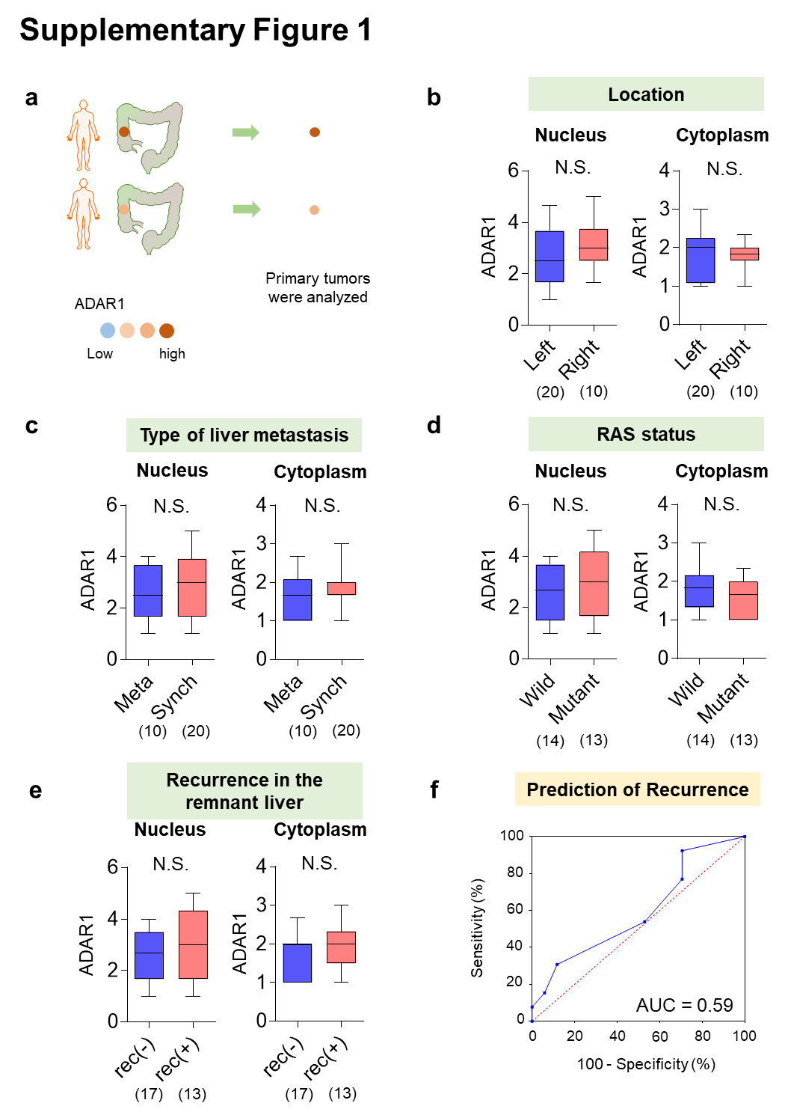

(a) The ADAR1 expression in the primary tumor was analyzed. (b–e) No correlation was observed between ADAR1 expression in the primary tumor and clinicopathological status. (f) The predictive ability of ADAR1 expression in the primary tumor for remnant liver recurrence was poor (area under the curve = 0.59).

